|  |
| --- |
| Creating Web Application |
| COS10011  Semester 1, 2021 |
|  |
|  |
|  |

|  |  |
| --- | --- |
| Member Name | Member ID |
| Law Yuk Fung | 102765848 |

|  |
| --- |
|  |

Contents

**Assignment 1**

1. Introduction 2

1.1 Scope of the website 2

1.2 Intended audience 2

2. Webpage Design and Structure 2

2.1 Website Layout Mock ups 2

2.2 Website Structure 5

3. End Product 6

3.1 Actual User Interface 6

3.2 Enhancements (if any) 11

**Assignment 1**

# Introduction

*[Brief introduction to the website: background and objectives]*

## Scope of the website

Imap company has provides rental service for photographer and shutterbug. Their services include camera rental service, lens rental service, printer rental service, and accessories rental service.

## Intended audience

It is target for photographer and shutterbug.

# Webpage Design and Structure

## Website Layout Mock ups

*[Provide Wireframe/sketch of the website. You may use the available online tools such as* [*https://moqups.com/*](https://moqups.com/) *]*

Index

Header

Images &text

Images

Images

Images

Images

Footer

Service

Description

Images

Images

Images

Images

Description

Description

Description

Footer

Images

Header

About me

Text

Images

Footer

Header

Enquiry

Form

Title

Footer

Header

Disclaimer

Title

text

Footer

Header

## Website Structure

*[Provide hierarchical structure of the website]*

Index

Disclaimer

Enhancements

About me

Categories

Enquiry

Camera

Lens

Printer

Accessories

# End Product

## Actual User Interface

*[Provide screenshots of the websites. Justify and explain the design used based on the webpage design principles. Do some reading online for design principle guidelines]*

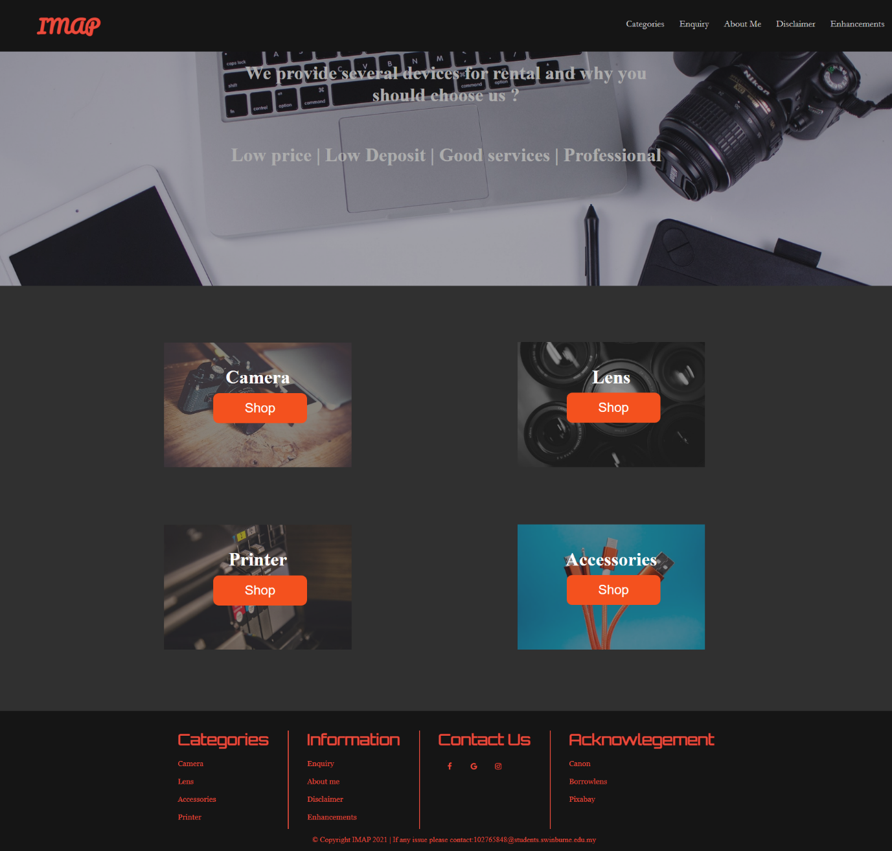Index

Service

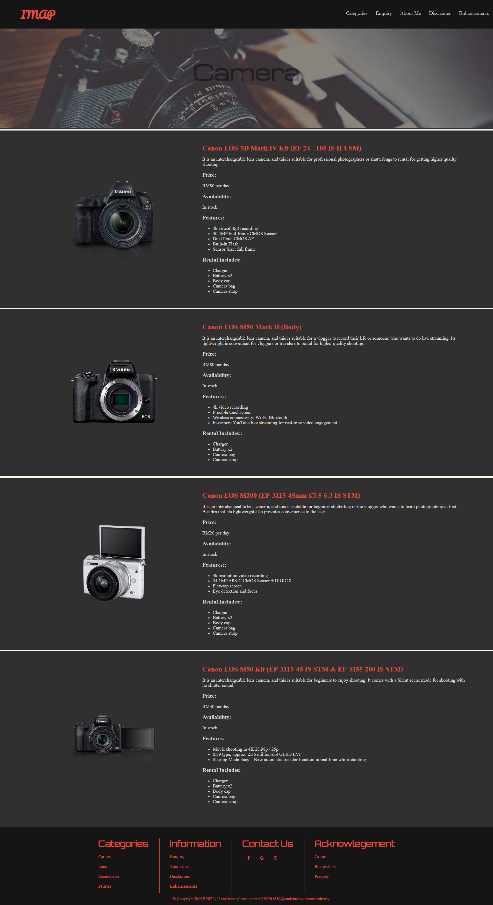

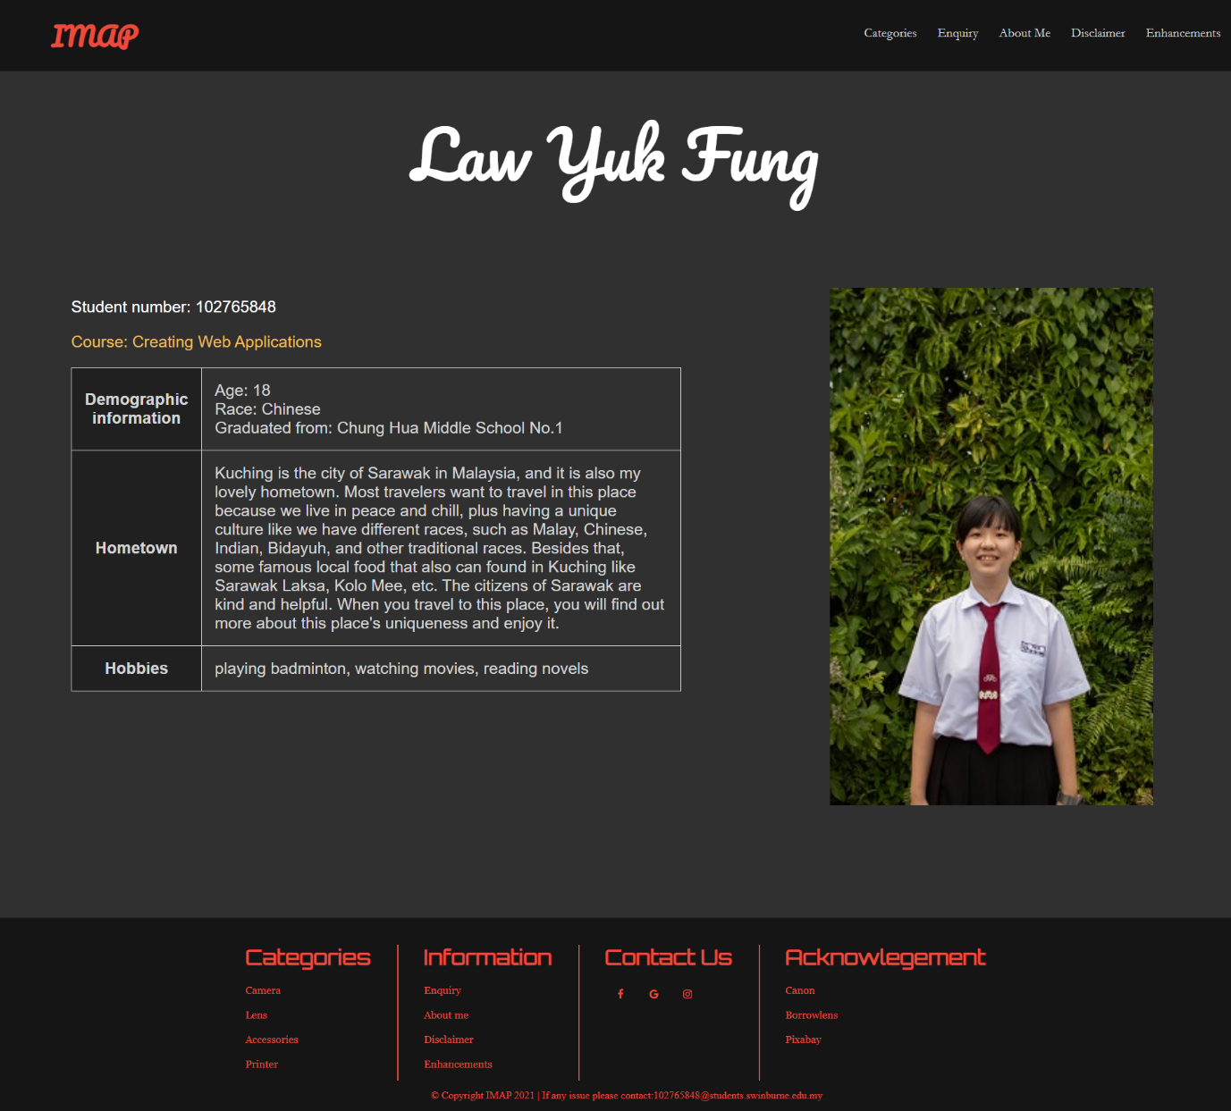About me

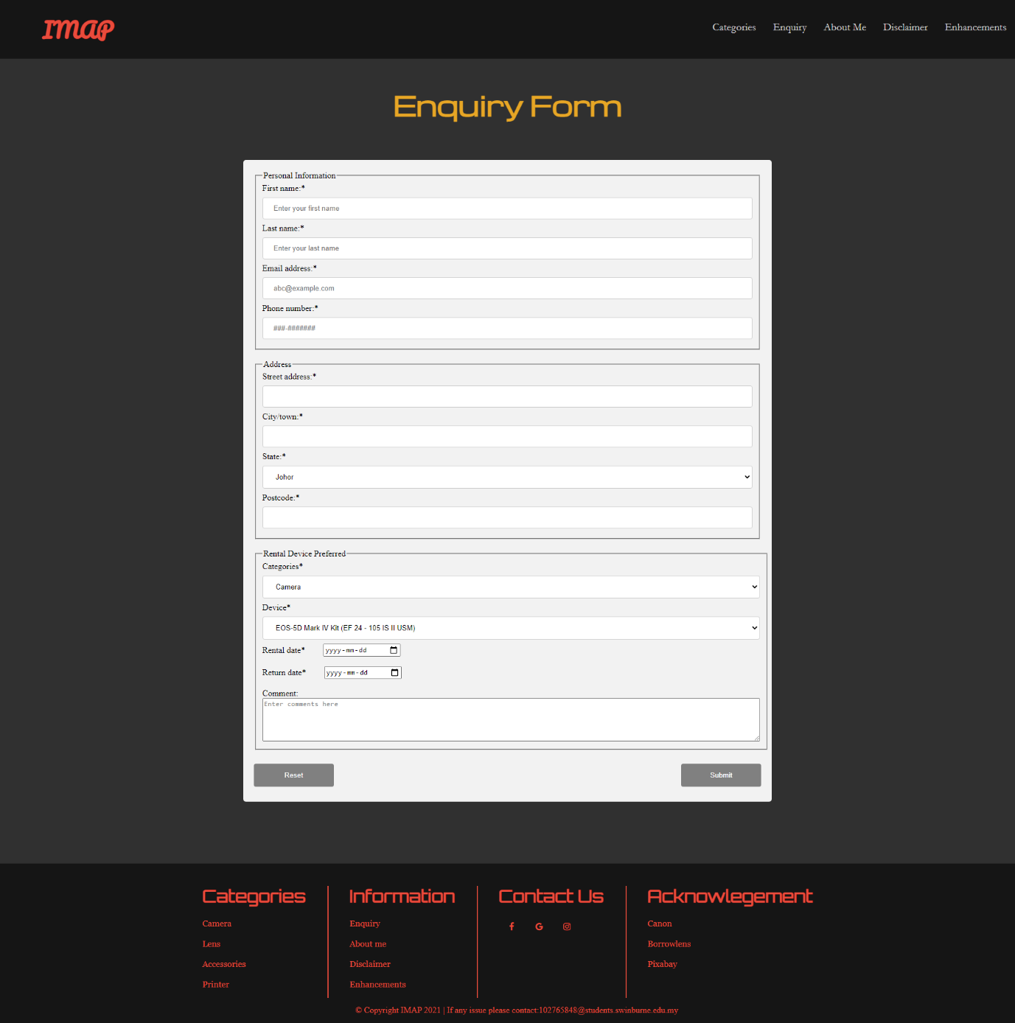Enquiry

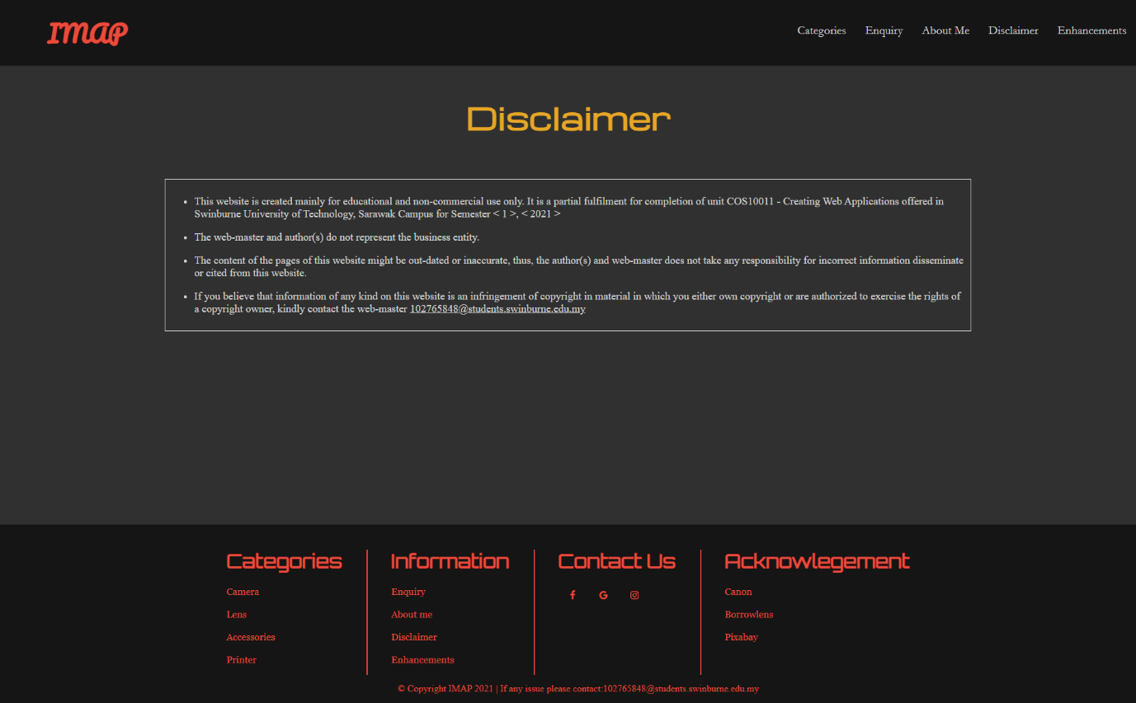Disclaimer

## Enhancements (if any)

*[Describe the enhancements if any]*

1. Social Media Button

The social media buttons are created for people who want to follow our advertisement through social media, and it also brings convenience to people. Moreover, social media buttons make us easy to share our content or promotions through a couple of click buttons. It is also a great way to promote our services to let more people understand our company deeply.

1. Dropdown

It is giving a fast and curious way to the customer who was interested in this products. The dropdown list provides feedback to customers and interacts with the customer, thus letting them have a better web experience.

**Assignment 2**

1. Description

*[Provide brief description on how javascript is applied to the website]*

1. End Product
   1. Enhancements (if any)

*[Describe the enhancements if any]*

**Assignment 3**

1. Description

*[Provide brief description on how PHP is applied to the website]*

1. MySQL database structure/schema

*[Prepare a table to show MySQL database used in the website]*

1. End Product
   1. Enhancements (if any)

*[Describe the enhancements if any]*