Predicting Earthquake Damage to Prioritise Building Inspections
A logistic-regression study of the 2015 Gorkha earthquake building-damage data (Richter's Predictor)

Course: [COURSE CODE] – [COURSE NAME]
Group: [GROUP NUMBER]
Submission date: [DD Month YYYY]

# | Member name | Student ID
1 | [MEMBER 1 NAME] | [STUDENT ID 1]
2 | [MEMBER 2 NAME] | [STUDENT ID 2]
3 | [MEMBER 3 NAME] | [STUDENT ID 3]
4 | [MEMBER 4 NAME] | [STUDENT ID 4]
5 | [MEMBER 5 NAME] | [STUDENT ID 5]
6 | [MEMBER 6 NAME] | [STUDENT ID 6]

Placeholders highlighted in yellow must be completed by the group before submission.

Abstract
After the 2015 Gorkha earthquake, Nepal surveyed hundreds of thousands of damaged buildings. We ask whether a building's recorded structure and location can predict its damage grade well enough to rank buildings for inspection. Using 260,601 labelled buildings from the DrivenData competition Richter's Predictor, we built a leakage-safe scikit-learn pipeline and ran seven controlled experiments, restricted to logistic regression. Location, encoded with cross-fitted multiclass target encoding of 11,595 local areas, gave the largest single gain (+6.3 pp in cross-validated micro-F1). An ordinal formulation using two cumulative binary models did not outperform the standard multinomial model, and class weighting traded overall accuracy for recall of the rare low-damage class. The tuned model (E4, C = 0.3) reaches a holdout micro-F1 of 0.740 and macro-F1 of 0.680, against 0.569 for the majority-class baseline. Ranking buildings by predicted probability of grade-3 damage, inspecting the top 20% of buildings finds 49.8% of all grade-3 buildings, 2.5 times what a random order finds. The coefficients agree with engineering intuition: mud-mortar stone and stone-flag construction raise the odds of destruction, and engineered reinforced concrete and cement-bonded masonry lower them.

Contents
Abstract 2
Contents 2
1. Introduction and Problem Statement 4
2. Dataset Description 4
3. Data Pre-processing 5
3.1 Exploration 5
3.2 Cleaning 7
3.3 Encoding and scaling 7
3.4 Feature engineering 8
4. Methodology 8
4.1 Training and testing procedure 8
4.2 Models 9
4.3 Experimental design 9
4.4 Evaluation metrics 9
5. Experimental Study and Analysis 9
5.1 Cross-validation results 9
5.2 Hyperparameter tuning 10
5.3 Holdout evaluation 11
5.4 Prioritisation analysis 11
5.5 Interpretation of coefficients 12
6. Highlights 14
6.1 Ordinal versus multinomial logistic regression 14
6.2 Cross-fitted target encoding of location 14
7. Limitations 15
8. Future Directions 15
9. Conclusion 16
References 16
Appendix 17
A. Full cross-validation results 17
B. Regularisation path 17
C. Additional exploration figures 18
D. Reproducibility 19
E. Contribution statement 19

1. Introduction and Problem Statement
On 25 April 2015 a magnitude-7.8 earthquake struck the Gorkha district of Nepal. It killed nearly 9,000 people and damaged or destroyed hundreds of thousands of buildings (National Planning Commission, 2015). After a disaster on this scale, trained structural inspectors are a scarce resource. Every building must eventually be assessed, but the order of inspection decides how quickly dangerous structures are cordoned off, families are rehoused, and reconstruction aid is targeted.
The Government of Nepal later released one of the largest post-disaster building surveys ever collected. A version of it underlies the DrivenData competition Richter's Predictor: Modeling Earthquake Damage (DrivenData, 2019). This project uses those data to answer one question:
“Can we predict how badly a building was damaged in the 2015 Gorkha earthquake from its structure and location, so post-disaster inspectors can prioritise which buildings to assess first?”
We treat this as a three-class classification problem with an ordered target: damage grade 1 (low), 2 (medium) and 3 (almost complete destruction). We deliberately restrict ourselves to logistic regression. Its predictions are fast to compute, its coefficients can be audited by engineers, and its probabilities can be used directly to rank buildings. Our contributions are:
- a fully leakage-safe preprocessing and modelling pipeline, evaluated with stratified 5-fold cross-validation and a holdout that is used only once;
- a controlled sequence of seven experiments that isolates the value of structure, coarse location, fine location, engineered features, class weighting and an ordinal formulation;
- cross-fitted multiclass target encoding of the high-cardinality location identifiers, which turns out to be the single most valuable idea;
- a prioritisation analysis that converts model output into an inspection policy, and a coefficient-level interpretation in plain language.

2. Dataset Description
The labelled data consist of two files joined on building_id: train_values.csv with 260,601 rows and 38 features, and train_labels.csv with the damage grade. A further 86,868 buildings in test_values.csv have no labels; we use them only to produce a competition submission. Table 1 groups the features.
Table 1. Feature groups in the Richter's Predictor data.
Group | Features | Type
Location | geo_level_1_id (31 regions), geo_level_2_id (1,414), geo_level_3_id (11,595) | nested categorical ids
Size & age | age, area_percentage, height_percentage, count_floors_pre_eq | numeric (normalised)
Construction | foundation_type, roof_type, ground_floor_type, other_floor_type, position, plan_configuration, land_surface_condition | categorical (anonymised letters)
Superstructure | 11 has_superstructure_* flags (adobe mud, mud-mortar stone, stone flag, cement-mortar stone/brick, mud-mortar brick, timber, bamboo, RC non-engineered, RC engineered, other) | binary
Use & ownership | legal_ownership_status, count_families, 11 has_secondary_use_* flags | categorical / numeric / binary

We verified the facts given in the brief rather than assuming them, and the notebook asserts each one. There are 0 missing values in either file, 8 categorical columns and 22 binary columns. The class distribution is imbalanced: grade 1 9.6%, grade 2 56.9% and grade 3 33.5% (Figure 1). Two data-quality issues matter. First, 1,390 buildings (0.53%) have age = 995, a placeholder far beyond the largest real age of 200 years. Second, the finest location level has 11,595 distinct values, too many to one-hot encode sensibly. Also, 0.38% of test buildings fall in a geo_level_3 area that never appears in the labelled data.
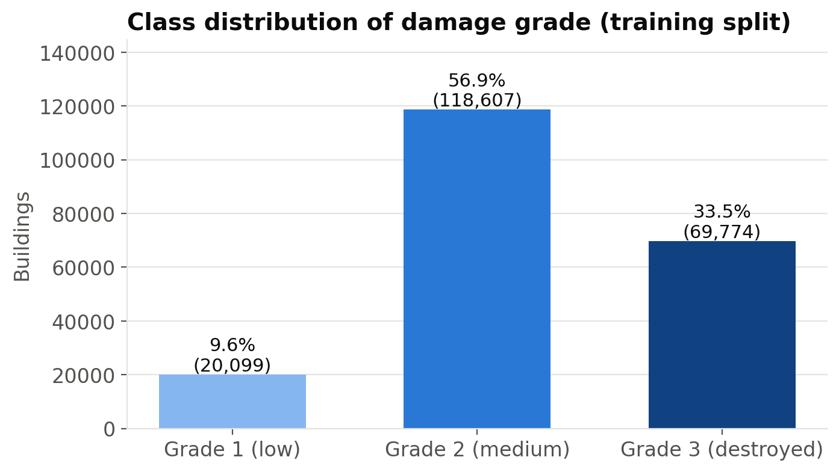
Figure 1. Damage-grade distribution in the 80% training split. Grade 2 is the majority class; grade 1 is rare.

3. Data Pre-processing
Before any exploration, we made a stratified 80/20 split (208,480 training and 52,121 holdout buildings). All exploration below uses only the training split, so nothing we decided about the features was influenced by the holdout.

3.1 Exploration
Construction type separates the classes sharply (Figure 2). Foundation type r, used by 84% of buildings, has a grade-3 share of 38%. Foundation i has a grade-3 share of only 2% and a grade-1 share of 57%. Roof type x shows the same protective pattern (4% grade 3). The category codes are anonymised, but these profiles are consistent with engineered, reinforced construction.
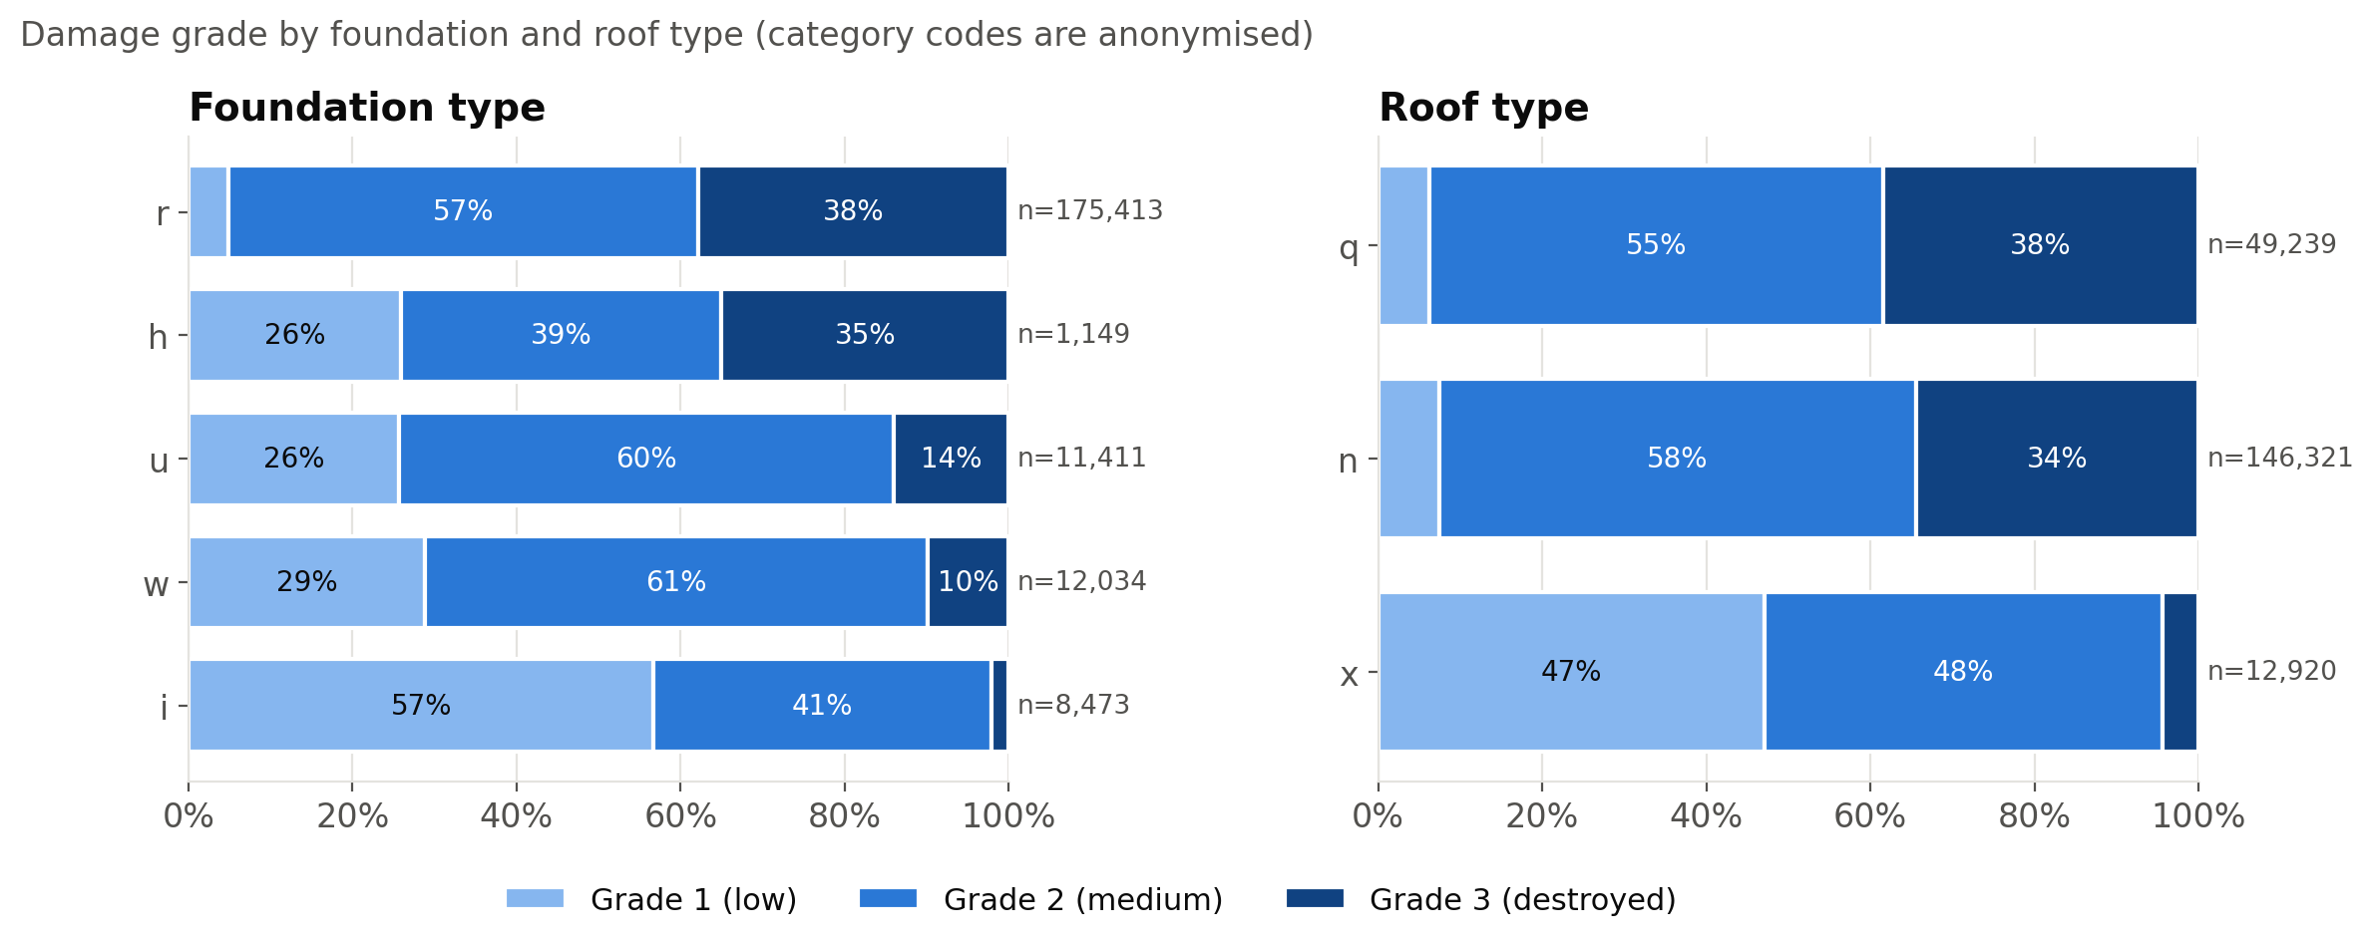
Figure 2. Damage-grade mix by foundation type (left) and roof type (right), training split. Bars are sorted by grade-3 share; n is the number of buildings.
Superstructure material is the clearest structural signal (Figure 3). Mud-mortar stone is used in 76% of buildings, and 38% of those reached grade 3. Engineered reinforced concrete (RC) reached grade 3 in only 1.9% of cases, with 64% at grade 1. Cement-mortar brick is similarly protective (6% grade 3).
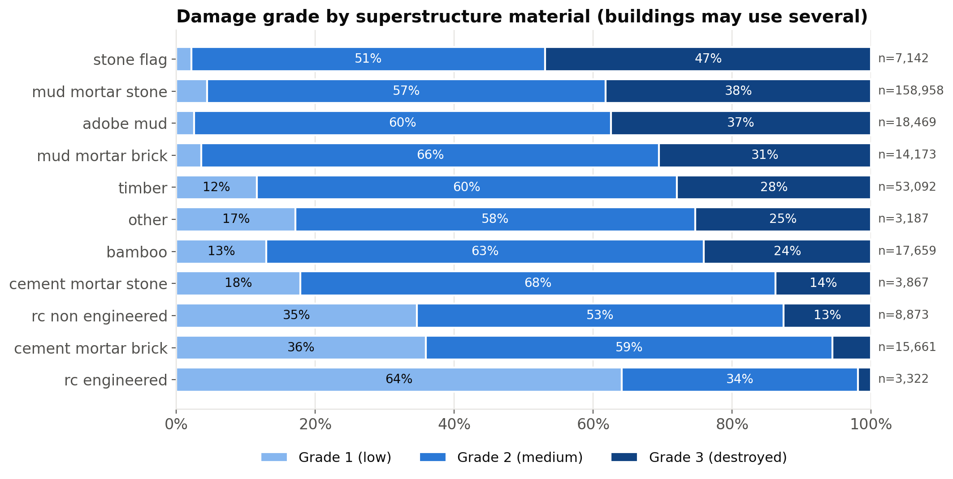
Figure 3. Damage-grade mix by superstructure material. A building can use several materials, so rows overlap.
Location matters at least as much as structure (Figure 4). Across the 31 top-level regions, the grade-3 share ranges from 9% (region 26) to 81% (region 17). Location most likely stands in for shaking intensity, that is, distance from the epicentre and local ground conditions. These are not in the data, but they strongly shape damage.
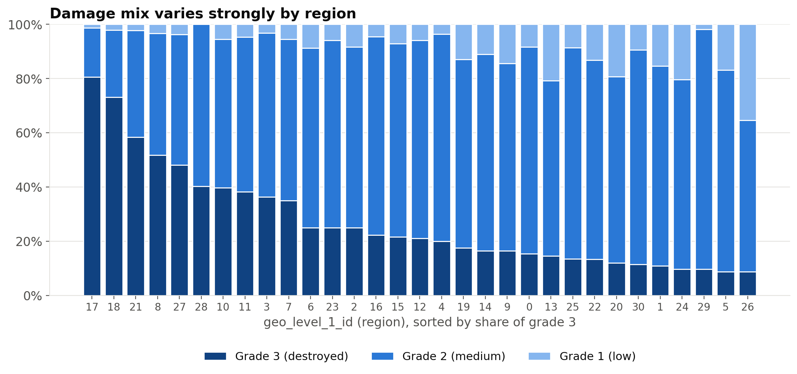
Figure 4. Damage-grade mix for each of the 31 geo_level_1 regions, sorted by grade-3 share.
The numeric features are right-skewed, with skewness 2.05 for age, 3.52 for area and 1.73 for height. A log1p transform reduces this to -1.04, 0.41 and -0.15 (Appendix C, Figure C1). Individually these features are only weakly related to damage: the largest absolute Spearman correlation with damage grade among numeric and material features is 0.27. Height and number of floors are strongly collinear (ρ = 0.76; Appendix C, Figure C2). The weak marginal correlations show that damage comes from combinations of many weak signals, which is what a multivariate model needs to capture. The L2 penalty of logistic regression keeps the collinear pair stable.

3.2 Cleaning
No imputation of genuinely missing values was needed. The age placeholder was handled explicitly. Buildings with age = 995 have a lower grade-3 share (28.6%) than the rest (33.5%), so the placeholder carries information and should not be treated as a real age of 995 years. A custom transformer (AgeCleaner) therefore (i) adds a binary indicator age_is_placeholder and (ii) replaces the placeholder with the median age of the training fold. Because the median is learned in fit, it is recomputed inside every cross-validation fold.

3.3 Encoding and scaling
All transformations are implemented as one scikit-learn ColumnTransformer inside a Pipeline (Table 2), so every learned statistic comes from training data only.
Table 2. Preprocessing pipeline. Every step is fitted on training folds only.
Columns | Transformation | Rationale
age, area_percentage, height_percentage | log1p, then StandardScaler | reduce right skew; common scale for L2 and lbfgs
count_floors_pre_eq, count_families (+ engineered) | StandardScaler | small counts, little skew
8 categorical columns | OneHotEncoder (all levels, handle_unknown='ignore') | nominal codes; L2 keeps full dummy sets identifiable
geo_level_1_id (E2+) | OneHotEncoder | 31 regions, small enough to one-hot
geo_level_2_id, geo_level_3_id (E3+) | TargetEncoder(target_type='multiclass'), 5-fold cross-fitting | high cardinality; 3 smoothed class rates per level
22 binary flags + age_is_placeholder | passthrough | already 0/1

The multiclass TargetEncoder replaces each geo id by three numbers: the smoothed proportions of grade-1, grade-2 and grade-3 buildings observed for that id. Rare ids are shrunk toward the global class distribution, and ids never seen in training receive the global distribution. Target encoding can leak the label, because a building's own grade would contribute to its own feature. scikit-learn's implementation therefore uses cross-fitting in fit_transform: training rows are encoded with statistics computed on the other internal folds (Micci-Barreca, 2001; Pedregosa et al., 2011).

3.4 Feature engineering
Four candidate features were constructed: n_superstructure (number of materials used), log_area_height_ratio (footprint relative to height, a slenderness proxy), floors_x_log_age (taller and older buildings), and height_per_floor. Fold-to-fold noise is of the same order as the expected effects, so each candidate was added to E3 on its own and compared on the same five folds. A candidate was kept only if its mean paired gain was positive and it improved at least four of the five folds. Table 3 shows the outcome; the features kept were floors_x_log_age.
Table 3. Add-one ablation of engineered features on top of E3 (E3 micro-F1 = 0.7350).
Candidate | CV micro-F1 | Mean paired gain | Folds improved | Decision
n_superstructure | 0.7349 | -0.00 pp | 2/5 | dropped
log_area_height_ratio | 0.7350 | +0.00 pp | 2/5 | dropped
floors_x_log_age | 0.7352 | +0.02 pp | 5/5 | kept
height_per_floor | 0.7350 | +0.00 pp | 1/5 | dropped

4. Methodology

4.1 Training and testing procedure
- Split. values and labels were merged on building_id and split 80/20, stratified by damage grade, with random_state = 42.
- Model selection. every experiment was scored by stratified 5-fold cross-validation (shuffled, random_state = 42) on the 80% split. We report the mean and standard deviation over folds. Identical folds across experiments allow paired comparisons.
- Tuning. the best of E4–E6 by mean CV micro-F1 was tuned over C ∈ {0.01, 0.03, 0.1, 0.3, 1, 3, 10, 30, 100} with GridSearchCV, using the same folds and scoring f1_micro. GridSearchCV then refitted the best setting on the whole 80% split.
- Final test. the refitted model was scored once on the 20% holdout; the notebook asserts that this happens only once.
- Submission. the tuned configuration was refitted on all 260,601 labelled buildings to predict the 86,868 test buildings.

4.2 Models
The multinomial logistic regression (Hosmer et al., 2013; Hastie et al., 2009) models the class probabilities with a softmax over linear scores:
P(y = k | x) = exp(β₀ₖ + βₖᵀx) / Σⱼ exp(β₀ⱼ + βⱼᵀx), k ∈ {1, 2, 3}
It is fitted by minimising the cross-entropy plus an L2 penalty ‖β‖²/(2C) with the lbfgs solver. All inputs are scaled or binary, and we allowed up to 5000 iterations. The largest number of iterations used by any fit (experiments, ablation, all 9×5 grid fits and the refits) was 337. Every fit therefore converged, and no ConvergenceWarning was raised.
For the ordinal model (E6) we follow Frank and Hall (2001). We fit two binary logistic models on the same features, for P(y > 1 | x) and P(y > 2 | x). Class probabilities are differences of the cumulative probabilities:
P(y=1) = 1 − P(y>1), P(y=2) = P(y>1) − P(y>2), P(y=3) = P(y>2)
The two models are fitted independently, so their cumulative probabilities can occasionally cross. We enforce P(y>2) ≤ P(y>1) before taking differences, and we predict the class with the highest probability. Unlike the proportional-odds model (McCullagh, 1980), the two models do not share slopes.

4.3 Experimental design
Each experiment changes one thing relative to its predecessor (Table 4).
Table 4. Experiment design. All logistic models use C = 1 before tuning.
ID | Configuration | Question answered
E0 | Majority-class baseline (always grade 2) | What does guessing achieve?
E1 | LR, all non-location features | How much does the building itself tell us?
E2 | E1 + one-hot geo_level_1_id | Value of coarse location
E3 | E2 + target-encoded geo_level_2_id and geo_level_3_id | Value of fine location
E4 | E3 + engineered features (floors_x_log_age) | Value of feature engineering
E5 | E4 with class_weight='balanced' | Does reweighting help the rare class?
E6 | E4 as ordinal (two cumulative binary LRs) | Does exploiting the order help?

4.4 Evaluation metrics
Micro-averaged F1 is the competition metric. For single-label multiclass prediction it equals accuracy. Macro-averaged F1 gives each grade equal weight and so shows performance on the rare grade 1. On the holdout we also report per-class precision and recall and a row-normalised confusion matrix. For the prioritisation analysis, the capture rate at x% is the share of all grade-3 buildings found among the x% of buildings with the highest predicted P(grade 3). Its ratio to x is the lift.

5. Experimental Study and Analysis

5.1 Cross-validation results
Table 5 and Figure 5 summarise the experiments.
Table 5. Stratified 5-fold CV results on the 80% training split. * = tuned final model.
ID | Description | Micro-F1 (mean ± sd) | Macro-F1 (mean ± sd) | Grade-1 recall
E0 | Majority-class baseline | 0.5689 ± 0.0000 | 0.2417 ± 0.0000 | 0.000
E1 | Logistic regression, structural features only | 0.5908 ± 0.0013 | 0.4640 ± 0.0021 | 0.317
E2 | E1 + one-hot geo_level_1_id | 0.6718 ± 0.0019 | 0.5917 ± 0.0029 | 0.357
E3 | E2 + target-encoded geo_level_2/3_id | 0.7350 ± 0.0012 | 0.6726 ± 0.0017 | 0.468
E4 | E3 + engineered features (floors_x_log_age) | 0.7352 ± 0.0010 | 0.6732 ± 0.0014 | 0.470
E5 | E4 with class_weight='balanced' | 0.6909 ± 0.0011 | 0.6644 ± 0.0008 | 0.825
E6 | E4 as ordinal logistic (P(y>1), P(y>2)) | 0.7346 ± 0.0012 | 0.6728 ± 0.0017 | 0.470
E4* | E3 + engineered features (floors_x_log_age), tuned C = 0.3 | 0.7354 ± 0.0010 | 0.6733 | –

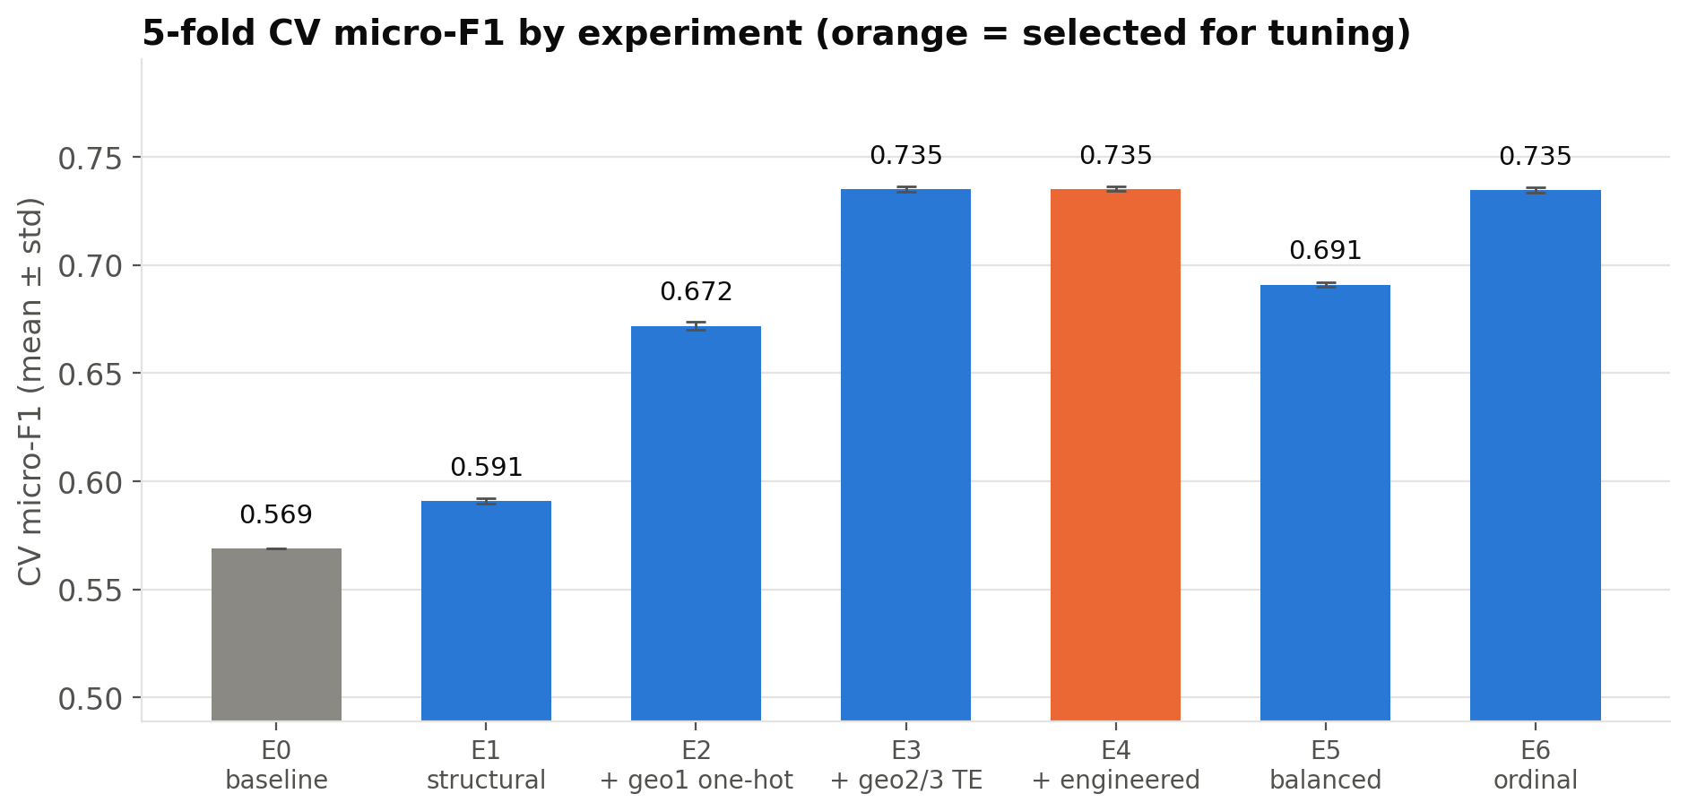
Figure 5. CV micro-F1 by experiment (error bars: ±1 sd over folds). Orange marks the configuration selected for tuning.
Structure alone (E1) improves on the 0.569 baseline to 0.591. That is a real gain, but most buildings still end up in the majority class. Coarse location (E2) adds +8.1 pp, and target-encoded fine location (E3) adds a further +6.3 pp, the largest single step in the study. The macro-F1 rises from 0.464 to 0.673 along the same path. Engineered features (E4) change micro-F1 by only +0.02 pp. The raw features already contain most of what a linear model can extract, and the remaining signal is in location rather than geometry. Fold standard deviations are at most 0.0019, so differences of more than about half a percentage point are robust.
Class weighting (E5) lowers micro-F1 by 4.43 pp and changes macro-F1 by -0.88 pp. Grade-1 recall rises from 0.470 to 0.825, and grade-2 recall falls from 0.845 to 0.647. The ordinal model (E6) scores 0.7346 micro-F1 against 0.7352 for the multinomial model. Section 6.1 discusses both. Since micro-F1 is the competition metric and the tuning criterion, the multinomial model with engineered features (E4) was carried forward to tuning.

5.2 Hyperparameter tuning
GridSearchCV selected C = 0.3 with CV micro-F1 0.7354 ± 0.0010. The curve is essentially flat (Appendix B, Figure B1): across four orders of magnitude of C, mean micro-F1 varies by only 0.05 percentage points, less than one fold standard deviation. With 208,480 training rows and only 104 model features, the L2 penalty barely matters, so the choice of C is not critical. Strong regularisation (C = 0.01) mainly costs macro-F1 (0.6709 vs 0.6733), because it shrinks the coefficients that separate the rare grade 1.

5.3 Holdout evaluation
On the untouched holdout (52,121 buildings), the tuned model achieves micro-F1 = 0.7405 and macro-F1 = 0.6798. These are within 0.50 percentage points of the CV estimate, which confirms that model selection did not overfit. Per-class results are in Table 6 and the confusion matrix in Figure 6.
Table 6. Per-class holdout metrics of the final model.
Grade | Precision | Recall | F1 | Support
1 | 0.672 | 0.478 | 0.559 | 5,025
2 | 0.740 | 0.848 | 0.790 | 29,652
3 | 0.759 | 0.633 | 0.691 | 17,444

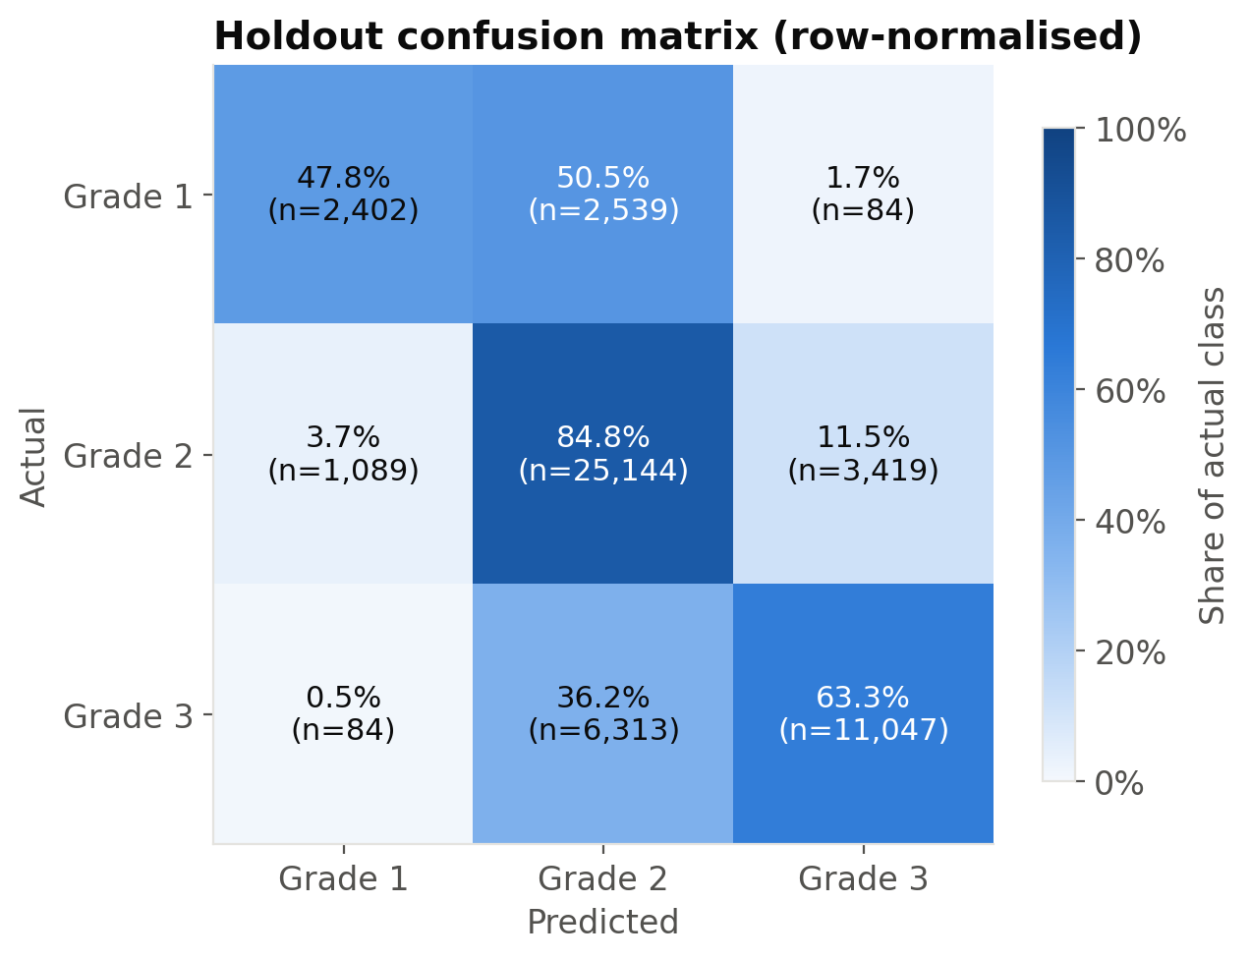
Figure 6. Row-normalised holdout confusion matrix (counts in brackets).
Grade 2 is recalled best (84.8%), then grade 3 (63.3%). Grade 1 is hardest (47.8%), and 50.5% of grade-1 buildings are predicted as grade 2. Almost all errors are between adjacent grades. Only 0.48% of grade-3 buildings are predicted as grade 1, and only 1.67% of grade-1 buildings as grade 3. The model therefore rarely makes the costly mistake of calling a destroyed building safe.

5.4 Prioritisation analysis
To connect the model to the problem statement, we ranked holdout buildings by predicted P(grade 3). We then measured the share of true grade-3 buildings found as inspectors work down the list (Figure 7, Table 7).
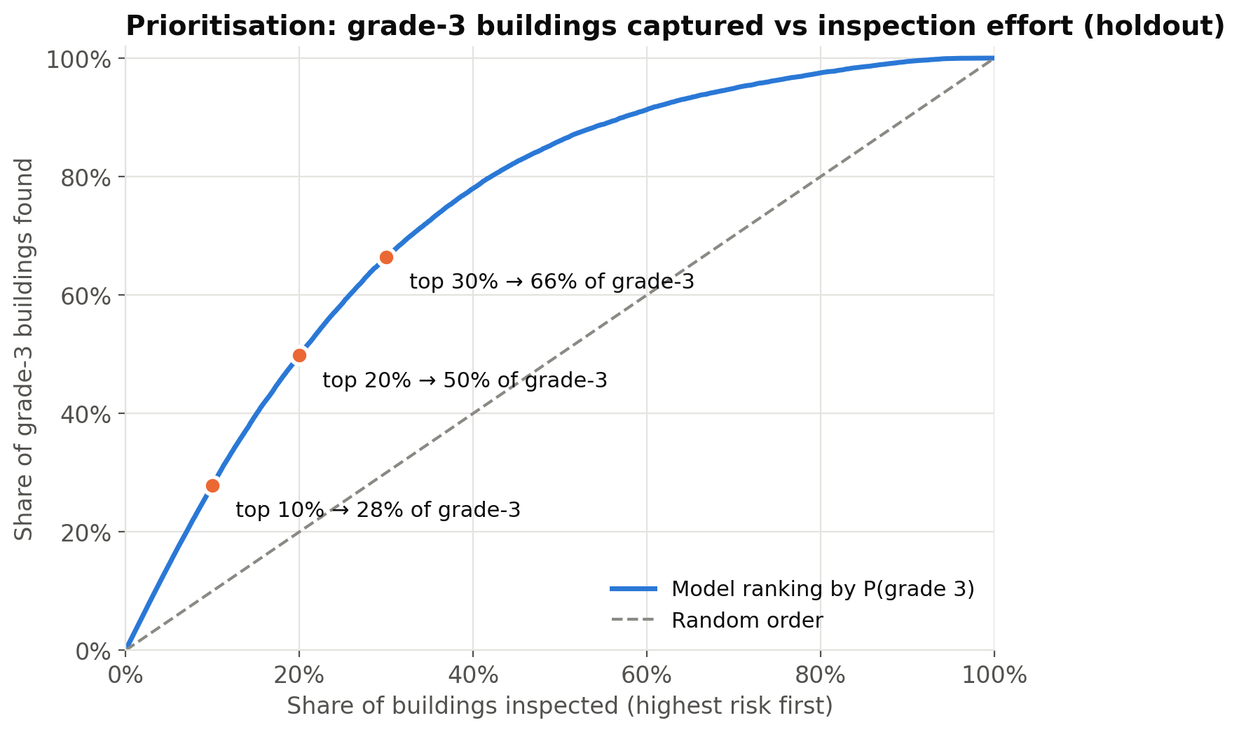
Figure 7. Cumulative share of grade-3 buildings found against the share of buildings inspected, holdout. The dashed line is a random inspection order.
Table 7. Capture rates on the holdout (17,444 grade-3 buildings, base rate 33.5%).
Top x% inspected | Buildings inspected | Grade-3 captured | Lift vs random | Grade-3 share within list
10% | 5,212 | 27.9% | 2.79× | 93.3%
20% | 10,424 | 49.8% | 2.49× | 83.3%
30% | 15,636 | 66.4% | 2.21× | 74.1%

Inspecting the top 10% of buildings finds 27.9% of all grade-3 buildings, 2.8 times what a random order finds. Within that top decile, 93.3% of buildings are actually grade 3, against a base rate of 33.5%. At 30% the capture rate is 66.4%. The ROC-AUC for grade 3 against the other grades is 0.866. For an inspection agency, this means the first teams in the field would spend most of their time at buildings that really are destroyed.

5.5 Interpretation of coefficients
Figure 8 shows the 15 features that most raise and most lower the odds of grade-3 damage in the final model (multinomial grade-3 row). Each is shown as an odds ratio exp(β): per one standard deviation for scaled numeric features, and for presence versus absence for flags and dummy variables. In a softmax model, a dummy's coefficient is relative to the L2-centred average level, so the bars are best read as directions and relative sizes, not exact causal effects. Two groups are excluded from the figure. Location features are discussed below. The other group is 21 flags and dummies present in fewer than 1% of buildings, whose coefficients rest on very few buildings and are unstable. For example, secondary use: school has an odds ratio of 2.08 but applies to only 0.04% of buildings.
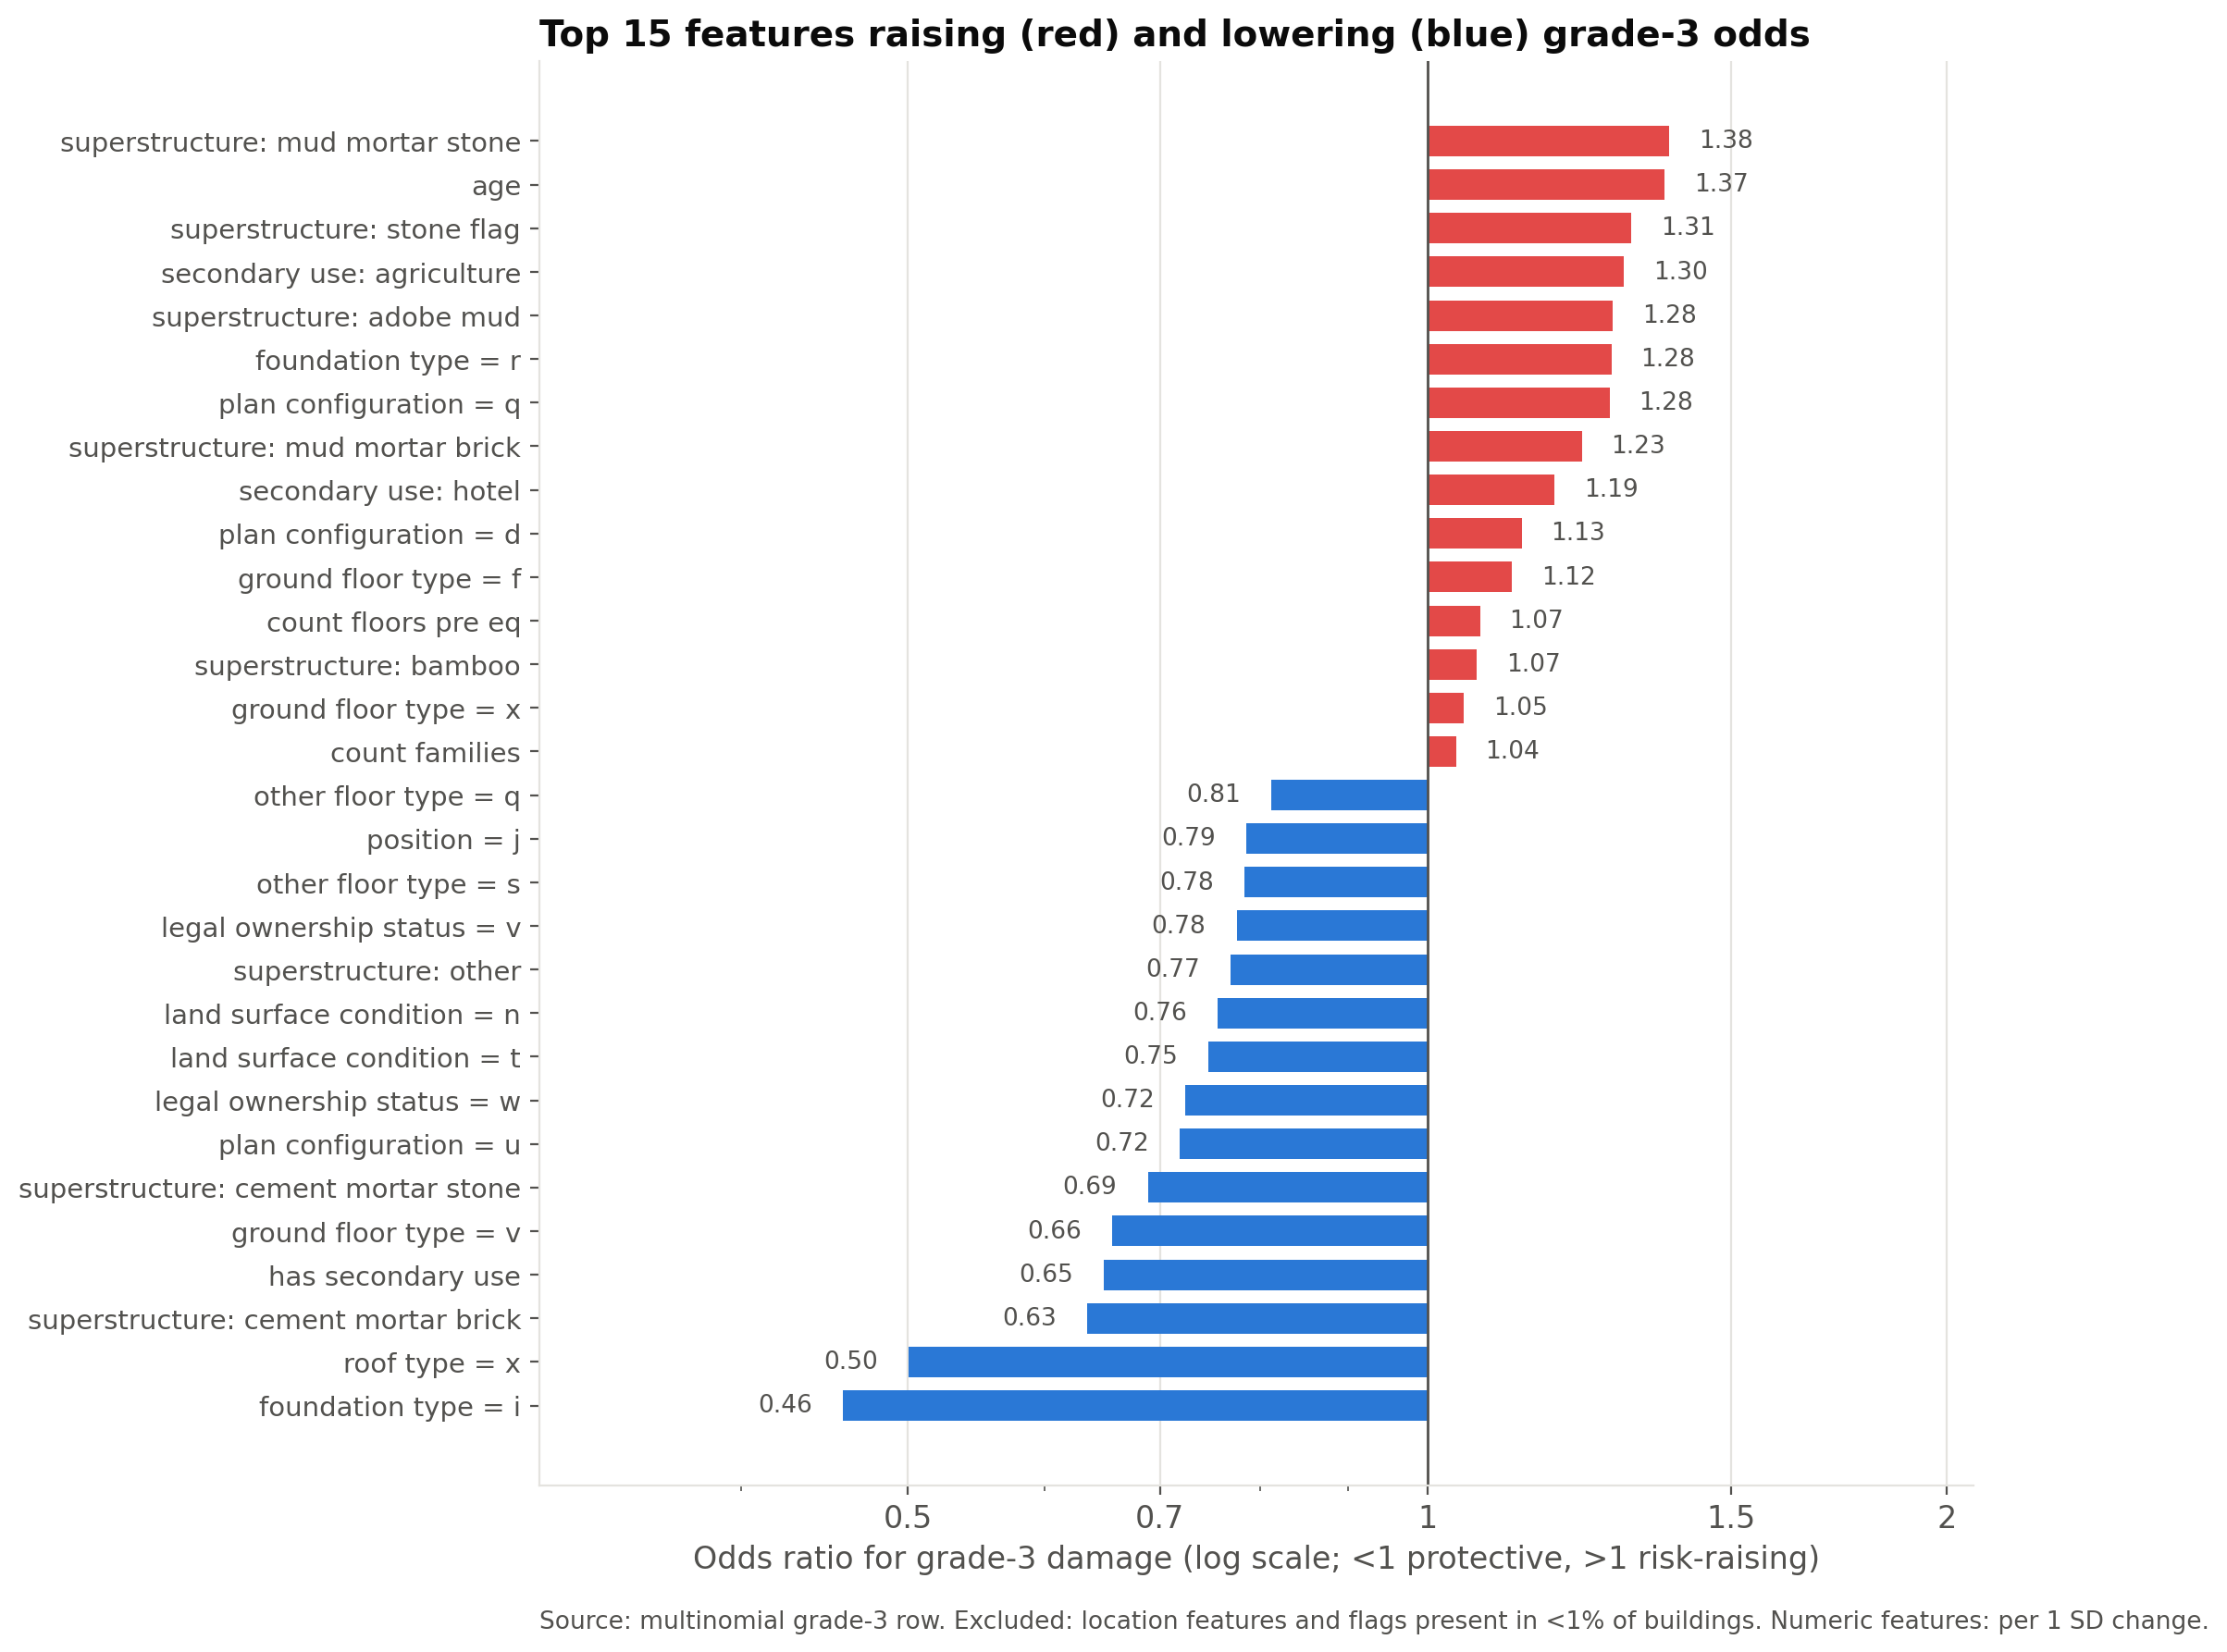
Figure 8. Top 15 risk-raising (red) and risk-lowering (blue) features for grade-3 damage, as odds ratios on a log scale. Location features and flags present in fewer than 1% of buildings are excluded.
The strongest risk-raising features are superstructure: mud mortar stone (OR 1.38), age (OR 1.37), superstructure: stone flag (OR 1.31), secondary use: agriculture (OR 1.30). The strongest protective features are foundation type = i (OR 0.46), roof type = x (OR 0.50), superstructure: cement mortar brick (OR 0.63), has secondary use (OR 0.65). For superstructure materials, holding everything else fixed, the odds ratios are: mud-mortar stone 1.38, stone flag 1.31, adobe mud 1.28, timber 0.88, cement-mortar brick 0.63 and engineered RC 0.84. In plain language, buildings with heavy, brittle walls of stone or mud bonded only by mud mortar break apart under strong shaking. Engineered reinforced-concrete frames and cement-bonded masonry hold together and are much more likely to escape with light damage. Older buildings are also at higher risk. The anonymised foundation and roof codes that the model treats as protective (foundation i, roof x) are the same ones that the exploration (Figure 2) linked to low damage. That the model and the raw data agree, and that both match engineering experience, gives some confidence that the model has learned real effects rather than artefacts. The engineered-RC odds ratio is smaller in magnitude than its raw grade-3 rate would suggest, because foundation, roof and floor types that come with RC construction already carry part of that effect.
Location features, which are excluded from the figure, have the largest coefficients of all (for example geo_level_3_id_3 with OR 22.77, geo_level_3_id_2 with OR 3.11). They describe where the ground shook hardest, not what makes a building vulnerable, so they matter for prediction but give an engineer nothing to act on.

6. Highlights

6.1 Ordinal versus multinomial logistic regression
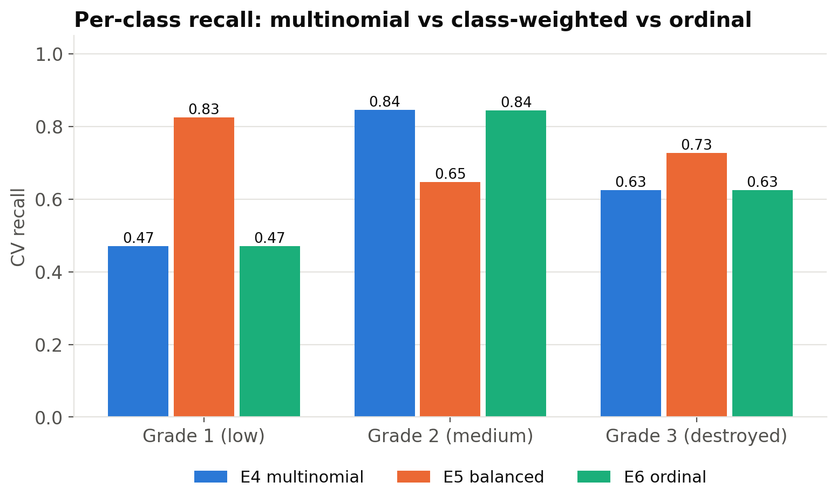
Figure 9. Per-class CV recall for the multinomial (E4), class-balanced (E5) and ordinal (E6) models.
Exploiting the ordering of damage grades seems natural, but on these data it did not help: the ordinal model changed micro-F1 by -0.06 pp and macro-F1 by -0.04 pp compared with the multinomial model on identical features (Figure 9). We see three reasons for this negative result. (i) With only three classes, the multinomial model has just one more set of coefficients than the ordinal model and can learn an ordered structure by itself. Its fitted probabilities already put very little mass on the non-adjacent grade (Section 5.3). (ii) Our ordinal model fits the two thresholds independently, so it gains nothing from sharing slopes. It can also produce crossing cumulative probabilities, which we have to clip. (iii) Ordinal structure mostly helps by avoiding large errors (1 ↔ 3), but micro-F1 counts every error the same, and large errors were already rare. This is still a useful finding: for this problem the simpler multinomial model is sufficient.
Class weighting (E5) did what it is designed to do for recall. Reweighting the rare grade 1 raised its recall from 0.47 to 0.83 and grade-3 recall from 0.63 to 0.73. The cost was grade-2 recall, which fell from 0.84 to 0.65. Micro-F1 therefore fell (-4.43 pp), and macro-F1 also fell (-0.88 pp). Macro-F1 falling is less obvious than micro-F1 falling. The extra grade-1 predictions are taken mostly from the large grade-2 class, so grade-1 precision drops faster than its recall rises, and grade-2 F1 falls as well. Whether that trade is worth making is a policy decision rather than a modelling one. An agency that cares about quickly clearing low-damage buildings, or about flagging more grade-3 buildings when acting on predicted labels rather than on a ranking, might prefer it. For the competition metric, the unweighted model is better.

6.2 Cross-fitted target encoding of location
The finest location level has 11,595 values, and level 2 has 1,414. One-hot encoding them would add 13,009 sparse columns, most with only a handful of buildings, and an L2-penalised linear model would either overfit them or shrink them to nothing. Multiclass target encoding compresses each level into three smoothed damage rates, which directly answer the question 'how badly was this neighbourhood hit?'. It produced the largest gain in the study, +6.3 pp micro-F1 and +8.1 pp macro-F1 over E2. Two safeguards keep this honest. First, cross-fitting inside fit_transform means that no training building's encoding uses its own label. Second, the encoder is part of the pipeline and so is refitted inside every outer CV fold and inside GridSearchCV. The close agreement between CV and holdout scores (0.7354 vs 0.7405) is consistent with there being no leakage.

7. Limitations
- Linear decision boundaries. Logistic regression cannot represent interactions it is not given, such as material × region. Tree ensembles are known to do better on this competition, and we excluded them by design.
- Location as a proxy. Region ids stand in for shaking intensity, soil and distance to the fault. The model would not transfer to a different earthquake, and 0.38% of test buildings fall in unseen local areas and receive only the global prior.
- Labels and features recorded after the event. Damage grades come from survey teams and may be noisy near grade boundaries. Some attributes, such as floor count before the earthquake, were reconstructed after it.
- Anonymised categories. Letter codes limit how far the coefficients can be explained in engineering terms.
- Associational, not causal. Odds ratios describe associations conditional on the other features. Collinear inputs (height and floors) share credit, and the softmax parameterisation makes dummy coefficients relative to an average level.
- Single split. The holdout estimate comes from one 20% split. CV standard deviations are small, but no confidence interval for the holdout score was computed.

8. Future Directions
- Physical hazard features. Join measured peak ground acceleration (USGS ShakeMap) and distance to the rupture, replacing region ids with physics that transfers to future events.
- Interactions and splines. Add material × region, floors × age and spline terms for age and area, which keeps the model linear in its parameters and interpretable.
- Proper cumulative-link model. Fit a proportional-odds model with shared slopes (for example statsmodels OrderedModel) and test the proportional-odds assumption.
- Cost-sensitive thresholds and calibration. Choose decision thresholds from inspection capacity and the relative cost of missing a destroyed building, and calibrate probabilities (Platt or isotonic).
- Uncertainty and validation. Bootstrap confidence intervals for holdout metrics, and spatially grouped CV (by geo_level_2) to estimate performance in unseen areas.
- Benchmarking and deployment. Measure the accuracy cost of interpretability against gradient boosting, and package the pipeline as a triage tool for field teams.

9. Conclusion
We asked whether a building's structure and location can predict its earthquake damage well enough to prioritise inspections. With a transparent, leakage-safe logistic-regression pipeline, the answer is a qualified yes. The final model reaches a holdout micro-F1 of 0.740 (macro-F1 0.680) against a 0.569 baseline, and its ranking finds 49.8% of destroyed buildings in the first 20% of inspections. Location, encoded with cross-fitted target encoding, contributed the most. Construction material contributed the most interpretable signal: mud-mortar stone raises risk and engineered RC lowers it. An ordinal reformulation did not improve on the multinomial model, and class weighting traded overall accuracy for recall of the rare class. The remaining errors are mostly between adjacent grades, and the largest further gains are likely to come from physical shaking data rather than from more complex models.

References
DrivenData. (2019). Richter's Predictor: Modeling Earthquake Damage [Data set and competition]. https://www.drivendata.org/competitions/57/nepal-earthquake/
Frank, E., & Hall, M. (2001). A simple approach to ordinal classification. In Proceedings of the 12th European Conference on Machine Learning (ECML), LNCS 2167, 145–156. Springer.
Hastie, T., Tibshirani, R., & Friedman, J. (2009). The Elements of Statistical Learning (2nd ed.). Springer.
Hosmer, D. W., Lemeshow, S., & Sturdivant, R. X. (2013). Applied Logistic Regression (3rd ed.). Wiley.
Hunter, J. D. (2007). Matplotlib: A 2D graphics environment. Computing in Science & Engineering, 9(3), 90–95.
McCullagh, P. (1980). Regression models for ordinal data. Journal of the Royal Statistical Society: Series B, 42(2), 109–142.
McKinney, W. (2010). Data structures for statistical computing in Python. In Proceedings of the 9th Python in Science Conference, 56–61.
Micci-Barreca, D. (2001). A preprocessing scheme for high-cardinality categorical attributes in classification and prediction problems. ACM SIGKDD Explorations, 3(1), 27–32.
National Planning Commission. (2015). Nepal Earthquake 2015: Post Disaster Needs Assessment, Vol. A: Key Findings. Government of Nepal, Kathmandu.
Pedregosa, F., et al. (2011). Scikit-learn: Machine learning in Python. Journal of Machine Learning Research, 12, 2825–2830.

Appendix

A. Full cross-validation results
Table 8. All experiments: 5-fold CV mean ± sd; recall is the per-class CV mean; max solver iterations over the 5 folds.
ID | Micro-F1 | Macro-F1 | Recall g1 | Recall g2 | Recall g3 | Max solver iter
E0 | 0.5689 ± 0.0000 | 0.2417 ± 0.0000 | 0.000 | 1.000 | 0.000 | 0
E1 | 0.5908 ± 0.0013 | 0.4640 ± 0.0021 | 0.317 | 0.880 | 0.177 | 143
E2 | 0.6718 ± 0.0019 | 0.5917 ± 0.0029 | 0.357 | 0.816 | 0.517 | 162
E3 | 0.7350 ± 0.0012 | 0.6726 ± 0.0017 | 0.468 | 0.845 | 0.625 | 258
E4 | 0.7352 ± 0.0010 | 0.6732 ± 0.0014 | 0.470 | 0.845 | 0.625 | 292
E5 | 0.6909 ± 0.0011 | 0.6644 ± 0.0008 | 0.825 | 0.647 | 0.727 | 259
E6 | 0.7346 ± 0.0012 | 0.6728 ± 0.0017 | 0.470 | 0.844 | 0.625 | 175

B. Regularisation path
Table 9. GridSearchCV results for E4.
C | Micro-F1 (mean) | Micro-F1 (sd) | Macro-F1 (mean) | Max solver iterations
0.01 | 0.7349 | 0.0011 | 0.6709 | 96
0.03 | 0.7352 | 0.0012 | 0.6723 | 110
0.1 | 0.7353 | 0.0011 | 0.6730 | 175
0.3 | 0.7354 | 0.0010 | 0.6733 | 232
1 | 0.7352 | 0.0010 | 0.6732 | 292
3 | 0.7351 | 0.0009 | 0.6731 | 317
10 | 0.7351 | 0.0010 | 0.6732 | 324
30 | 0.7350 | 0.0010 | 0.6731 | 336
100 | 0.7351 | 0.0011 | 0.6732 | 337

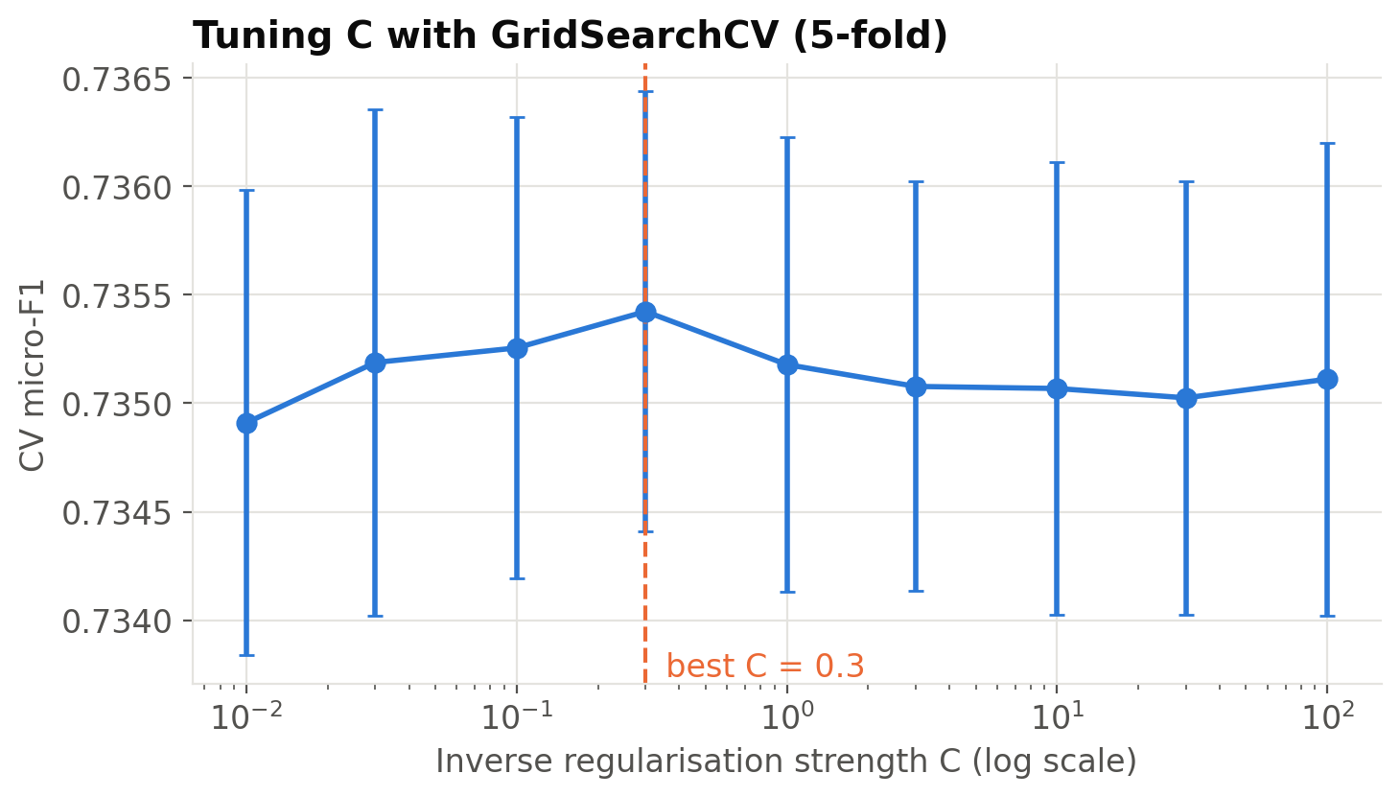
Figure B1. CV micro-F1 as a function of C (log scale). The dashed line marks the selected value.

C. Additional exploration figures
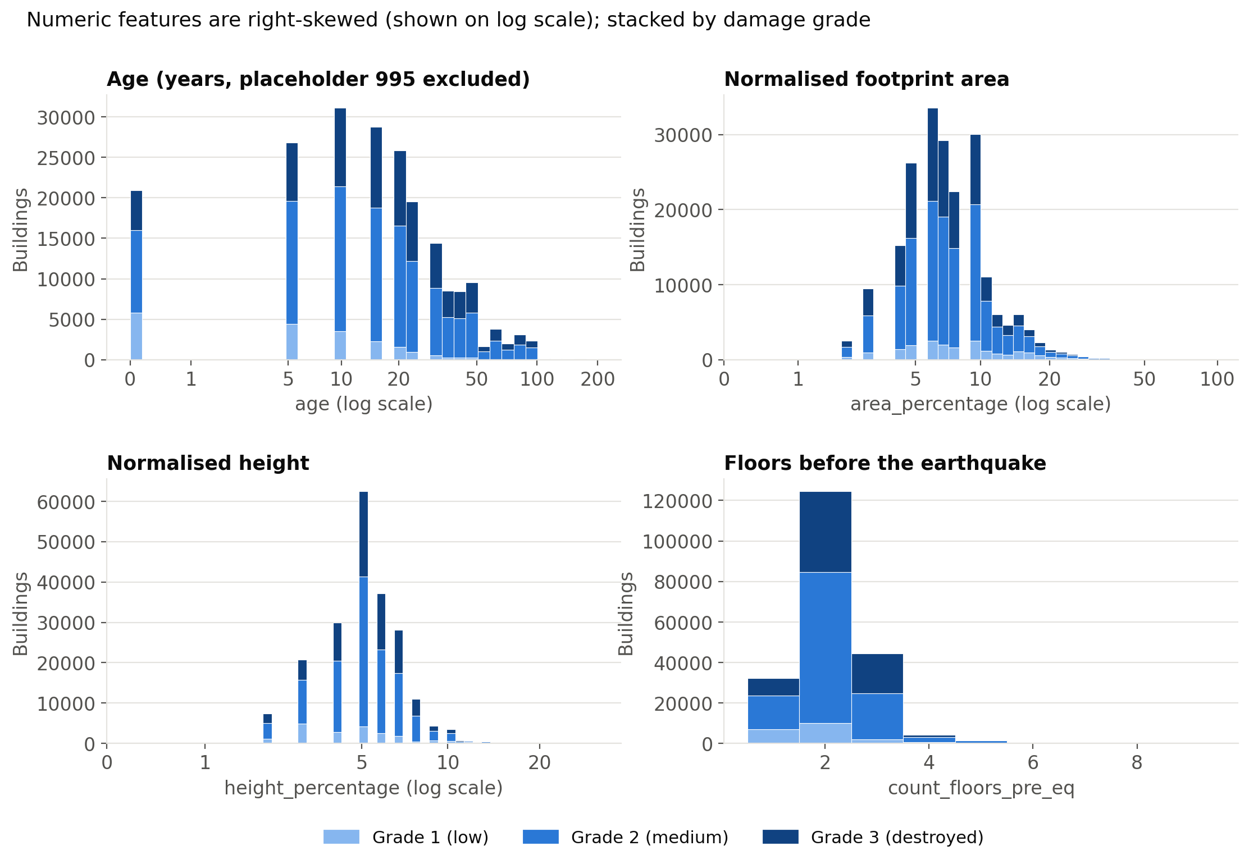
Figure C1. Distributions of age, area, height (log scale) and floors, stacked by damage grade. Placeholder ages are excluded.
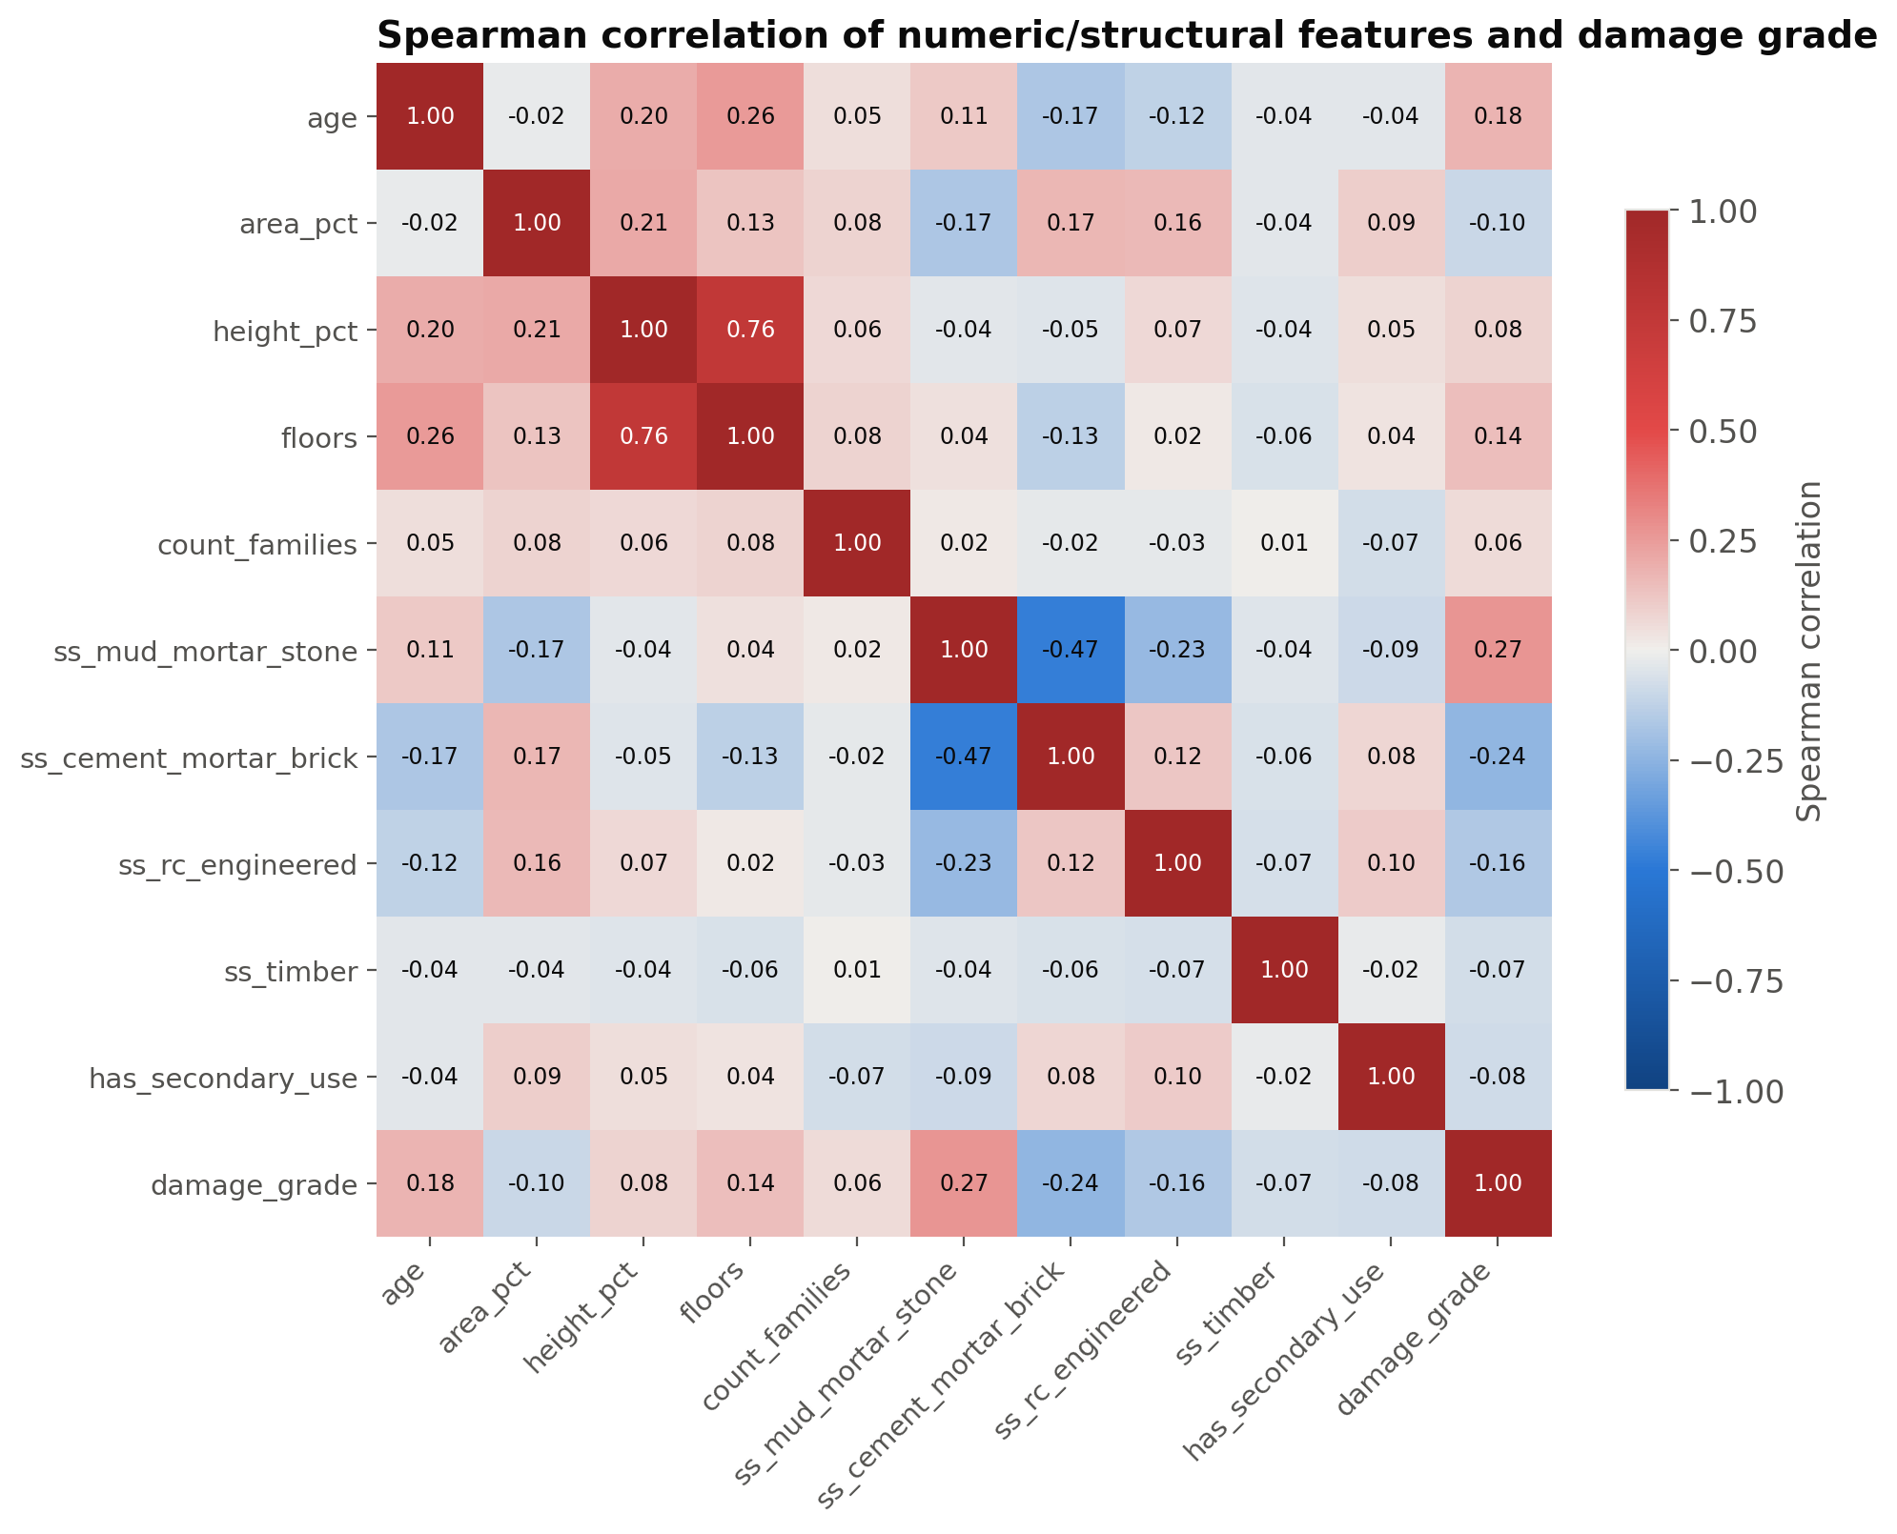
Figure C2. Spearman correlations among numeric and selected material features and the damage grade.

D. Reproducibility
Environment: Python 3.11.14, scikit-learn 1.5.2 (Pedregosa et al., 2011), pandas 2.2.3 (McKinney, 2010), NumPy 2.1.3, matplotlib 3.9.2 (Hunter, 2007), seaborn 0.13.2. random_state = 42 everywhere; StratifiedKFold(n_splits=5, shuffle=True, random_state=42). The full pipeline runs with python -m src.run_all (about 24.1 minutes for the notebook). Every number in this report is read from outputs/results.json, which the notebook writes. The submission file outputs/submission.csv has 86,868 rows with columns building_id, damage_grade (integers 1–3). Its predicted class shares are grade 1 6.8%, grade 2 64.9% and grade 3 28.3%.

E. Contribution statement
[To be completed by the group: one line per member describing their contribution.]

