*This week you will continue that work by adding to your bibliography by writing a detailed summary of at least 2 additional articles. You should also review the feedback that you received and adjust the summaries of the prior two articles as well as the current two to more well aligned with the feedback. A perfect score on this question will reflect the quality of the adjustments that you made as a result of the feedback.*

*Below are the instructions, which are (mostly) repeated from last week:*

*For this week, read and summarize 2 additional journal articles. While working through each paper think about the following questions to guide your summary of each: What does the paper say about your phenomenon? How are the theoretical models constructed? What assumptions and approximations are being made? What are the predictions and implications? What more do you need to know to understand this article? For this first summary, I expect you to write 2-3 paragraphs per article that you summarize. You may include equations and figures, but they do not count towards the total number of paragraphs.*

Eack, K. B., Beasley, W. H., Rust, W. D., Marshall, T. C., & Stolzenburg, M. (1996). Initial results from simultaneous observation of X‐rays and electric fields in a thunderstorm. *Journal of Geophysical Research: Atmospheres*, *101*(D23), 29637-29640.

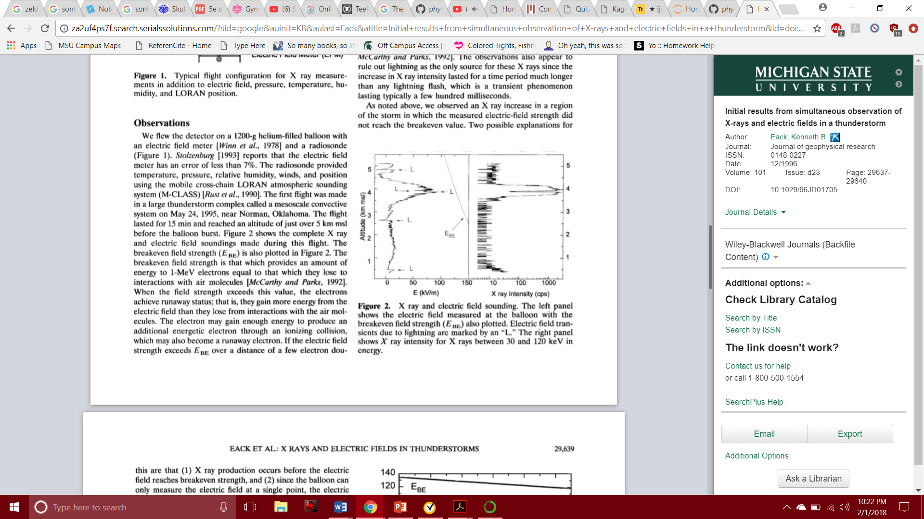Eack et al. formulate their paper on the correlation of X-rays with the Electric Field of a storm.

Observing this chart, Eack et al. have confirmed – though through very few, or only one test – that X-ray intensity shifts in the same manner that Electric Field does in a storm. That is, if Electric Field increases, as does X-Ray intensity. Their results are relatively inconclusive, but tell an interesting story about what a storm is truly made of; it is not simply runaway electrons, but gamma and X-rays that we observe so much less than the former.

In telling the story of the thunderstorm, I wish to portray as much of the storm as possible. This includes the mysteries, the smaller pieces that transpire as a result of electromagnetic phenomena. The correlation between X-ray intensity an Electric Field is something that strikes as a definite phenomenon of the storm. This paper also has a great description of the ‘runaway electron’ formation of lightning, with the quote, ‘they gain more energy from the electric field than they lose from interactions with the air molecules’. This encapsulates the initial thought of a storm as a phenomenon and begins my paper’s description of E&M in storms with accurate, powerful facts.

Krider, E. P. (1986). Physics of lightning. *The Earth‘s electrical environment, National Academic Press. Washington DC*, 30-39.

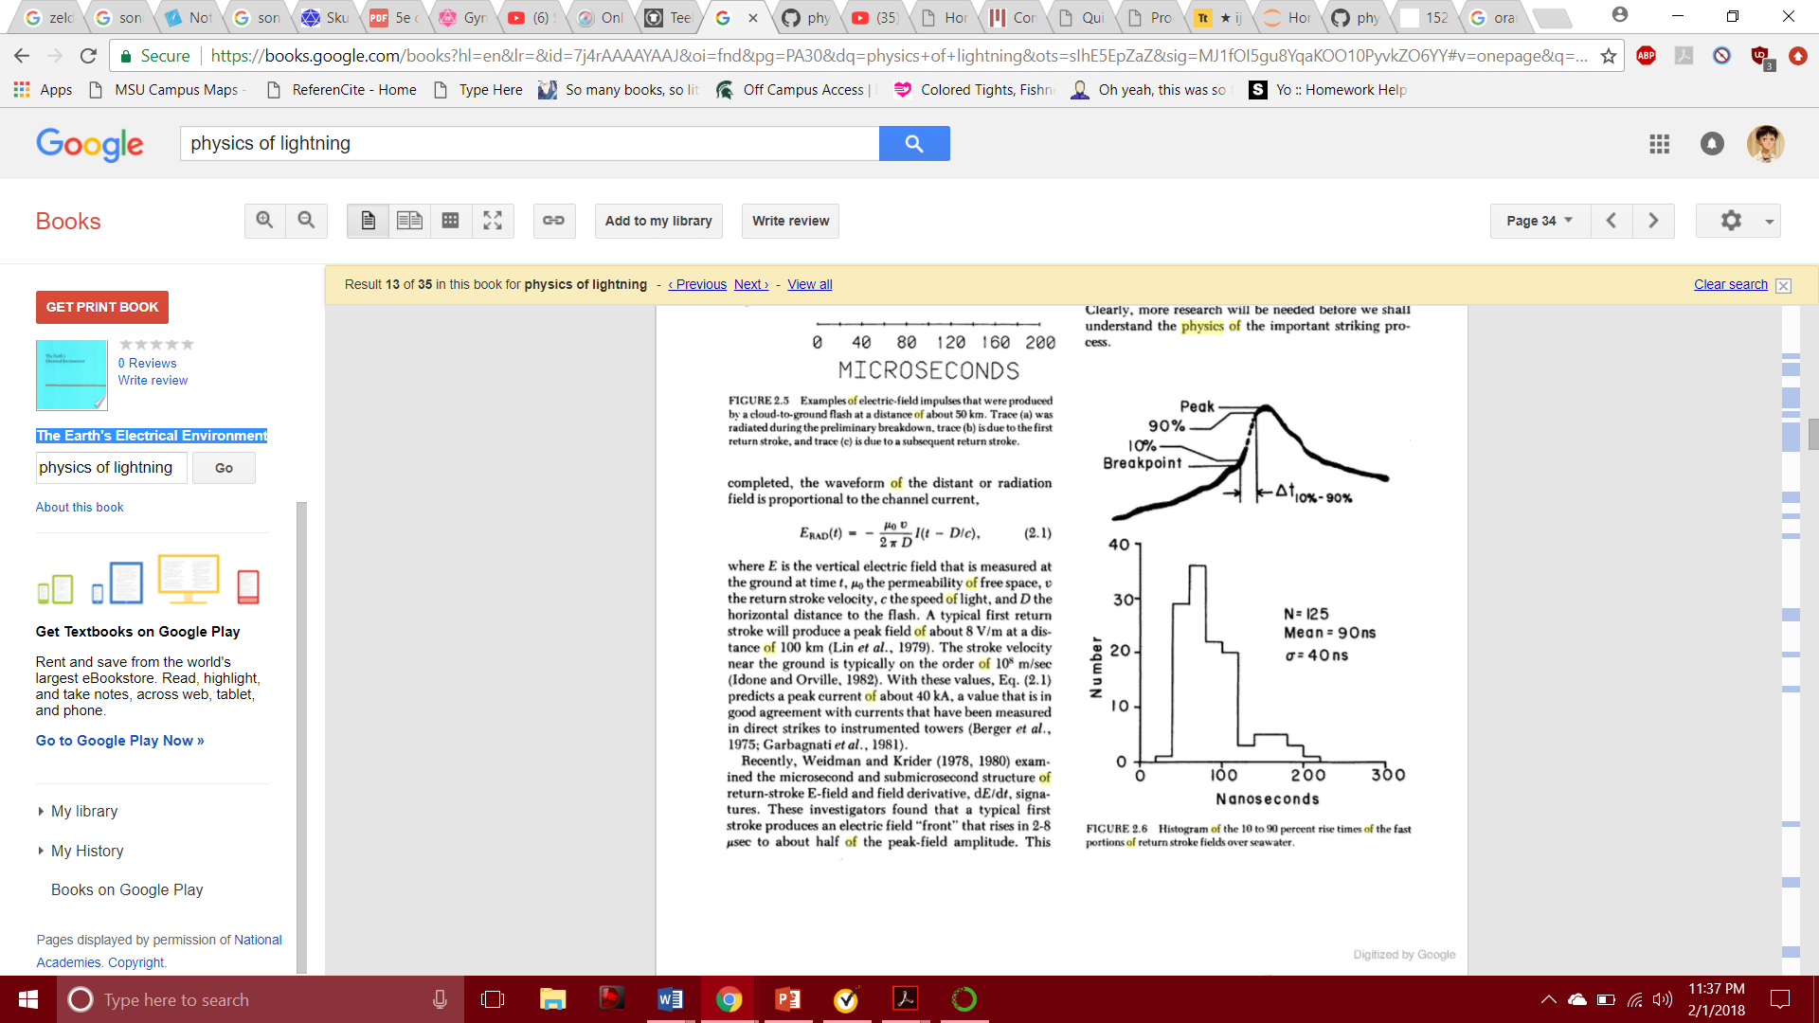Krider, in his addition in the book ‘The Earth’s electrical environment’, seeks to describe lightning and its mystery, beginning with the idea of a ‘return stroke’ within lightning. As lightning strikes, it creates a connection with what it strikes and with the cloud it forms from, allowing a two-way interaction. He also shortly describes the time-derivative of current to explore this, plus uses this equation for electric field:

This represents electric field of radiation field, which relates to the current of the channel formed. As well, he describes how lightning can be artificially triggered along-side natural occurrence. This allows insight on what outside influences may drive a storm to pose a threat.

This article adds a lot of phenomenological insight to lightning in particular – as a key part of a storm, lightning is close to being explained in full with Krider’s work. My paper seeks to highlight the electromagnetic causes and effects of storms, lightning included. Krider does a wonderful job highlighting mathematical properties of lightning while also bringing conceptual and theoretical reasoning to support his research. This article will be useful when describing lightning *as it strikes* rather than how it forms, unlike other articles have done for the latter.

Petrov, N. I., & Petrova, G. N. (1999). *Physical mechanisms for the development of lightning discharges between a thundercloud and the ionosphere*. Technical Physics, 44(4), 472-475.

Petrov and Petrova write in their article a short, descriptive context of the effects of altitude and pressure on the formation of lightning in storms. Through several figures and equations, the phenomena is described using intensity, pressure, electric field, and charge, with correlations between them and several references to support the values or concepts they did not personally conceive. Overall, their paper successfully points out the strong correlation between amplitude of cloud structure and air pressure to the formation of lightning, plus the type or vague expected trajectory of lightning produced.

This paper provides a flourishing start to describing the phenomena of lightning, electrically. Petrov and Petrova describe an approximation of the cloud being an electric dipole charge distribution to model the cloud ‘predominantly positively charged’ at the top and negatively at the bottom. As well, among many other elements that contribute to the formation of lightning, there is described a ‘cellular type structure’ of clouds, where parts of the clouds can be denser with excess charge, increasing the likeliness of lightning formation. Added with several threshold values for possible lightning formation, this article presents a foundation for the intent of describing, fully, the occurrence of lightning.

Dwyer, J. R. (2003). *A fundamental limit on electric fields in air.* Geophysical Research Letters, 30(20).

With a strong focus on the nuclear and radiative aspects of storms, Dwyer presents a paper on the effect of ‘feedback’ on the Electric Field threshold for the production of lightning. Excluding atmospheric pressure and the Earth’s own field, it is described that certain feedbacks can induce the breakdown of Electric Fields in air, causing somewhat of an ‘electron avalanche’ that sparks lightning. In the end, the goal of the paper is to present a new fundamental upper limit on how strong the Electric Field can be due to these conditions.

In relation to my research, I wish to incorporate the assumptions made in this paper; ignoring the Earth’s magnetic field, plus *starting* with a uniform electric field before an intruding event causing the actual event process. With the additional information on possible causes of lightning – besides the known limit of Electric Field being reached – this adds another level to storm creation. It pulls electricity and magnetism and collides it with the nuclear sciences, which is still explainable and far more interesting than before. It also provides some numerical values to ‘stable’ or ‘unstable’ Electric Fields, much needed for a more conceptually driven research paper.