* What are people saying about this phenomenon? Is there agreement about how it is explained?
* What are the relevant models? How are the models described?
* How do people investigate it theoretically? Experimentally? Computationally?
* What are open questions surrounding the phenomenon?

Lightning – from birth to death.

Thunderstorms are mysteries in themselves. Measuring a storm is highly difficult, and as a result, analyzing its components is also a hefty task. The focus that this paper wishes to possess lies with what people most commonly associate a storm as having: lightning. These bolts of pure electricity place people in awe at every strike, and for good reason – their breathtaking beauty lasts for a literal flash of a moment, lasting only in fluorescent illusion in your eyes until the illusion fades. It bears the question, then, *why* is lightning considered a phenomenon if not merely for its beauty? It bears the answer that lightning is a feat of electromagnetic beauty alongside its visual allure.

The papers chosen for the electric anomaly of lightning are chosen for their description of either the *formation* or the *effect* of lightning. The disparity between these components lies not in their differences, but in their ability to work together to fully define the timeline of lightning manifestation. Depending on the specific subject of the paper toward storms, the measurement of phenomena varies between papers. Dwyer explicitly states the ignoring of the Earth’s magnetic field and atmospheric pressure in his analysis[1], whereas Petrov and Petrova embrace pressure in their paper[2].

Despite the underlying differences between the papers, there are many similarities in the mention of lightning. There is explicit description of a preliminary breakdown *or* an ‘avalanche of electrons’ [1][3][4] that causes the birth of lightning itself. An extremely common thread is the mention of Electric Field – as there should be – when defining the storm’s electrical background. Plus, the push of Electric Field thresholds being flexible under certain conditions [1][2] is a common theme. Along the theme of commonality, two papers describe nuclear effects of lightning through gamma rays and X-rays, of which spikes occur in tandem with Electric Field increases [1][4].

With the differences in topics in each paper, there also comes differences in models. It was mentioned before that one paper dismisses magnetic field and atmospheric pressure; in that same paper, Compton scattering is used to describe the avalanche of runaway electrons. One paper, as well, is the only one so far to describe the cloud that lightning forms from as having ‘charge deposits’, or sorts of pockets of charge that push the description of excess charge being a contributor to lightning formation, plus being the *only* paper to call the cloud an electric dipole charge distribution [2]. This last distinction is important when emphasis on Electric Field is so large – one should wonder, why do the other papers not emphasize this disparity in charge distribution (i.e. more positive charges at the top of a cloud) if they also wish to describe the threshold of Electric Field?

Most computational models are quite sparse, since the description of the creation of lightning is a very conceptual phenomenon. That, combined with the difficulty of measuring a storm at all, means that equations are only present if heavy assumptions are made. Krider has an excellent equation depicting current and Electric Field of a formed lightning bolt:

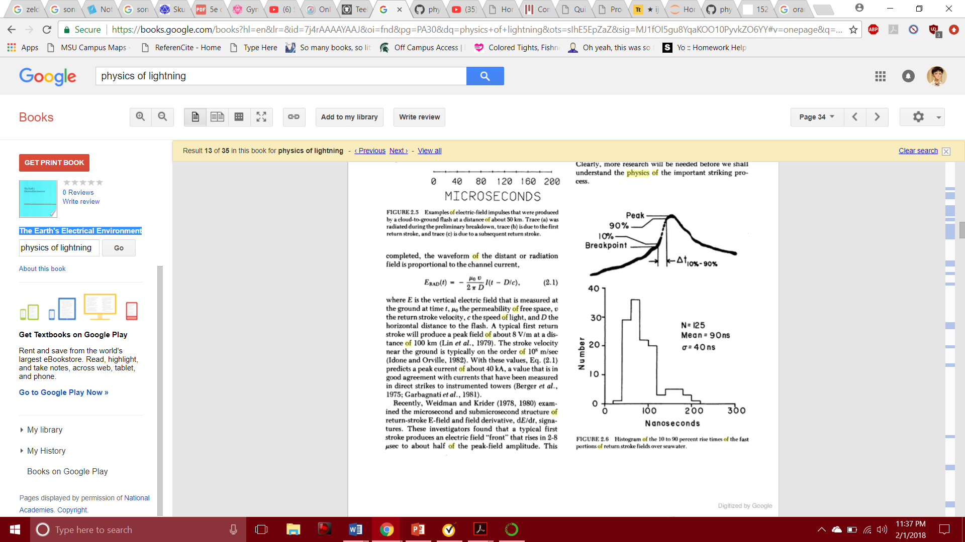Krider, however, is the only one connecting current to lightning[3]. The others, in their analysis, do not need current to describe their specific phenomena. Those wishing to connect nuclear physics to the electrical physics use either physical instrumentation[4] or Monte Carlo simulation[1] to reflect their findings.

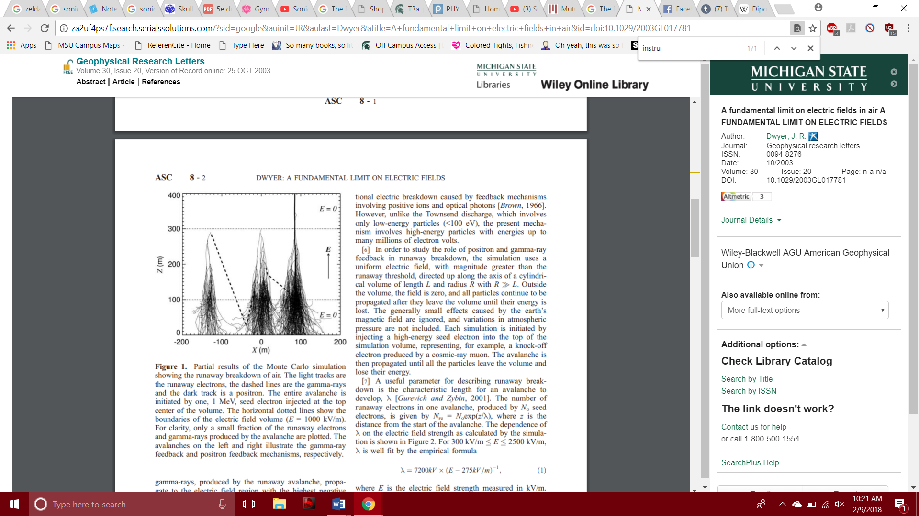

[1] Dwyer, J. R. (2003). *A fundamental limit on electric fields in air.* Geophysical Research Letters, 30(20).

[2] Petrov, N. I., & Petrova, G. N. (1999). *Physical mechanisms for the development of lightning discharges between a thundercloud and the ionosphere*. Technical Physics, 44(4), 472-475.

[3] Krider, E. P. (1986). Physics of lightning. *The Earth‘s electrical environment, National Academic Press. Washington DC*, 30-39.

[4] Eack, K. B., Beasley, W. H., Rust, W. D., Marshall, T. C., & Stolzenburg, M. (1996). Initial results from simultaneous observation of X‐rays and electric fields in a thunderstorm. *Journal of Geophysical Research: Atmospheres*, *101*(D23), 29637-29640.