* What are people saying about this phenomenon? Is there agreement about how it is explained?
* What are the relevant models? How are the models described?
* How do people investigate it theoretically? Experimentally? Computationally?
* What are open questions surrounding the phenomenon?

Lightning – from birth to death.

Thunderstorms are mysteries in themselves. Measuring a storm is highly difficult, and as a result, analyzing its components is also a hefty task. The focus that this paper wishes to possess lies with what people most commonly associate a storm as having: lightning. These bolts of pure electricity place people in awe at every strike, and for good reason – their breathtaking beauty lasts for a literal flash of a moment, lasting only in fluorescent illusion in your eyes until the illusion fades. It bears the question, then, *why* is lightning considered a phenomenon if not merely for its beauty? It bears the answer that lightning is a feat of electromagnetic beauty alongside its visual allure.

The papers chosen for the electric anomaly of lightning are chosen for their description of either the *formation* or the *effect* of lightning. The disparity between these components lies not in their differences, but in their ability to work together to fully define the timeline of lightning manifestation. Depending on the specific subject of the paper toward storms, the measurement of phenomena varies between papers. Dwyer explicitly states the ignoring of the Earth’s magnetic field and atmospheric pressure in his analysis[1], whereas Petrov and Petrova embrace pressure in their paper[2].

Despite the underlying differences between the papers, there are many similarities in the mention of lightning. There is explicit description of a preliminary breakdown *or* an ‘avalanche of electrons’ [1][3][4][5]  that causes the birth of lightning itself. An extremely common thread is the mention of Electric Field – as there should be – when defining the storm’s electrical background. Plus, the push of Electric Field thresholds being flexible under certain conditions [1][2] is a common theme. Along the theme of commonality, three papers analyze nuclear effects of lightning through gamma rays and X-rays, of which spikes occur in tandem with Electric Field increases [1][4][6].

With the differences in topics in each paper, there also comes differences in models. It was mentioned before that one paper dismisses magnetic field and atmospheric pressure; in that same paper, Compton scattering is used to describe the avalanche of runaway electrons. One paper, as well, is the only one so far to describe the cloud that lightning forms from as having ‘charge deposits’, or sorts of pockets of charge that push the description of excess charge being a contributor to lightning formation, plus being the *only* paper to call the cloud an electric dipole charge distribution [2]. This last distinction is important when emphasis on Electric Field is so large – one should wonder, why do the other papers not emphasize this disparity in charge distribution (i.e. more positive charges at the top of a cloud) if they also wish to describe the threshold of Electric Field?

Most computational models are quite sparse, since the description of the creation of lightning is a very conceptual phenomenon. That, combined with the difficulty of measuring a storm at all, means that equations are only present if heavy assumptions are made. Krider has an excellent equation depicting current and Electric Field of a formed lightning bolt:

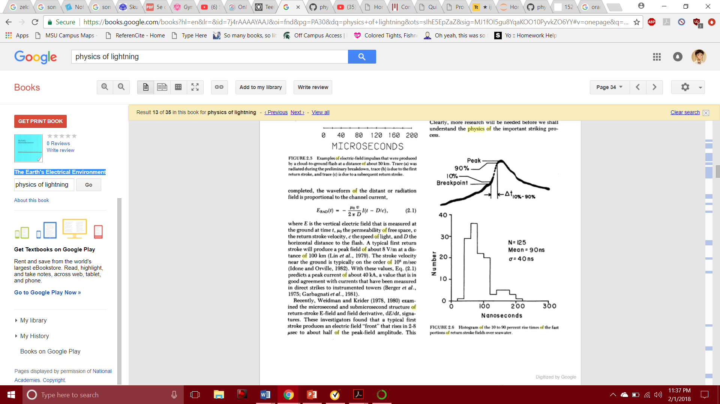Krider, however, is not the only one connecting current to lightning[3]. There is also description of the amount of current in certain strokes of lightning; “First stroke currents are typically near 30 kA, while subsequent stroke peak currents are typically 10–15 kA” says Dwyer in *The physics of lightning*[5]*.*

**Monte Carlo Simulation & Lightning**

The others, in their analysis, do not need current to describe their specific phenomena. Those wishing to connect nuclear physics to the electrical physics use either physical instrumentation[4] or Monte Carlo simulation[1] [6] to reflect their findings. Monte Carlo simulation, in general, generates probability distributions to model some phenomena – an example of a simpler simulation is that which coders approximate pi by making a quarter of a circle and counting dots that end up in that quarter (Figure 1).

(Figure 1), approximating pi using Monte Carlo method.

Monte Carlo has been used world-wide, dating itself even prior to the 1950’s, before computation came along to simulate it. Beyond estimating pi, Monte Carlo simulation gets complicated – one must analyze their own subject, see potential statistically with using the MC method, and then apply it to the best of their ability. It is more than estimating pi: we can predict statistical values by forecasting potential values, using pseudorandom numbers, and stacking historical data en masse. As a clarification, pseudorandom numbers are that which are inserted into your data that are both ‘random’ and ‘applicable’, as in the situation with above; the dots are ‘randomly’ placed, but they are still in a range from 0 to 1 in both axes, making them not as random as they seem.

Yet, what does this mean for our evaluation of lightning? As we know, storms are very unpredictable; what we know for sure is that an ‘avalanche of electrons’ sweeps through the cloud and rapidly changes the Electric Field, changing energy rapidly. What does this do for us?

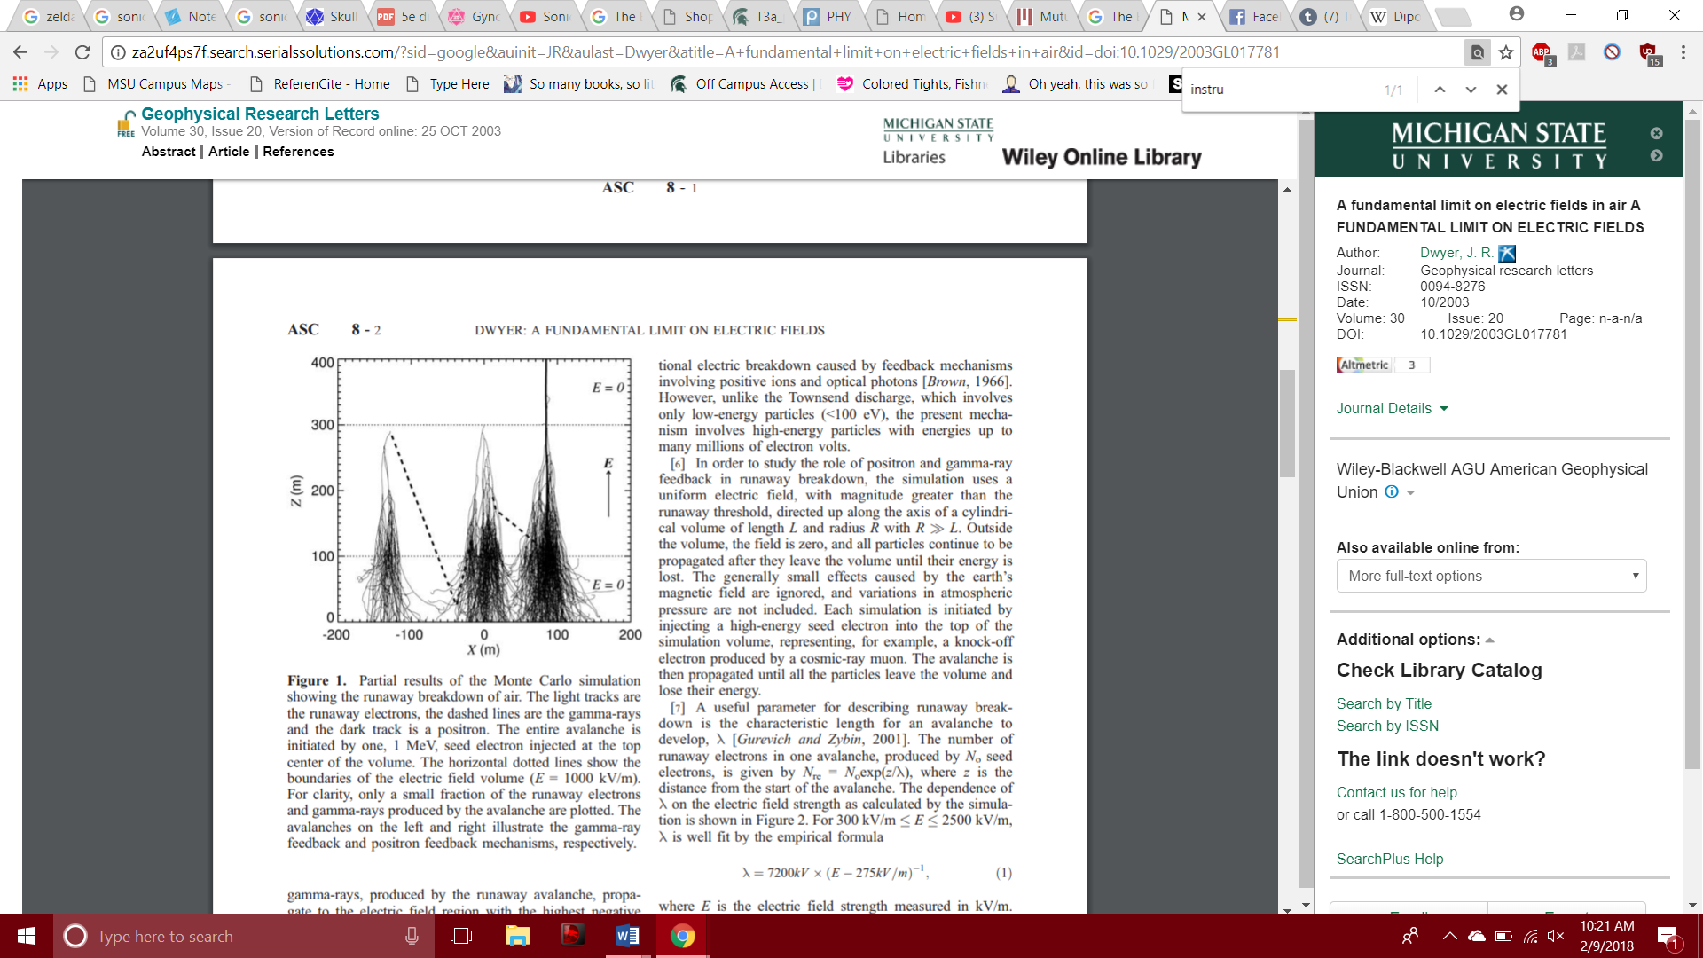

(Figure 2) Monte Carlo simulation depicting peaks of radioactivity

in same peaks of Electric Field threshold breaking.

*Dwyer* et al. [1] make an approach toward applying Monte Carlo simulation to lightning. In Figure 2, we see several lines seemingly like the ends of broomsticks, fanning out below, yet coming together to a nearly singular point atop the lines. This is one classic structure, creating a ‘bell-curve’ type shape that allows us to take the peak value as somewhat of an average for the data. To take this further, we need to delve into the research itself.

To help our evaluation, we see Monte Carlo being used in a less uniform manner. This Monte Carlo simulation displays random selections of data showing runaway electrons and gamma rays produced during lightning[1]. With these selections mapped, we can see that this random data is not so random in accordance to how runaway electrons, and therefore changing Electric Field, coincides with gamma ray (and perhaps X-Ray) detection. Monte Carlo simulation here takes the seemingly random data from separate sets of data and projects them together, allowing us to compare their consistencies.

Here, though, Dwyer et al. attribute their start to *Lehtinen* et al. who use Monte Carlo to plot the “probability for an electron with given initial momentum vector to become a runaway” (Figure _).

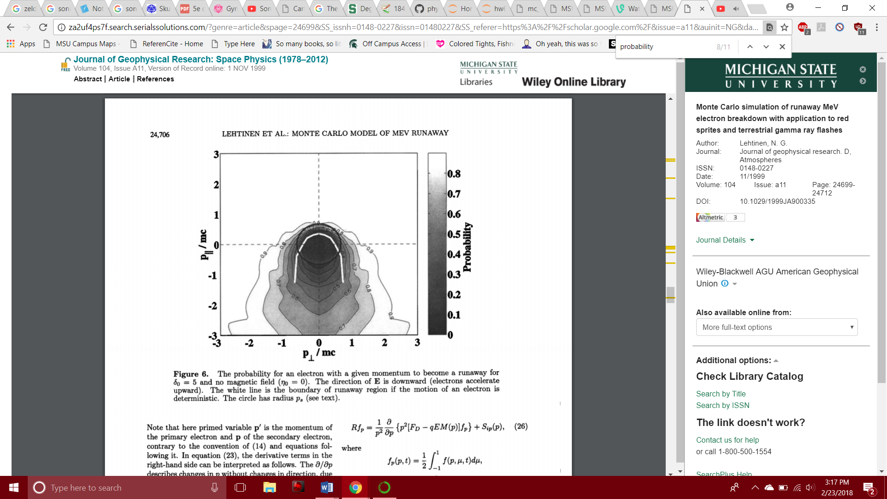

(Figure _) Monte Carlo depicting the probability that an electron with

some momentum will become a runaway.

This evaluation is important since it gives Dwyer a basis to work his simulation off of – not simply from this above figure, but from Lehtinen’s calculations themselves [To be added lol].

Another Monte Carlo simulation by Dwyer in a Monte Carlo-themed paper simulates a similar experiment:

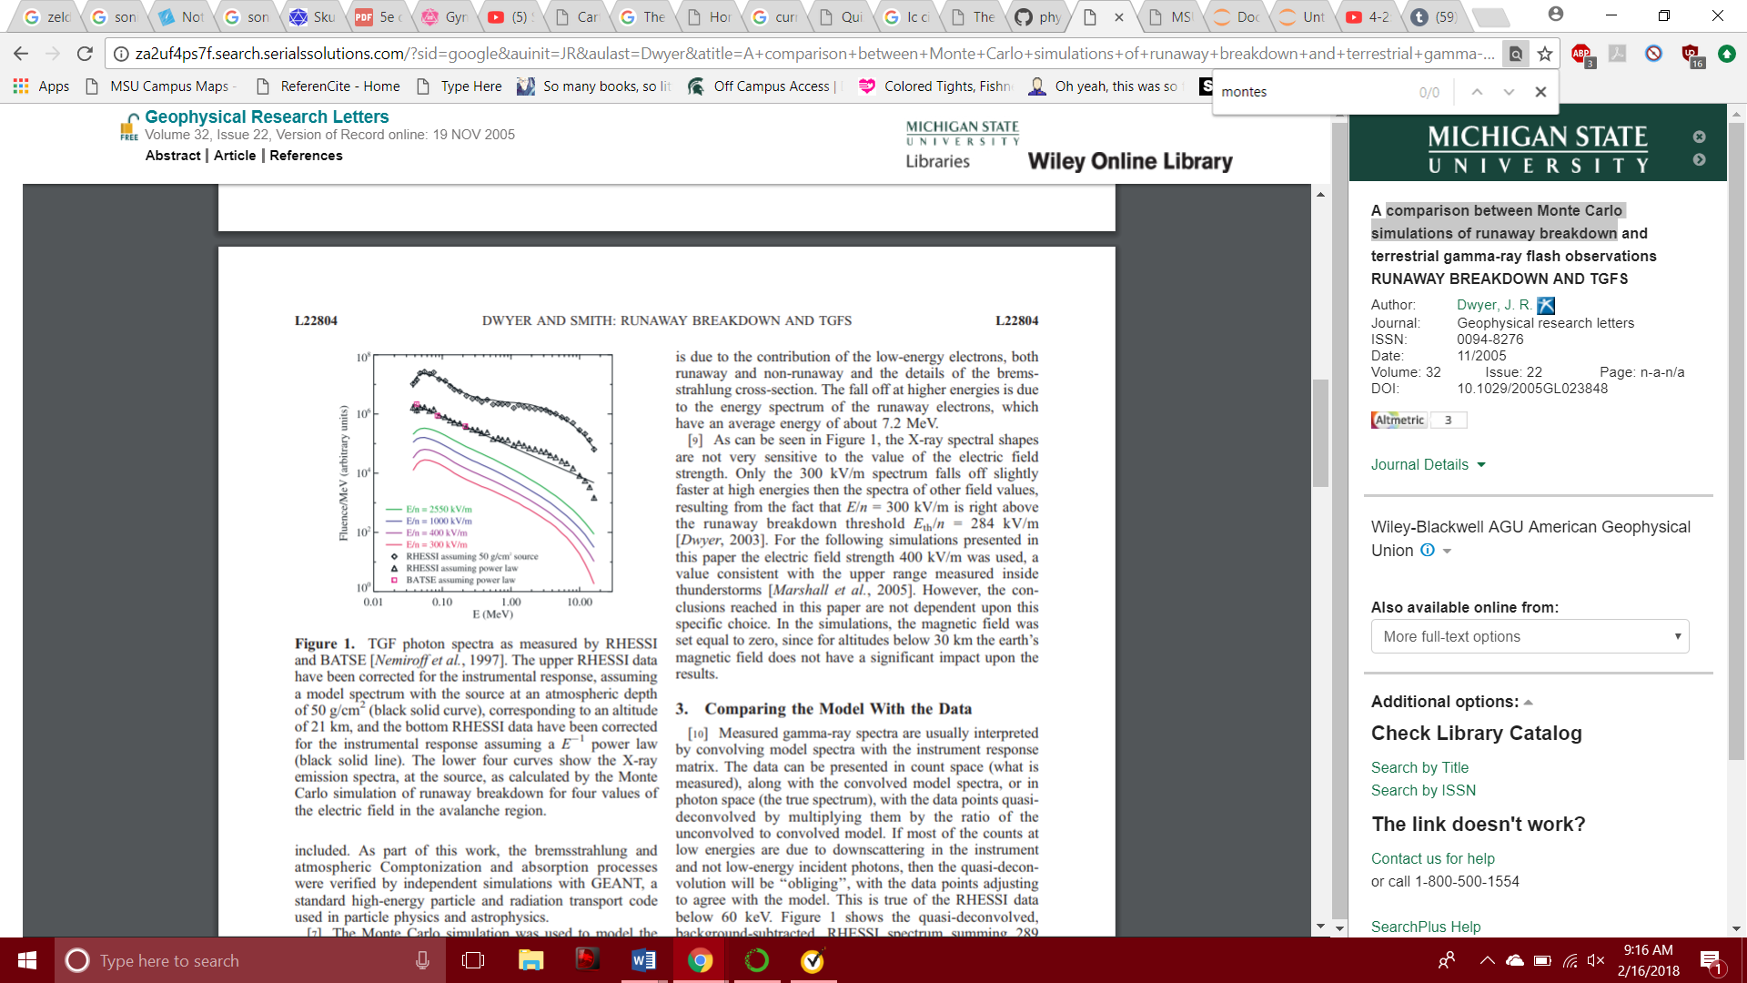

(Figure 3) Monte Carlo depicting trends

of runaway electrons affecting E-Fields.

As we can see from their results (Figure 3)[6], as the energy is lost, there is a correlation between changing Electric Field and changing emission or energies produced by colliding photons, electrons, and air particles. For this experiment, an assumption was made that the initial Electric Field was uniform, allowing the assumption to be made that the runaway electrons both *propogate* the E-Field *and* spark the emission of radioactive waves.

**The Strike & Monte Carlo**

It was mentioned before that with the strike of lightning comes a current – to anyone experienced with electricity and magnetism, this may be a given. *Of course* hundreds of moving charges from cloud to ground makes a current. However, it is notable that very few mention the actual action of lightning step by step; two collected papers lovingly describe lightning as a *ladder* and as having a *return stroke*[3] [5]. What does this mean for us lightning enthusiasts? Is there a way to analyze this stage of lightning formation with the Monte Carlo method?

Long story short, it would be very, very difficult if we were using Monte Carlo to reflect the path strike itself – the path that lightning takes is variable and ever-changing, much like how no two snowflakes are the same. A simulation of the path, then, is out of the picture. Thus, we stick with the traditional method of ‘measure and make a conceptual analysis’, as done by those interested in the ‘ladder’ and ‘return stroke’.

[this will now be the end of the paper, the finish where we discuss further applications of Monte Carlo to other aspects of lightning striking. However I’m not adding anything to this particular section yet because I added the explanation of Monte Carlo so I’ll need to think about these applications]

[1] Dwyer, J. R. (2003). *A fundamental limit on electric fields in air.* Geophysical Research Letters, 30(20).

[2] Petrov, N. I., & Petrova, G. N. (1999). *Physical mechanisms for the development of lightning discharges between a thundercloud and the ionosphere*. Technical Physics, 44(4), 472-475.

[3] Krider, E. P. (1986). Physics of lightning. *The Earth‘s electrical environment, National Academic Press. Washington DC*, 30-39.

[4] Eack, K. B., Beasley, W. H., Rust, W. D., Marshall, T. C., & Stolzenburg, M. (1996). Initial results from simultaneous observation of X‐rays and electric fields in a thunderstorm. *Journal of Geophysical Research: Atmospheres*, *101*(D23), 29637-29640.

[5] Dwyer, J. R., & Uman, M. A. (2014). The physics of lightning. *Physics Reports*, *534*(4), 147-241.

[6] Dwyer, J. R., & Smith, D. M. (2005). A comparison between Monte Carlo simulations of runaway breakdown and terrestrial gamma‐ray flash observations. *Geophysical Research Letters*, *32*(22).

[7] Lehtinen, N. G., Bell, T. F., & Inan, U. S. (1999). Monte Carlo simulation of runaway MeV electron breakdown with application to red sprites and terrestrial gamma ray flashes. *Journal of Geophysical Research: Space Physics*, *104*(A11), 24699-24712.