1. WCF Framework 1

1.1. Dll 1

1.2. Namespace 1

1.3. Main Classes 2

1.3-1. ServiceEndPoint 2

1.3-2. ClientBase<TChanel> 2

1.3-3. ChanelFactory<TChannel> 2

2. Authentication and Authorization in WCF 2

<http://www.codeproject.com/Articles/642444/Creating-and-consuming-a-simple-WCF-Service-withou>

https://msdn.microsoft.com/en-us/library/ff405740.aspx

# WCF Framework

## Dll

System.ServiceModel.dll

## Namespace

System.ServiceModel

System.ServiceModel.Description

System.ServiceModel.Configuration

System.Runtime.Serialization(那些DataContract标识的类)

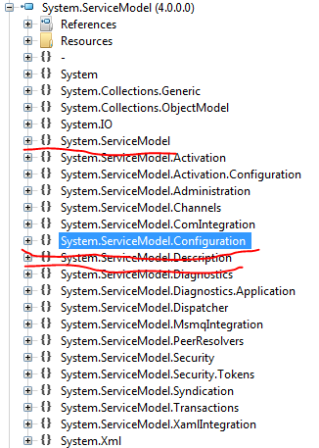

## Main Classes

### ServiceEndPoint

不管是client 还是 server， 用的都是这个类来代表一个endpoint

### ClientBase<TChanel>

客户端继承的基类，用来封装channel和endpoint



### ChanelFactory<TChannel>

用来生成Channel



注意其CreateChannel 方法返回的还是一个service Interface 类型的object

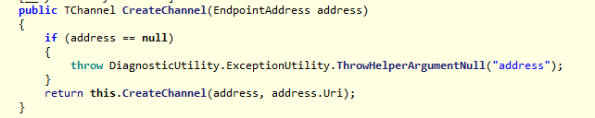

# Authentication and Authorization in WCF

[Authentication and Authorization in WCF.docx](Authentication%20and%20Authorization%20in%20WCF.docx)