1. 以TextBox 为例 2

1-1. 最终继承自DependencyObject 2

1-1-1. DependencyObject 2

1-1-2. DependencyProperty 3

1-2. 有一个Static的属性 TextProperty 3

1-3. 有一个实例属性Text 3

1-4. 在TextBox的静态构造函数里对TextProperty初始化 4

1-4-1. FrameworkPropertyMetadata 5

1-4-2. FrameworkPropertyMetadataOptions 5

1-4-3. PropertyChangedCallback 6

1-5. 有两个OnTextPropertyChanged 方法 7

1-6. 父类TextBoxBase 中定义了常规的方法 8

https://www.kancloud.cn/wizardforcel/learning-hard-csharp/111584

# 以TextBox 为例

## 最终继承自DependencyObject

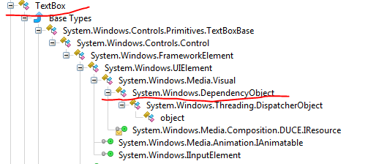

### DependencyObject

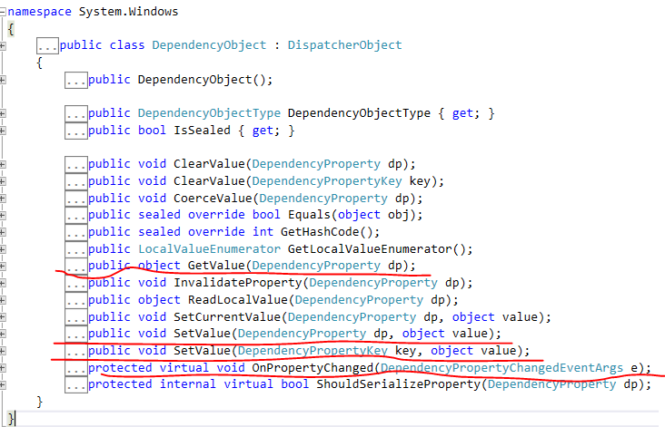

### DependencyProperty

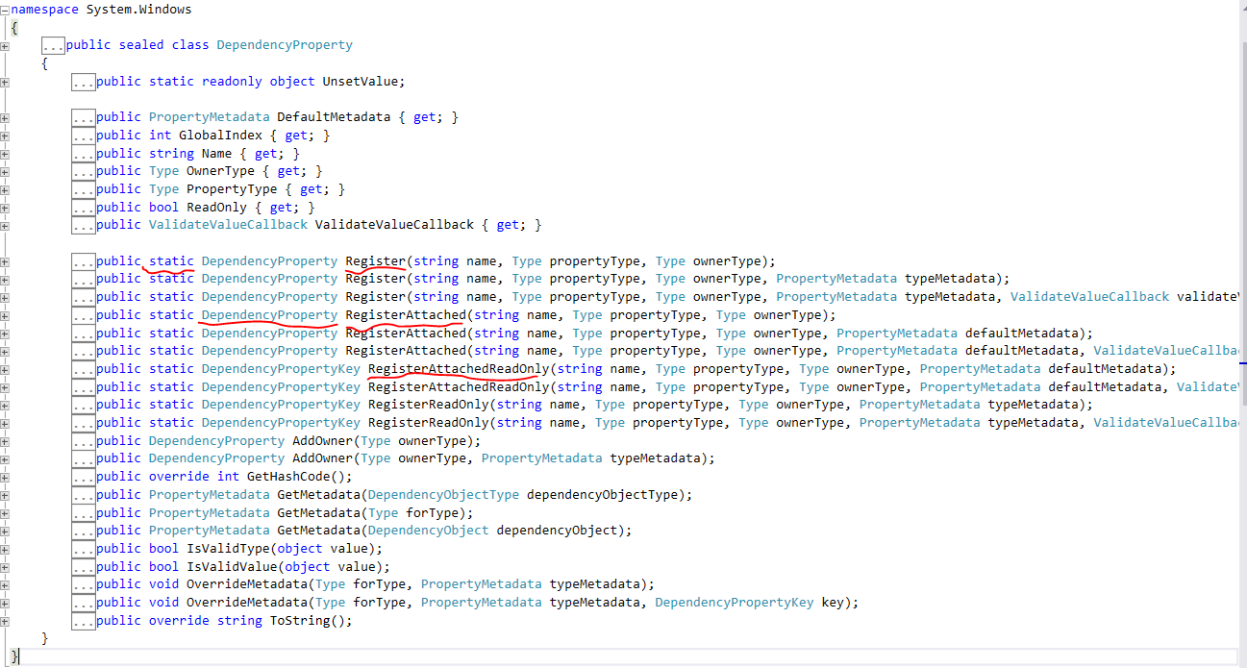

## 有一个Static的属性 TextProperty



### Static 属性不能通过实例对象访问

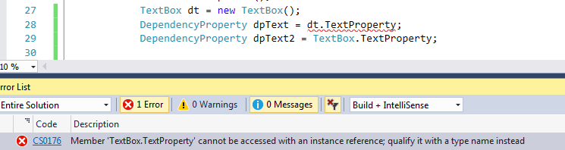

### 让用户对依赖属性无感

使用已有的大家熟悉的Text属性对依赖属性进行封装，让用户对依赖属性无感知的使用。

可能是把TextProperty设计为Static的原因。这帮人还真是费心啊。

## 有一个实例属性Text

Text 属性封装了TextProperty

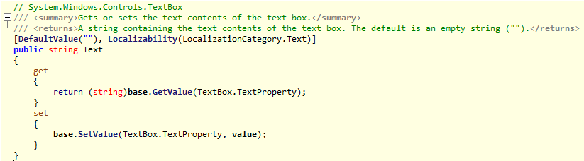

## 在TextBox的静态构造函数里对TextProperty初始化

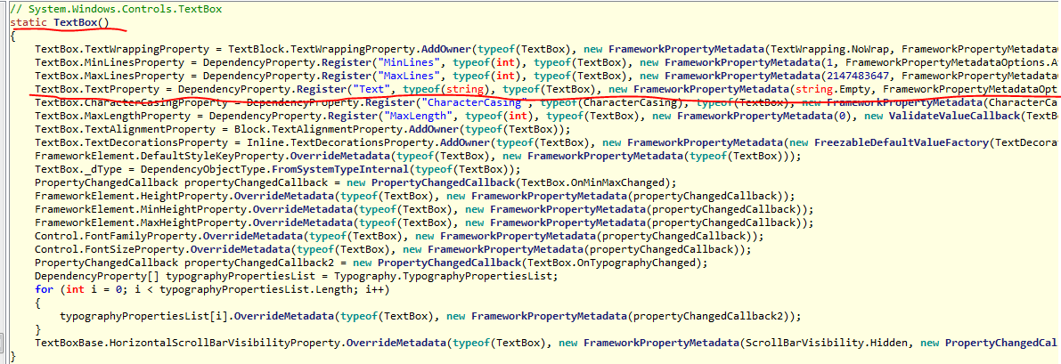

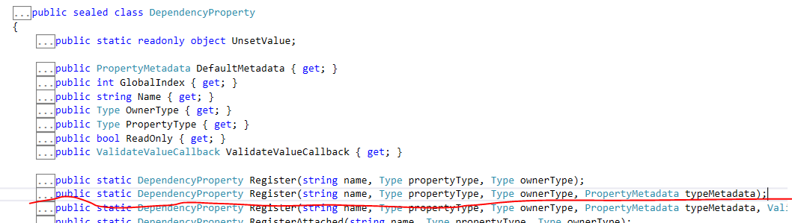

TextBox.TextProperty = DependencyProperty.**Register**("Text",

**typeof**(string),

**typeof**(TextBox),

**new** **FrameworkPropertyMetadata**(string.Empty,

FrameworkPropertyMetadataOptions.BindsTwoWayByDefault |FrameworkPropertyMetadataOptions.Journal,

**new** **PropertyChangedCallback**(TextBox.OnTextPropertyChanged),

**new** **CoerceValueCallback**(TextBox.CoerceText),

**true**,

UpdateSourceTrigger.LostFocus)

);

### FrameworkPropertyMetadata

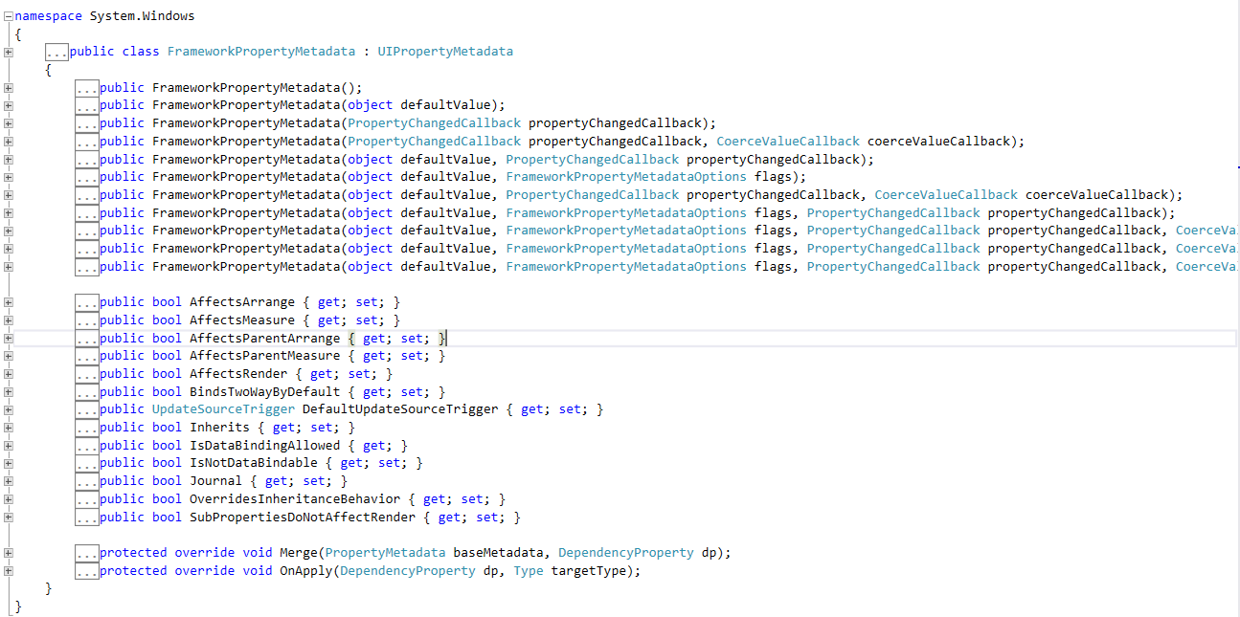

public FrameworkPropertyMetadata(object defaultValue,

FrameworkPropertyMetadataOptions flags, PropertyChangedCallback propertyChangedCallback, CoerceValueCallback coerceValueCallback,

bool isAnimationProhibited,

UpdateSourceTrigger defaultUpdateSourceTrigger);

### FrameworkPropertyMetadataOptions

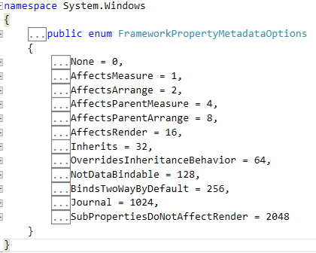

|  |  |  |
| --- | --- | --- |
|  | None | No options are specified; the dependency property uses the default behavior of the Windows Presentation Foundation (WPF) property system. |
|  | AffectsMeasure | The measure pass of layout compositions is affected by value changes to this dependency property. |
|  | AffectsArrange | The arrange pass of layout composition is affected by value changes to this dependency property. |
|  | AffectsParentMeasure | The measure pass on the parent element is affected by value changes to this dependency property. |
|  | AffectsParentArrange | The arrange pass on the parent element is affected by value changes to this dependency property. |
|  | AffectsRender | Some aspect of rendering or layout composition (other than measure or arrange) is affected by value changes to this dependency property. |
|  | Inherits | The values of this dependency property are inherited by child elements. |
|  | OverridesInheritanceBehavior | The values of this dependency property span separated trees for purposes of property value inheritance. |
|  | NotDataBindable | Data binding to this dependency property is not allowed. |
|  | BindsTwoWayByDefault | The System.Windows.Data.BindingMode for data bindings on this dependency property defaults to System.Windows.Data.BindingMode.TwoWay. |
|  | Journal | The values of this dependency property should be saved or restored by journaling processes, or when navigating by Uniform resource identifiers (URIs). |
|  | SubPropertiesDoNotAffectRender | The subproperties on the value of this dependency property do not affect any aspect of rendering. |

### PropertyChangedCallback

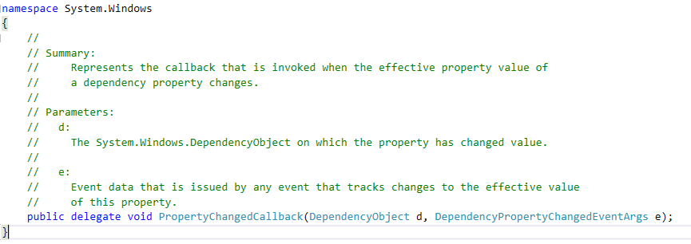

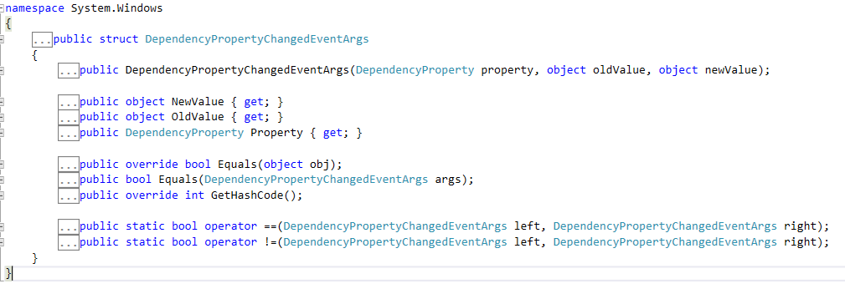

## 有两个OnTextPropertyChanged 方法

这两个都是private 方法，在Visual Studio IDE里看不到

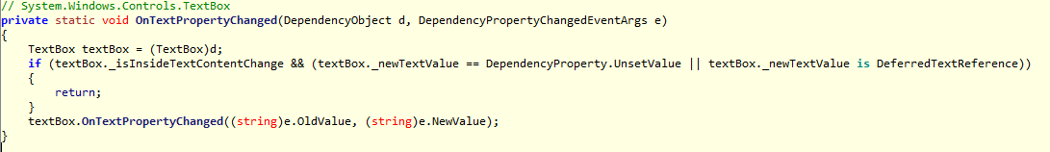

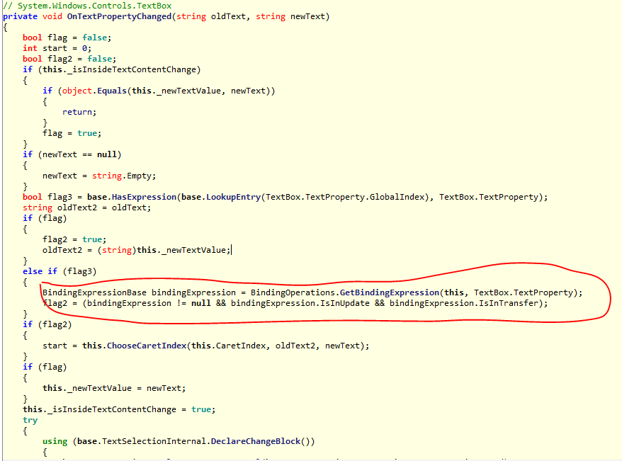

## 父类TextBoxBase 中定义了常规的方法

