1. Where do I put image files, css, js, etc. in Codeigniter? 2

2. Usage 2

# Where do I put image files, css, js, etc. in Codeigniter?

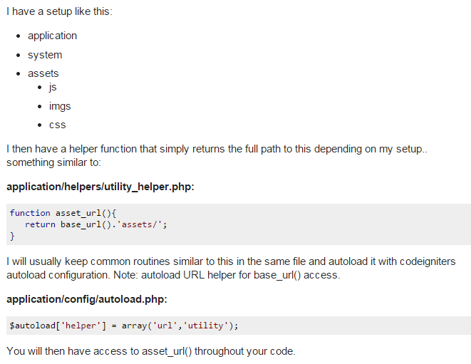



# Usage

<link href="<?php echo css_url(); ?> style.css" rel="stylesheet" type="text/css" />

<script type="text/javascript" src="<?php echo js_url(); ?> javascript.js"></script>