1. 季线 1

1.1. 2017-02-05 1

2. 月线 2

2.1. 2017-01-08 2

3. 周线 2

3.1. 2017-01-08 2

4. 日线 2

4.1. 2017-01-08 2

# 总的趋势

|  |  |  |  |  |  |  |  |  |
| --- | --- | --- | --- | --- | --- | --- | --- | --- |
|  | **季** | **月** | **周** | **日** | **60** | **30** | **15** | **5** |
| **2017-02-05** |  |  |  |  |  |  |  |  |
|  |  |  |  |  |  |  |  |  |
|  |  |  |  |  |  |  |  |  |
|  |  |  |  |  |  |  |  |  |
|  |  |  |  |  |  |  |  |  |
|  |  |  |  |  |  |  |  |  |
|  |  |  |  |  |  |  |  |  |

# 季线

## 2017-02-05

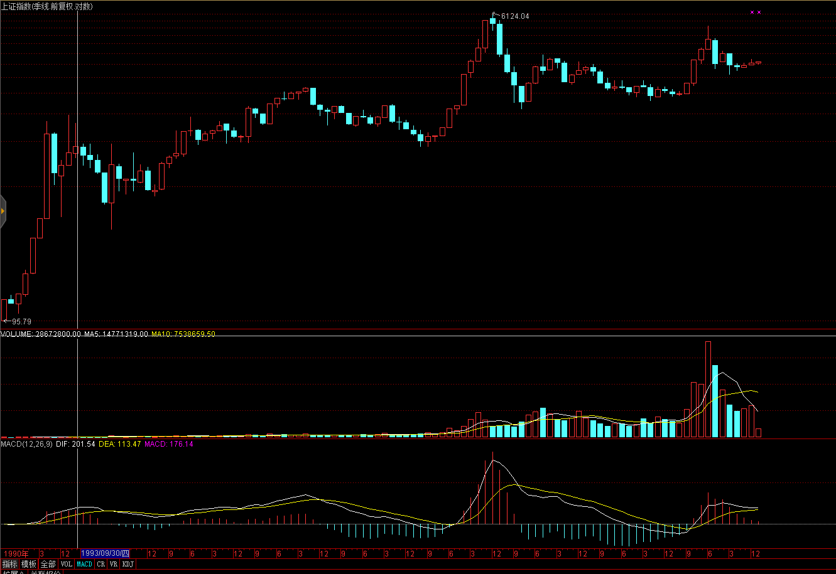

# 月线

## 2017-02-05

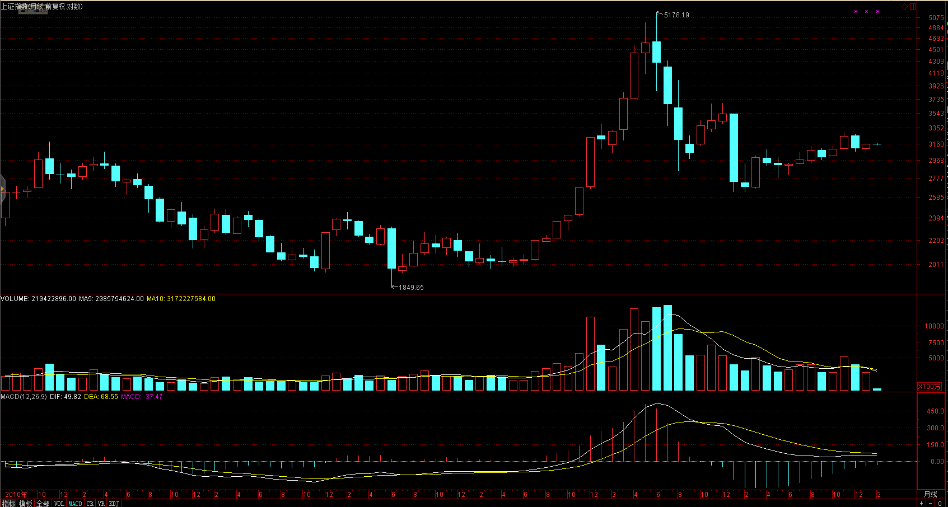

# 周线

## 2017-02-05

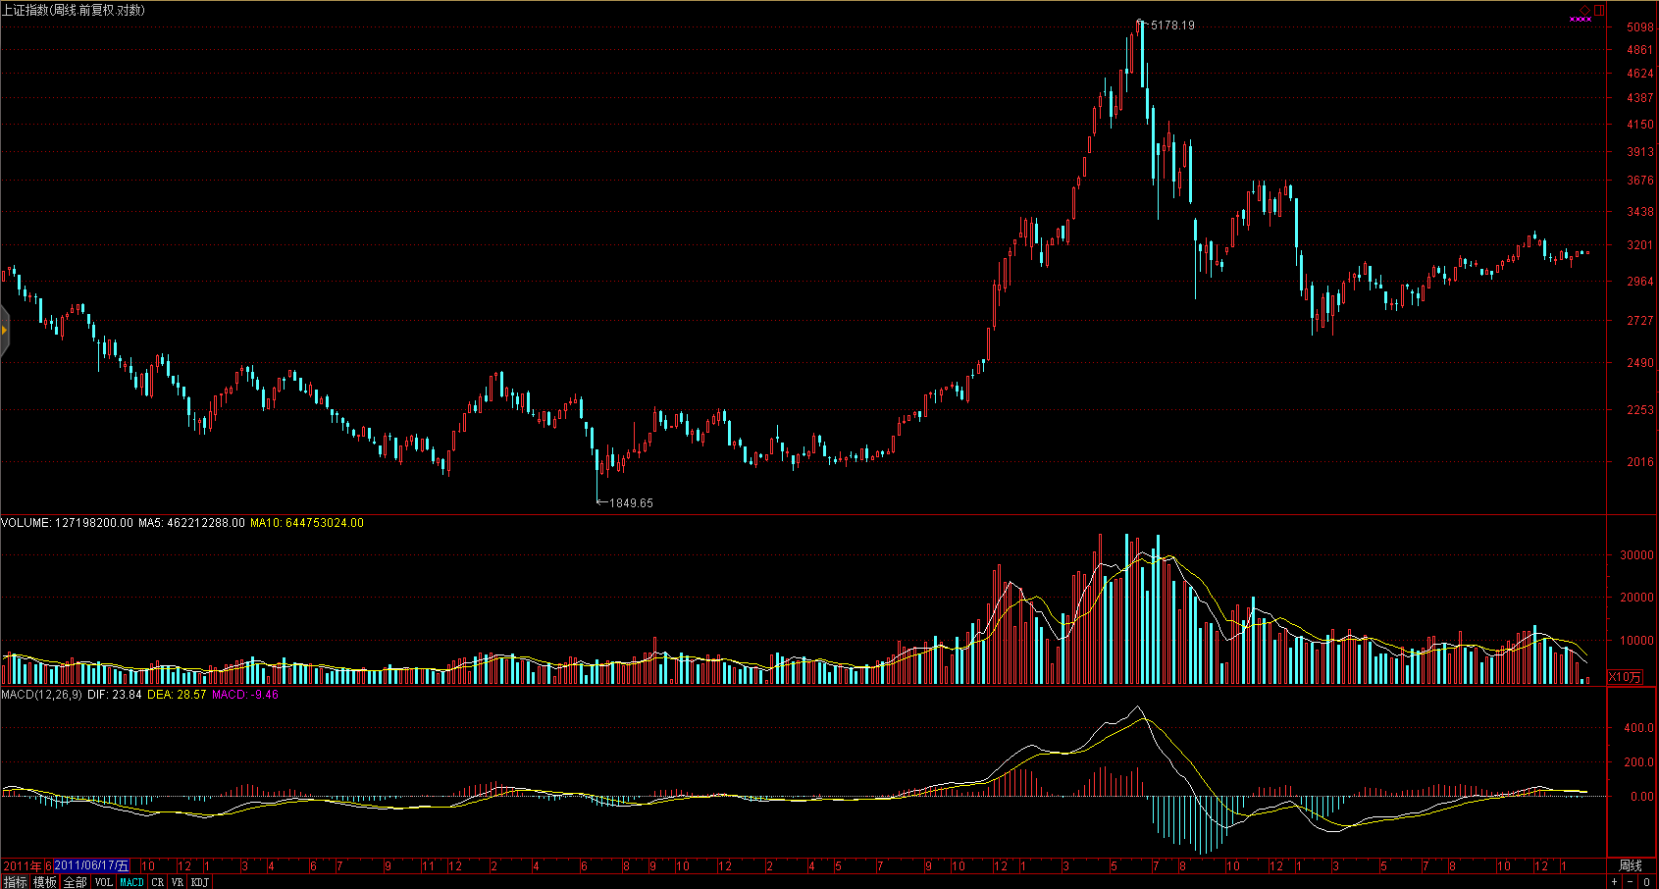

# 日线

## 2017-02-05

