Using IRB and Watir

The Ruby Interactive Shell (IRB)

Ruby comes with a very powerful tool – the Ruby Interactive Shell. This allows you to type commands directly into the interpreter – you don’t need to save a file and run it.

To start, open a command prompt.

Type:
irb

You Should see a prompt like below.

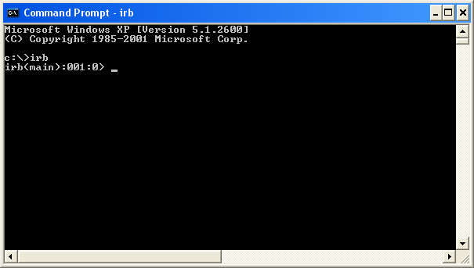

At the prompt, we can now execute ruby commands. Any command that would normally be in a program can be entered in irb. Here we add two numbers together:

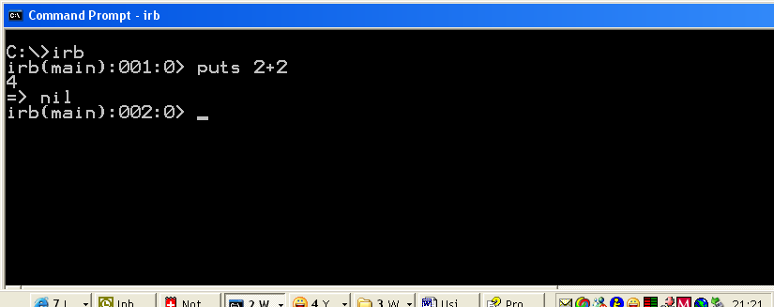

Here we use a for loop to print some numbers. Ruby also provides many other looping mechanisms.

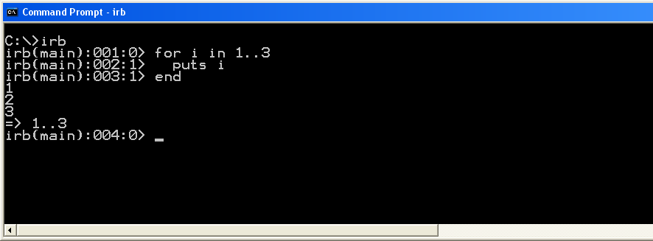

A more ‘rubyish’ way of doing a loop is shown next.

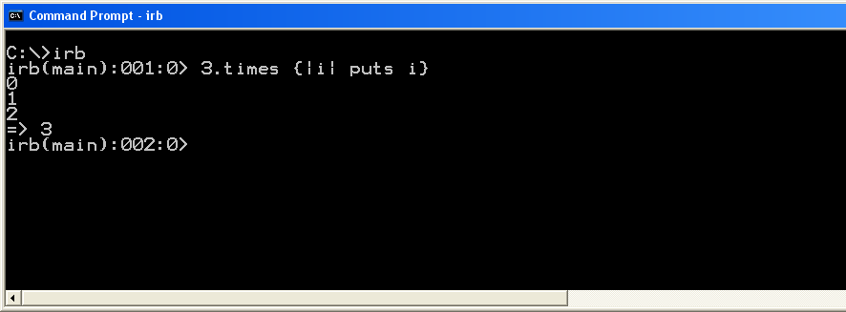

We’re not restricted to using one liners though. We can enter almost anything:
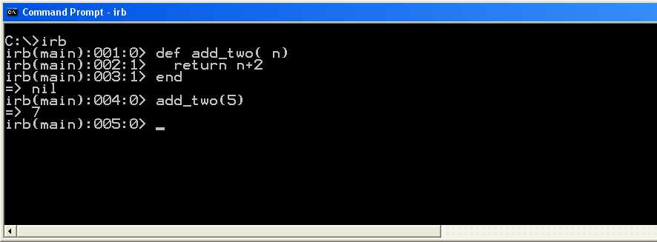
Here we’ve defined a simple method that adds two to its argument, and then used it.
Using Watir from IRB

In the following pages, we assume that you have the time clock installed and running. The time clock is available for download from the Scripting101 package at http://rubyforge.org/projects/wtr/

To first use Watir, we must tell irb to require it, just the same as if we were writing a ruby program.

In place of the screen shots, we’ll use this box to show what happens. We’ll also change the prompt to just irb>

irb> require ‘watir’
=> true

We can now create a new Internet Explorer starting at http://localhost:8080 ( the timeclock start page) , controlled by Watir using the following:

irb> ie=Watir::IE.start(‘http://localhost:8080’)
#<Watir::IE:0x2c26150 @defaultSleepTime=0.1………………

You’ll get lots more printed to the console. You don’t need to worry about it.
Internet Explorer should now be displaying the Time Clock login page.

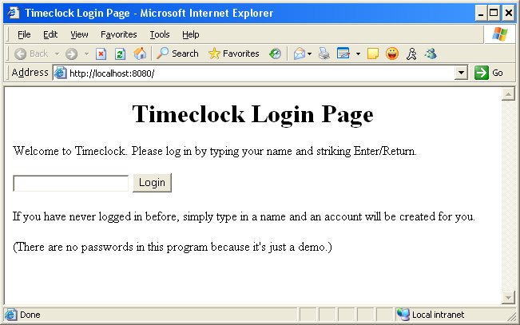

Watir gives us some powerful tools to help write the scripts we need for the auto tests.

We can use the show_all_objects method to show all the links and controls that are on the page.
Heres that in the console window:

irb> ie.show_all_objects
-----------Objects in page -------------
text name=name id= value=
submit name=submit_logon id= value=Login

Here, watir is telling us that it found 2 objects, a text field, and a submit button.
It also tells us that neither object had the id attribute set, but both objects had a name attribute.

Using the login page, its fairly obvious which object is which, but on a more complex page with lots of buttons and textfields, we may not be able to determine which one we want to access. Watir can help us with that too.

We can make an object on the page ‘flash’ by sending it the flash method. Heres how to do it for the text field:
irb> ie.text_field(:name, 'name').flash
=> 10
irb> ie.text_field(:name, 'name').flash
=> 10

If we’d been looking at Internet Explorer, when this happned, we would have seen the textfield flicker between its current clear background and a yellow one.

We can also flash the button, using the following:

irb> ie.button(:value, 'Login').flash
=> 10
irb> ie.button(:value, 'Login').flash
=> 10

In this example, we used :value and ‘Login’ to tell watir to use the button caption to find the correct button to use. The 10 as the return value shows us that watir flashed the button 10 times

Again, if we had been watching Internet Explorer, we would have seen the button change color to yellow, and then back to the normal grey.

We can use this flash method on almost all objects that watir supports.

Watir also helps us identify the currently active object on the page, by using the show_active method. To use it, you must first set the highlight to the object you want to identify. For a text field, you can just click the field. For other objects you need to move around the browser window using the keyboard.
First though, lets use show_active on the text field.
Click in the text field box, so it has a cursor,
Now use ALT-TAB to switch to the console window that is running irb
In the console, type: puts ie.show_active:
irb> puts ie.show_active
text name=name
id= value=
alt= src=
innerText=
=> nil

(In the console above, I had to change the formatting to make it show correctly)

To do the same for the button, we must return to Internet Explorer, and then use the TAB key until the button receives a dashed line, meaning it has focus, as shown in the next picture.
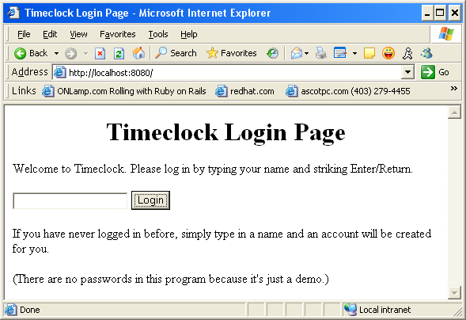

We can repeat the steps above, and the console will display
irb> puts ie.show_active
submit name=submit_logon
id= value=Login
alt= src=
innerText=
=> nil

We can enter text into the text field using this
irb> ie.text_field(:name, 'name').set(‘Test1’)
=> nil

The text_field object allows many more methods, including, clear, append, enabled? and readOnly? See the Watir api reference for all the methods it supports.

We can now click the button using the following. In this example, as there is only one button on the page, we can use the index attribute to identify the button.
irb> ie.button(:index,1).click
=> nil

We should now have moved onto a new page in the time clock.
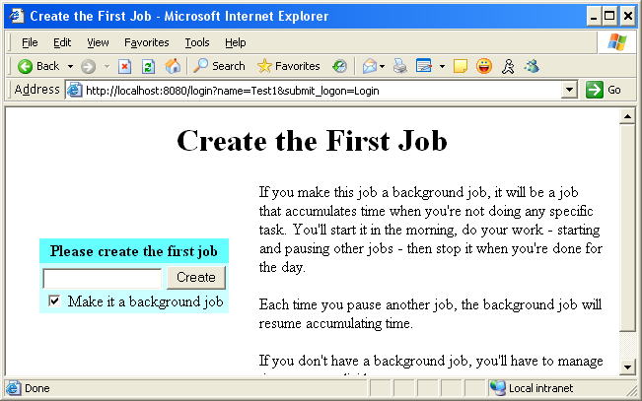

Watir gives us some mechanisms to see the HTML or just the text in a page:

irb> puts ie.html
<H1>
<P align=center>Create the First Job </P></H1>
<TABLE cellSpacing=0 cellPadding=3 border=0>
<TBODY>
<TR>
<TD align=middle width="40%">
<FORM id=job name=job action=job method=get><INPUT type=hidden value=22909012 name=session></INPUT>
<TABLE cellSpacing=0 cellPadding=3 border=0>
<TBODY>
<TR>
<TD align=middle bgColor=#66ffff><B>Please create the first job</B> </TD></TR>
<TR>…………
irb> puts ie.html
<H1>
<P align=center>Create the First Job </P></H1>
<TABLE cellSpacing=0 cellPadding=3 border=0>
<TBODY>
<TR>
<TD align=middle width="40%">
<FORM id=job name=job action=job method=get><INPUT type=hidden value=22909012 name=session></INPUT>
<TABLE cellSpacing=0 cellPadding=3 border=0>
<TBODY>
<TR>
<TD align=middle bgColor=#66ffff><B>Please create the first job</B> </TD></TR>
<TR>…………

I didn’t show all the html, but trust me, its there!

We can also view the text of the page in a similar manner
irb> puts ie.text
Create the First Job
Please create the first job

Make it a background job
If you make this job a background job, it will be a job that accumulates time when you're not doing any specific task. You'll start it in the morning,
do your work - starting and pausing other jobs - then stop it when you're done for the day.
Each time you pause another job, the background job will resume accumulating time.
If you don't have a background job, you'll have to manage time more explicitly.
=> nil
irb(main):024:0>

irb> puts ie.text
Create the First Job
Please create the first job

Make it a background job
If you make this job a background job, it will be a job that accumulates time when you're not doing any specific task. You'll start it in the morning,
do your work - starting and pausing other jobs - then stop it when you're done for the day.
Each time you pause another job, the background job will resume accumulating time.
If you don't have a background job, you'll have to manage time more explicitly.
=> nil
irb(main):024:0>

We’ll move onto the next screen in the Timclock by entering our background job , lets use ‘Testing for Bugs’ and then clicking the Create button. We don’t need to change the state of the checkbox, as its already set.

To set the job name, we use some code that is similar to the code we used to enter the username

ie.text_field(:index, 1).set(‘Testing for Bugs’)

In this case though, I used the index attribute to tell Watir to use the first text field on the page.

We can then click the button

ie.button(:value, ‘Create’).click

We will now be on the Timeclocks’ main page, as shown in the next picture.

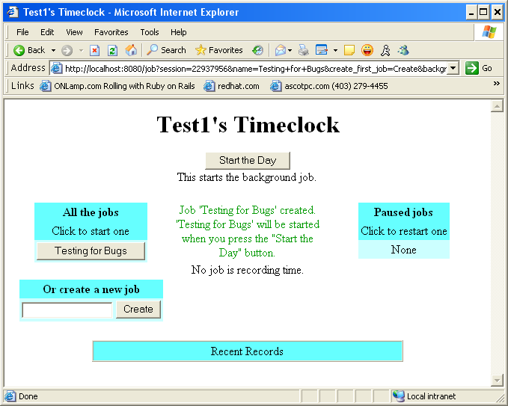

To give us some data to better demonstrate what we can do with Watir, lets start the ‘Testing for Bugs’ job by clicking that button

ie.button(:value, ‘Testing for Bugs’).click

The Timeclock page will now look like this:
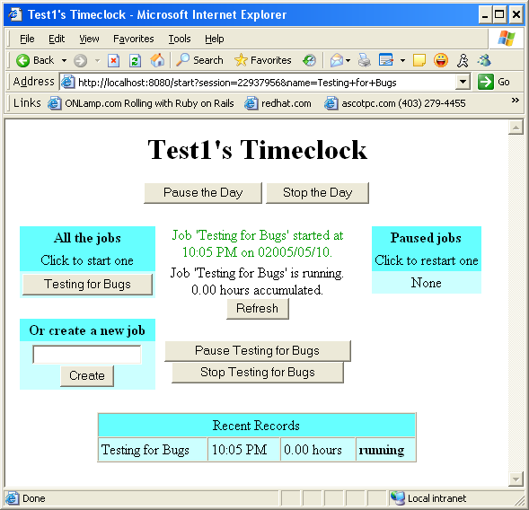

As well as the show_all_objects method, Watir has many more that can be used. Here we use the show_tables method to see the tables that are in the page

irb> ie.show_tables
Found 8 tables
1 id= rows=1 columns=3
2 id= rows=2 columns=1
3 id= rows=3 columns=1
4 id= rows=2 columns=1
5 id= rows=3 columns=1
6 id= rows=1 columns=1
7 id= rows=3 columns=1
8 id=recent_records rows=2 columns=1
=> nil

irb> ie.show_tables
Found 8 tables
1 id= rows=1 columns=3
2 id= rows=2 columns=1
3 id= rows=3 columns=1
4 id= rows=2 columns=1
5 id= rows=3 columns=1
6 id= rows=1 columns=1
7 id= rows=3 columns=1
8 id=recent_records rows=2 columns=1
=> nil

We can again use the flash method to help us identify a table
irb> ie.table(:id , ‘recent_records’).flash

irb> ie.table(:id , ‘recent_records’).flash

Depending on the formatting ( color, borders etc) that already exist on the table it may not turn yellow, as other colors are already being used in the table, but its border should flash.

irb> ie.tables.each { |t| t.flash }

We can see the HTML that makes up just a particular table by using the html method:
irb> puts ie.table(:id , ‘recent_records’).html

<TABLE id=recent_records cellSpacing=0 cellPadding=3 width="66%" align=center border=1><TBODY>
<TR bgColor=#66ffff>
<TD align=middle colSpan=4>Recent Records </TD></TR>
<TR bgColor=#ccffff>
<TD>Testing for Bugs </TD>
<TD>10:05 PM </TD>
<TD>0.00 hours </TD>
<TD><B>running</B> </TD></TR></TBODY></TABLE>
=> nil
=>

irb(main):032:0>

irb> puts ie.table(:id , ‘recent_records’).html

<TABLE id=recent_records cellSpacing=0 cellPadding=3 width="66%" align=center border=1><TBODY>
<TR bgColor=#66ffff>
<TD align=middle colSpan=4>Recent Records </TD></TR>
<TR bgColor=#ccffff>
<TD>Testing for Bugs </TD>
<TD>10:05 PM </TD>
<TD>0.00 hours </TD>
<TD><B>running</B> </TD></TR></TBODY></TABLE>
=> nil
=>

irb(main):032:0>

Since this table contains information that is useful to us as testers, we may want to capture its content and access it using standard Ruby. We can do that using the .to_a ( to array ) method of the table object.

irb> irb(main):009:0> my_array = ie.table(:id , 'recent_records').to_a
=> [["Recent Records"], ["Testing for Bugs", "10:05 PM", "0.00 hours", "running"]]

=>

irb(main):032:0>

The array, my_array now contains the data from the table, and can be accessed by using any of the standard methods for arrays.

Watir supports show_ methods for other objects. They are shown in the next table.
show_images | Show all the images in the document
show_spans | Show all the span tags in the document
show_labels | Show all the labels in the document
show_links | Show all the links in the document
show_divs | Show all the div tags in the document
show_frames | Show all the frames in the document
show_forms | Show all the forms in the document

