Using The Timeclock

Starting the Timeclock

Open a dos prompt
Change to the directory where you unzipped the scripting101 file
(Normally this is c:\scripting101)
c:
cd scripting101
Change directories to the timeclock\bin directory
cd timeclock\bin

Start the Timeclock web server by typing
ruby http-server.rb

You will now see some text printed out to the console window.

To stop the Timeclock, make the dos window in which the Timeclock server is running active, by clicking in it with the mouse
Then hold down the ctrl key and then press the Break key. You will now be returned to the dos prompt.

Viewing the Timeclock in a browser.

Open Internet Explorer, and goto this site:
http://localhost:8080

You should see the Timeclock login page displayed.
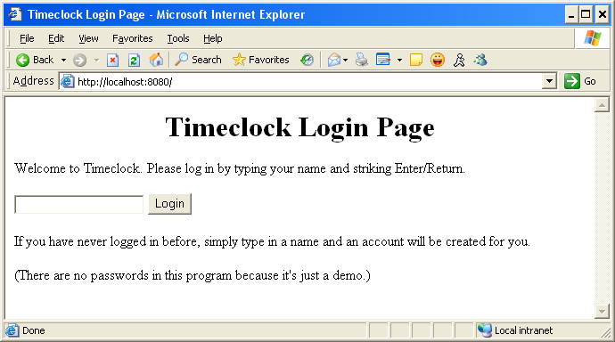

What the Timeclock does.

The Timeclock is an application for recording how much time was spent on a particular activity. It is written in Ruby, by Brian Marrick.

The idea is that you have different ‘Jobs’ Each job is a task that you spend some time on.
There is also a background job. A background job is one you work on when you are not working on anything else.

For example, in my job as a software tester, I do various different things:
- Testing bug fixes
- Attending meetings
- Writing test cases
If I have no meetings, I’ve tested all my bug fixes, and there are no test cases to work on, I spend my time adding unit tests to Watir.

If we were to create these in the Timeclock, my background job would be ‘adding unit tests to Watir’.

Let’s log into the time clock and see how it works.

On the login page, shown above, you can type your name, or any other helpful text, maybe ‘test1’. If you’ve logged in before, the Timeclock will goto your main page, otherwise you will goto a page that asks you to create a new job.

Let’s assume this is the first time you’ve logged in, you will be presented with this page:

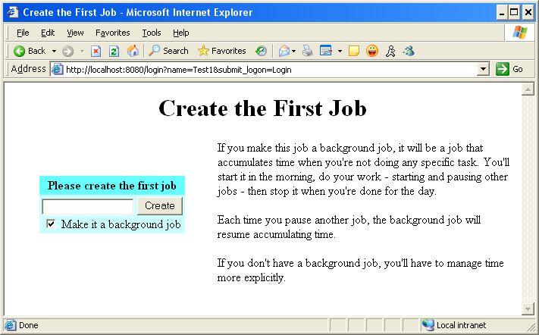

If we were doing this using the jobs above, we would enter ‘Watir Unit Tests’ (or some other description) into the text box. We would leave the check box set, as this would be the background job. Then click the create button.
You should now see this page:

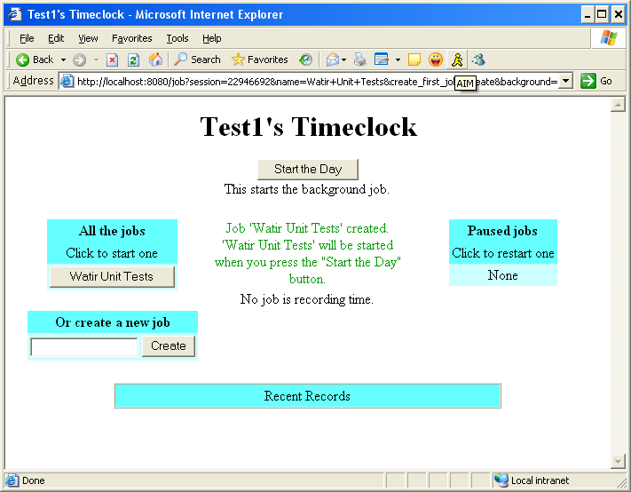

The Timeclock tells us that no job is running. We need to Start The Day to start recording time.

Click the Start the Day Button. This will tell the Timeclock that we’ve come into work and want to start recording how we spend our time.

You will now see the following page. The Start the Day button has been replaced by 2 other buttons, Pause the Day and Stop the Day.

At the end of the day we would click the Stop the Day button, to tell the Timeclock that we are going home.

When we stop for lunch, we would click the Pause the Day button, to tell the Timeclock to stop recording time, but that we will be back later.
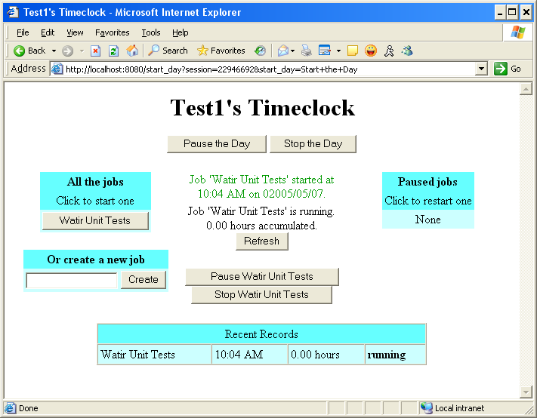

The ‘Recent Records’ table at the bottom shows how much time we have been spending on different jobs. If you hit the Refresh button in the middle of the screen, the table will get updated with a more recent time.

I can create more jobs using the text box and the create button on the left hand side.
If I create the other jobs I do during the day, here’s what the screen will look like

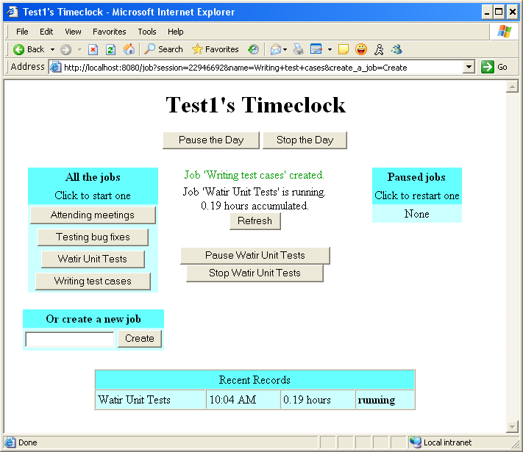

Notice that the time in the Recent Records table has increased.

If I now have to go to a meeting, I can click the Attending Meetings button, and the time clock will make the Attend Meetings job the active one.

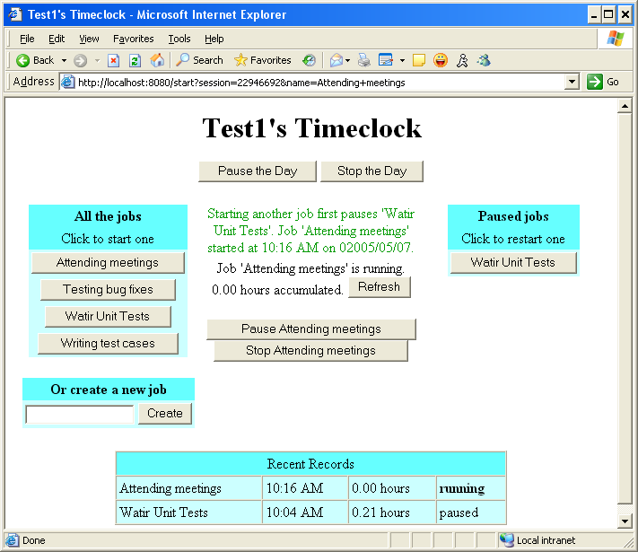

Once I finish my meeting, I can return to the Watir Unit Tests, by clicking the Button in the Paused Jobs section.

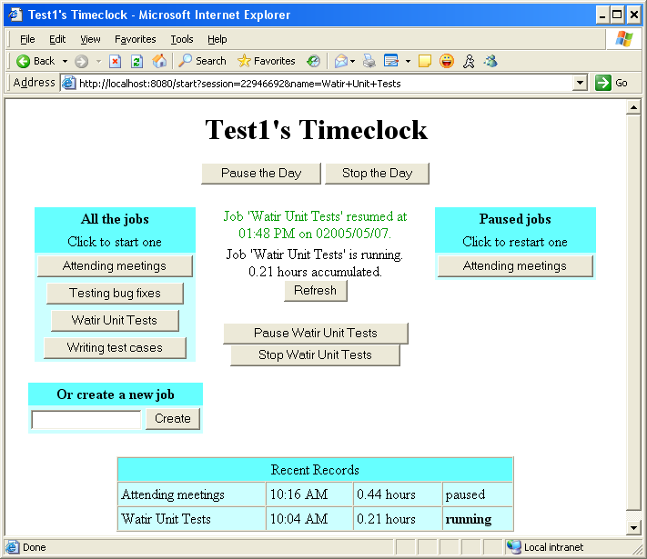

If I now go for lunch, I can click the Pause The Day button, and no jobs will record time:

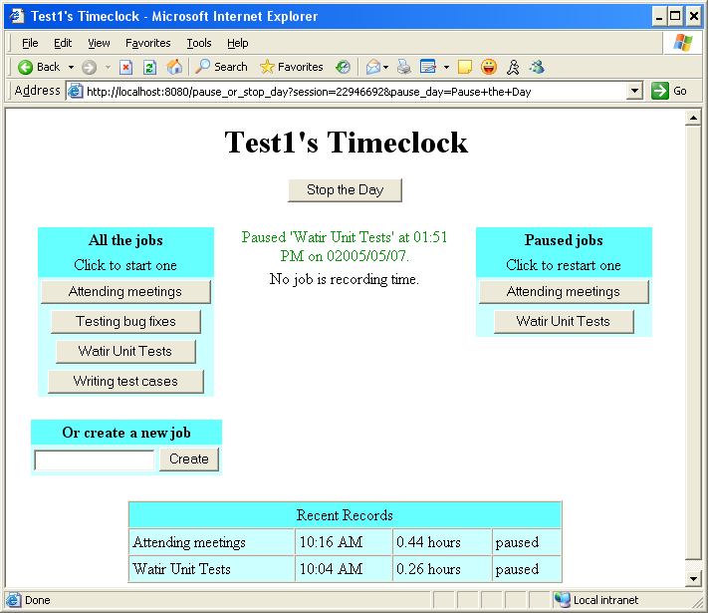

When I return from lunch, clicking one of the paused jobs on the right, or starting a new job on the left, will cause that job to start recording time.
Here I started Bug Fixes job
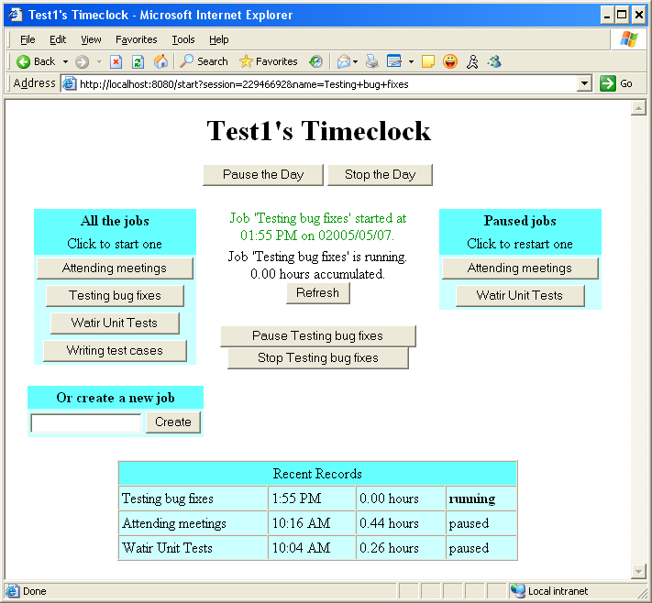

If I try and start a job that is already running, in this case by clicking the Testing Bug Fixes button, the Timeclock will give me an error message:

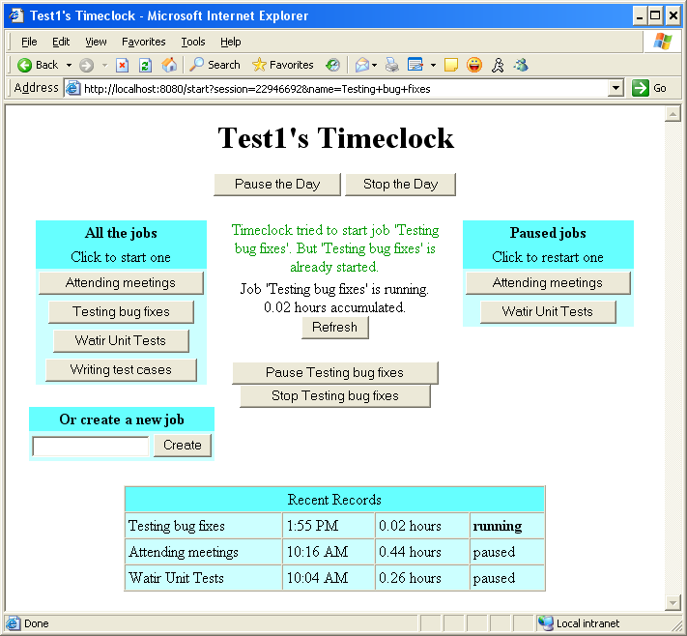

When my day ends, I can click the Stop the Day button:

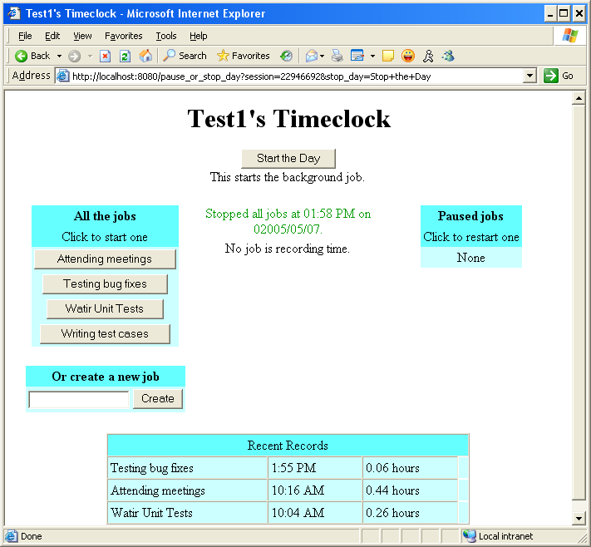
Deleting Timeclock Data

If you create a user, but then decide you want to get rid of it, you can delete the data.
The data is stored in a directory called timeclock_data in c:

Open a console, and type
c:
cd timeclock_data

there will be 2 directoreis, logs and user-data
cd into user-date
and then delete the file using
del test1

You will need to stop and start the server to see the user correctly deleted.

