Functional Specification for the Timeclock Application

Overview

The timeclock is a web based application that allows people to track how much time they spend on a particular project.

This specification does not discuss the internal code of the Timeclock, just the aspects that the user deals with.

Scenarios

Here are some various uses the timeclock could be used for.

Scenario 1.
A worker spends all of their time doing one particular thing.
=> they use a ‘background job’
A background job will be where the time gets used if they don’t explicitly set another job

Scenario 2.
A consultant switches between many clients, doing little bits for each of them.
=> they create many jobs, with no background job

Scenario 3.
A receptionist answers the phone and directs vistors when needed. Other wise he types up letters for the company VP
=> Create a background job of ‘typing letters’
=> Create jobs for ‘answering phone’ and ‘directing visitors’

FlowCharts

To help understand how the timeclock works, here are some flowcharts.

This first flowchart is for the whole application.

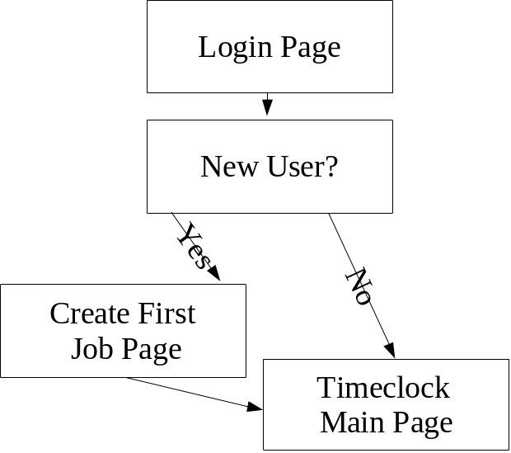

This second flowchart is for the Timeclock main page

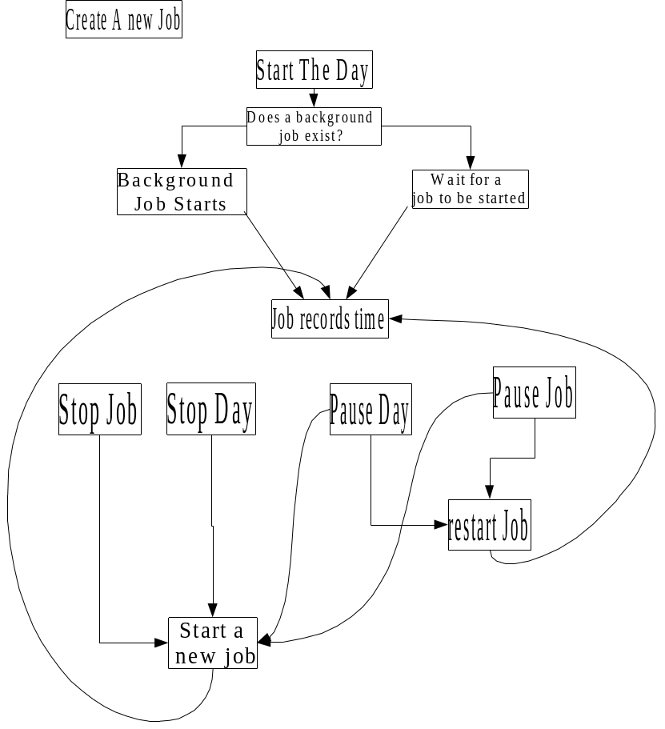

Screen Views

Login Page
We must provide some mechanism for the user to enter the application. We don’t care about passwords in this release.

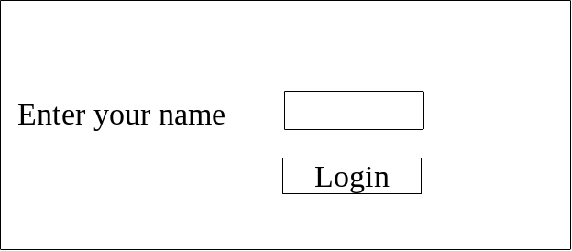

Create First Job Page
When a new user logs in, they get to create a job. Default to a background job, so they always have a job running.
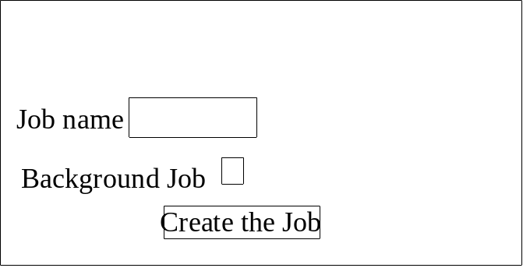

Main Page
Heres a suggested layout for the main page. Theres a lot on there, so we may need to change its design during development
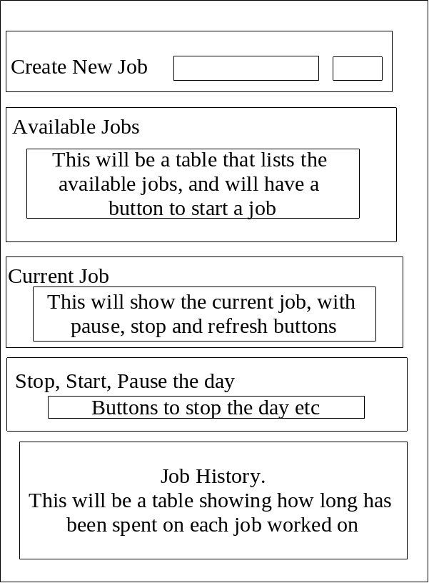

Storage
The user data for the timeclock needs to be stored in a file. Storing it on the c:\ ( as we are only using windows) in a dir called time_clock_data with sub-dirs for each user seems like a good idea.

