ITSC 1307 Unix

Chapter 4 Lab Part 2

In this lab, you will use what you learned from Chapter 4 to complete this exercise.

1) Using your VM login using the **root** account

2) Create a directory called **/Labs/chap4/*your-last-name*** under **/root** directory, then **cd** to **/root/Labs/chap4**.

3) Create a directory and file structure as follows using **mkdir** to create the directories and **touch** to create the files. Note the directory names, file names, and permissions. Your structure should look identical. I’ve also included a long listing of the structure below the screenshot. View your structure from **Labs/chap4** using:

**cd ~/Labs/chap4 (this is to make sure you’re in the /root/Labs/chap4 directory**

**tree -p your-last-name   
ls -lR your-last-name**

4) When you have finished run the following two commands from your **/root/Labs/chap4** directory to create 2 txt files:

**tree -p your-last-name > *your-last-name-tree.txt*  
ls -l -R your-last-name > *your-last-name-list.txt***

5) I will show you how to upload the 2 txt files to your host.

**Tree View (make sure you’re in /root/Labs/chap4)**

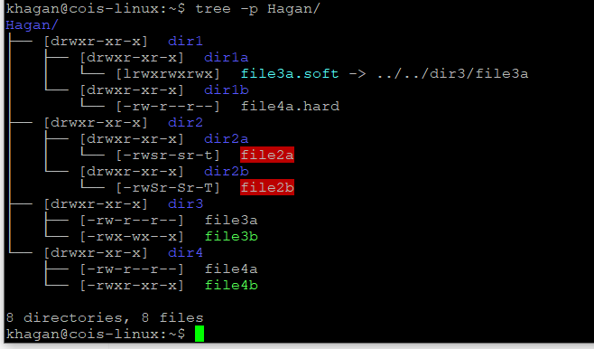

Listing View

Hagan/:

total 16

drwxr-xr-x 4 khagan khagan 4096 Oct 2 16:10 dir1

drwxr-xr-x 4 khagan khagan 4096 Oct 2 16:10 dir2

drwxr-xr-x 2 khagan khagan 4096 Oct 2 16:11 dir3

drwxr-xr-x 2 khagan khagan 4096 Oct 2 16:12 dir4

Hagan/dir1:

total 8

drwxr-xr-x 2 khagan khagan 4096 Oct 2 16:15 dir1a

drwxr-xr-x 2 khagan khagan 4096 Oct 2 16:17 dir1b

Hagan/dir1/dir1a:

total 0

lrwxrwxrwx 1 khagan khagan 17 Oct 2 16:15 file3a.soft -> ../../dir3/file3a

Hagan/dir1/dir1b:

total 0

-rw-r--r-- 2 khagan khagan 0 Oct 2 16:12 file4a.hard

Hagan/dir2:

total 8

drwxr-xr-x 2 khagan khagan 4096 Oct 2 16:35 dir2a

drwxr-xr-x 2 khagan khagan 4096 Oct 2 16:43 dir2b

Hagan/dir2/dir2a:

total 0

-rwsr-sr-t 1 khagan khagan 0 Oct 2 16:35 file2a

Hagan/dir2/dir2b:

total 0

-rwSr-Sr-T 1 khagan khagan 0 Oct 2 16:43 file2b

Hagan/dir3:

total 0

-rw-r--r-- 1 khagan khagan 0 Oct 2 16:11 file3a

-rwx-wx--x 1 khagan khagan 0 Oct 2 16:11 file3b

Hagan/dir4:

total 0

-rw-r--r-- 2 khagan khagan 0 Oct 2 16:12 file4a

-rwxr-xr-x 1 khagan khagan 0 Oct 2 16:11 file4b