Getting Started with *Logisim Evolution*

ECEN 240

Introduction

*Logisim Evolution* is a logic circuit simulator written in Java. The “logisim-evolution.jar” file may be run from any operating system as long as Java is installed on the system (Windows, Mac OSx, Linux, etc.). In most systems you simply need to double-click on the “jar” file. In other systems it is invoked at the command prompt with “java -jar logisim-evolution.jar” command.

*Logisim Evolution* will enable the user to get a firm grasp of digital logic circuits from a schematic entry and simulation perspective. Use the following figures as a guide in getting started with *Logisim Evolution*.

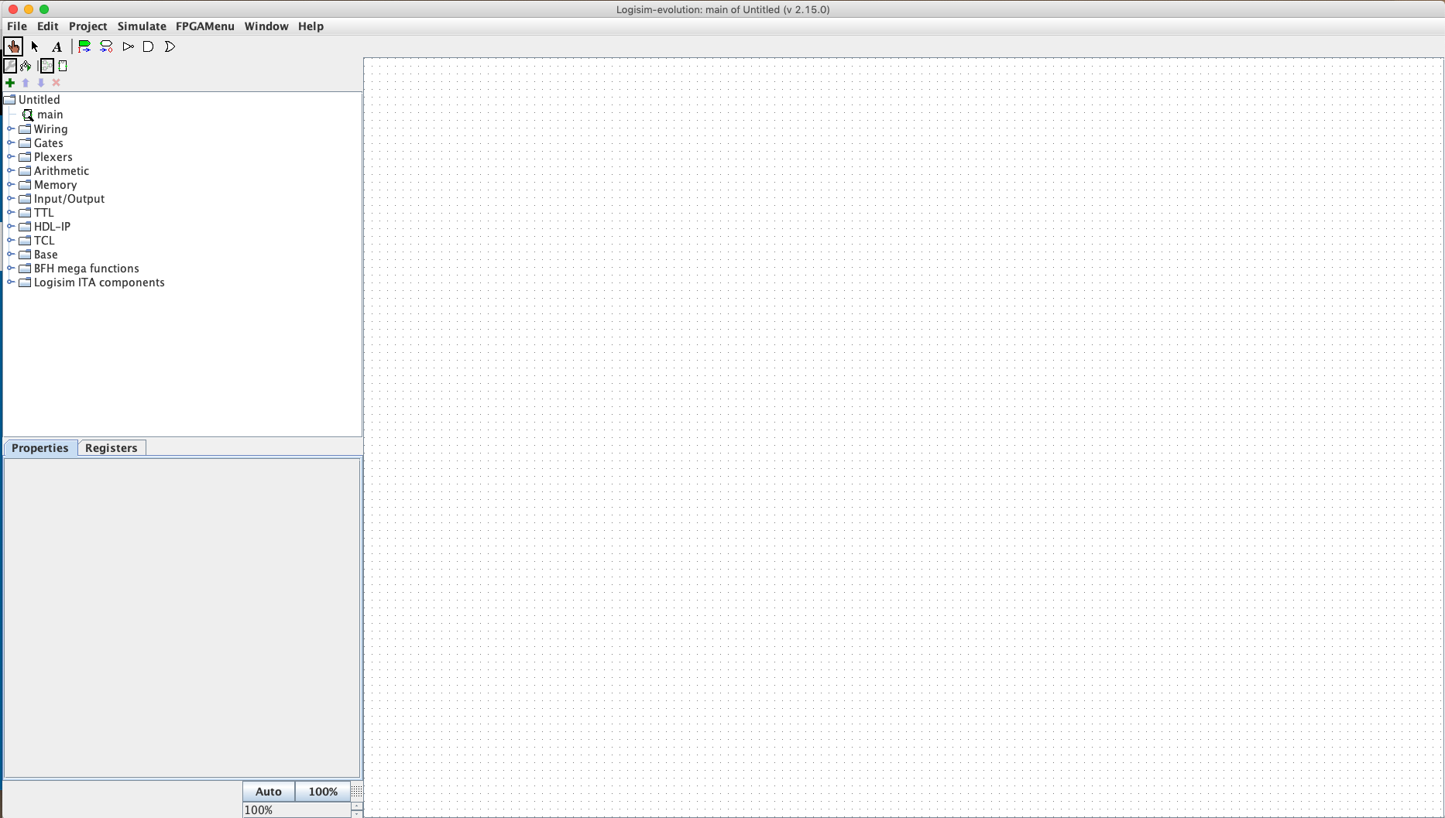

Full *Logisim Evolution* view

Once you have the *Logisim Evolution* window open, follow the steps below to create a simple circuit:

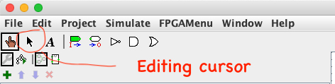

Step 1 – Select the editing cursor (top left toolbar)

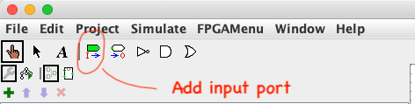

Step 2 – Select an input port

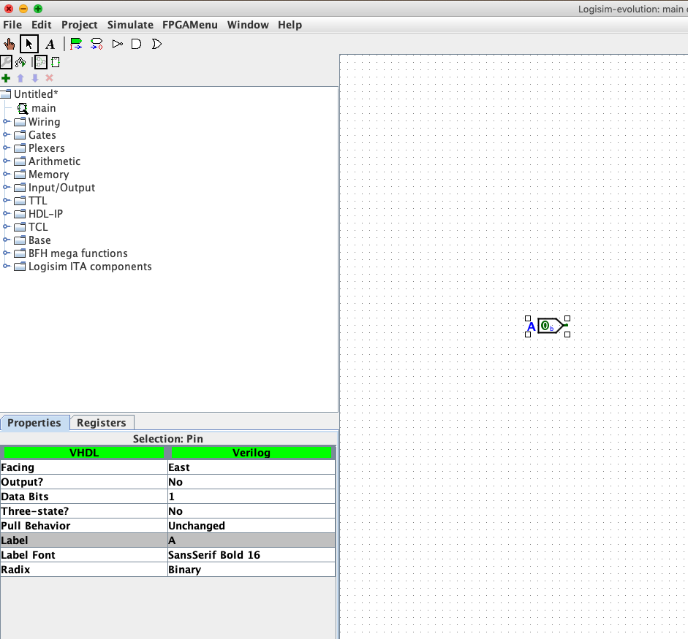

Step 3 – Place the input port and add label “A” in bottom left window

Step 4 - Place a second input port below the first, and label it “B”

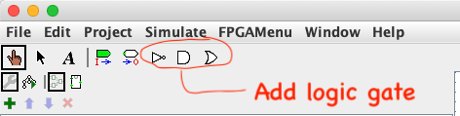

Step 5 – Select an AND gate from the toolbar

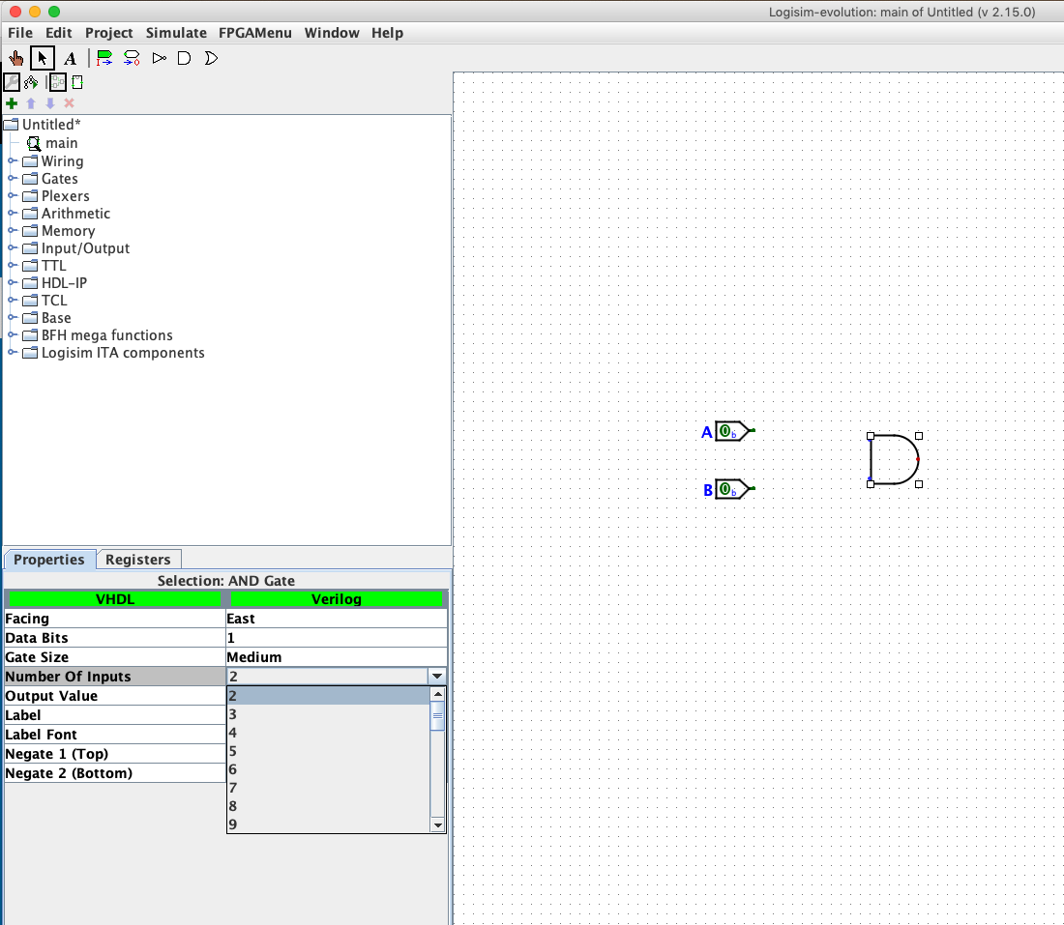

Step 6 – Place the AND gate near input ports and select the proper number of inputs (2)

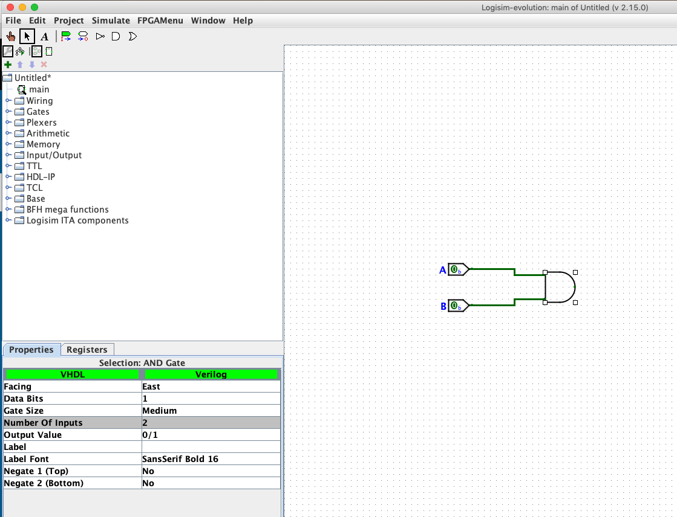

Step 7 – Drag the cursor to place wires connecting ports to Gate inputs

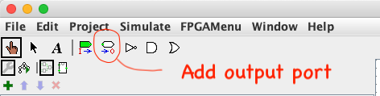

Step 8 – Select and output port

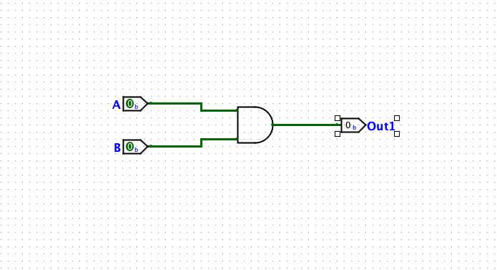

Step 9 – Place the output port and connect wire from AND gate

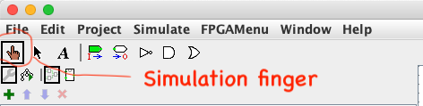

Step 10 – Select the simulation finger

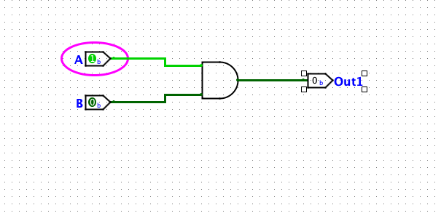

Step 11 - Select the “A” port. It should change from a “0” to a “1”

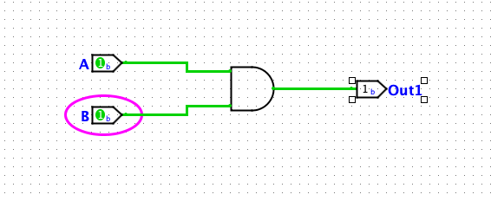

Step 12 – Select the “B” port and observe the change in the output

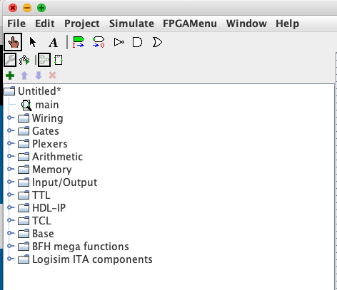

Component menu for adding additional components

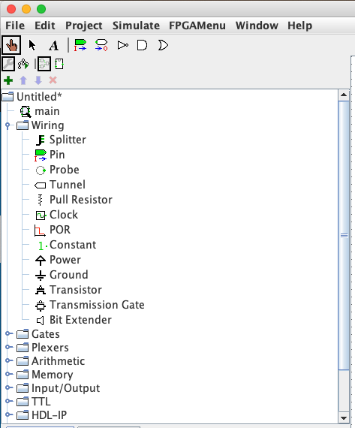

Wiring submenu is used frequently

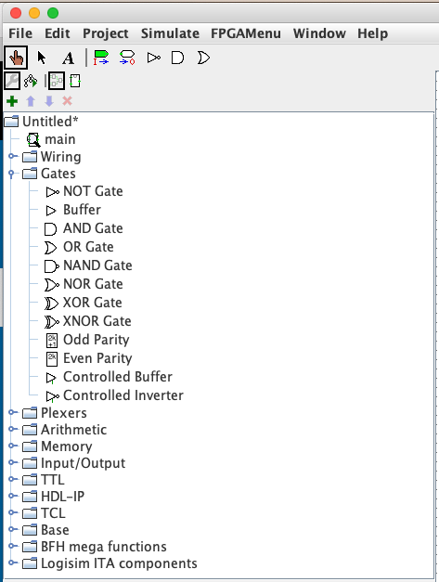

Additional Logic gates are available