**Communication App User’s Manual**

Jeff Elliott, Zac Erba, Ryan Seale, Lindsey Watterson

May 6, 2015

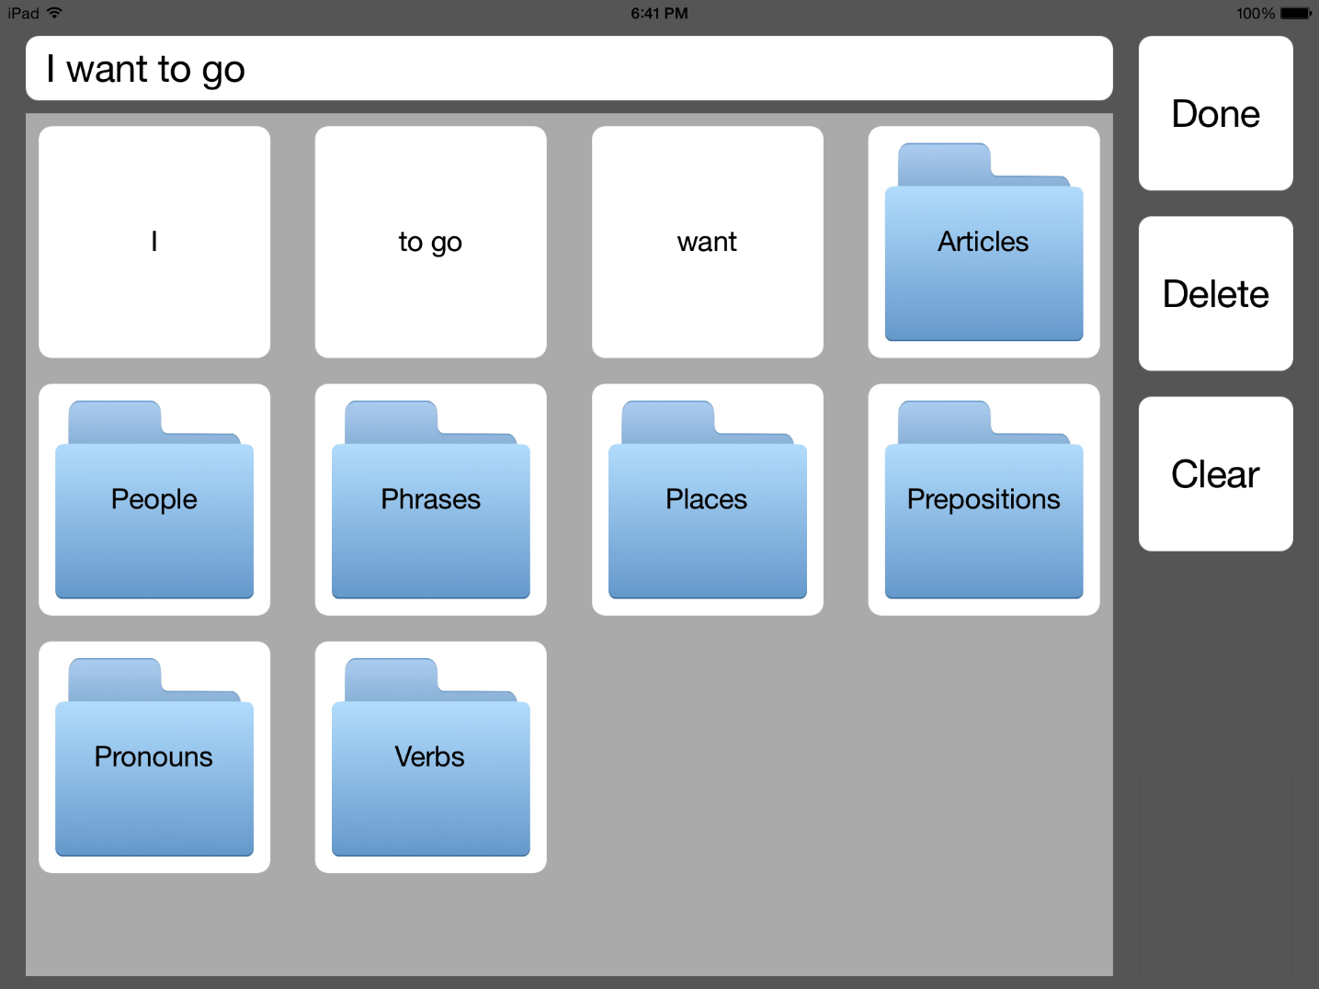

TABLE OF CONTENTS

INTRODUCTION 1

INSTRUCTIONS 2

STARTUP 2

ADDING A CATEGORY 3

EDITING A CATEGORY 4

DELETING A CATEGORY 5

ADDING A WORD 6

RECORDING AUDIO FOR A WORD 9

EDITING A WORD 9

DELETING A WORD 11

CHANGING THE ORDER OF WORDS 12

CREATING A SENTENCE 12

DELETING A WORD FROM THE SENTENCE. 13

CLEARING THE SENTENCE 13

NAVIGATING TO A CATEGORY 13

NAVIGATING BACK FROM A CATEGORY 13

ROUTINE MAINTENANCE 13

PRECAUTIONARY INFORMATION 13

TROUBLESHOOTING 14

APP FREEZES 14

APP IS SLOW 14

APP WAS DELETED 14

# INTRODUCTION

The Communication App or Easy Communication App is an iPad app that serves to help the user communicate more efficiently than through body language alone. It allows the user to select words to form sentences and then reads it allowed for the user. The app initially comes completely blank to allow the user to completely customize the app. This allows the user to maintain the same playback voice across all words played and allows them to only enter the words that they want and place them in the categories that make the most sense to them.

# INSTRUCTIONS

Below are listed the instructions for performing the main activities necessary for using the PAS.

## STARTUP

1. Find the app icon.
2. Click the icon.
3. A startup screen should appear
4. One first start up there should be no words or categories.

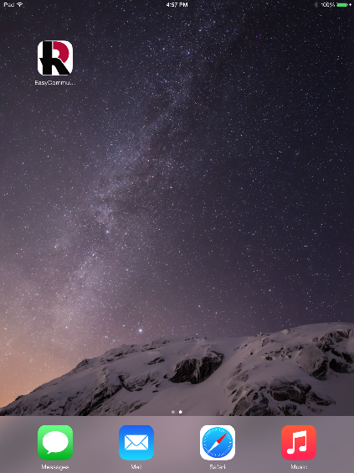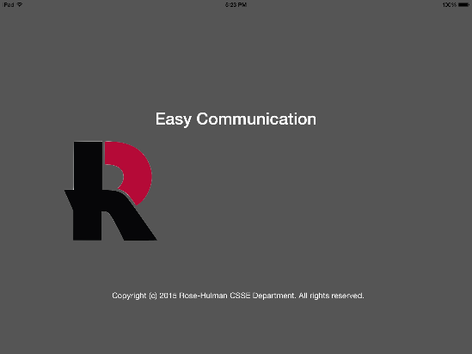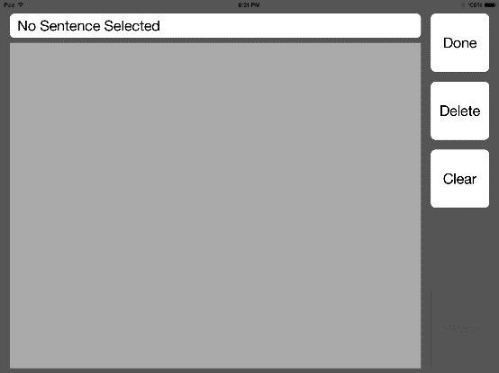

3

4

1

**Figure 1.** The screens that appear in the steps for starting the app.

## ADDING A CATEGORY

**NOTE: This option is not available if not in the main category.**

1. Click and hold in the bottom right hand corner of the app. (Location denoted in Figure 2 by red box.)
2. A menu will popup. Select Add Categories
3. A new popup will appear
   1. Press Cancel to close the Add Category screen without adding the Category
   2. If Add is pressed before a title is entered, a new popup with an error will appear.
      1. Press Ok and the original Add Category Popup will reappear
4. Enter a Title for the category and press Add
5. The screen will refresh and the category will be added. (NOTE: As more is added to the app this could take a couple seconds)

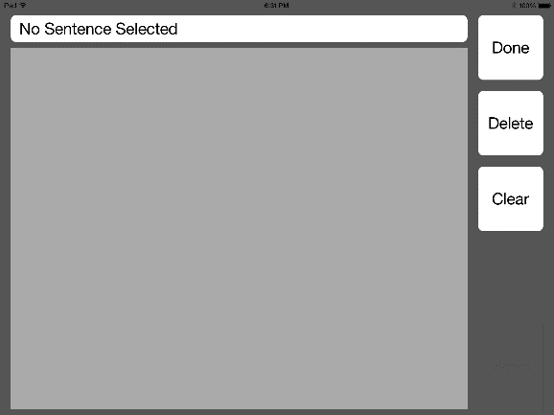 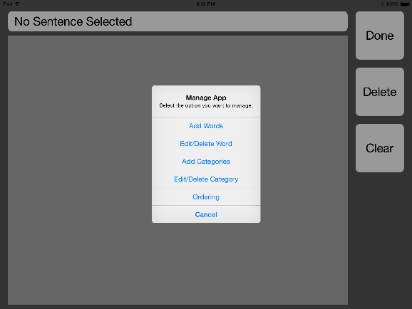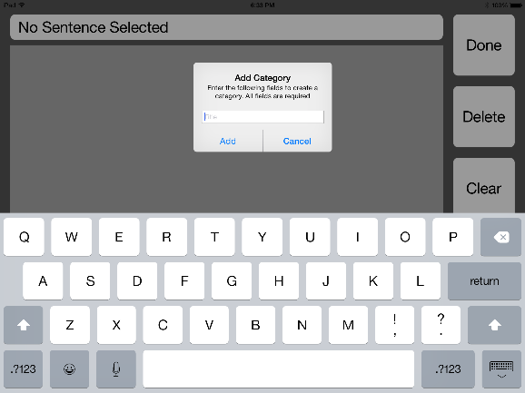 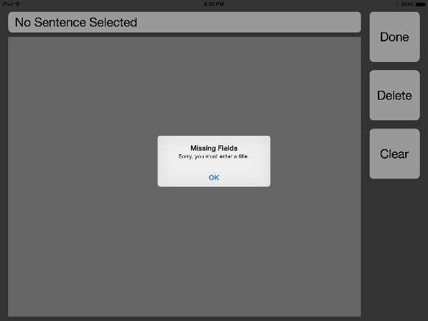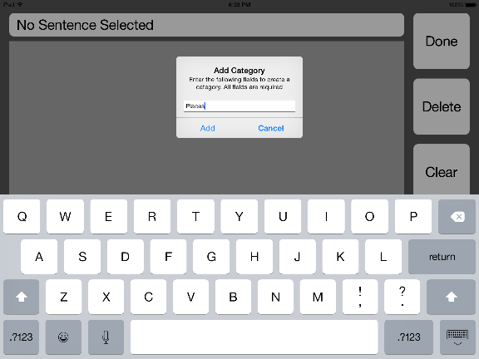 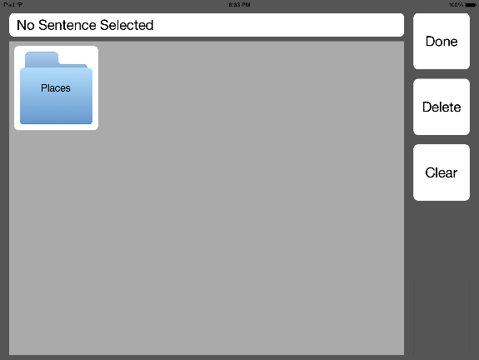

1

4

3

5

3b

2

**Figure 2.** The screens for some steps step for adding a category as well as the alternate paths.

## EDITING A CATEGORY

**NOTE: This option is not available if not in the main category.**

1. Click and hold in the bottom right hand corner of the app. (Location denoted in Figure 3 by red box.)
2. A menu will popup. Select Edit/Delete Category.
   1. If Edit/Delete Category is selected when there are no categories a popup with just a Cancel button will appear.
   2. Press Cancel to return to the app.
3. A new popup will appear with a list of categories. Select the Category to edit.
4. A new popup will appear with the option to Edit or Delete the Category. Select Edit.
5. A new popup will appear with an editable title with the previous title populated. Enter a new title and press Update
6. The screen will refresh and the category will be updated. (NOTE: As more is added to the app this could take a couple seconds)

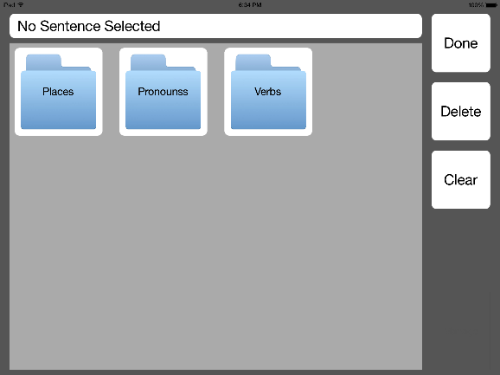 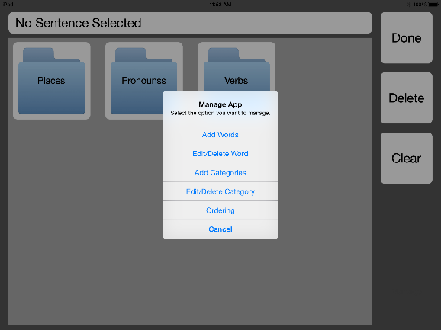 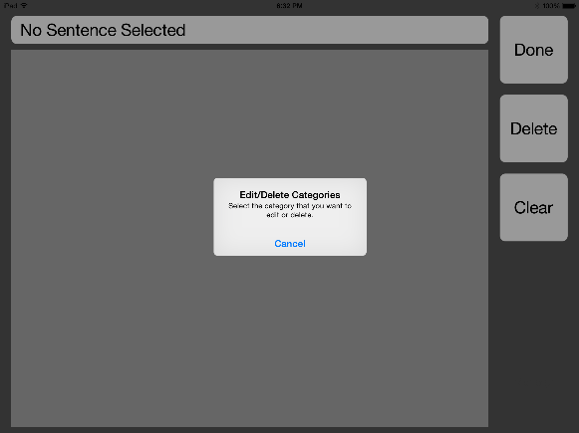 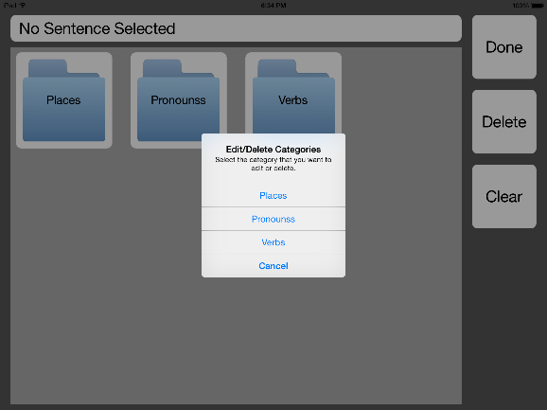 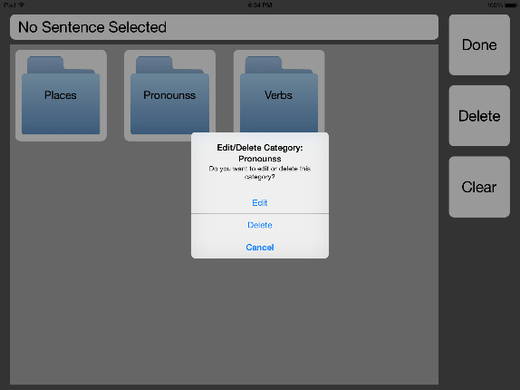 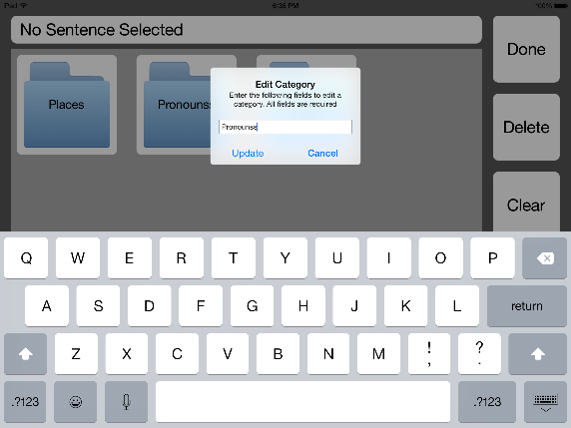

1

5

4

3

2a

2

**Figure 3.** The screens for some steps step for editing a category as well as the alternate paths.

## DELETING A CATEGORY

**NOTE: This option is not available if not in the main category.**

1. Click and hold in the bottom right hand corner of the app. (Location denoted in Figure 4 by red box.)
2. A menu will popup. Select Edit/Delete Category.
   1. If Edit/Delete Category is selected when there are no categories a popup with just a Cancel button will appear.
   2. Press Cancel to return to the app.
3. A new popup will appear with a list of categories. Select the Category to delete.
4. A new popup will appear with the option to Edit or Delete the Category. Select Delete.
5. The screen will refresh and the category will be removed. (NOTE: As more is added to the app this could take a couple seconds)

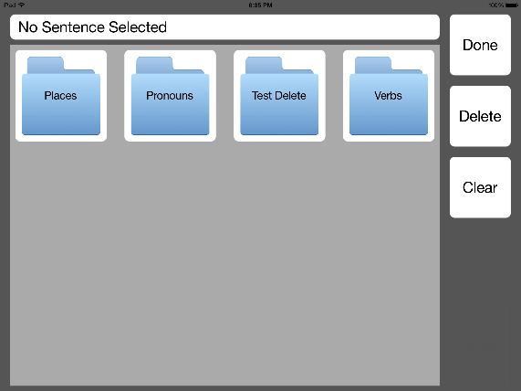 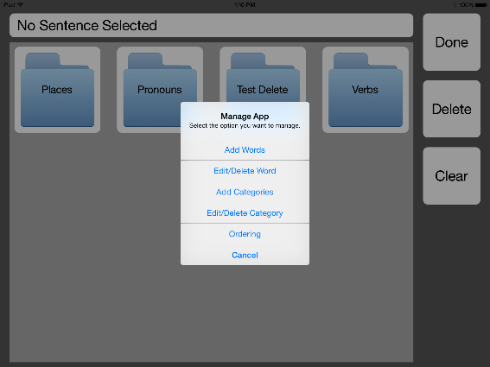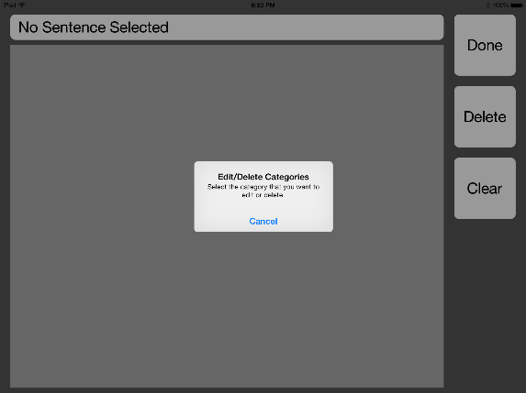 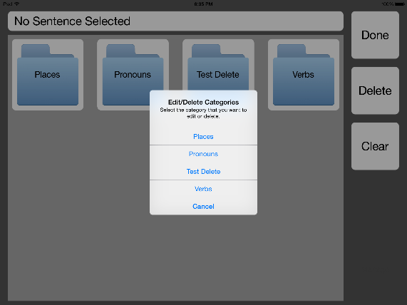 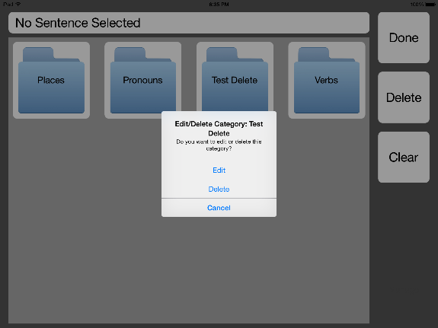 

5

4

2a

2

1

3

**Figure 4.** The screens for some steps for deleting a category as well as the alternate paths.

## ADDING A WORD

1. Click and hold in the bottom right hand corner of the app. (Location denoted in Figure 5 by red box.)
2. A menu will popup. Select Add Words.
3. A new screen will appear with multiple fields (See Figure 5 image 3 for a screenshot of this page.). Of these fields the Word/Phrase, Recording, and either Add to Current Category or more than one Selected Categories are required.
   1. To return to the previous screen without adding a word, select Cancel.
   2. To quickly clear data press Clear. This will remove all entered data.
4. Select Attach Image. A new popup will appear over the button.
5. Select either Choose from Camera Roll to use pictures already stored on the device or Take Picture to take a new one.
   1. Select Choose from Camera Roll and the popup will be replaced by a popup with the device’s albums.
      1. Select an image from an album to upload.
   2. Select Take Picture From Camera and the camera will open.
      1. Take a picture.
      2. Choose Use Photo or Retake if the image is not correct or good.
6. After uploading an image the image will appear beside the Attach Image button.
7. Next to start Recording Audio press Start and start speaking what should be stored with the word. (See Recording Audio for a Word for suggestions on this process to improve the quality of the recording) (*NOTE: Steps 7 – 15 are shown in Figure 6.*)
8. When done recording press Stop. This will enable the playback button beside Stop.
9. To review the recording press the playback button beside Stop. This will playback the recording.
   1. If recording is not correct or of poor quality, repeat steps 7-9.
10. Enter a word or phrase in the Word/Phrase textbox.
11. Next Select the Categories to add the word to. First select whether or not the word should be added to the Current Category which is shown at the top of the page. Main is the startup screen.
12. If the word should be added to additional categories besides the current one, select Select Categories. This will open a new screen with a list of all categories in the system.
13. Check the categories to add the word to.
14. When finished press Done. The add word page will reappear with a list of all the selected categories beside the Select Categories button.
15. To add the word press Upload. The main page will refresh and show the new word. (NOTE: If Add to Current Category was not selected, when the word was added, the word will not appear on the refresh. Navigate to the category the word was added to to see it.)
    1. If any of the required fields are empty when upload is pressed, a popup with an error will occur.

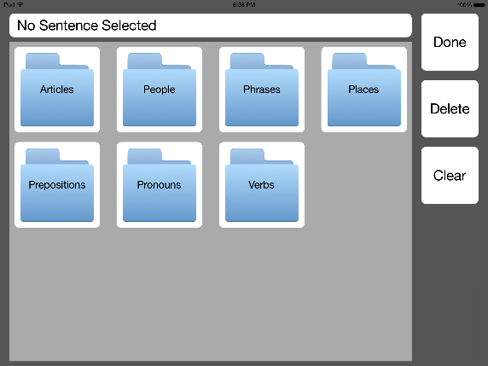 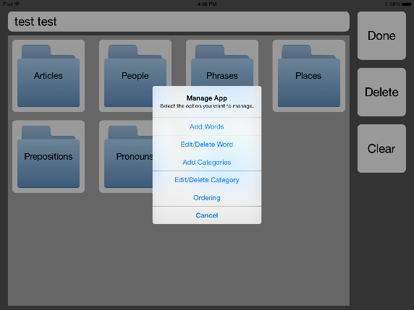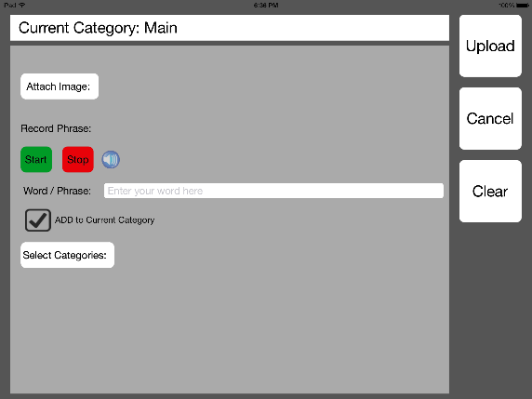 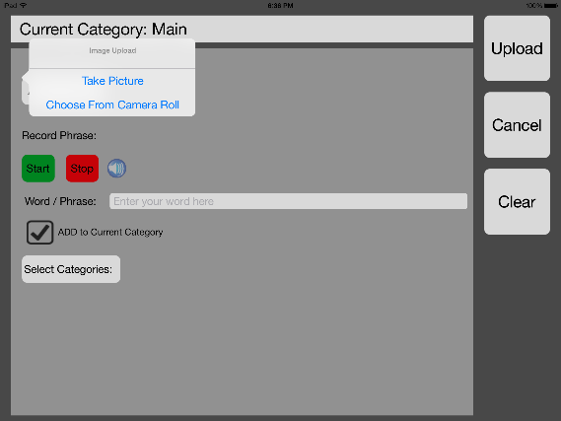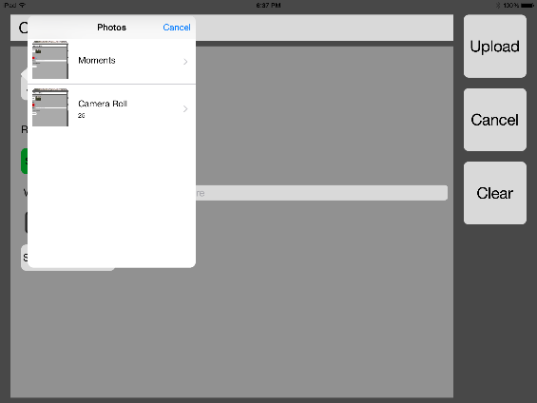 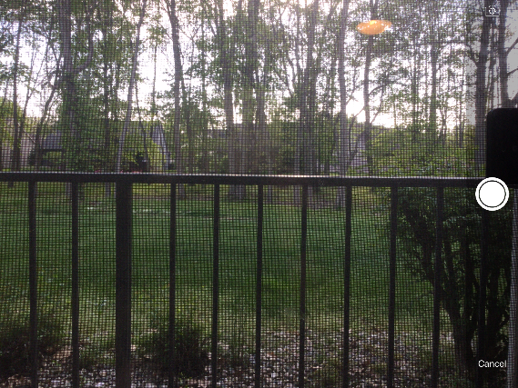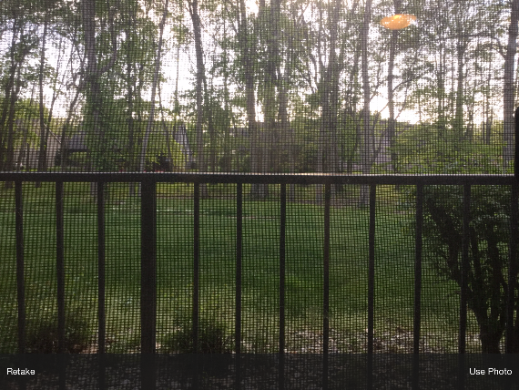 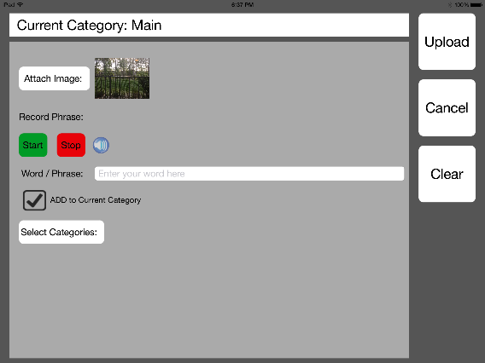

6

5bii

5b

5a

3

2

1

4

**Figure 5.** The screens for some steps for adding a word as well as the alternate paths.

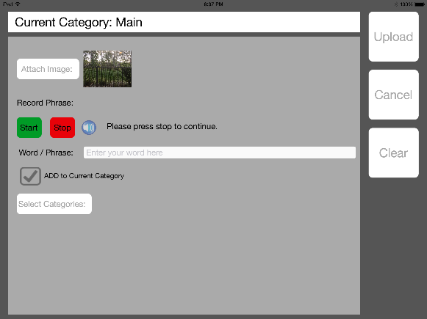 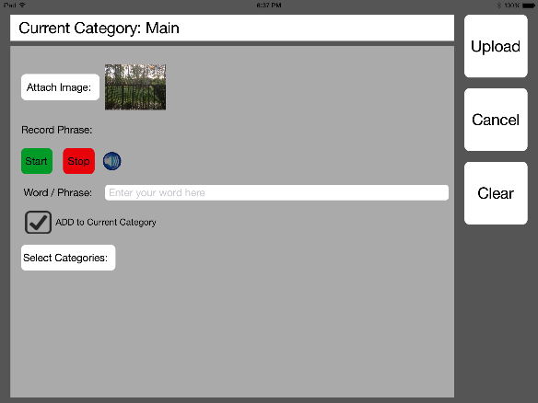 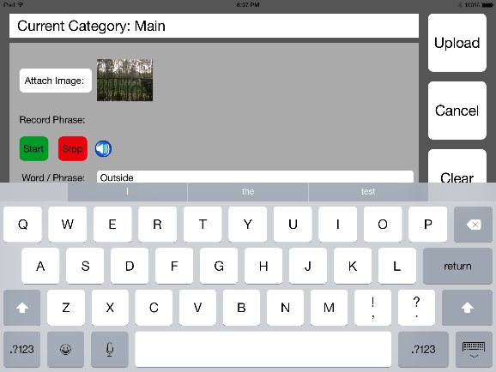 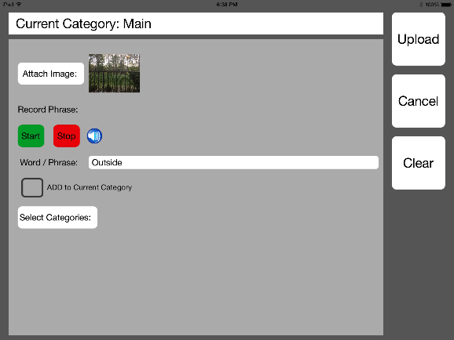 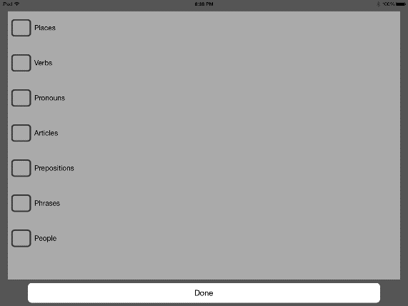 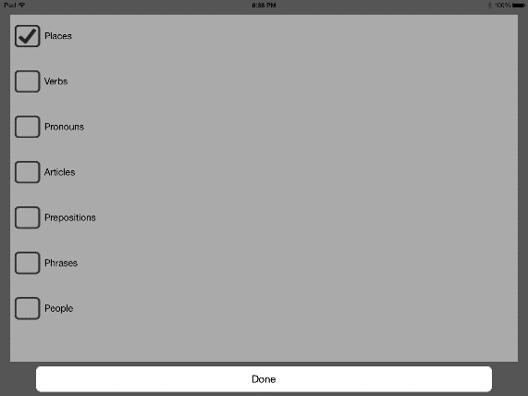 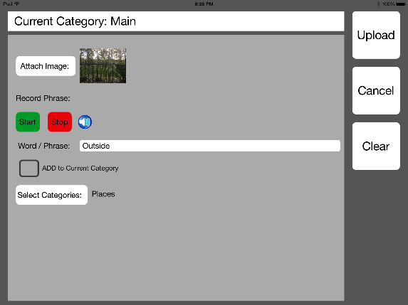 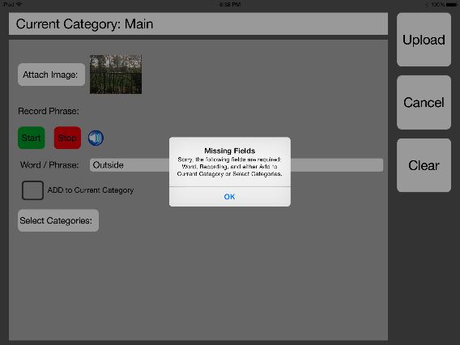

7

15 a

14

13

12

11

10

8

**Figure 6.** A continuation of the screens for some steps for adding a word as well as the alternate paths.

## RECORDING AUDIO FOR A WORD

When recording audio, move to an area with minimal background noise. In order to get the best result, attempt to say the word or phrase immediately after pressing the Start button. It is also recommended to try to say the word in a sentence and have the word said directly after the Start button. Saying the word in a sentence makes the word sound more like normal speaking.

## EDITING A WORD

1. Click and hold in the bottom right hand corner of the app. (Location denoted in Figure 7 by red box.)
2. A menu will popup. Select Edit/Delete Word
   1. If Edit/Delete Word is selected when there are no words a popup with just a Cancel button will appear.
   2. Press Cancel to return to the app.
3. A new popup will appear with a list of words in the current category. Select the Word to edit.
4. A new popup will appear with the option to Edit or Delete the Word. Select Edit.
5. The Add Word page will appear with the selected Word’s information pre-populated. Edit any of the fields as desired. (For Editing fields in a word view the steps in Add Word.)
6. When finished editing, select Upload and the main page will refresh to show the edits.

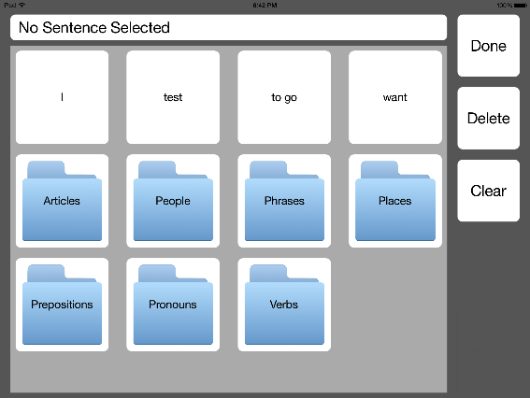 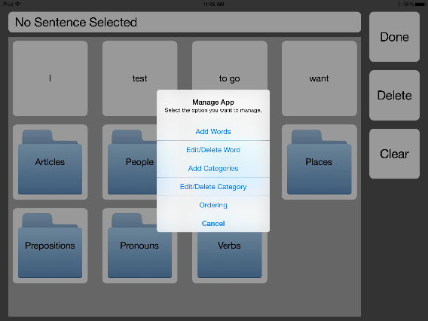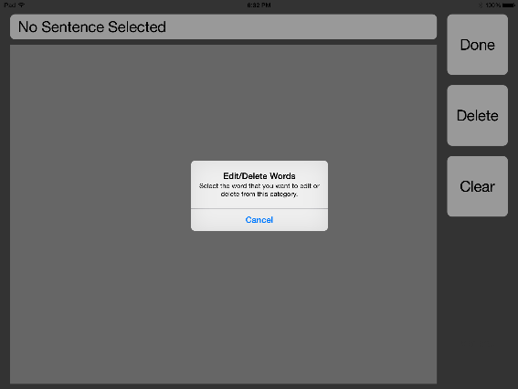 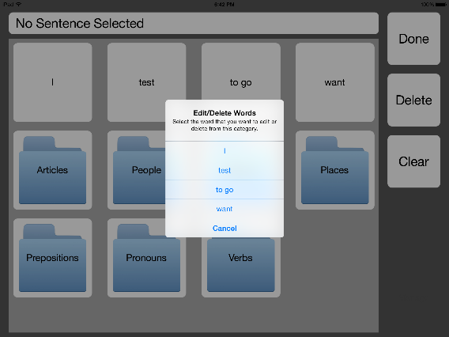 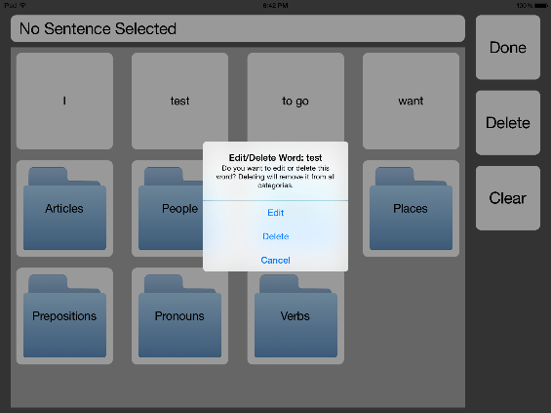 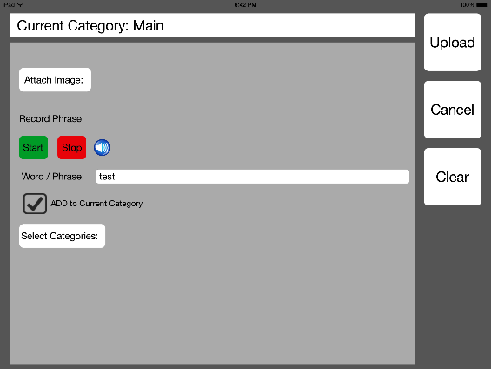 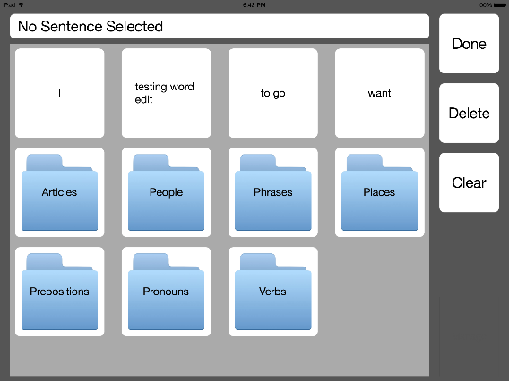

6

5

4

3

2a

2

1

**Figure 7.** The screens for some steps for editing a word as well as the alternate paths.

## DELETING A WORD

1. Click and hold in the bottom right hand corner of the app. (Location denoted in Figure 8 by red box.)
2. A menu will popup. Select Edit/Delete Word
   1. If Edit/Delete Word is selected when there are no words a popup with just a Cancel button will appear.
   2. Press Cancel to return to the app.
3. A new popup will appear with a list of words in the current category. Select the Word to delete.
4. A new popup will appear with the option to Edit or Delete the Word. Select Delete.
5. The screen will refresh and the word will be removed. It will also be removed from all categories it was included in. (NOTE: As more is added to the app this could take a couple seconds)

 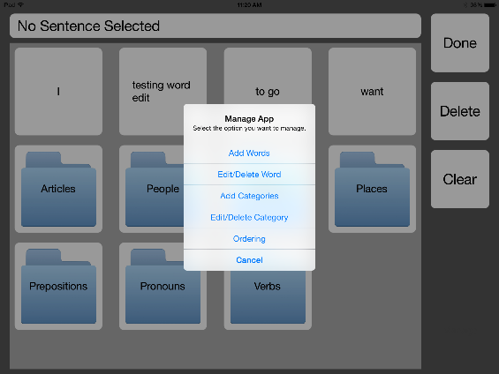  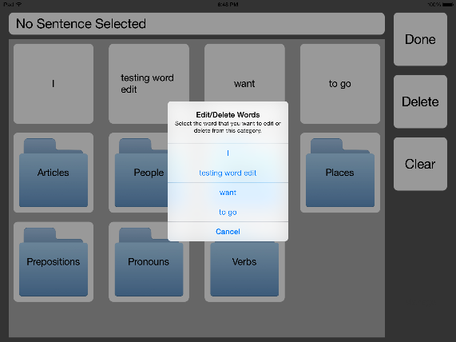 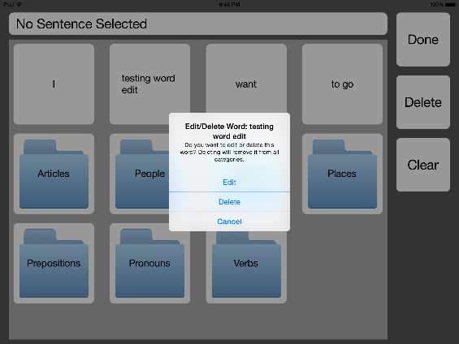 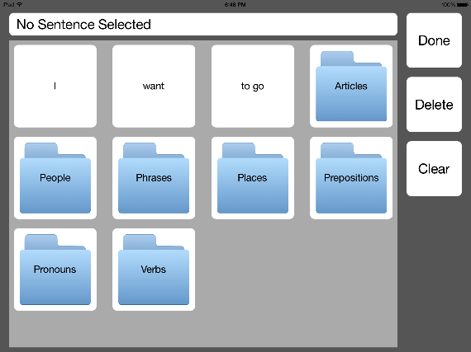

5

4

3

2a

2

1

**Figure 8.** The screens for some steps for deleting a word as well as the alternate paths.

## CHANGING THE ORDER OF WORDS

There are three different word orderings offered: Alphabetic, Reverse Alphabetic, and Most Used. Words with images are ordered by their stored word/phrase value. The Most Used is a dynamic ordering that will move the most used words to the beginning of the category.

1. Click and hold in the bottom right hand corner of the app. (Location denoted in Figure 9 by red box.)
2. A menu will popup. Select Ordering
3. A new popup will appear with ordering options.
4. Select the ordering desired. And the main page will reorder the words to the specified ordering.

  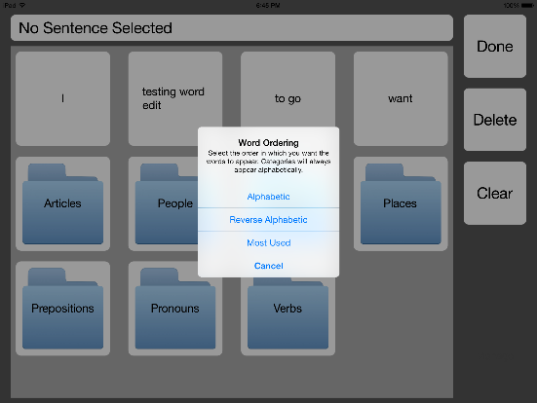

3

2

1

**Figure 9.** The screens for some steps for deleting a word as well as the alternate paths.

## CREATING A SENTENCE

To create a sentence there first must be words added to the app.

1. Select a word to add to the sentence. The word will be added to the sentence textbox at the top of the app.
2. Continue selecting words until the sentence is complete.
3. Select Done when complete. The sentence will be cleared and read aloud. (NOTE: This process will take a little while depending on the number of words in the sentence.

## DELETING A WORD FROM THE SENTENCE To create a sentence there first must be words added to the app. To a delete a word from the sentence there must first be a word in the sentence.

1. Press the Delete button.
2. The word will be removed from the sentence.

## CLEARING THE SENTENCE

To create a sentence there first must be words added to the app. To clear the sentence there must first be a word in the sentence.

1. Press the Clear button.
2. The sentence will be cleared. If Clear was pressed while in a category besides main, the app will redirect to the main category.

## NAVIGATING TO A CATEGORY

To navigate to a category there must first be categories added.

1. Select a category.
2. The app will refresh to show the words in that category

## NAVIGATING BACK FROM A CATEGORY

To navigate to a category there must first be categories added. To navigate back from a category, the app must be showing a category besides main.

1. Select the Back button.
2. The app will refresh to show the main page.

# ROUTINE MAINTENANCE

There is no routine maintenance needed for this app. Some updates may be needed if the iPad iOS version is updated. This will require someone from Rose-Hulman to update.

If the system starts to become too slow, delete some of the less used words and categories. Another option would be to contact the Rose-Hulman CSSE department about creating a senior project to improve upon the current design and improving performance.

# PRECAUTIONARY INFORMATION

There is no precautionary information for the use of the communication app; however, do not delete the app once it has been installed. The process for reinstalling it will require contacting Dr. Rogge or Dr. Livesay and meeting with someone at Rose-Hulman to reinstall it on the device.

As a note to performance, the more words that are created with images the slower the system will respond. Some response do have a slight lag time but will complete within 5 seconds of pressing the button. This time may suffer as more words and categories are added.

# TROUBLESHOOTING

Below are some basic scenarios that may occur while using the device and how to fix them.

## APP FREEZES

If the app freezes, exit the app and restart it. If the issues persists contact Dr. Livesay and Dr. Rogge. They will send the issue to someone who can assist with it.

## APP IS SLOW

If the app is running slow, delete any words or categories that are not used very often especially words with images. If this does not fix the problem, a potential solution is to contact Rose-Hulman CSSE department to create senior design project to improve the app and the app’s performance.

## APP WAS DELETED

If the app is accidentally deleted, contact Dr. Livesay and Dr.Rogge. They will contact someone who can reinstall the app on the device. This will require a visit to Rose-Hulman.