Peter Watters Resume WebSite Specifications
Proposed domain name: www.peterwatters.net
1.0 OVERVIEW OF WEB SITE REQUIREMENT
The new site will perform the following function
"This site will introduce Peter Watters to a professional audience and demonstrate an ability to produce a professional static webstie."
2.0 SEARCH ENGINE OPTIMIZATION
2.1 Search Engine Ranking
  - The website should be accessible to search engine spiders and be coded with good on-page search engine optimization.

3.0 LIST OF PAGES
3.1 Home Page
The home page will give visitors an overview of Peter Watters. It will show links to social media and other contact information.
  - Resume
This page will be a printable resume
  - Interests
This page will show links to Peter Watters' interests
  - Reflections
This page will present thoughts of Peter Watters
  - Guestbook
This page will give visitors an opportunity to provide feedback on the website.
  - Projects
This page will present a professional portfolio.

4.0 STYLE AND LAYOUT
4.1 Overall Style
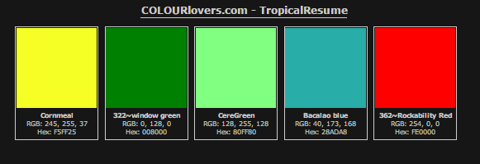
The site style should incorporate our corporate colors and logo.
grey – Type font color, Title font color
window green - Navigation background
Cornmeal - Navigation text
CereGreen – Article field
Rockability Red - Header background
Bacalao Blue - background

4.2 Navigation
We will include a common navigation bar on all pages. The navigation bar will include links to the top level pages as listed in the navigation diagram below. Users will be able to navigate from each of the pages to the other.
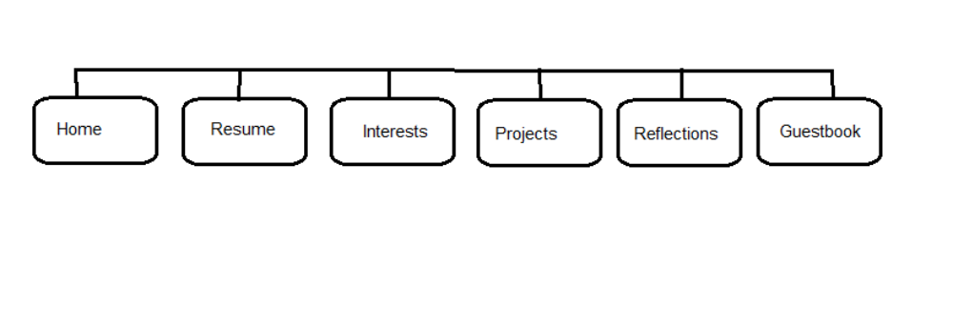

4.3 Font Selection
Tahoma 12pt
Tahoma 18pt
Tahoma 24pt
Tahoma 12pt bold
Tahoma 18pt bold
Tahoma 24pt bold
Tahoma 12pt italic
Tahoma 18pt italic
Tahoma 24pt italic

5.0 SITE LAYOUT
5.1 Wireframe
We recommend the vertical navigation as seen in illustration 1 for the site layout. This will provide a simple and intuitive interface that is amenable to formatting for a variety of screen sizes.
Illustration 1: Vertical navigation
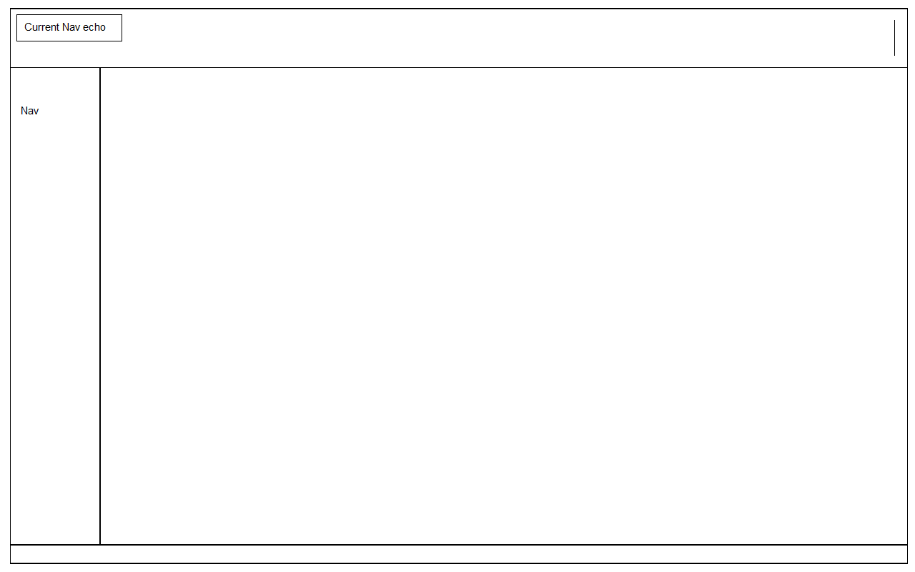

5.2 Site Folder Structure
Root
├───Documentation
│ resumeFileStructure.rtf
│ SiteSpec_PeterWattersResumeVersion01-1.doc
│ SiteSpec_PeterWattersResumeVersion01-2.doc
├───includes (this will contain the non-public php files used throughout the website)
│ └───layout (this will contain the session based code for header and footer php files)
└───public
│ guestbook.htm
│ home.htm
│ interests.htm
│ projects.htm
│ reflections.htm
│ resume.htm
│
├───images ( this will contain all the media - images/audio/video for the website)
│ Chauncey_Olcott_-_Too_Ra_Loo_Ra_Loo_Ral_Irish_Lullaby.mp3
│ collage.png
│ dogsled.mp4
│ Warship-2400px.png
│ Warship-300px.png
│ Warship-800px.png
│
├───js ( this will contain all the java script for the website)
│ geoloc.js
│ utility.js
│
├───layout ( this will contain the common header and footer php files)
└───stylesheet ( this will contain the style sheets used in the website)
animation.css
mystyle.css
print.css
.

6.0 ADDITIONAL REQUIREMENTS
6.1 Accessibility
This site must comply with the standards of accessibility contained in W3C WAI (World Wide Web Consortium Web Accessibility Initiative) level A Guidelines.
6.2 Valid Code
All code on the site should validate to W3C (World Wide Web Consortium) specifications.

