International Student Dorm
North Campus - located on the side of the West Lake
South Campus -Building C15
North Campus
With over 380 rooms and six different room types to choose from, you will find a great place on our North Campus. All rooms are fully furnished and include individual bathrooms, internet access ports, telephones, TV (except 1st Floor) and air-conditioning in some rooms. You will also have a fully fitted kitchen, coin-operated laundry facilities, and entertainment room and security service in the dormitory building.
South Campus
All rooms are fully furnished at South Campus, including individual bathrooms, internet access ports, telephones and air-conditioning. You will also have a fully fitted kitchen, coin-operated laundry facilities, gym room, and Ping-pong room; snooker room and security service in the dormitory building.
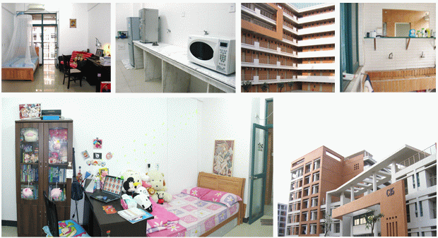
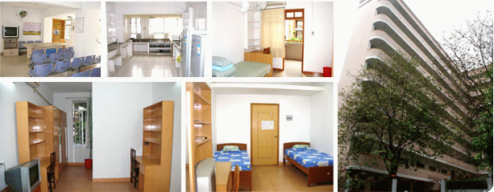
Health care
You are required to join the Health Insurance if you study for more than six months at SCUT.
Sports & Recreation
Basketball courts: 8 courts are located in the west area, opening to public for free
Tennis courts, Badminton courts , 8 courts of International standard are located inside the gymnasium , Skating rink , opening to public for free , Swimming pool .
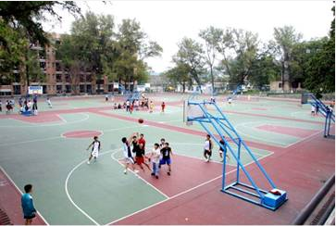
Air-conditioned Single Room Double Room
A variety of activities are organized by students’ office for international students. 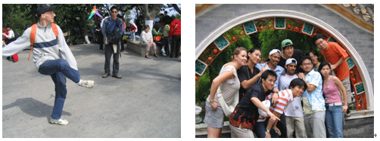
Interesting Guangzhou attractions:
Guangzhou, once known as Canton, the capital of Guangdong Province, is the host venue for the busy Canton Fair. Thousands of travelers come to Guangzhou for the wonderful scenery in this large metropolis, but also the authentic and tempting Yue Cuisine, and the local culture, like Cantonese Opera.
Being the most important port on the Pearl River after Hong Kong, Guangzhou boasts convenient ferry transport to Hong Kong and Macau. Baiyun International Airport is one of China's largest, making it an excellent place to enter or leave China.
You can find scores of gorgeous natural parks and historic spots interspersed in this modern city, such as White Cloud Mountain and Chen Ancestral Shrine. Modern buildings and theme parks in the urban area, like Canton Tower andChimelong Holiday Resort, mark Guangzhou as an international-level developed city.
Baiyun Mountain,located in north of Guangzhou,covering an area of 28 square kilometers. The main peak, Moxingling,is 382 meters high.
