简介
华工的材料学院是华工传统强院,华工材料学院分为无机和高分子2部分。
其中无机中，华工以水泥最强，代表人物 苏达根。
高分子中，华工传统的强项是橡胶，是全国最早开办橡胶专业的学校之一。华工的塑料改性开始崛起，特别是工程塑料的改性。
Profile:
School of materials is one of the best schools in SCUT,which can be devided into two quarters .one is inorganic, The other is polymeric.
In Inorganic area, lcement is the best developed field,in which Su Peigen can be seen as a representative figure.
What the strong point in polymeric area is rubber. SCUT is one of the earliest universities who Offer rubber professional.

材料科学与工程学院（简称材料学院）设有高分子材料科学与工程系、无机材料科学与工程系、金属材料科学与工程系、电子材料科学与工程系、材料科学研究所、高分子研究所、高分子光电材料与元器件研究所、光通讯材料研究所、和生物材料研究所等教学科研机构。
School of materials science and engineering (called School of materials for short) consists of Department of polymer science and engineering, Department of inorganic materials science and engineering, Department of materials science and engineering, Department of materials science and engineering, Department of electronic material science and engineering, Institute of materials science, Institute of Polymer Science, Institute of polymer optoelectronic materials and components, Institute of optical communication materials, and Institute of biological materials,and so on.
从以下图形中可窥一斑
From the graphics，we can see much more clearly.
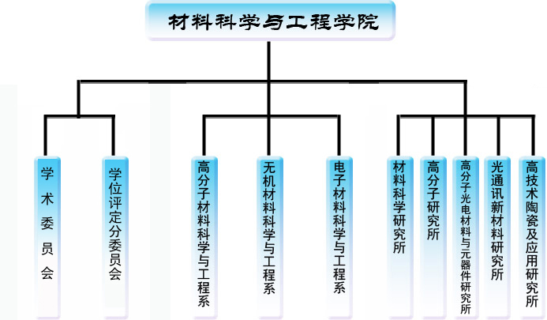
School of materials science and engineering
Department of polymer science and engineering
Department of inorganic materials science and engineering
Department of materials science and engineering
Department of materials science and engineering
Department of electronic material science and engineering
Institute of materials science
Institute of polymer optoelectronic materials and components
Institute of optical communication materials
Institute of biological materials
实验室设施
材料学院具有良好的科研条件，拥有发光物理与化学国家重点实验室（筹）、国家人体组织功能重建工程技术研究中心、国家金属材料近净成形工程技术中心（与机械与汽车工程学院共建）、国家“111工程”高分子光电材料研究学科创新引智基地等
Laboratory facilities
Material College has glow physical and chemical national key laboratory , and National Engineering Technology Research Center for reconstruction of human organization features, and National Engineering Technology Center of metal near-net-shape technology (builded with College of machinery and car Engineering), and national innovative base of polymer optoelectronic materials research included in "111 engineering", and so on,which can be seen that Material College owns good research conditions.
材料学院非常注重实验室建设，近年来在国家“211 工程”、“985工程”和学校的支持下，实验室建设取得显著成效，实验室面积达1.5余万平方米，共有设备8401台（套），总价值达1.8余亿元以上。高分子光电材料与器件实验室、高分子结构与性能实验室达到国际先进水平，一些其他的实验室达到国内先进水平。
Attach great importance to the construction of laboratory materials, School of materials developed very well. In recent years with the support of national "project 211" ,"project 985" and school, laboratory construction obtained remarkable results, laboratory can be up to more than 15,000 square meters, and has 8401 sets of equipments, which value at more than 180 million Yuan. laboratory of polymer optoelectronic materials and laboratory of devices and polymer structure and properties that are mainly builded have reached international advanced level, some other laboratories also have reached the domestic advanced level.
师资：
学院有丰富的教学资源。
学院现有在职教职员工223人，其中，教授59人，副教授、副研究员和高级工程师77人，教师中具有博士学位者占81%。博士生导师，硕士生导师都可达几十人，还有其他很多厉害人物。
College is reach in teaching resources.
At present，there are 223 serving faculty, including 59 professors, 77 Associate Professor and senior engineer.besides, 81% of those have got Doctor's degree. The number of Master Instructor and Doctor Instructor can up to be dozens of people.
In addition，there are many other great instructors.
学生：现有在校学生2371人.
学生毕业后可从事相关专业的工作。例如设计、新产品开发、生产管理等。不少校友已是相关领域的杰出人物，包括中科院院士、知名大学教授、知名集团/企业总裁等。
There are 2371 students in school.
After graduation students may engage in the work that is related to their own profession. Such as design, product development, production management, and so on. A great number of alumnus are outstanding in kinds of fields concerned, including the Chinese Academies of Sciences, distinguished University Professors, famous Group/corporate Presidents.
环境：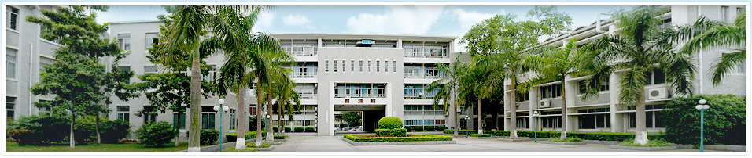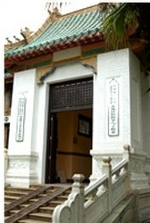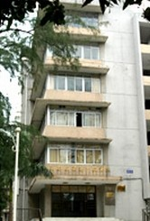
材料学院环境优美，教学楼两旁绿树成荫。宿舍干净整洁，设施齐全。
The environment there is beautiful . Teaching building is surrounded by trees. Dormitory is not only clean and tidy，but also is properly furnished.

