Laboratory and Field Resources in college of life sciences

John A. Widtsoe Building

. Numerous offices, laboratories, and classrooms are housed within the building. Classrooms in the building's basement are dedicated to marine biology, and the hallways are lined with 15 live aquariums. On the fourth floor there is a small lab for mobile field equipment for teaching and research in plant physiology including: pressure bomb for measuring stem water potential, platinum oxygen electrode set up for measuring oxygen uptake and production on small plant samples. Lab facilities include, centrifuge and Beckman UV-Visible spectrophotometer and also a lot of high-vacuum glassware.

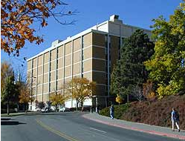

Monte L. Bean Life Science Museum
Exhibits and collections of biological specimens are housed in the M.L. Bean Life Science Museum. The exhibits include habitat studies of local as well as exotic plant and animal species and a large and valuable collection of trophies from North America, Africa, and Asia.
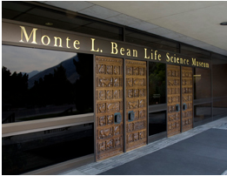

Life Sciences Greenhouses

the new greenhouses offer sophisticated features that will provide enhanced research and educational opportunities
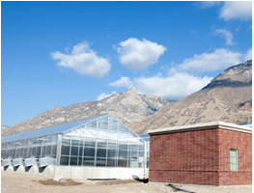

The Lytle Perserve

The Lytle Preserve in southwestern Utah provides a 460-acre area as an outdoor classroom in the northernmost extension of the Mojave Desert. It is managed for natural study and ecological research in a unique desert setting.
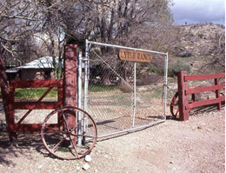

USDA Forest Service Shrub Science Laboratory

Housed on the BYU campus, this laboratory supports one of the finest research programs on native shrubs in the world. Here eleven PhD research scientists with adjunct facility appointments work with BYU faculty members and graduate students. Laboratories, greenhouses, and gardens on campus and around the state support studies on desert shrubs
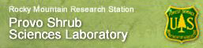

Other Laboratory and Field Resources

……
Which students from SCUT are most appropriate to go to BYU, and what would they study there?
Major Choice :
Taking into account the fact that biology in scut is not very stong among Chinese universities and the students who need get a high point to study in that major of scut has a good sense of learning , it is a good choice if students majored in biology could study in BYU who is good at biology.
Major:Biology
Advantages
- Numbers of faculty labs are available such as Adams Lab , Gill Lab , Jerry Johnson Lab and so on .
- This major provides students with current understanding of the full breadth of biology. The course of study is comprehensive and integrates knowledge across molecular, cellular, organismal, and ecological levels of organization. Students that earn this degree come to understand the biological world in its broadest sense. This degree focuses on understanding the diversity of life, emphasizing whole organism biology in ecological and evolutionary contexts.
- We provide several undergraduate research opportunities for biology majors, including internships, museum collections curation, bioinventory and data-basing activities, conservation projects, applied molecular genetics, and field and laboratory research in ecology, conservation biology, or evolutionary biology
- There is a great deal of flexibility with elective courses in this major, allowing students to emphasize botanical or zoological fields, or to create a create a combined program of study. This major is designed to be 'hands on'.
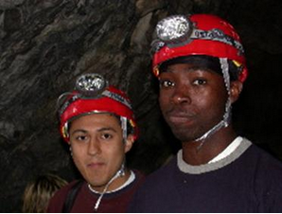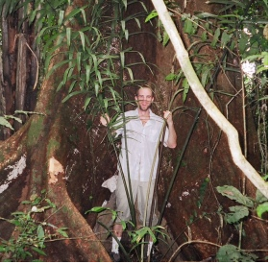
Department of biology
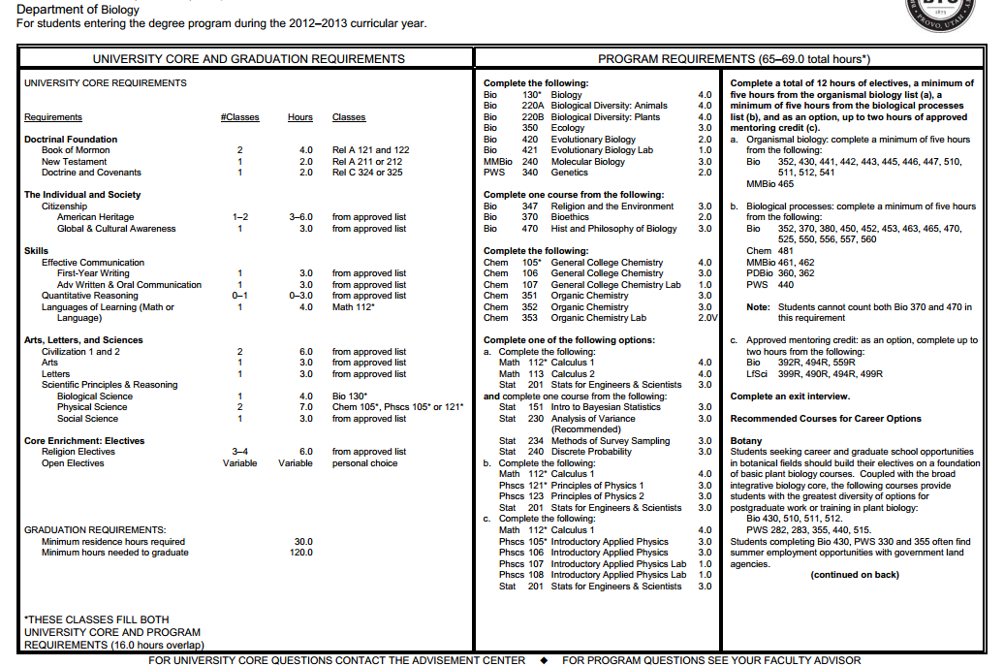
So many student opportunities are offered :internships mentored research club and so on.
Scholarships : SMART scholarship and Department & College Scholarships .

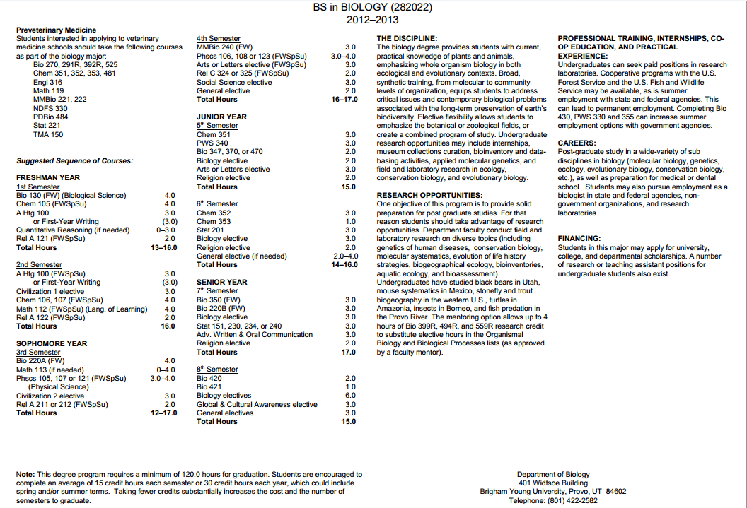

According to the ppt provided , I want to focus on living conditions , exercise facilities ,eating facilities and learning facilities.
1 living conditons
Where do we live ? Far from or near school ? Is the environment good enough ？

2 exercise facilities:
Basketball Skills & Agility Development Clinic


3.eating facilities:
Can BYU provide some Chinese food for breakfast , lunch and supper .
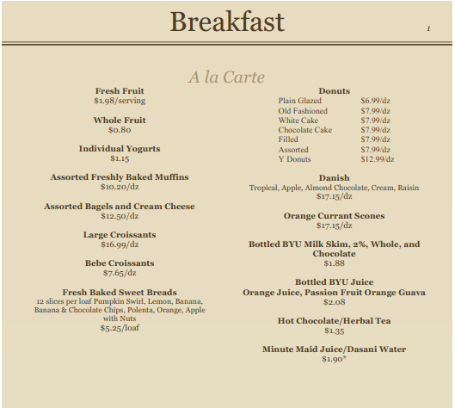

learning facilities
Now that Laboratory and Field Resources are in BYU , can we just share all of them as others do ?

