**Learning Log.**

I started this course with no prior experience in coding with HTML or CSS, as I had never done anything to do with web development beyond using Dream Weaver several years ago. For the most part, I had no trouble learning the basics of CSS and HTML. All the class tutorials and examples were accurate and concise, allowing me to quickly learn and integrate different functions of CSS and HTML in to my work. Some of the more advanced CSS and HTML for the level we were learning at gave me pause. I had some issues with Wire Framing when I first came across it and attempted it myself. This required several hours extra work outside of class to fully sort out. However, with the flex function as another method of making a website responsive, I could still develop this website without struggling to terribly. I was tempted to implement Java Script into my website for animation and such, but I instead decided to focus on the required content for the finished work.

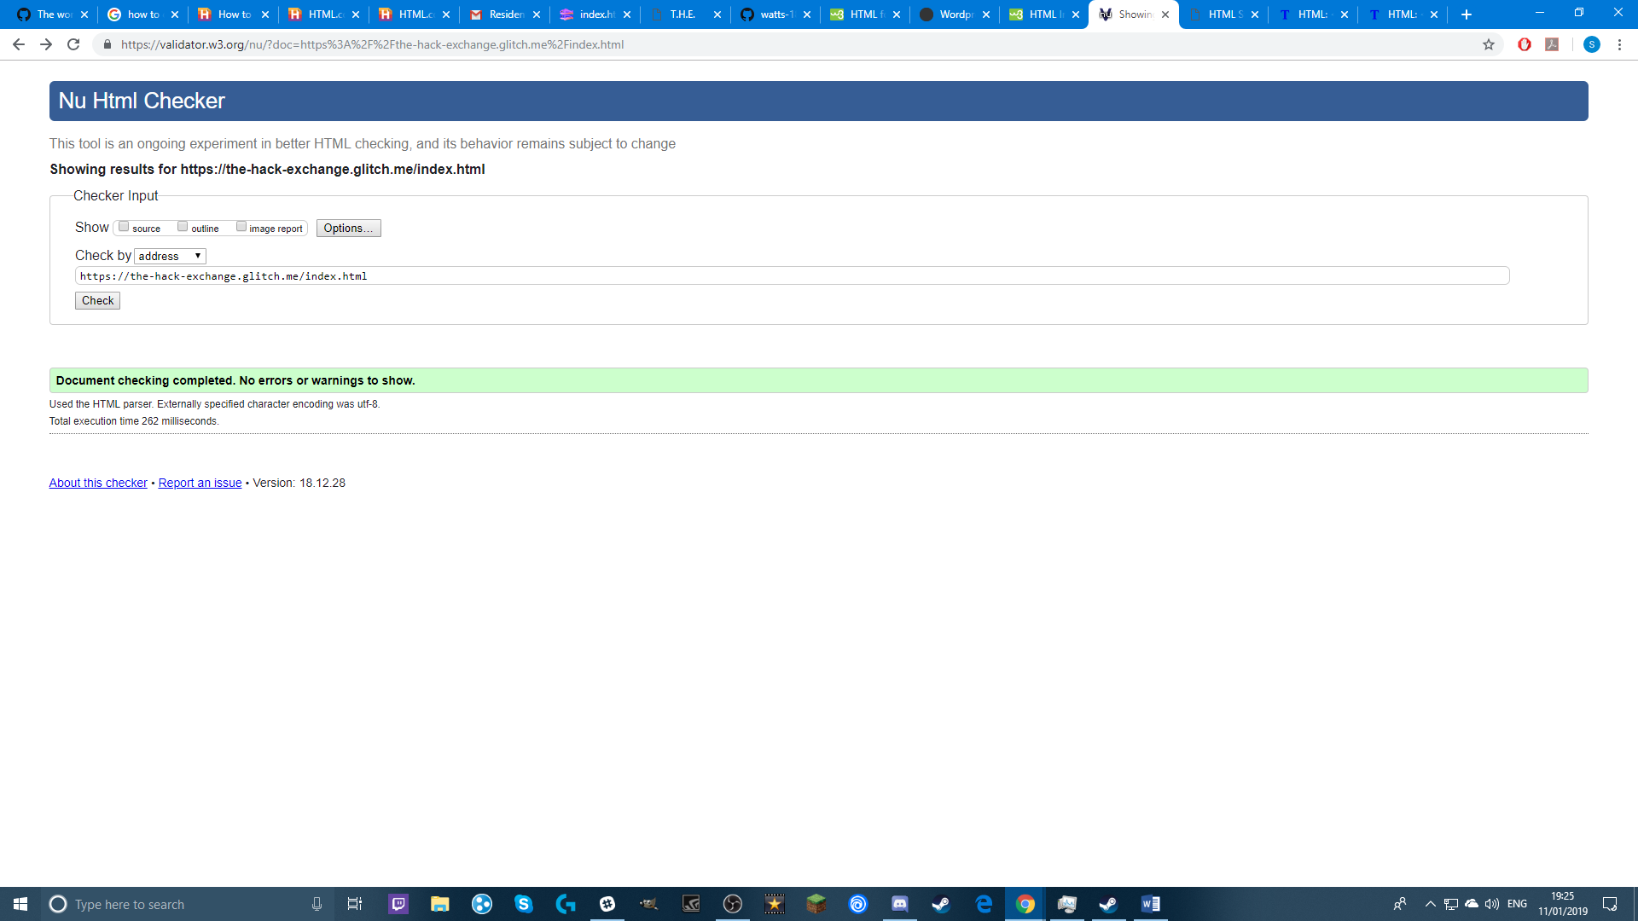

Proof of no errors in index.html

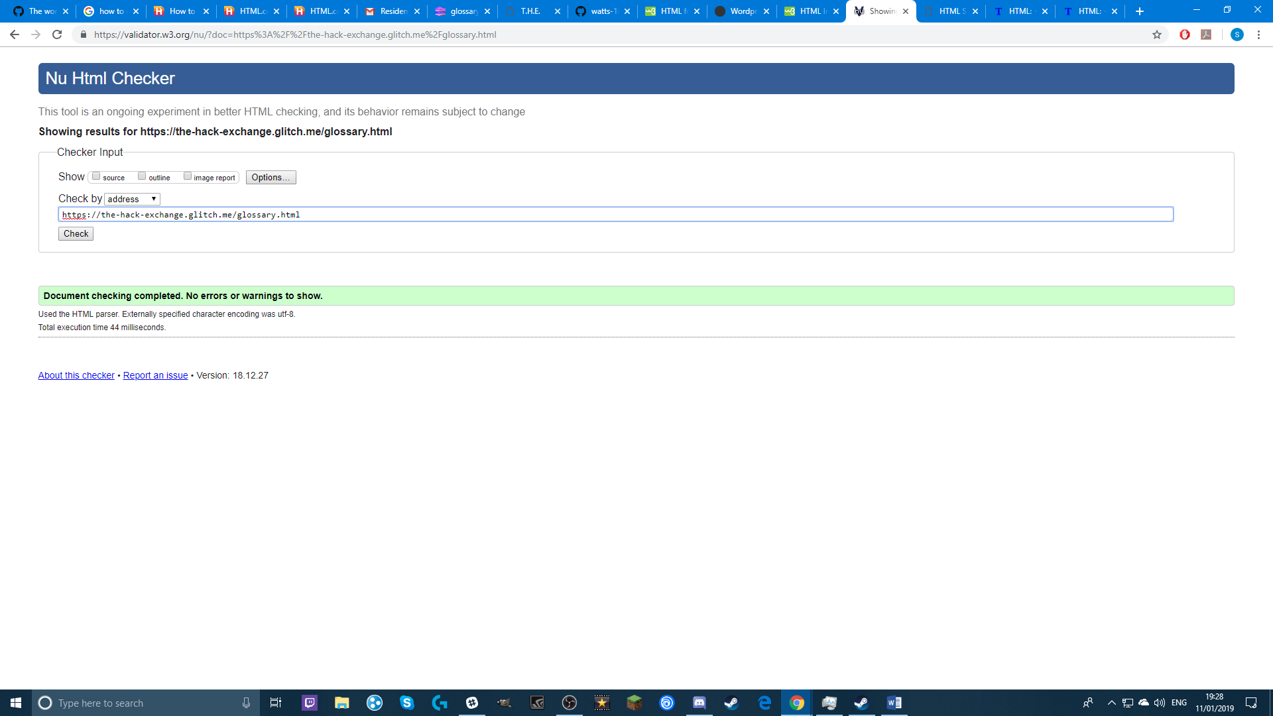

Proof of no errors in glossary.html

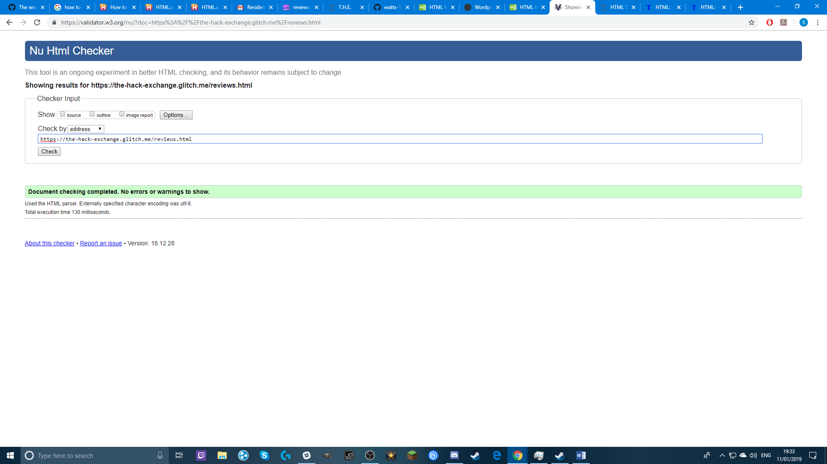

Proof of no errors in reviews.html

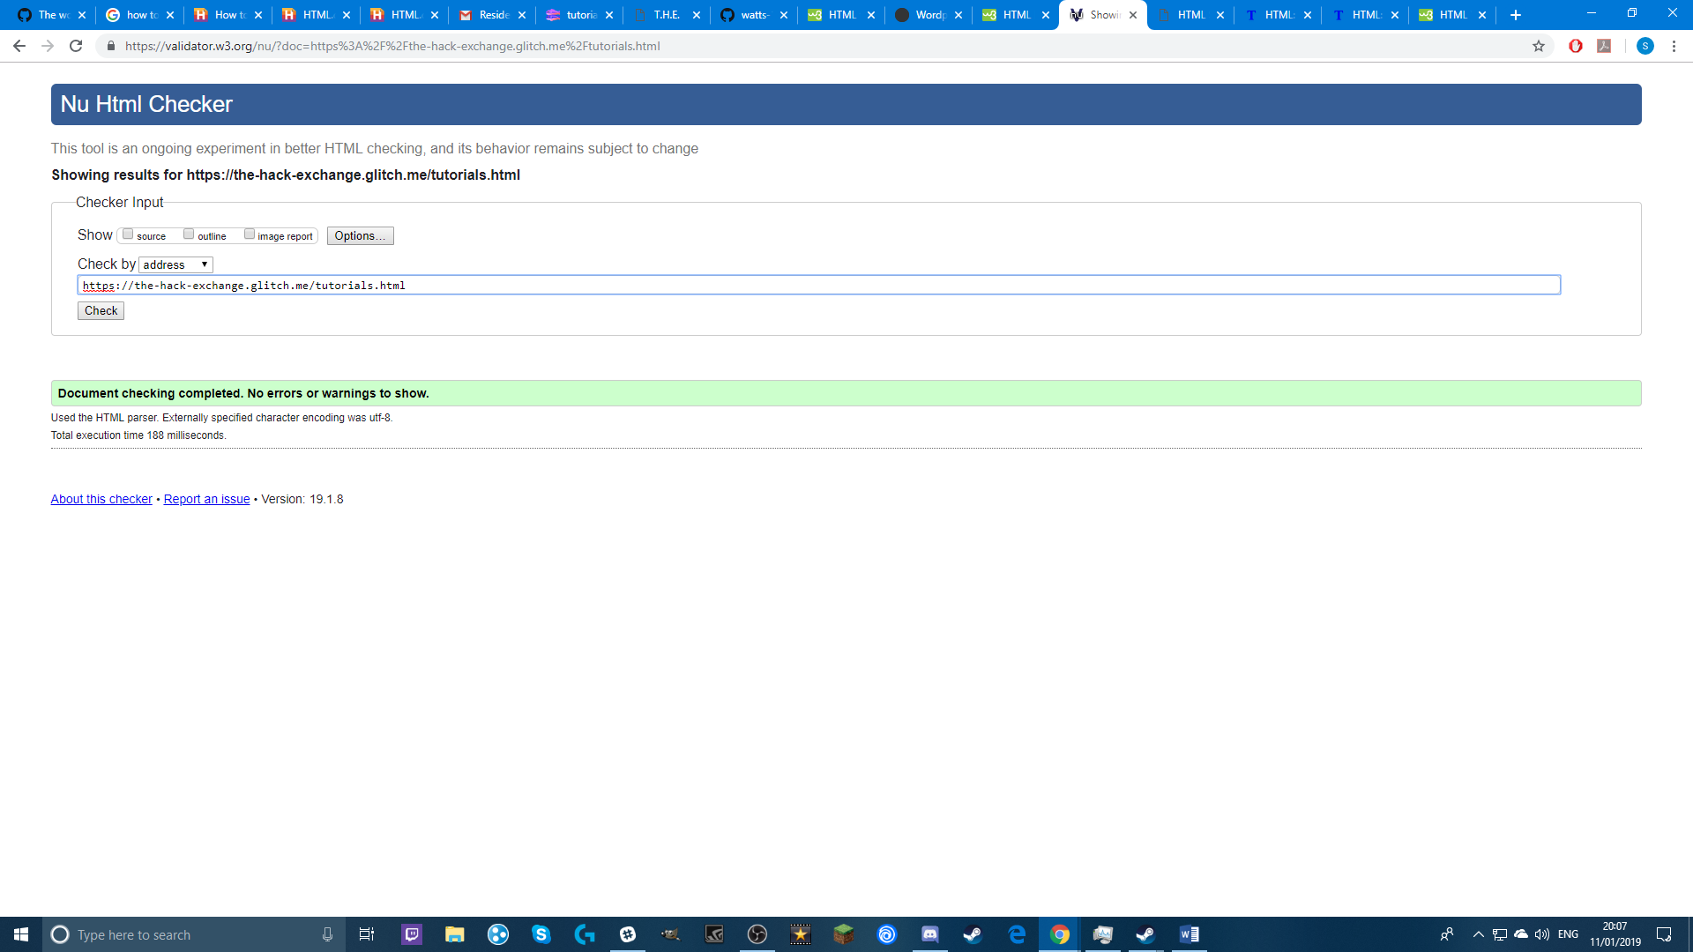

Proof of no errors in tutorials.html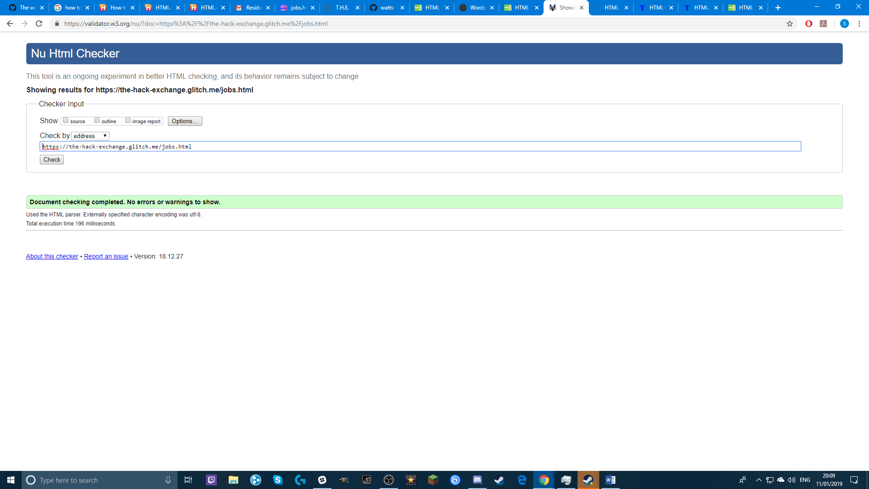

Proof of no errors in jobs.html

All proof was gathered using the Nu html checker at <https://validator.w3.org/nu/>

**Accessibility**

My website has high contrast colours in order to make things easier for users to see, it uses thick borders around each part of the page allowing them to be identified with ease. The navigation system is simple and static in its positioning on the webpage, allowing for easy operation whilst navigating the website. The majority of YouTube Tutorials I linked have subtitles that can be enabled, allowing for use by those with hearing impairments. All images shown in the webpage are large enough that they can be used on mobile or by those with vision impairments, and still be visible and discernible.

**Bibliography**

YouTube clips were each taken from someone else’s work, I own none of it.

* How to build webpages YouTube tutorial - https://www.youtube.com/watch?v=3JluqTojuME
* Basic CSS YouTube tutorial - https://www.youtube.com/watch?v=gBi8Obib0tw
* How to create CSS Layouts YouTube tutorial - https://www.youtube.com/watch?v=9tzyJEwO9Os
* Java script tutorial for beginners YouTube tutorial - https://www.youtube.com/watch?v=fGdd9qNwQdQ
* Rock, paper scissors game YouTube tutorial - https://www.youtube.com/watch?v=jaVNP3nIAv0
* CSS program bar YouTube tutorial - https://www.youtube.com/watch?v=DYevj6UGNWA&list=PLRCvSNiMyEmyBsu6nGxB5LtMdAltgNDX5
* Notification panel with vertical timeline CSS YouTube tutorial - https://www.youtube.com/watch?v=eIqre0Wsbro&index=2&list=PLRCvSNiMyEmyBsu6nGxB5LtMdAltgNDX5
* Customised HTML check box using CSS YouTube tutorial - <https://www.youtube.com/watch?v=r3HX2bMIzOc&list=PLRCvSNiMyEmyBsu6nGxB5LtMdAltgNDX5&index=3>
* Facebook logo – https://mettisglobal.news/wp-content/uploads/2018/07/IMG1720facebook-2661207_960_720-696x696.jpg
* Twitter logo - https://seeklogo.com/images/T/twitter-2012-positive-logo-916EDF1309-seeklogo.com.png
* Instagram Logo - https://instagram-brand.com/wp-content/uploads/2016/11/app-icon2.png
* Harold Memeor image – https://i.kym-cdn.com/photos/images/original/000/839/199/8a9.jpg
* Garreth Schwarten image – https://www.k24klik.com/blog/wp-content/uploads/2018/04/duduk-.jpg
* Barnaby Cass image - <https://f3y.com/wp-content/uploads/2010/12/Man-at-computer1.jpg>
* The Hack Exchange Image - <https://excelwithbusiness.com/wp-content/uploads/2018/06/WebDev.jpg>
* GitHub News article - <https://thenextweb.com/dd/2019/01/05/github-now-gives-free-users-unlimited-private-repositories/>
* In app payments article - <https://thenextweb.com/dd/2019/01/09/square-launches-sdk-to-help-mobile-developers-take-in-app-payments>
* Design is about finishing projects article - <https://thenextweb.com/syndication/2019/01/04/design-isnt-only-about-great-ideas-its-about-finishing-projects/>
* Glossary definitions - <https://www.smashingmagazine.com/2009/05/web-design-industry-jargon-glossary-and-resources/>
* Web Developer Job entry – <https://hiring.monster.com/hr/hr-best-practices/recruiting-hiring-advice/job-descriptions/web-developer-job-description-sample.aspx>
* Web Design Job entry – <https://www.monster.co.uk/career-advice/article/web-designer-job-description>
* Graphic Designer Job entry – <https://hiring.monster.co.uk/hr/hr-best-practices/recruiting-hiring-advice/job-descriptions/graphic-design-job-description.aspx>
* W3Schools Review - <https://www.mouthshut.com/websites/W3schools-com-reviews-925024289>
* List of top rated blogs - <https://medium.com/web-development-zone/top-blogs-about-web-design-and-web-development-57706bb620be>
* Code academy review - <https://skillcrush.com/2017/01/16/codecademy-learn-to-code/-->

**Website Quality**

Clearly structured, easy to use and responsive, the website does have several issues however. Underneath the navigation menu, the title of each page is in the middle of a gap, leaving it open, making the page seem as if something was missing. There is no set logo shown on the page other than the one shown in the homepage “Site Purpose” div. Minimum sizing on each div means that the contents won’t get forced into unreadable formats by a change in dimensions.