**ISLAMIC UNIVERSITY IN UGANDA**

**INTERNSHIP MANAGEMENT SYSTEM: A CASE STUDY OF ISLAMIC UNIVERSITY IN UGANDA**

**BY**

|  |  |  |
| --- | --- | --- |
| **NAMES** | **STUDENT** **NUMBER** | **TELEPHONE NUMBER** |
| BALIKOWA YUSUF | 217-063012-09946 | +256774024387 |
| WATUMWA MUSOKE ISAAC | 220-063011-19529 | +256762640590 |
| MUGISHA WARID | 220-063011-19607 | +256750475789 |

SUPERVISED BY

DR. KASULE ABDAL

DEPARTMENT OF COMPUTER SCIENCE

A PROJECT REPORT SUBMITTED TO ISLAMIC UNIVERSITY IN UGANDA IN PARTIAL FULFILLMENT FOR THE AWARD OF THE BACHELOR’S DEGREE IN INFORMATION TECHNOLOGY OF ISLAMIC UNIVERSITY IN UGANDA

JULY 2023

# 

# DECLARATION

To the best of our knowledge, we, the undersigned, declare that this report and project is our original work, and has never been published and/or submitted for any award in any other University or Higher Institution of Learning.

|  |  |  |
| --- | --- | --- |
| **NAMES** | **STUDENT** **NUMBER** | **SIGNATURE** |
| BALIKOWA YUSUF | 217-063012-09946 |  |
| WATUMWA MUSOKE ISAAC | 220-063011-19529 |  |
| MUGISHA WARID | 220-063011-19607 |  |

Date: ………………………………………………….

# APPROVAL

This project proposal has been submitted with my approval as a supervisor and my signature is here appended:

Signed……………………………… Date: ………………………………

Dr. Kasule Abdal

Islamic University In Uganda

# ACKNOWLEDGEMENT

In the first place, we thank the Almighty Allah for our lives, guidance, protection, wisdom, our parents, friends, and for His love upon us as the one wholly determinant of our academic route.

Our deepest appreciation and thanks go to our Supervisor, Dr. Kasule Abdal for his support and guidance.it is his effort that we pushed out to refine this work to its current state.

Special thanks go to our dear friends, family members, brothers and sisters and others for their extensive contributions during our study.

# DEDICATION

All comes from the Almighty Allah, Passionate thanks for the outstanding efforts and energy you provide to us. To our parents whose efforts have seen us through to this level, may God Bless you always. Your unreserved support will be appreciated

# TABLE OF CONTENTS

DECLARATION i

APPROVAL ii

ACKNOWLEDGEMENT iii

DEDICATION iv

TABLE OF CONTENTS v

LIST OF FIGURES ix

LIST OF ACRONYMS x

ABSTRACT 1

CHAPTER ONE: INTRODUCTION 2

1.0 Background 2

1.1 Problem Statement 3

1.2 Main Objectives 3

1.2.1 Specific objectives. 3

1.3 Research Questions: 3

1.4 Study Scope 4

1.4.1 Geographical scope 4

1.4.2 Time scope 4

1.4.3 Content/Functional Scope 4

1.5 Significance/ Justification of the Research Study 5

CHAPTER TWO: LITERATURE REVIEW 6

2.0 Introduction: 6

2.1 Challenges associated with Internship management in higher institutions of learning 6

2.2 Solutions to the challenges 8

2.3 Internship programs at higher institutions of learning. 8

2.3.1 Benefits of internships to students. 8

2.3.2 Benefits of internships to institutions 10

2.3.3 Benefits of internships for employers 11

2.3.4 Advantages of Internship systems in higher institutions of learning 11

2.3.5 Disadvantages of Internship systems in higher institutions of learning. 12

2.4 Information Management Concepts 13

2.5 Examples of existing Internship Management Systems 13

2.5.1 Simplicity 13

2.5.2 Intern Shala: 13

2.5.3 Intern Bridge 13

2.6 Proposed System 14

2.6.1 Comparing the functionalities of internship management systems. 14

Conclusion 14

CHAPTER THREE: METHODOLOGY 16

3.0 Introduction 16

3.1 Research Design 16

3.2 Methods of the research 16

3.2.1 Design science research method. 16

3.2.2 Qualitative research approach 17

3.2.3 Study population 17

3.2.4 Sample size 17

3.3 Faculty Dean and the faculty coordinators 18

3.3.1 ICT Technicians 18

3.3.2 Students 18

3.3.3 Supervisors. 18

3.3.4 Table 2: sample size 19

3.4 Sampling technique 19

3.4.1 System study and investigation 19

3.4.2 Questionnaire 20

3.5 Validity and Reliability 21

3.6 Data Analysis 21

3.6.1 System designs 21

3.6.2 Logical Design 21

3.6.3 Physical Design 22

3.7 System Testing 23

3.8 System Implementation 23

3.9 Ethical considerations 24

CHAPTER FOUR: RESEARCH FINDINGS AND SYSTEM ANALYSIS 25

4.0 Introduction 25

4.1 Background of Islamic University in Uganda 25

4.2 Description of the study respondents 25

4.3 System Requirement 30

4.3.1Functional Requirements 30

4.3.2 Non-Functional Requirements 31

4.5 System Design 31

4.5.1 A Level 0 Data Flow Diagram (DFD) for an Internship Management System. 31

4.5.2 Functional decomposition of an Internship Management System 32

CHAPTER FIVE: SYSTEM IMPLEMENTATION 36

5.0 Introduction 36

5.1 System Login Page 36

5.2 Student registration Form 37

5.3 Record Daily Activity 37

5.4 Uploading Internship report. 38

5.5 University Supervisor Notifications 39

5.6 View Students to supervise 39

5.7 Faculty Coordinator. 40

CHAPTER SIX: DISCUSSION, CONCLUSIONS AND RECOMMENDATIONS 41

6.0 Introduction 41

6.1 Research Report Summary 41

6.2 General Conclusion of the Study 42

6.3 Challenges and Weaknesses 42

6.4 Recommendations 43

6.5 Further Work on the System 43

6.6 Conclusion 43

References 44

APPENDICES 47

**Personal Information** 47

LIST OF TABLES

Table 1 Comparing Internship systems 14

**Table 2 sample size** 19

Table 3 showing the response, requirements and category 29

# LIST OF FIGURES

Figure 1Challenges faced when finding internship placement 26

Figure 2Challenges faced during internship 27

Figure 3How effective internees prioritise tasks 27

Figure 4 Requirements of internship management system 28

Figure 5 Important features of internship management system 28

Figure 6 Level 0 DFD 32

Figure 7Level 1DFD 33

Figure 8 Entity relationship diagram 35

Figure 9 system architecture 36

Figure 10 Login page of the system. 37

Figure 11 Student registration Form 38

Figure 12 Record Daily Activity Form 38

Figure 14 Showing uploading internship report 39

Figure 15 Showing notifications. 39

Figure 16 Showing assigned students. 40

Figure 17 Creating Accounts 40

# LIST OF ACRONYMS

CSS Cascading Style Sheet

DBMS Database Management System

DFD Data Flow Diagram

ERP Enterprise Resource Planning

ER Entity Relationship

HTTP Hypertext Transfer Protocol

HTML Hypertext Markup Language

MYSQL My Structured Query Language

SQL Structured Query Language

ORM Object Relational Mapping

ICT Information Communications Technology

IT Information Technology

IS Information System

IUIU Islamic University in Uganda

IUIU-KC Islamic University In Uganda Kampala Campus

# ABSTRACT

As the world approaches a fast and rapidly improved technological era, more and more processes and programs in certain organisations are being computerized and rapid retrieval and use of necessary information is vital if an organisation is to remain competitive. Internship management system is involved in using manual methods to manage internship program thus a justification of this system package. The main objective of the research was to develop an online internship management system for easy and effective management of internship program. The specific objectives were to identify the major elements in online management systems, how they were applied in the system and a code was developed for elements in the software by using python,

Django Framework, Html, Css and Java Script programing Language.

The system developed consisted of a database which stored user’s data and a user friendly dialogue interface for input of data and output of desired reports. The methodology used to achieve the above mentioned objectives involved Literature survey, which involved consultation with written literature about online management systems. This involved search for data from the internet, -textbooks and personal interactions about online management systems. The software design gave the architecture layout, data structure and the user interface. The present work develops an online Internship Management System to assist in management of Internship program.

# CHAPTER ONE: INTRODUCTION

## 1.0 Background

The increasing use of digital tools and platforms in education and the workplace has transformed the way organizations operate and how individuals learn and work. According to a study by McKinsey, "the digitization of the economy could add $1.36 trillion to the US GDP, and create significant value for organizations and individuals." Musoke (2008) With the rise of digital technologies, many organizations have moved away from current methods of managing internships and instead turned to digital platforms to streamline their processes. As more and more activities shift online, it may be beneficial to have a digital solution for tracking and documenting internship activities.

The potential for this internship management system is to be more efficient and accurate than a paper-based solution. A digital internship management system could potentially eliminate the need for manual data entry and make it easier to track and update internship activities. In a study conducted by the National Association of Colleges and Employers (NACE), it was found that "nearly 90 percent of employers use technology to manage their internship programs."(Oates, 2022)

An internship management system could make it easier for students to keep track of their progress and reflect on their learning, and it could also provide a convenient way for students to share their experience with others. According to a study by the Economist, "experiential learning, such as internships, can have a positive impact on students' future employment prospects." (Orrel, 2004)

As internships and other forms of experiential learning become more common in college and university programs, there may be a need for more efficient ways to document and evaluate these experiences. In a study by the Association for Experiential Education, it was found that "experiential education has been shown to have a positive impact on student learning and development."

## 1.1 Problem Statement

One major problem with current internship process at Islamic University in Uganda is hectic and inflexible for students. For example, the process of applying for internship placement, losing of internship logbook where they may have to purchase a new one which can be expensive. On the university side, the cost of printing logbooks can be high and supervisors may find it tiresome to sign every page of a logbook. An internship Management system could potentially address these problems by providing a digital, flexible, and cost-effective alternative to traditional system.

## 1.2 Main Objectives

The main objective of the study is to manage all the internship activities and track information over time.

### 1.2.1 Specific objectives.

1. To identify requirements of the internship Management system.
2. To design the internship Management system.
3. To develop the system
4. To test and evaluate the internship Management system.
5. To implement and deploy the system.

## 1.3 Research Questions:

1. What are the current requirements of an effective internship management system?
2. What are the key design principles and considerations that should be taken into account when developing an internship management system, and how can they be effectively applied in practice?
3. What are the most effective software development methodologies and tools for building an internship management system, and how can they be integrated into the development process?
4. How can the performance and usability of an internship management system be measured and evaluated, and what metrics should be used to assess its effectiveness?
5. What are the key challenges and considerations involved in deploying an internship management system in a real-world organizational context, and how can they be effectively addressed?

## 1.4 Study Scope

The scope of the study was divided into three: Geographical, time scope and content/functional scope.

### 1.4.1 Geographical scope

The study was conducted in educational institutions particularly Islamic University in Uganda where students are given a chance to go outside classroom environment and gain practical experience in their fields of specialization. Islamic University in Uganda was chosen by the researcher to represent other areas facing a similar challenge.

The study was focus on understanding how Internship is managed in Islamic University In Uganda. Thus, the researcher was put more emphasis on collecting data from various stockholders ranging from faculty coordinators, senior lecturers, lecturers’ heads of departments, and students undergoing internship exercise at the Islamic University In Uganda.

### 1.4.2 Time scope

The study was conducted in a period of three (3) months between April 2023 and July 2023.

### 1.4.3 Content/Functional Scope

The main function of the system is the allocation of supervisors to interns as well as keeping track of students’ internship activities. The system must be able to allow the faculty coordinators to allocate the students to their supervisors and secured companies once it reaches the time for the internship. Additionally, the system can provide real-time supervision functionality that allows supervisors to monitor their interns' progress and provide feedback as needed.

The system can also be able to save the information and allow faculty coordinators to retrieve and view the students' secured companies, their supervisors, and their internship progression in real-time. This functionality can ensure that the internship program runs smoothly and that the students receive the necessary guidance and support throughout their internship.

A notification module allows the faculty coordinator to inform all the students and supervisors to fill up student evaluation forms before the end of industrial training and any other information that is needed to be communicated to the internship participants. By using this module, faculty coordinators are able to broadcast any message to all the supervisors instead of informing them one by one and by mouth or phone. This function can help to speed up the process and saving time.

Before training is started, students can be informed to log in to the system to fill up their company details to allow proper allocation of supervisors to their interns.

## 1.5 Significance/ Justification of the Research Study

The study can add knowledge and understanding to the already existing literature so that the strategies for having well restructured and automated online systems are implemented even in other sectors of the economy.

Furthermore, the study can generate insights and information to administrators, industrial companies, and other universities to offer the best hands-on experience to students undergoing internship exercise

More still, if the system is implemented, it can lead to improved productivity, efficiency and proper timely decision making since there is improved processes and the use of computerized Internship management system with reliable Security features

# CHAPTER TWO: LITERATURE REVIEW

## 2.0 Introduction:

This chapter presents documented evidence and ideas from other researchers’ works that were relevant to the project’s context. It contains reviews of copious sources where the researcher borrowed constructive ideas that are deemed ideal for the fulfillment of this research. It also focuses on summary and synthesis of work products related to this study and various areas that are relevant to the subject area. Literature Review is an extensive search of the information available on a topic which results in a list of references to books, periodicals and other materials on the topic ( Ahmed and Hossain, 2019). Reviews included the problem area, application area, Methodological issues, information management, technologies and concepts of information management and database system development approaches.

According to Sweiter (2017), internships are defined as programs engaging students in service activities primarily for the purpose of providing them with hands-on experience that enhances their learning or understanding of issues relevant to a particular area of study. A literature review is an explanation and summary of key studies relevant to a proposed project.

## 2.1 Challenges associated with Internship management in higher institutions of learning

One challenge associated with internship management in higher institutions of learning across the world is the difficulty in matching students with appropriate internships. This can occur due to a lack of available internships in certain industries or geographic locations, as well as a lack of communication and coordination between universities and potential internship providers Oates (2022) Limited monitoring and evaluation of internship programs: Many higher institutions of learning across the world do not have proper monitoring and evaluation mechanisms for their internship programs. This can lead to poor quality internships and a lack of learning opportunities for students. For instance, a study by Oyebisi ( 2016a) found that there was a lack of monitoring and evaluation of internship programs in Thailand.

Limited funding for internship programs: Many higher institutions of learning across the world struggle with funding their internship programs. This can lead to limited opportunities for students to participate in internships. For instance, a study by Dannels ( 2018) found that funding was a major challenge for internship programs in Nigeria.

Limited availability of internship opportunities: Many higher institutions of learning across the world struggle with finding enough internship opportunities for their students. This is particularly true for students studying in fields that are not as in-demand as others. For instance, a study by Oates (2022) found that students in the humanities and social sciences in Kenya had limited internship opportunities compared to their counterparts in science and technology fields.

Each university in Uganda and other tertiary institutions all over the world conduct a program called the Industrial Training Program for a certain time of period for its students before they can graduate with a degree, diploma or even Masters for some Universities. According to(Binti, 2006), the developments of computerized management systems are expanding over the past years and most of these systems are increasingly replacing the manual systems. For instance, there are the registration systems, clinic systems, hotel management systems that are widely used.

According to Ogheneruemu & Tiemo ( 2007) also emphasize the need to expose trainees to ICT facilities. Despite all those technological advancements, only a few universities have a full computerized system in managing the program in the whole world. And for the Ugandan case, almost none of the higher institutions have endeavored to design or acquire a fully computerized Internship management system except by (Ssempijja, 2018).

A few research have been conducted on the industrial training program management system notwithstanding the numerous advantages of internship training to the human resource capital of an economy. Nevertheless, little or no effort has been taken to improve Internship management in Uganda and in many parts of the developing world even with the technological advancements in many sectors of the economy. Also, Orrel (2004) and Patrick (2008), emphasize that, instead of building and applying skills through workplace practice, employers are seeking graduates with a range of technical and generic skills that minimize additional on-the-job training by employers.

## 2.2 Solutions to the challenges

Implementation of computerized management systems: Universities and other institutions should invest in developing or acquiring computerized systems to manage the industrial training program. This can not only streamline the process but also provide students with exposure to ICT facilities, as recommended in Oyebisi (2016b). Such systems have already been widely implemented in other sectors, as noted in (Ahmed and Hossain, 2019).

Institutions could collaborate to develop a shared computerized management system for the industrial training program. This would be particularly beneficial for smaller institutions that may not have the resources to develop their own system.

Integration of soft skills training: Employers are seeking graduates with a range of technical and generic skills, as emphasized in Ismail (2011) and Sari Akkurt, (2019) Therefore, institutions could integrate soft skills training into the industrial training program to better prepare students for the workforce.

Greater involvement of employers: Employers could be more involved in the industrial training program, providing students with opportunities to gain practical skills in a real-world environment. This would not only benefit the students but also help to bridge the gap between the skills that employers seek and the skills that graduates possess.

## 2.3 Internship programs at higher institutions of learning.

According to Musoke (2008) stresses the fact that changes in demand needs skilled and innovative well-trained librarians who can meet the need of users. According to Sheldon (2005), the Contemporary debate focuses on employability skills, which expresses a view that graduates must come to workplaces ready to hit the ground running in order to better face increased competition in the graduate employment market.

### 2.3.1 Benefits of internships to students.

i. Opportunity to solidify knowledge learned in the classroom: Internships allow students to put their academic knowledge into practice. This reinforces their learning and helps them remember what they have learned. It also helps them identify areas where they need further improvement or learning.

ii. Develop an awareness of personal values: Internships can help students develop a deeper understanding of their personal values and how they align with the values of the organization they are interning with. This can help them make informed decisions about their future career paths and the kind of work they want to do.

iii. Enhance understanding of personal characteristics (e.g., strengths or weaknesses): Internships provide students with the opportunity to gain a better understanding of their own strengths and weaknesses. By working in a professional environment, they can identify areas where they excel and areas where they need to improve. This can help them make better decisions about their career paths and how they can continue to develop their skills.

iv. Opportunity for career exploration: Internships can provide students with the opportunity to explore different career paths and gain insight into the kind of work they want to do. By working in a professional environment, they can gain a better understanding of what it takes to succeed in different fields and industries. This can help them make informed decisions about their future career paths.

v. Increase market ability based on job-related skill development: By participating in internships, students gain practical, hands-on experience in their chosen field of study. This allows them to develop job-related skills that employers are looking for and make them more attractive to potential employers. This can include anything from technical skills such as programming or data analysis, to softer skills such as communication and teamwork.

vi. Increase perceived employability: Employers are more likely to hire candidates who have completed internships because they have demonstrated an ability to apply their knowledge in real-world settings. By completing an internship, students can demonstrate that they have the necessary skills and experience to succeed in the workforce. This can increase their perceived employability and make them more competitive in the job market.

vii. Completing an internship can provide students with valuable networking opportunities, allowing them to make connections with professionals in their chosen field. These connections can lead to job offers or job leads following graduation, expediting their entry into the workforce.

viii. Higher job satisfaction: By participating in internships, students can gain a better understanding of what type of work they enjoy and what type of work they don't. This can help them make more informed career choices and find jobs that are a good fit for their interests and skills. As a result, they may experience higher job satisfaction throughout their career.

### 2.3.2 Benefits of internships to institutions

i. Internships provide students with hands-on experience in their field of study, which can help them develop practical skills and gain valuable insight into their chosen profession. This experience can make them better-prepared candidates for future employment, which can benefit the institution that they attend. Additionally, internships can help institutions attract high-achieving students who are looking for opportunities to gain real-world experience.

ii. Increase communication with businesses in the community: By offering internships, institutions can forge closer relationships with businesses in their local community. This can lead to increased collaboration and partnerships, which can benefit both the institution and the local business community. It can also provide opportunities for networking and professional development for both students and faculty.

iii. Allow opportunities for curriculum content evaluation and program improvement: Internships can provide valuable feedback to institutions about the effectiveness of their curriculum and program offerings. By working closely with businesses in their field of study, students can provide insight into what skills and knowledge are most valuable in the workplace. Institutions can use this feedback to improve their curriculum and ensure that their programs are meeting the needs of employers and students alike.

iv. Develop a distinguished reputation: By offering high-quality internships, institutions can develop a reputation as a leader in their field of study. This can attract top employers and students, and help to enhance the institution's overall brand and reputation. Additionally, institutions that are known for offering valuable internship opportunities may be more likely to attract funding and other resources to support their programs.

### 2.3.3 Benefits of internships for employers

i Opportunity to select high-quality students upon graduation: Employers can use internships as a way to identify and develop high-potential students for future employment opportunities. By selecting interns who demonstrate strong skills and work ethic, employers can build a pipeline of talented employees for the future.

ii. Obtain students with current theoretical knowledge of the workforce: Interns can bring fresh ideas and perspectives to the workplace, as they have been trained in the latest theoretical and practical knowledge in their field of study. This can help employers stay up-to-date with current trends and best practices in their industry.

iii. Development and maintenance of a positive reputation: Employers that offer high-quality internship opportunities can develop a positive reputation among students, faculty, and the wider community. This can help attract top talent, enhance the company's brand, and improve employee morale.

iv. Enhance morale among colleagues: Internships can provide opportunities for older employees to mentor and share their knowledge and experience with younger colleagues. This can help to build stronger relationships within the workplace and enhance overall morale.

v Access to the perspectives of a younger population: Interns can provide employers with valuable insight into the perspectives and preferences of a younger generation, including their use of social media and technology. This can help companies stay relevant and adapt to the changing needs and expectations of their customers.

### 2.3.4 Advantages of Internship systems in higher institutions of learning

i. Internships play a crucial role in preparing students for their future careers by providing them with valuable practical experience. In addition to learning job-specific knowledge and skills, interns also acquire employer workplace skills such as communication, teamwork, and time management. Internships can act as a stepping stone for graduates, making the transition from academic life to the workplace more seamless. By giving students the opportunity to put theory into practice, internships can help them understand and appreciate the relevance of classroom learning to real-world scenarios. The practical skills and knowledge gained through internships can be invaluable for future career success and can even accelerate job performance.

ii. Moreover, internships also serve as a means for educational institutions to evaluate the effectiveness of their academic programs. By providing feedback from employers, internships can help institutions improve their curriculum and better prepare students for the job market. This allows institutions to tailor their programs to the changing needs of the workforce, ensuring that students are equipped with the necessary skills and knowledge for success in their chosen fields. Furthermore, internships can also contribute to the accreditation of educational institutions, highlighting the quality of their programs and their commitment to producing highly skilled graduates. Overall, internships benefit not only students but also educational institutions, employers, and the workforce as a whole.

### 2.3.5 Disadvantages of Internship systems in higher institutions of learning.

i Limited access to opportunities: Depending on the industry or location, internship opportunities may be limited, particularly for students who are attending institutions in rural or remote areas. This can create a disadvantage for students who are unable to access the same level and quality of internship opportunities as their peers attending institutions in larger cities or more developed regions.

ii Unpaid internships: Some internships may be unpaid, which can create a financial burden for students who are already paying for tuition and other college expenses. Unpaid internships can also create issues around equity and access, as students from lower-income backgrounds may be unable to afford to take an unpaid internship, while their more affluent peers are able to gain valuable work experience without financial hardship.

iii Lack of regulation and oversight: In some cases, there may be limited regulation or oversight of internship programs, which can create issues around quality and safety. Interns may be asked to perform tasks that are outside of their skill level or comfort zone, or they may be exposed to unsafe working conditions. Additionally, without proper regulation, there may be little accountability for employers who mistreat or exploit their interns.

iv Limited integration with academic programs: In some cases, internships may not be fully integrated with academic programs, which can create a disjointed experience for students. If internships are not closely tied to the academic curriculum, students may not be able to apply the skills and knowledge they have gained in the classroom to their internship work, and vice versa. This can limit the overall impact of internships on student learning and development.

## 2.4 Information Management Concepts

According to the Carnegie Mellon School and its followers, information management, i.e., the organization's ability to process information is at the core of organizational and managerial competencies Bailey (2023). Consequently, strategies for organization design and technologies must be aiming at improved information processing capability. Therefore, to clearly understand the role of information management in organizations, understanding of the underlying technologies, methods and approaches used in achieving the purpose of this job is of paramount importance. The proposed system involves some of these technologies and concepts. Such technologies and concepts include: Databases, Database Systems, Database management systems, Database system development approaches.

## 2.5 Examples of existing Internship Management Systems

2.5.1 Simplicity: Simplicity is a comprehensive internship management system that helps organizations manage their internship programs from start to finish. It offers tools for recruiting and selecting interns, managing their schedules and assignments, and tracking their progress throughout the program (Symplicity, 2023).

2.5.2 Intern Shala: Intern Shala is a leading internship management platform in India. It offers a range of services for both students and employers, including internships, online training programs, and campus recruitment solutions. its features include internship listings, virtual internships, certifications (Internshala, 2023).

2.5.3 Intern Bridge: Intern Bridge is an internship management system designed to help employers streamline their internship programs. It offers tools for recruiting interns, managing their assignments, and tracking their progress throughout the program. It also offers resources for training and evaluating interns to ensure a successful experience for both the intern and the employer (Intern Bridge, 2020).

## 2.6 Proposed System

The Internship Management System is a comprehensive system that will be designed to simplify the management of the internship experience. With features such as getting a placement letter, assigning a university supervisor, making a report, real-time supervision, uploading daily activities in the form of pictures, text, or videos, and keeping track of all activities, the system ensures a seamless experience for users.

The system streamlines the entire internship process, providing a one-stop platform to manage all aspects of the internship, from start to finish. With real-time supervision and daily activity uploads, the system enables both students and supervisors to stay updated and track progress effectively. Overall, the Internship Management System is an efficient and user-friendly tool that makes managing internships easy

### 2.6.1 Comparing the functionalities of internship management systems.

Table 1 Comparing Internship systems

|  |  |  |  |  |
| --- | --- | --- | --- | --- |
| Features/Functionalities | Simplicity | Intern Shala | Intern Bridge | Proposed System |
| User friendly | Yes | Yes | Yes | Yes |
| Analytics and reporting  functionalities | Yes | Yes | Yes | Yes |
| Security measures e.g.  User authentication, Encryption | Yes | Yes | Yes | Yes |
| Real time supervision | No | No | No | Yes |
| Performance Tracking | No | yes | yes | yes |

# Conclusion

Simplicity, Intern Shala, Intern Bridge, and a Proposed System. All four systems are user-friendly and have analytics and reporting functionalities, as well as security measures such as user authentication and encryption. However, only the Proposed System offers real-time supervision and performance tracking, while the other systems do not. Therefore, if real-time supervision and performance tracking are important features for an internship management system, the Proposed System may be the best option.

# CHAPTER THREE: METHODOLOGY

## 3.0 Introduction

This chapter addresses the research approach which was followed during the study; it also provides descriptive information on the methods that was encountered during the research process. It further addresses the methods, procedures, tools and techniques the researchers used to archive the project objectives as presented in the content presented herein.

## 3.1 Research Design

The research was mainly follow a qualitative research approach. The study was aim at finding out the facts about the challenges associated with Internship management systems in higher institutions of learning particularly Islamic University in Uganda. The researcher intends to explore the existence of Internship management challenges in order to come up with an appropriate solution. This Exploratory research was to facilitate the researcher to determine the best research design and data collection method during the research process. A qualitative technique was adopted to observe the phenomenon and this is what qualitative research is all about and this justifies the use of a qualitative research approach (Schwartz et al., 2015).

## 3.2 Methods of the research

### 3.2.1 Design science research method.

Design science research is a set of analytical techniques and perspectives for performing research in Information Systems (IS) and Information Technology (IT). Since this study involved coming up with innovative artifacts to improve and understand the behavior of aspects of information systems, the researcher can get involved in a rigorous process to design artifacts to solve observed problems, to make research contributions, to evaluate the designs, and to communicate the results to appropriate audiences. Such artifacts may include constructs, models, methods, and instantiations. They also included social innovations or new properties of technical, social, and informational resources.

### 3.2.2 Qualitative research approach

According to (Cohen et al., 2017) is defined as ‘the collection of extensive data on many variables over an extended period of time, in a naturalistic setting, in order to gain insights not possible using other types of research’. people, cases, phenomena, social situations and processes in their natural settings in order to reveal in descriptive terms the meanings that people attach to their experiences of the world. It should be noted that qualitative research is not based on a single methodology and does not belong to a single discipline (Patricia Leavy, 2017).

According to (Patricia Leavy, 2017), it draws on philosophical ideas in phenomenology, symbolic interactionism, hermeneutics and other traditions to support the attention on “quality” rather than “quantity”. Therefore, since the study is aiming at using a number of methodologies and it is not to deal with large quantities of data which requires mathematical and statistical analysis, a quality research approach is found suitable for this kind of research and it is what the researcher adopted for the study.

### 3.2.3 Study population

The study population consisted of students doing internship, lecturers which can be used to carry out the supervision, administrators like faculty coordinators, faculty deans and external supervisors who are at the heart of handling internship activity.

### 3.2.4 Sample size

The sample size expected to be totaling to 28 respondents which will include 2 faculty deans, 2 faculty coordinators, 2 ICT technician 20 students and 2 supervisors.

## 3.3 Faculty Dean and the faculty coordinators

The Dean of the Faculty along with the faculty coordinators can present a comprehensive introduction to the internship management system, encompassing its framework, regulations, and goals, explaining its purpose and function. They will highlight how the system streamlines the internship process, from identifying opportunities to tracking student progress and evaluating outcomes. The faculty coordinators will discuss how the system integrates with academic programs, engages employers, and supports student success. They can also address any specific concerns or questions that may arise during the interview process.

### 3.3.1 ICT Technicians

ICT Technicians can highlight their technical expertise and experience with various hardware and software systems. They can explain how they approach troubleshooting and problem-solving in their work, providing specific examples. The technicians can also discuss their communication and teamwork skills, as well as their knowledge of industry trends and updates. They can address any specific concerns or questions that may arise during the interview process.

### 3.3.2 Students

Students can likely discuss their academic background and interests, as well as their previous experience in internships or related fields. They may also highlight their skills and abilities, including their communication, critical thinking, and problem-solving skills. Additionally, students may explain how they see the internship fitting into their future career goals and what they hope to gain from the experience. They can address any specific concerns or questions that arise during the interview process.

### 3.3.3 Supervisors.

supervisors can likely provide an overview of the internship program and the expectations for the interns. They may discuss the specific goals and objectives of the program, as well as the skills and experiences that are required for the position. Additionally, supervisors may highlight the types of projects and tasks that the intern was working on, as well as the support and resources that was available to them. They can also address any specific concerns or questions that may arise during the interview process.

### 3.3.4 Table 2: sample size

**Table 2 sample size**

|  |  |
| --- | --- |
| Population | Respondents |
| Faculty deans | 2 |
| Faculty coordinators | 2 |
| ICT Technicians | 2 |
| Students | 20 |
| Supervisors | 2 |
| Total | 28 |

## 3.4 Sampling technique

The technique that was used in this study is random sampling technique because it eradicates favoritism or bias thus the selection based on equal parameters so as to get ideas from students who belong to different faculties and faculty coordinators plus deans of faculties. According to Yin (2016), Random sampling is perhaps the most well-known of all sampling strategies. The faculty deans were chosen because of their informed positions.

### 3.4.1 System study and investigation

This involves a critical study of the new management systems in Islamic University in Uganda. This chapter introduces the methodology and techniques that was used in acquiring and analyzing information and to achieve the objectives of the project. It therefore includes the methods, technique, design tools, approaches and procedures which was adopted to collect and analyze information.

### 3.4.2 Questionnaire

Questionnaires were chosen as a method of data collection for the internship management system because they offer several advantages for gathering information from a large and diverse group of participants. The use of questionnaires allows the efficient collection of qualitative data, making it a suitable choice for obtaining a wide range of information from various stakeholders involved in the system such as students,faculty coordinator and university supervisor.

One of the primary reasons for choosing questionnaires is their ability to reach a larger number of participants in a relatively short period. By distributing questionnaires to students, university supervisors, faculty coordinators, researchers can obtain insights from a broad cross-section of individuals involved in the internship management system. This widespread participation contributes to a more comprehensive understanding of the system's functioning and effectiveness.

Questionnaires also offer a level of anonymity and privacy for the respondents. Participants can complete the questionnaires without feeling observed or influenced by the presence of the researcher. This feature can encourage greater honesty and openness in responses, ensuring the validity of the data collected.

Moreover, questionnaires are a standardized data collection tool, meaning that all participants respond to the same set of questions. This consistency allows for easier data analysis and comparison, facilitating the identification of common themes, trends, and patterns within the responses.

Questionnaires helped us to include a mix of closed-ended and open-ended questions. Closed-ended questions, such as multiple-choice or Likert scale questions, provide quantitative data that can be easily analyzed using statistical methods. On the other hand, open-ended questions allow participants to elaborate on their responses, offering valuable qualitative data and insights into their experiences, perceptions, and suggestions for improvement.

Furthermore, questionnaires provided us with the flexibility to tailor questions to specific research objectives and to capture information on various aspects of the internship management system. This versatility allows for a comprehensive exploration of the system's strengths, weaknesses, and potential areas for enhancement.

## 3.5 Validity and Reliability

A research instrument is said to be valid and reliable if it actually measures what it is supposed to measure Amin (2005). The instruments was given to the faculty coordinators and interns to provide technical guidance and constructive criticism and the researcher can revise them according to the given advice. The researcher was able to control the validity and reliability by avoiding biases during the interviews and record the findings accurately. The researcher can conduct a pre- test to find out whether the instruments were bringing out what they are designed for with minimal interference.

The language that was used at the level of the respondents and clear enough to help respondents give a straight answer.

## 3.6 Data Analysis

The researcher can use qualitative methods to analyze data.

Collected data from the interviews was analyzed to generate the requirements using simple data analysis tool like content analysis

### 3.6.1 System designs

It refers to the art of defining the architecture, components, modules, interfaces, and data for the system to fulfill the project main objective. The main goal of the design phase is to find the best possible design, within the limitations imposed by the requirement and the physical as well as social environment in which the system can operates.

### 3.6.2 Logical Design

The logical design of a system pertains to an abstract representation of how data flows, in and out of the system.

The logical design of the system describes the abstract presentation of how data flows, inputs and outputs of the system; this was conducted by modeling which involves theoretical and graphical representation of an actual system design. The physical design relates to the actual input and output processes of the system. This is laid down in terms of how data into a system, how it flows, how it is processed and how it is displayed as an output.

The system was designed by using entity relationship diagram, dataflow.

### 3.6.3 Physical Design

The physical design relates to the actual input and output processes of the system. The physical design describes how data was input into the system, how it is verified, how it is processed and stored and how it is manipulated to be displayed on the screen as output.

## 3.7 System Testing

System testing is a critical aspect of Software Quality Assurance and represents the ultimate review of specification, design and coding. Testing is a process of executing a program with the intent of finding an error.

A good test is one that has a probability of finding an as yet undercover error The purpose of testing is to identify and correct bugs in the developed system In the code testing the logic of the developed system is tested.

For this, every module of the program is executed to find an error.

To perform specification test, the examination of the specifications stating what the program should do and how it should perform under various conditions.

Unit testing focuses first on the modules in the proposed system to locate errors. This enables to detect errors in the coding and logic that are contained within that module alone. Those resulting from the interaction between modules are initially avoided. In unit testing step each module has to be checked separately.

System testing does not test the software as a whole, but rather than integration of each module in the system. One has to find areas where modules have been designed with different specifications of data lengths, type and data element name.

Testing and validation are the most important steps after the implementation of the developed system. The system testing is performed to ensure that there are no errors in the implemented system.

## 3.8 System Implementation

The system was implemented using structured query language MySQL as the DBMS was used because it is fast, can handle large volumes of data, easy to learn, is open source and goes well with Visual Studio Code.

In implementation of this system the following software was used:

1. python
2. Django Framework
3. Html , Css
4. Java Script

## 3.9 Ethical considerations

The primary ethical imperative for the researcher is this: “Tell the Truth”. This can instruct the researcher to refrain from fabricating data, or from deliberately structuring a research study so that demand characteristics or social pressure can produce the results that the researcher wants for some personal or political reason. It helped the researcher interpret the data objectively, and report all results accurately, whether were good or bad (from the perspective of the researcher).

During the research, the researcher can considerably reflect on educational professional ethics as follows:

1. The questionnaires was the same to all respondents in order to avoid suspicion and victimization of respondents.
2. The researcher can have to ensure confidentiality to his informants over the information gathered, so as not to harm any respondent. The filled questionnaires was taken away as soon as they are finished.

# **CHAPTER FOUR: RESEARCH FINDINGS AND SYSTEM ANALYSIS**

## 4.0 Introduction

This chapter presents the findings and analysis of the internship management system developed for the Islamic University in Uganda (IUIU). The system is a web-based solution with a centralized database designed to streamline the internship process and improve the quality of internships offered to students.

The study begins with an overview of the user's problems and requirements for the development of the system. The requirements were translated into preliminary and detailed designs, and decisions were made to address how the system would meet functional and non-functional requirements.

The study also collected data from IUIU internship participants and analyzed the observed typical internship management system of IUIU. The findings indicate that the new system offers benefits such as streamlining the application and evaluation process, providing students with clear expectations and goals, and fostering a positive internship culture.

The design aspects of the new system are presented, emphasizing the functional features of the system as a high-level guide. The study also outlines the development and testing of the new internship management system to ensure that it meets the needs of users and is free from errors.

## 4.1 Background of Islamic University in Uganda

Islamic University in Uganda Kampala campus being the case study is a branch of IUIU main campus, located In Mbale. Kampala Campus was started in 2001, and it’s at Kibuli hill, approximately 3.5 Kilometres (2.2m) south-east of the central business district of Kampala, the capital and largest city of Uganda. IUIU-KC. The campus has an internal human resource department which ensures that employees perform as expected, through training.

The objective of training according to the staff training policy is to ensure that through their career, employees receive training approximate to their needs at any given time.

## 4.2 Description of the study respondents

The study was conducted at Islamic University in Uganda particularly in the department of IT. The findings were guided by the selected instruments for this study, that is, interviews, observation, document reviews and questionnaires.

At iuiu students of various courses are required to complete 6 weeks of internship training during the recession period of the second year second semester before they complete their degree.

Qualitative methods were employed for data collection throughout 2022-2023 academic year and various aspects were observed as can be seen bellow.

Internship management system was assessed from three perspectives: students, the university and placement organizations. During data collection, 18 questionnaires were administered to 18 students of which 17 were returned with their sub samples as indicated below;

1. Student participants: The research was conducted with (all) 18 students, of whom 3 had completed industrial training and 15 were about to join industrial training at the time of the study.

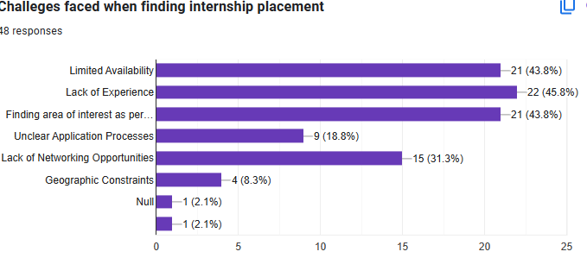

Figure 1 Challenges faced when finding internship placement

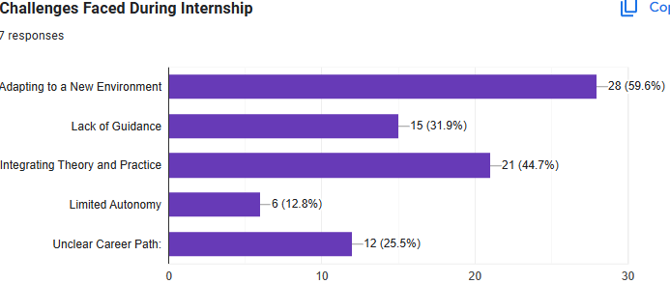

Figure 2 Challenges faced during internship

1. Organization participants: The research was conducted at iuiu particularly in the faculty of science. within iuiu there are departments with deans and faculty coordinators who are in charge of internship management. 2 faculty coordinators where included.

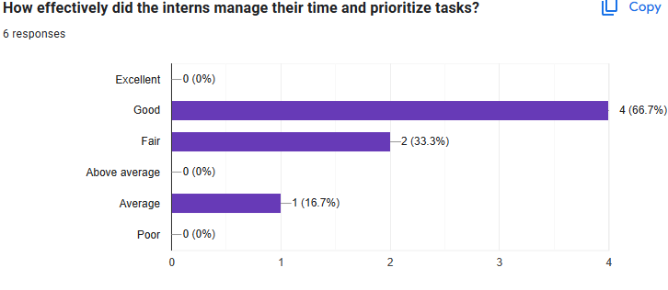

Figure 3 How effective internees prioritise tasks

1. University Internship Supervisors: the different faculties use some of their lecturers to supervise the students on internship. These supervisors take responsibility of traveling to the various places physically to evaluate the students at their placement organizations and at the end forward their assessments to the faculty coordinators.

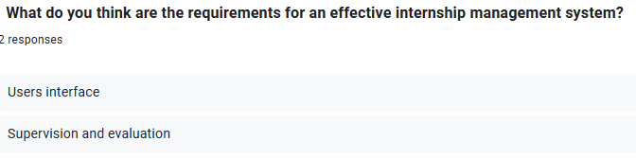

Figure 4 Requirements of internship management system

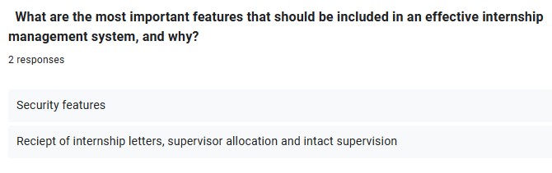

Figure 5 Important features of internship management system

**Table 3 showing the response, requirements and category**

Table 3 showing the response, requirements and category

|  |  |  |
| --- | --- | --- |
| Response | Requirements | Category |
| Students should be able to register for internships | Student registration and profile management | Functional |
| Supervisors should visit students | Supervisory visit scheduling and tracking | Functional |
| Students should record their daily activity | Daily activity reporting and review | Functional |
| Students should be able to upload their reports | Document upload (e.g. reports,letters) | Functional |
| The system should have good performance | Response time and system loading speed | Non-functional |
| The system should be able to store information regarding internships | Database design for efficient data storage and retrieval | Non-functional |
| It should allow communication | Communication and notification features | Functional |

## 4.3 System Requirement

The data collected were then transformed into system requirements and the features ware refined logical data flow diagram to best capture the functional requirements of the system.

### 4.3.1Functional Requirements

#### 4.3.1.1 Students Application Module

The system will allow students to apply for internship by registering their details.

It will allow students register details of their placement organization.

It will allow students to view their supervisor’s details particularly the internal supervisors for proper coordination.

It will allow student to view announcements posted by the faculty coordinators.

#### 4.3.1.2 Allocation Module

The system will allow faculty coordinators to allocate students supervisors and to their secured internship organizations.

It will allow faculty coordinators to view, update and delete the supervisors as a need may require.

#### 4.3.1.3 Announcement Modules

The system will allow faculty coordinators to send announcements and notifications to the interns and supervisors.

**Report**

It will allow faculty coordinators to view and print different types of reports.

### 4.3.2 Non-Functional Requirements

#### 4.3.2.1 Security Module

The system will be able to identify authorized users to login to the system.

It will be able to differentiate the authorized level of users.

It will encrypt users' passwords to enhance security.

#### 4.3.2.2 Efficiency

Introductory letters will be ready for printing so longer as a student registers in the system.

Internship activities will be ready to be viewed or printed after evaluation form and survey form is collected from student and the organization.

Notification is will always be ready to update users.

#### 4.3.2.3 Reliability

Up-to-date information will be provided to users.

Users will do decision-making effectively and produce valuable reports.

## 4.5 System Design

### **4.5.1 A Level 0 Data Flow Diagram (DFD) for an Internship Management System**.

It provides an overview of the main processes and data flows within the system at a high level. It represents the interactions between different external entities and the system itself, showing the major activities and the data exchanged among them.

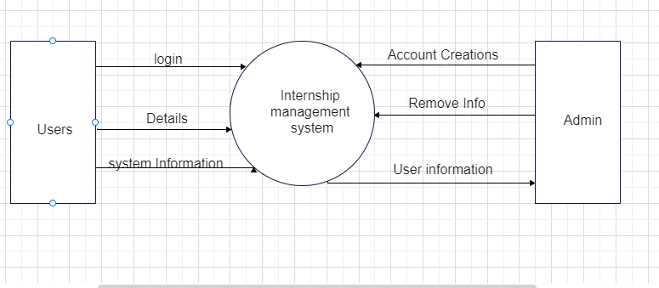

Figure 6 Level 0 DFD

## 4.5.2 Functional decomposition of an Internship Management System

Budd, Timothy (2002), defines Functional Decomposition as a process of taking a complex process and breaking it down into its smaller, simpler parts. The internship management system is broken down into the most decomposed pieces of subsystems in order to have manageable parts that are easy to code/ engineer and later be composed into a greater whole internship management system.

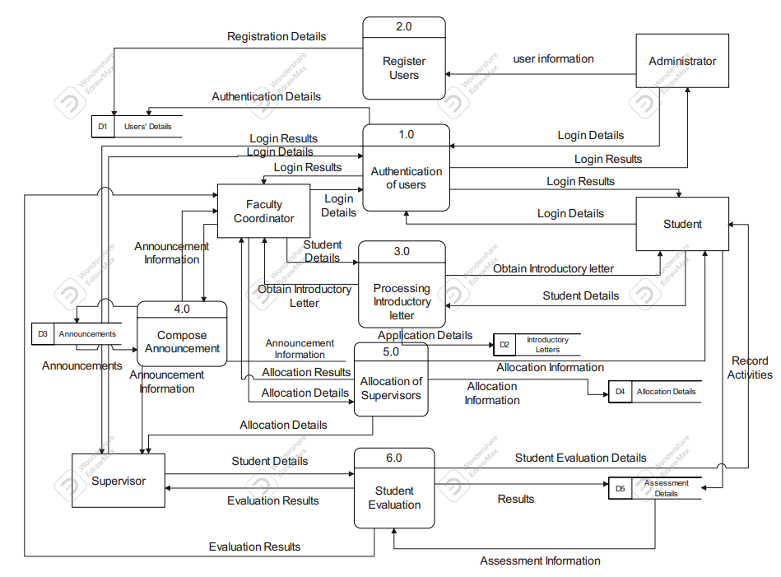

Figure 7 Level 1DFD

**4.5.3 Entity relationship diagram**

An entity relationship (E-R) diagram is used to visualize the system and represent the user requirements. This is used to represent entities and how they relate to one another. The ER diagram below shows the relationships between the entities and attributes of the Internship management System

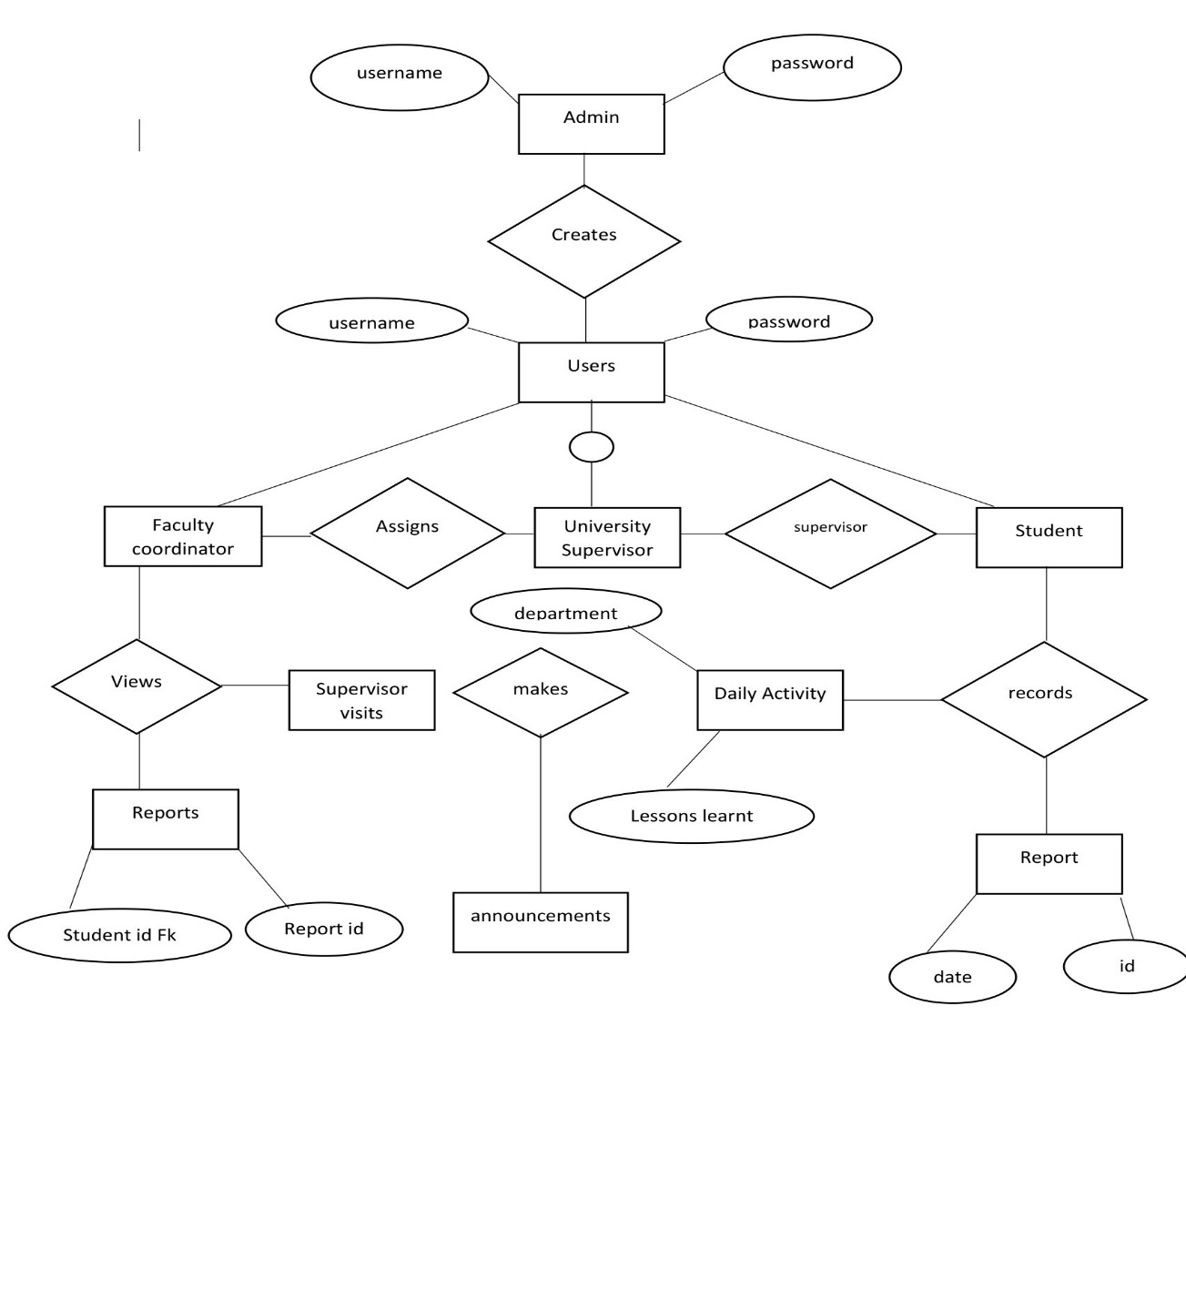

Figure 8 Entity relationship diagram

**4.5.4 System Architectural Design**

The system architecture design describes the environment in which the system will operate. This section focuses on the architectural framework with the minimum software and hardware specifications for the effective functioning of the system.

**4.5.5 System architecture**

Figure 9 system architecture

Active Database

Backup Database

Application Logic

Data Management

Application Logic

User Interface

interface is the client that sends queries and requires some resource.

This system is a web-based Information System that uses 3-tiers architecture where the user

The server is the data manager which responds to the queries by providing the resources. Client- server technology provides the means for distributing work across machines and coordinating the results. The backup database is used for archiving the database and data ware housing for the historical data.

Level 1 the user interface through which users interact with the system

Level 2 handle HTTP-request and give the response after the request is processed by web server.

Level 3 handle database and for the Front end tool, python programming language was used for developing the code. The motivation for choosing this language was the need for a platform independent language that could be used to create software to be embedded in various consumer electronic device.

# CHAPTER FIVE: SYSTEM IMPLEMENTATION

## 5.0 Introduction

Django is a web framework that is commonly used as a backend tool to build web applications. It provides a range of features for managing databases, including relational database management systems, such as PostgreSQL and MySQL. Django is known for its reliability, data integrity, scalability, and high level of security for the stored information, making it a popular choice among developers.

Django is a free, open-source software that is easy to use, fast, and can accommodate large amounts of data. Its powerful and intuitive ORM (Object-Relational Mapping) system allows developers to work with databases without having to write complex SQL queries.

## 5.1 System Login Page

The main introduction page of the system where the student, faculty coordinator and university supervisor use to log into the system.

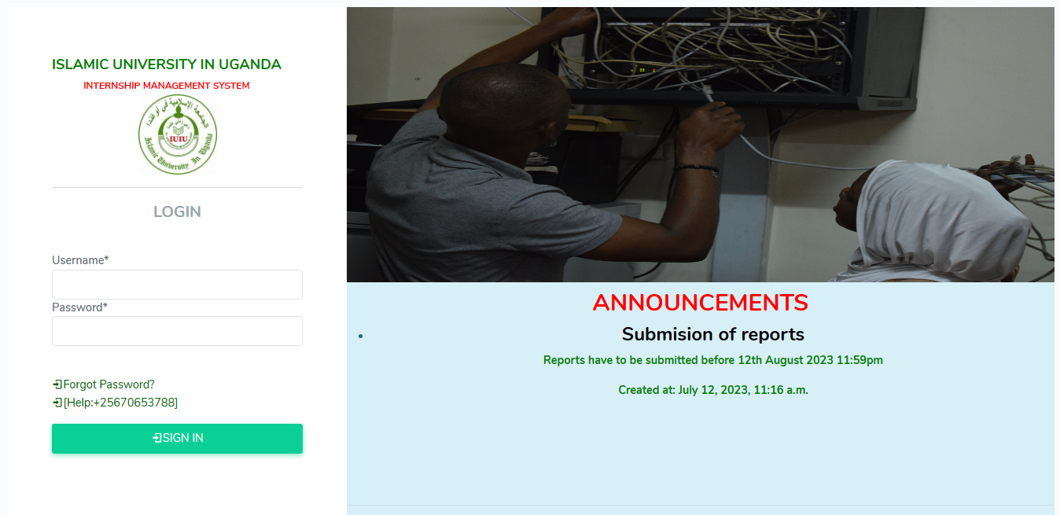

Figure 10 Login page of the system.

Before accessing the system, you must have an account that the faculty coordinator created for you

## 5.2 Student registration Form

When a student logs in, he or she has to register for internship where he provides his placement letter.

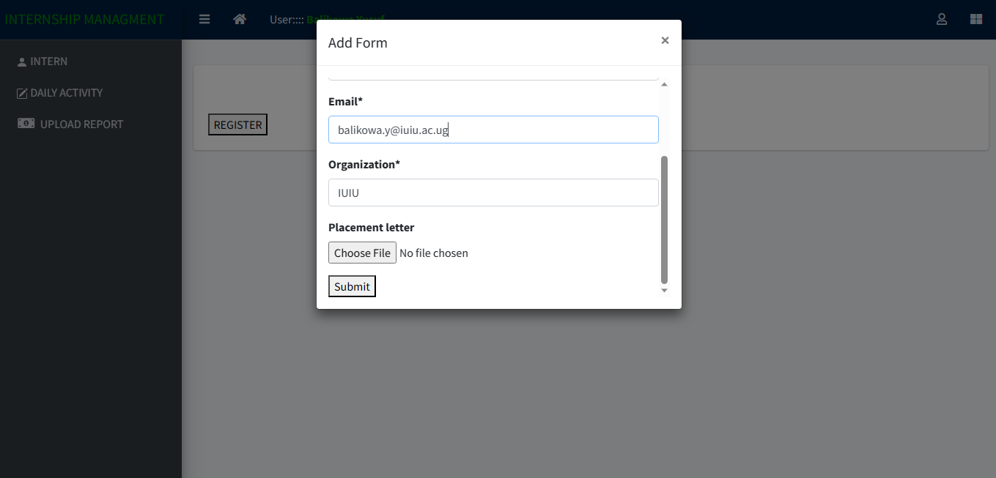

Figure 11 Student registration Form

After filling in all required information, click on submit in order the data to be captured in the database of this system

## 5.3 Record Daily Activity

After registering in the system, the student can record the daily activities.

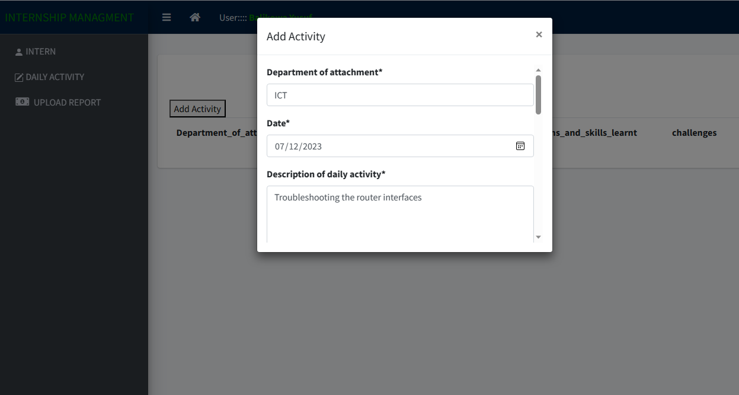

Figure 12 Record Daily Activity Form

## 5.4 Uploading Internship report.

The student can upload the report and his university supervisor can access it from his interface.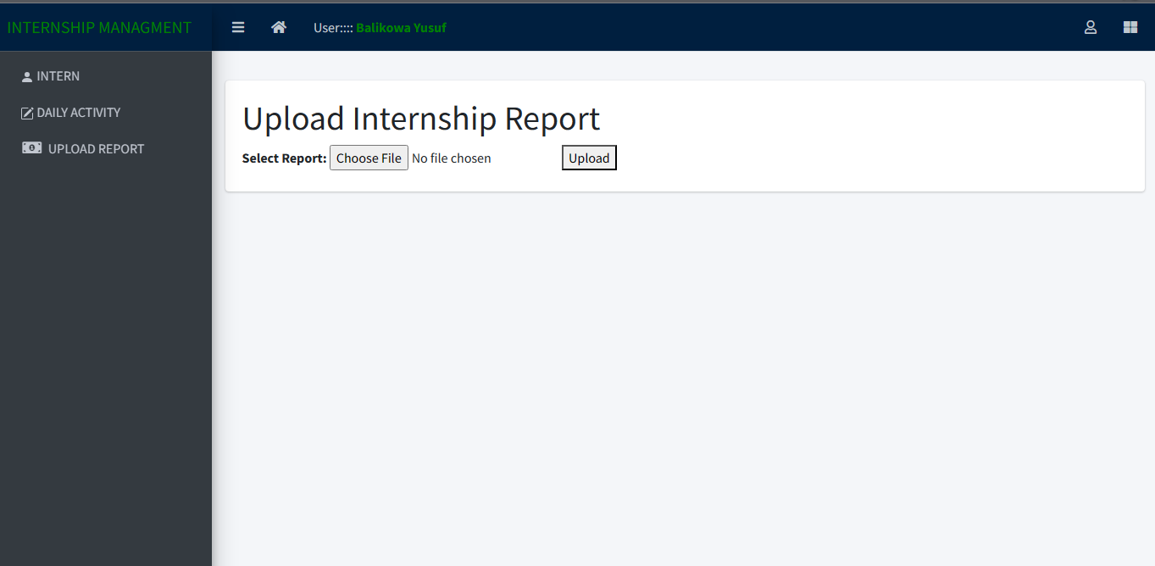

Figure 14 Showing uploading internship report

## 5.5 University Supervisor Notifications

After the university supervisor logging into the system, he is notified to the assigned students which he will supervise during internship exercise.

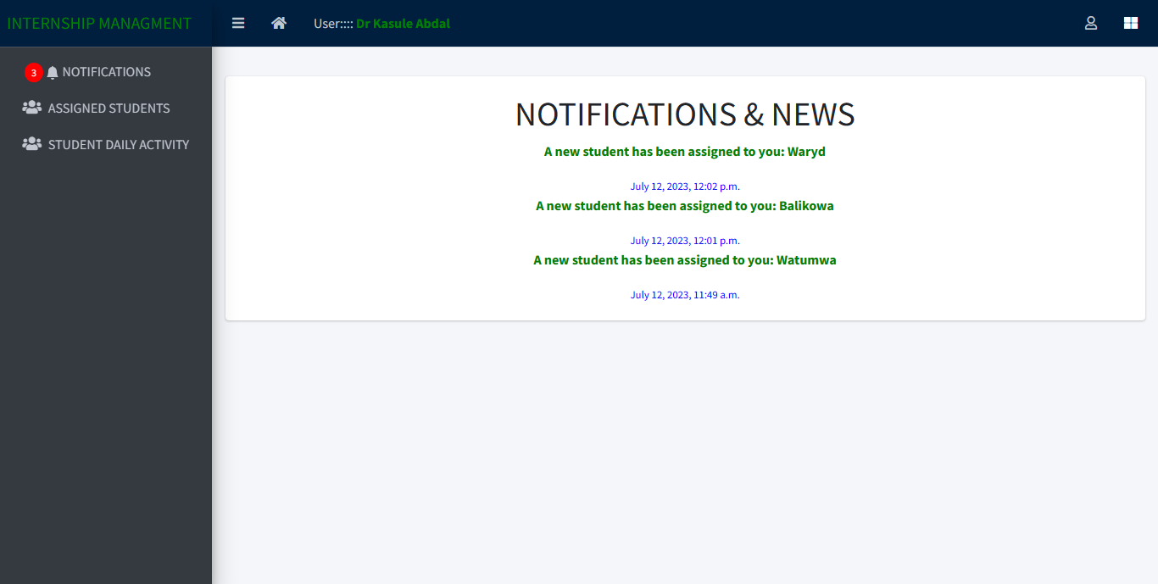

Figure 15 Showing notifications.

## 5.6 View Students to supervise

After the faculty coordinator has assigned each university supervisor a student, he is in position to view the list of students assigned to him.

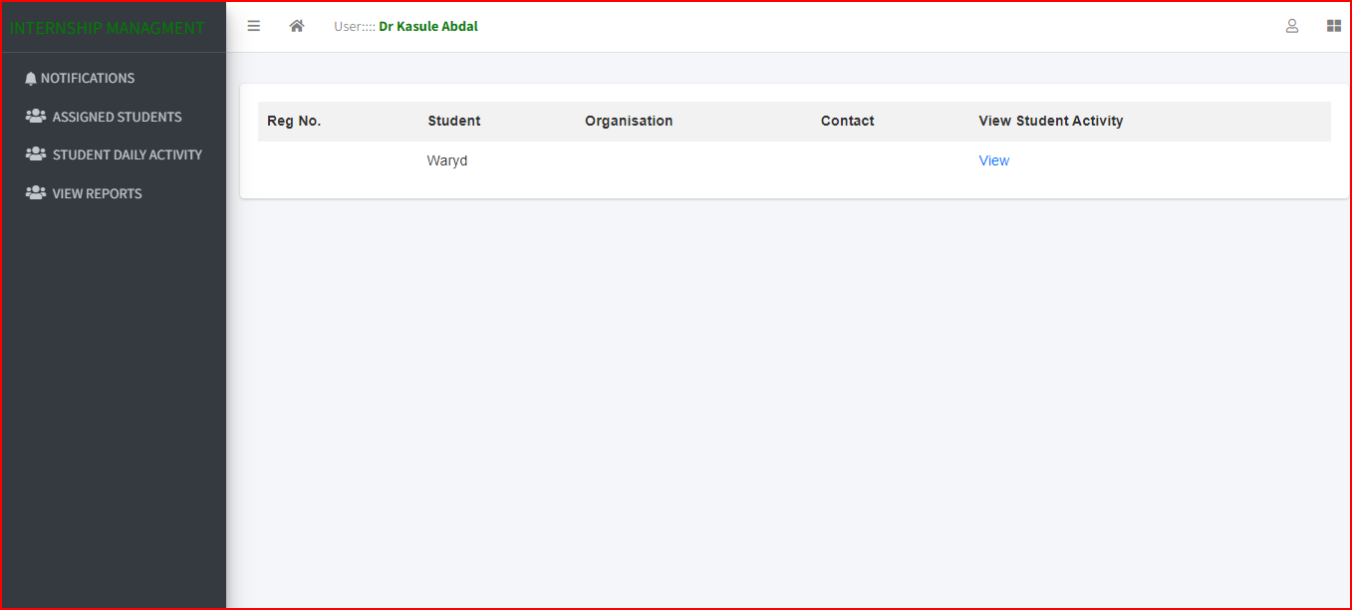

Figure 16 Showing assigned students.

5.7 view uploaded reports.

The university supervisor can view student uploaded reports.

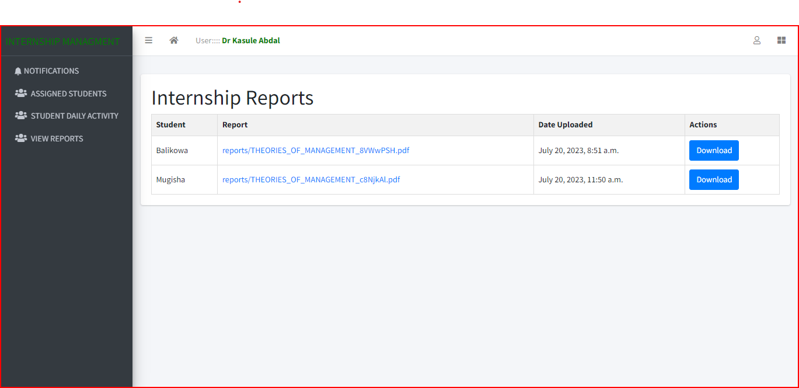

5.8 Setting Internship period.

The faculty coordinator can set how long the internship period will take.

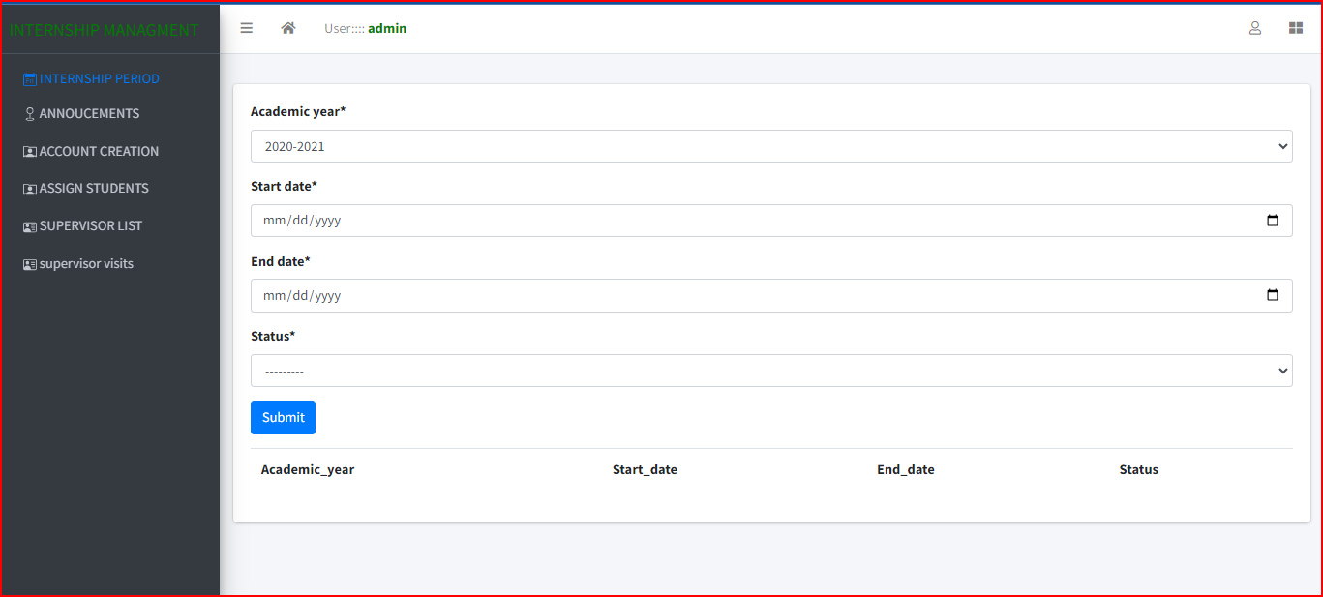

## 5.9 Creating Users

The faculty coordinator can create accounts for students and university supervisors which enables them to log into the system.

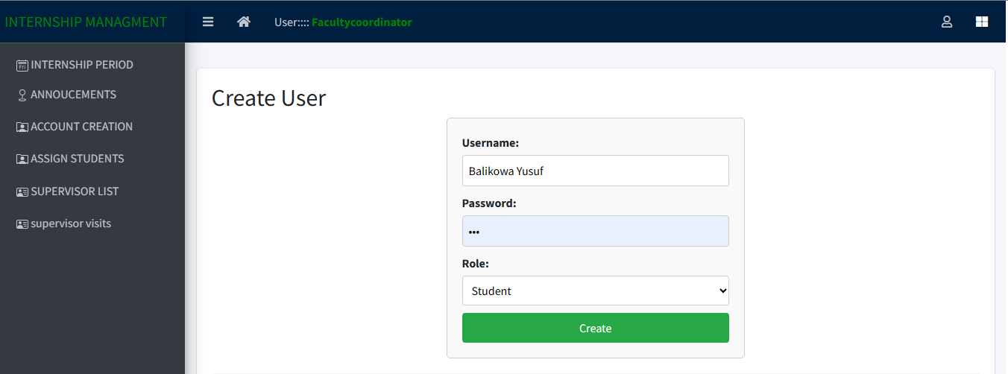

Figure 17 Creating Accounts

# CHAPTER SIX: DISCUSSION, CONCLUSIONS AND RECOMMENDATIONS

## 6.0 Introduction

This research’s main aim was to study and understand how internship is managed at Islamic University in Uganda and establish its associated challenges for an improved internship management system, analyze the functional and non-functional requirements of the new internship management system which resulted into logical designs and prototypes of an improved Internships management system in order to ensure that it meets the functional and non-functional requirements as well as to test whether it is free from errors. This set off with the study and analysis of the current systems followed by the establishment of user and system requirements that aided in specifying the functional and non-functional requirements that were used to design models from which the prototype for a new solution was implemented. This chapter therefore discusses the study’s conclusions, recommendations and future plans after the implementation of the solution.

## 6.1 Research Report Summary

The study’s focus was at improving internship management through designing and implementing a web-based internship management system. For this to be achieved, objects were set to guide the flow of the study and help understand and analysis the current system being used at the study’s case study institution; Islamic University in Uganda. The study was conducted in view of business processes and technologies to establish weaknesses in relation to the institution’s goals and review methodologies to come up with the best approach and methods for executing the project.

The study reviewed literature on related works to determine the gaps in the current internship management system and establish the need to bridge the gaps and give a solution to improve internship management. This was carried forward by evaluating the business processes on the information supply side through use of data collection techniques and tools.

The finding of the study revealed that the current system does not allow Faculty coordinators toserve students in a timely manner because, it is still manual and time consuming, The internship registration process, monitoring and evaluation plus supervisor allocation are too manual, students record their daily activities on papers. This stressing process slowly led to the poor reporting culture of students and supervisors in different departments of Islamic University in Uganda which affects the performance of various departments. In an attempt to solve these problems, the current internship management was analyzed based on the business processes of the University and the user requirements collected during the study.

After the analysis of the system, it was designed and the solution implemented basing on the project objectives and requirements prior determined.

## 6.2 General Conclusion of the Study

The Study of current practices of how internship is done at Islamic University in Uganda established that the old internship system was handling each aspect of internship independent of the other. By providing a common platform for integration of all the internship management aspects within the new system, the University can now utilize the system to access all information on the students’ internship at a central point.

The analysis of the research finding and system requirements for developing an information system to improve internship management at Islamic University in Uganda revealed a need for a system that would provide a central storage space for all the data collected on the internship activity and reduction on the time taken by the University staff to produce periodic reports. As an answer to the requirements analyzed, a system prototype was designed and implemented. This greatly cut back on the time taken to work on internship information.

Despite delays in implementation of the internship management system, the Islamic University in Uganda staff and students were excited to have a system that eased their work of managing internship data, generating reports and improving the overall management of internship.

## 6.3 Challenges and Weaknesses

During the undertaking of this research, several challenges and weaknesses were encountered in the process of studying the current system, designing and implementing the internship management system among which the most pressing included;

The researcher had underestimated the complexity of the whole study especially the system implementation part thinking it would take a short time to be done but it ended up taking a longer time and delaying the whole research completion.

Secondly, the researcher faced a challenge of the university schedule which didn’t favor the supervisor to be on ground because the university was in test week period, end of quarter 2 exams and so many times it was not possible to meet supervisors. This also greatly caused delays in delivering the project on time.

## Recommendations

1. We recommend integrating an Internship Management System into the university's existing Enterprise Resource Planning (EPR) to enhance the overall efficiency and effectiveness of managing internships for students and administrative staff. This integration will bring numerous benefits to the internship program and streamline various processes.

ii Adequate testing

Adequate testing plays a pivotal role in identifying and resolving potential issues, ensuring system stability, and providing a smooth experience for all stakeholders. Therefore, we highly recommend conducting comprehensive testing for the integrated Internship Management System. Here's why testing is essential and how to approach it:

## 6.5 Further Work on the System

1. Adding other functionality into the system like managing companies with internship placements can post them on the system to allow the student to apply for them.
2. The implemented prototype runs on ordinary web browsers and networked computers, and mobile devices with web browsers, further work can be done to improve the prototype to implement a mobile application that can be used and compatible with the new technologies of mobile devices like mobile phones and notepad computers.

## 6.6 Conclusion

Timely and better quality services extended to users is an all organizations’ dream in Uganda especially in this error of technology; therefore, an improvement in the management of internship system would guarantee every person timely access and almost self-service of user needs pertaining internship at Islamic University in Uganda. The development of the internship management information system obviously improves the process of internship management through timely access to student’s data like the log books, supervisor details and how they are progressing with their students on internship. The study has not only produced a system prototype of internship management systems but has also proved the new system to be an efficient way of enhancing performance of students and improve supervisor roles compared to the former system.

# 

# References

Alshenqeeti, H. (2014). Interviewing as a Data Collection Method: A Critical Review. *English Linguistics Research*, *3*(1). https://doi.org/10.5430/elr.v3n1p39

Amin, M. E. (2005). *Social Science Research_ Conception, Methodology and Analysis* (1st ed.).

Bailey, C. A. (2023). *Thematic Analysis*. A Guide to Qualitative Field Research. https://doi.org/10.4135/9781071909614.n13

Binti, I. (2006). *Industrial Training Programme Management. Report on Database management systems*.

Cohen, L., Manion, L., & Morrison, K. (2017). Research Methods in Education. In *Research Methods in Education*. https://doi.org/10.4324/9780203029053

Dannels, A. S. (2018). Research design. In *The reviewer’s guide to quantitative methods in the social sciences*.

Intern Bridge. (2020). *Intern Bridge: About us*. https://internbridge.com/about-us/

Internshala. (2023). *Internshala*. https://internshala.com/

Ismail, R., Yussof, I., & Siang, L. W. (2011). Employers perception on graduates in Malaysia service sector. *International Business Management*, *5*(3), 184–193.

Lewis, S. (2015). Qualitative Inquiry and Research Design: Choosing Among Five Approaches. *Health Promotion Practice*, *16*(4), 473–475. https://doi.org/10.1177/1524839915580941

Musoke, M. G. N. (2008). Strategies for addressing the university library users’ changing needs and practices in Sub-Saharan Africa. *Journal of Academic Librarianship*, *34*(6), 532–538. https://doi.org/10.1016/j.acalib.2008.10.002

Oates, B. J. (2022). Researching Information Systems and Computing. In *Inorganic Chemistry* (Vol. 37). http://www.pubmedcentral.nih.gov/articlerender.fcgi?artid=2836698&tool=pmcentrez&rendertype=abstract

Ogheneruemu, A., & Tiemo, P. A. (2007). Evaluation of the practicum trainee librarians at Delta State University, Abraka, Nigeria. *Library Philosophy and Practice*, *2007*(AUG.).

Orrel, J. (2004). Work-integrated learning programs. *Management and Educational Quality Proceedings of the Australian Universities Quality Forum 2004*.

Oyebisi, T. M. (2016a). *“Assessment of the Computer Literacy Skills of Tertiary Institution Students in Nigeria,” 2016 International Conference on Computational Science and Computational Intelligence*.

Oyebisi, T. M. (2016b). *Assessment of the Computer Literacy Skills of Tertiary Institution Students in Nigeria*.

Patricia Leavy. (2017). Research Design: Quantitative, Qualitative, Mixed Methods, Arts-Based, and Community-Based Participatory Research Approaches. In *The Guilford Press*.

Patrick, C., Peach, D., & Pocknee, C. (2008). *The WIL report: A national scoping study*.

S. S. Ahmed and M. S. Hossain. (2019). *Computerized Management Systems and Efficiency: A Study on Bangladeshi Garment Industry*.

S. S. Sari and S. Akkurt. (2019). *Graduate Employability Skills and Higher Education: A Review of Conceptual and Empirical Literature*.

Schwartz, K., Tutusaus Luque, M., Rusca, M., & Ahlers, R. (2015). Research design: qualitative, quantitative, and mixed methods approaches. In *WIREs Water* (Vol. 2, Issue 1).

Sheldon, P. (2005). Employability skills and vocational education and training policy in Australia: An analysis of employer association agendas. *Asia Pacific Journal of Human Resources*, *43*(3), 404–425. https://doi.org/10.1177/1038411105059100

Ssempijja, I. (2018). *Developing an online internship management system for CEDAT* [Makerere]. http://dissertations.mak.ac.ug/handle/20.500.12281/5003

Sweiter, H. F. (2017). The successful Internship. In *Journal of Chemical Information and Modeling* (Vol. 53, Issue 9). file:///C:/Users/User/Downloads/fvm939e.pdf

Symplicity. (2023). *Symplicity: about us*. https://www.symplicity.com/higher-ed/internship-management-system

Totawar, A., & Prasad, M. (2016). Research Methodology: A Step-by-Step Guide for Beginners. *South Asian Journal of Management*, *23*(3), 210.

Yin, R. K. (2016). Qualitative research from start to finish. In *Guildford Press: Vol. 2nd Ed*. https://books.google.co.nz/books?id=_XP3CQAAQBAJ

Zikmund, W. G. (2010). Business Research Methods Business Research Defined. In *sl OH Cengage Learning*.

# APPENDICES

**Appendix A: Sample Questionnaire for students doing internship**

Dear Respondent;

We are students at Islamic University in Uganda pursuing a Bachelors' degree in Information Technology. We are undertaking a research on developing an “internship management system at Islamic University Kampala campus”.

We kindly request that you answer the questions below with honesty. The research is carried out purely for academic purposes and all responses shall be treated with utmost confidentiality.

**Personal Information**

1. **Name**

2. **Gender** *

Mark only one oval.

Female

Male

3. **Email Address**

4. **Select your position** *

Mark only one oval.

Student

University Supervisor

Faculty Coordinator/Dean

**Student Section**

5. **What is your field of Study?** *

Mark only one oval.

Bachelor of Information Technology

Bachelor of Business Studies

Bachelor of Human Resource Management

Bachelor of Public Administration

Bachelor of Secretarial and Administrative Studies

Diploma In Computer Science and Information Technology Diploma In Business Studies

Diploma in Law

Bachelor of Laws

Bachelor of Science in Computer Science

Bachelor of Science Mass Communication

Bachelor of Social works and Social Administration Bachelor of Procurement and Logistics Management Bachelor of Islamic Banking and Finance

6. **What is your year of study?** *

Mark only one oval.

Year 1

Year 2

Year 3

Year 4

7. **Challenges Faced During Internship Application**

Tick all that apply.

Application Deadlines

Lack of Response or Rejection

Balancing Applications with Academic Commitments

Finding Suitable Organizations

8. **Challenges faced when finding internship placement** *

Tick all that apply.

Limited Availability

Lack of Experience

Finding area of interest as per course

Unclear Application Processes Lack of Networking Opportunities Geographic Constraints

Other:

9. **Challenges Faced During Internship**

Tick all that apply.

Adapting to a New Environment

Lack of Guidance

Integrating Theory and Practice

Limited Autonomy

Unclear Career Path:

10.

11.

**What should be done to solve the above challenges?** *

**what features should an internship management system have to help** *

**address these challenges?**

**ApAppendix B: Sample Interview Guide to the University Supervisor Section**

**12.How long have you been supervising interns?** *

Mark only one oval.

1year

1-2 years

2-4 years

5 years and Above

6 month

13.

**How would you rate the current internship management process in terms**

**of its effectiveness**

Mark only one oval per row*.*

Communication

Mentorship and

Guidance

Task

Assignment

Performance

Evaluation

Sttrronglly

IIneffecttiive

IIneffecttiive

Hiighlly

Effecttiive

Effecttiive

14.

**What do you think are the requirements for an effective internship management system?**

15.

**What are the Challenges faced during supervision?**

**------------------------------------------------------------------------------------------------------------**

**-----------------------------------------------------------------------------------------------------------**

**-----------------------------------------------------------------------------------------------------------**

**-----------------------------------------------------------------------------------------------------------**

**Appendix C: Sample Interview Guide to the Faculty Coordinator Section/Dean**

16.**How long have you been coordinating internship exercise?** *

Mark only one oval.

6 months

1 year

1-2 years

2-4 years

5years and Above

17.

**What challenges do you face when coordinating internship exercise?**

18.

19.

**How can these challenges be effectively addressed?** *

**How would you rate the current internship management process in terms of**\*

**its effectiveness**

Mark only one oval per row.

Communication

Mentorship and

Guidance

Task

Assignment

Performance

Evaluation

Sttrronglly

IIneffecttiive

IIneffecttiive

Hiighlly

Effecttiive

Effecttiive

20.

**What do you think are the requirements for an effective internship** *

**management system?**

21.

**What are the most important features that should be included in an** *

**effective internship management system, and why?**

22.

**What are the most effective ways to ensure that the internship** *

**management system meets the needs of all stakeholders?**

**Appendix D: Project Budget for the development of an Internship management system**

|  |  |  |  |  |  |
| --- | --- | --- | --- | --- | --- |
| No | **ITEM** | **DESCRIPTION** | QUTY | **UNIT COST(UGX)** | **TOTAL COST’** |
| 1 | Stationary | Reams of Paper  Compact Discs (CDs)  Pens | 05  05  10 | 25000  1500  600 | 125,000  7,500  6,000 |
| 2 | Printing | Books | 06 | 10,000 | 60,000 |
| 3 | Binding | spiral binding Hardcover binding | 06  06 | 20,000  50,000 | 120,000  300,000 |
| 4 | Consultancy |  |  |  | 300,000 |
| 5 | Laptop | Dell core i7 | 01 |  | 2,500,000 |
| 6 | Miscellaneous |  |  |  | 10,0000 |
| 7 | TOTAL |  | | | **3,586,000** |

**Appendix E: Time Frame for Degree Research about internship management system at IUIU.**

