= translation =

cd /opt

git clone <https://github.com/mlperf/reference.git>

cd /opt/reference

# bash install_cuda_docker.sh

cd /opt/reference/translation

sh ./download_data.sh

cd tensorflow

## modify dockerfile & requirement.txt 中 protobuf=3.6.1 & tf-nightly-gpu==1.9.0rc0

vim requirement.txt

protobuf==3.6.1

tf-nightly-gpu==1.9.0rc0

vim Dockerfile

RUN pip3 install --upgrade numpy scipy sklearn tf-nightly-gpu==1.9.0rc0 protobuf==3.6.1

cd /opt/reference/translation/tensorflow

docker build -t "benchmark/mlperf:v3" .

IMAGE=$(docker images | grep "mlperf"| awk '{print $3}')

SEED=1;

NOW=`date "+%F-%T"`

docker run -v /opt/reference/translation/raw_data:/raw_data --runtime=nvidia -t -i $IMAGE "./run_and_time.sh" $SEED | tee benchmark-$NOW.log

=> 1d 3h 30min

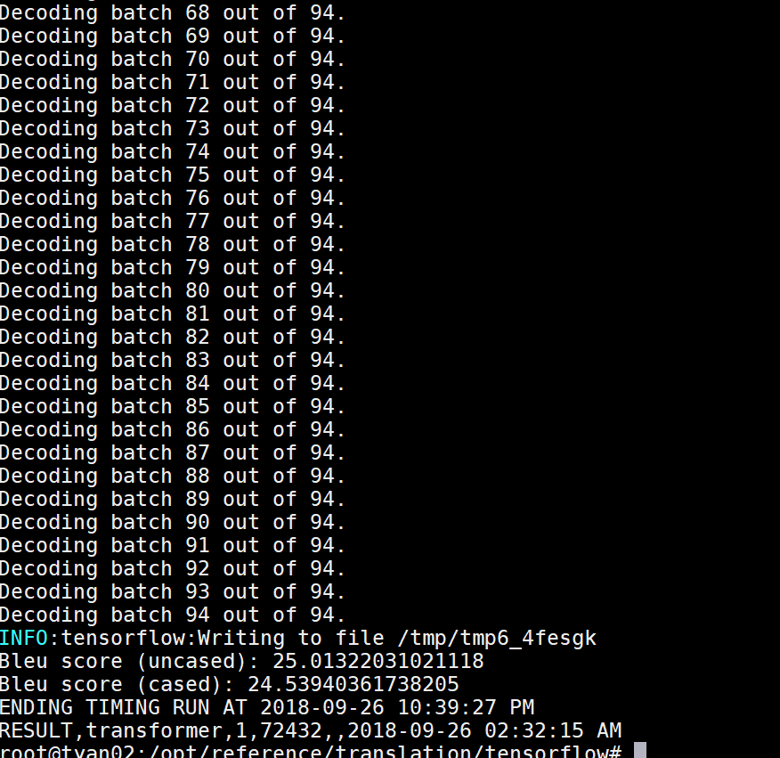

== Other Records ==

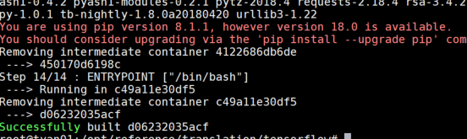

docker build -t "benchmark/mlperf:v3" .

docker tag <image_id> benchmark/mlperf:v2

IMAGE=`docker images | grep "mlperf"| awk '{print $3}'`;

echo $IMAGE > imageid

docker build -t "benchmark/mlperf:v3" .

IMAGE=$(docker images | grep "mlperf"| awk '{print $3}')

SEED=1;

NOW=`date "+%F-%T"`

docker run -v /opt/reference/translation/raw_data:/raw_data --runtime=nvidia -t -i $IMAGE "./run_and_time.sh" $SEED | tee benchmark-$NOW.log

or

docker run -v /opt/reference/translation/raw_data:/raw_data --runtime=nvidia -t -i benchmark/mlperf:v3 "./run_and_time.sh" $SEED | tee benchmark-$NOW.log

cd /opt/reference/translation/tensorflow

docker run -v /opt/reference/translation/raw_data:/raw_data --runtime=nvidia -t -i dd9ddc20e348 "./run_and_time.sh" 1 | tee benchmark.log

solution：must modify  protobuf=3.6.1 & tf-nightly-gpu==1.9.0rc0 in dockerfile & requirement.txt

= recommendation =

#recommendation

cd /opt/reference/

# docker pull mlperf/recommendation

cd /opt/reference/recommendation/pytorch

docker build -t benchmark/recommendation .

rm ml-20m/*

bash ../download_dataset.sh

bash ../verify_dataset.sh

pip install numpy pandas scipy torch

nvidia-docker run -i -t --rm --ipc=host --mount "type=bind,source=$(pwd),destination=/mlperf/experiment" benchmark/recommendation 1

* About 1h 4 min

