= Introduction =

== reference ==

ref :

* ubuntu  <https://www.digitalocean.com/community/tutorials/how-to-install-prometheus-on-ubuntu-16-04>
* centos <https://www.digitalocean.com/community/tutorials/how-to-use-prometheus-to-monitor-your-centos-7-server>

<http://140.110.141.135:9090/graph>   |   prometheus db

http://165.124.3.99:3000/login   |  waue / manager1

<http://tctst03.nchc.org.tw:5000/login>    |  waue / Manager1

== architecture ==

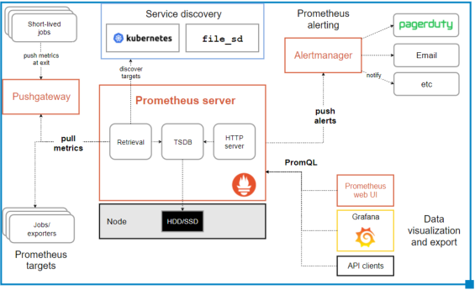

= 安裝設定 =

== install Prometheus ==

$ cd /opt

$ wget <https://github.com/prometheus/prometheus/releases/download/v2.4.2/prometheus-2.4.2.linux-amd64.tar.gz>

$ tar -zxvf prometheus-2.4.2.linux-amd64.tar.gz

$ mv prometheus-2.4.2.linux-amd64/ prometheus

$ cd /opt/prometheus/

$ ./prometheus --version

$ mkdir /etc/

$ mkdir /etc/prometheus/

$ ln -sf /opt/prometheus/data/ /var/lib/prometheus

$ ln -sf /opt/prometheus/prometheus /usr/local/bin/

$ ln -sf /opt/prometheus/promtool /usr/local/bin/

$ ln -sf /opt/prometheus/consoles /etc/prometheus/

$ ln -sf /opt/prometheus/console_libraries/ /etc/prometheus/

$ sudo useradd --no-create-home --shell /bin/false prometheus

$ sudo useradd --no-create-home --shell /bin/false node_exporter

$ chown -R prometheus:prometheus /opt/prometheus/

== setup promethues ==

$ vim /etc/prometheus/prometheus.yml

$ sudo chown prometheus:prometheus /etc/prometheus/prometheus.yml

|  |
| --- |
| global:    scrape_interval: 15s  scrape_configs:    - job_name: 'prometheus'      scrape_interval: 5s      static_configs:        - targets: ['140.110.141.135:9090']    - job_name: 'node_exporter_dell03'      scrape_interval: 5s      static_configs:        - targets: ['dell03:18080']    - job_name: 'node_exporter_dell04'      scrape_interval: 5s      static_configs:        - targets: ['dell04:18080']    - job_name: 'node_exporter_dell05'      scrape_interval: 5s      static_configs:        - targets: ['dell05:18080']    - job_name: 'node_exporter_dell06'      scrape_interval: 5s      static_configs:        - targets: ['dell06:18080']    - job_name: 'node_exporter_tyan01'      scrape_interval: 5s      static_configs:        - targets: ['tyan01:18080']    - job_name: 'node_exporter_tyan02'      scrape_interval: 5s      static_configs:        - targets: ['tyan02:18080']    - job_name: 'node_exporter_tcgw01'      scrape_interval: 5s      static_configs:        - targets: ['tcgw01:18080'] |

vim /etc/systemd/system/prometheus.service

|  |
| --- |
| [Unit]  Description=Prometheus  Wants=network-online.target  After=network-online.target  [Service]  User=prometheus  Group=prometheus  Type=simple  ExecStart=/usr/local/bin/prometheus \      --config.file=/etc/prometheus/prometheus.yml \      --storage.tsdb.path=/var/lib/prometheus/ \      --web.console.templates=/etc/prometheus/consoles \      --web.console.libraries=/etc/prometheus/console_libraries \      --web.enable-admin-api  [Install]  WantedBy=multi-user.target |

## test

$ sudo -u prometheus /usr/local/bin/prometheus     --config.file /etc/prometheus/prometheus.yml     --storage.tsdb.path /var/lib/prometheus/     --web.console.templates=/etc/prometheus/consoles     --web.console.libraries=/etc/prometheus/console_libraries

## start

$ sudo systemctl daemon-reload

$ sudo systemctl start prometheus

$ systemctl status prometheus

$ sudo systemctl enable prometheus

== deploy node_exporter  ==

## root@tyan01:~/e17_admin

$ vim /etc/systemd/system/node_exporter.service

|  |
| --- |
| [Unit]  Description=Node Exporter  Wants=network-online.target  After=network-online.target  [Service]  User=node_exporter  Group=node_exporter  Type=simple  ExecStart=/usr/local/bin/node_exporter --web.listen-address=:18080  [Install]  WantedBy=multi-user.target |

./hascp /usr/local/bin/node_exporter /usr/local/bin/node_exporter

./hascp /etc/systemd/system/node_exporter.service /etc/systemd/system/

./hacmd "useradd --no-create-home --shell /bin/false node_exporter"

./hacmd "chown node_exporter:node_exporter /usr/local/bin/node_exporter"

./hacmd "systemctl daemon-reload"

./hacmd "systemctl restart node_exporter"

./hacmd "systemctl status node_exporter"

./hascp /usr/local/bin/node_exporter /usr/local/bin/node_exporter

./hascp /etc/systemd/system/node_exporter.service /etc/systemd/system/

./hacmd "useradd --no-create-home --shell /bin/false node_exporter"

./hacmd "chown node_exporter:node_exporter /usr/local/bin/node_exporter"

./hacmd "systemctl daemon-reload"

./hacmd "systemctl restart node_exporter"

./hacmd "systemctl status node_exporter"

== deploy nvidia_node_exporter  ==

== check ==

<http://140.110.141.135:9090/graph?g0.range_input=1h&g0.expr=node_memory_Bounce_bytes&g0.tab=0>

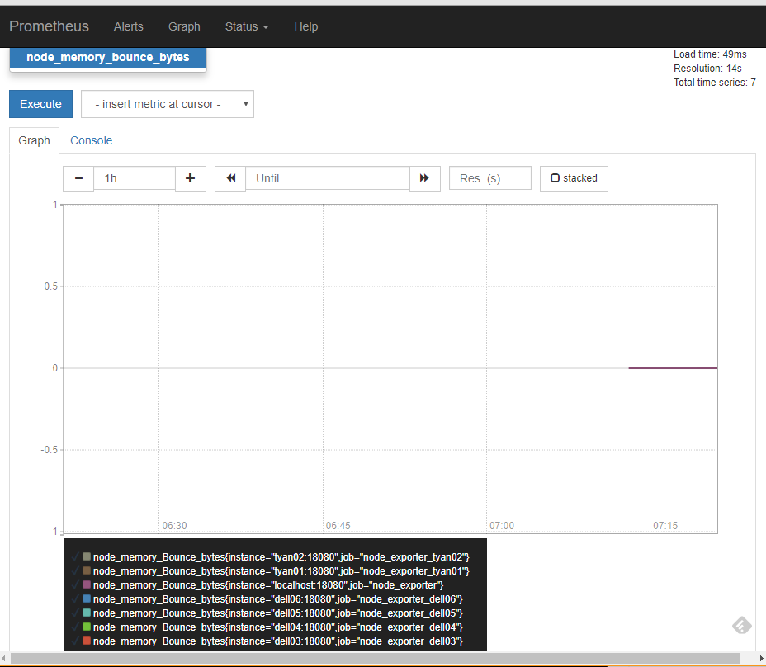

= use =

<http://140.110.141.135:9090/graph?g0.range_input=1h&g0.expr=node_memory_MemAvailable_bytes%2F1024%2F1024&g0.tab=1>

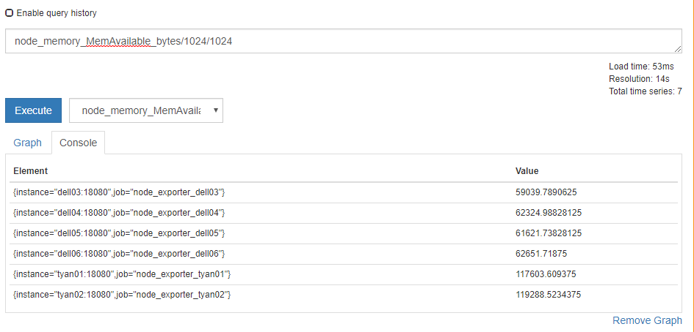

gpu

nvidia_gpu_duty_cycle

