**Assignment 1 – Business Rules**

**Disclaimer**

The ORD’s, database scripts, programming files, etc., must be saved in your GitHub repository.

**ORD:**

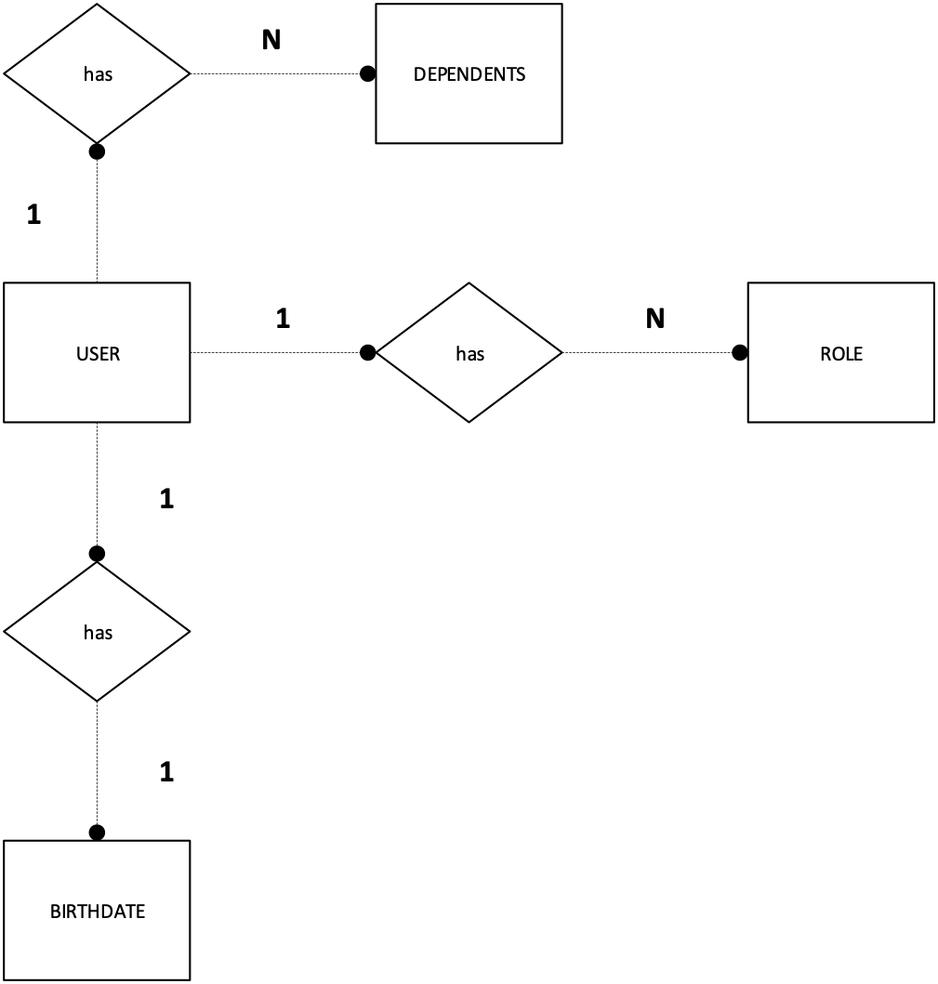

**Instructions**

1. Covert the above ORD into business rules.

**Business Rules:**

1. A USER has many DEPENDENTS

1

N

USER

has

N

DEPENDENT

1. A USER has many ROLES

1

N

N

USER

has

USER

has

ROLE

1. A USER has one BIRTHDATE

1

1

1

has

has

USER

USER

BIRTHDATE