William Austin

06/17/2023

Exercise 4.3 - MongoDB Shell

Display all the documents in the user’s collection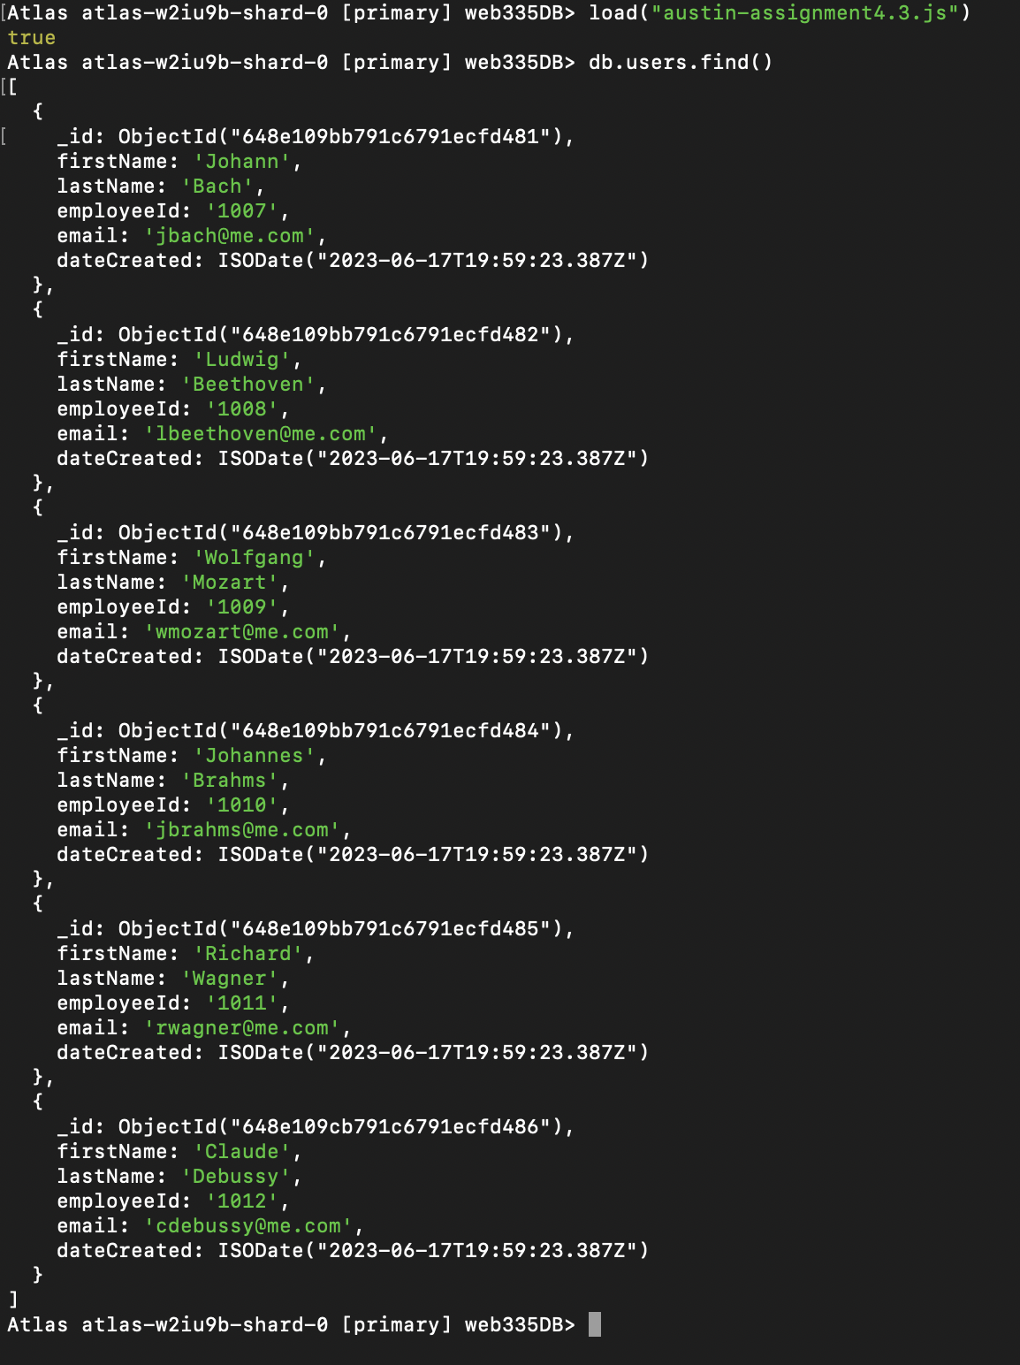

Query for email search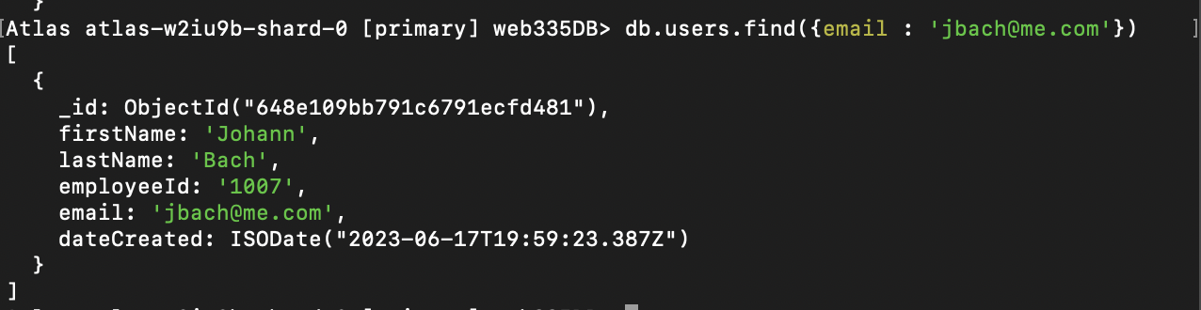

Query for last name search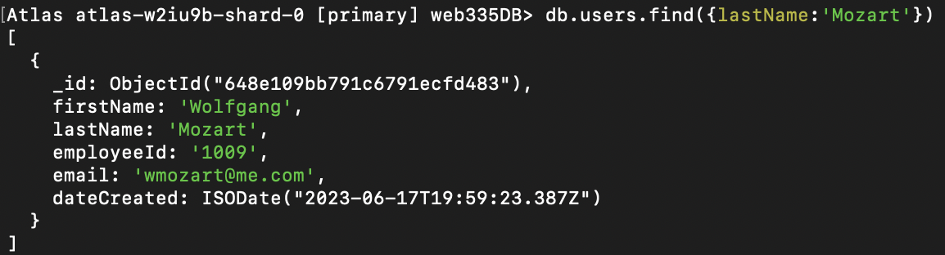

Query for first name search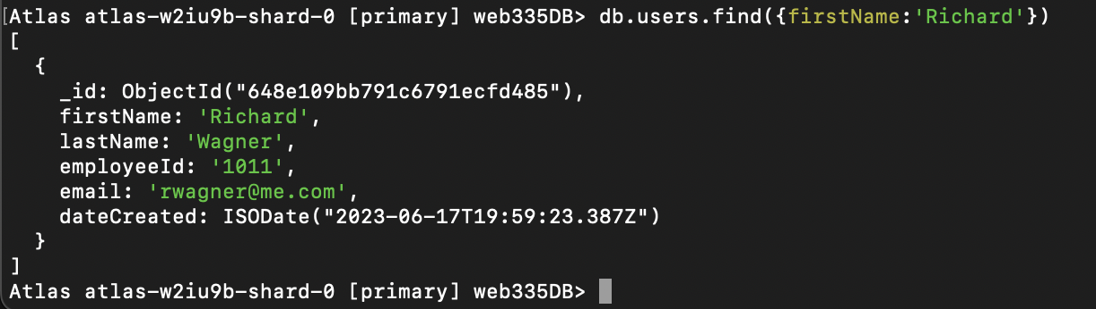

Query for ID search