William Austin

06/22/2023

Assignment 5.2 - Projections

Query to add a new user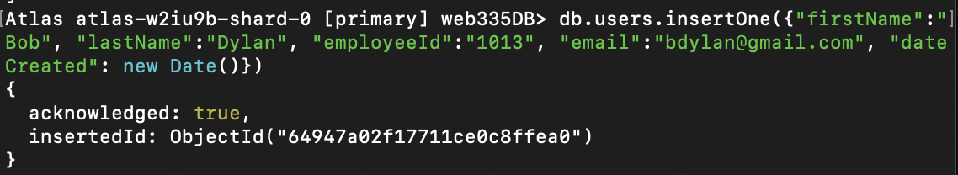

Query to update a user’s email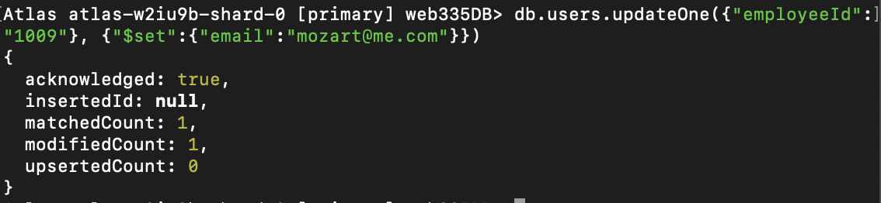

Query to list all documents but only certain fields within those documents