William Austin

07/01/2023

Web 335 - Assignment 6.2 - Aggregate Queries

List of documents in the ‘houses’ collection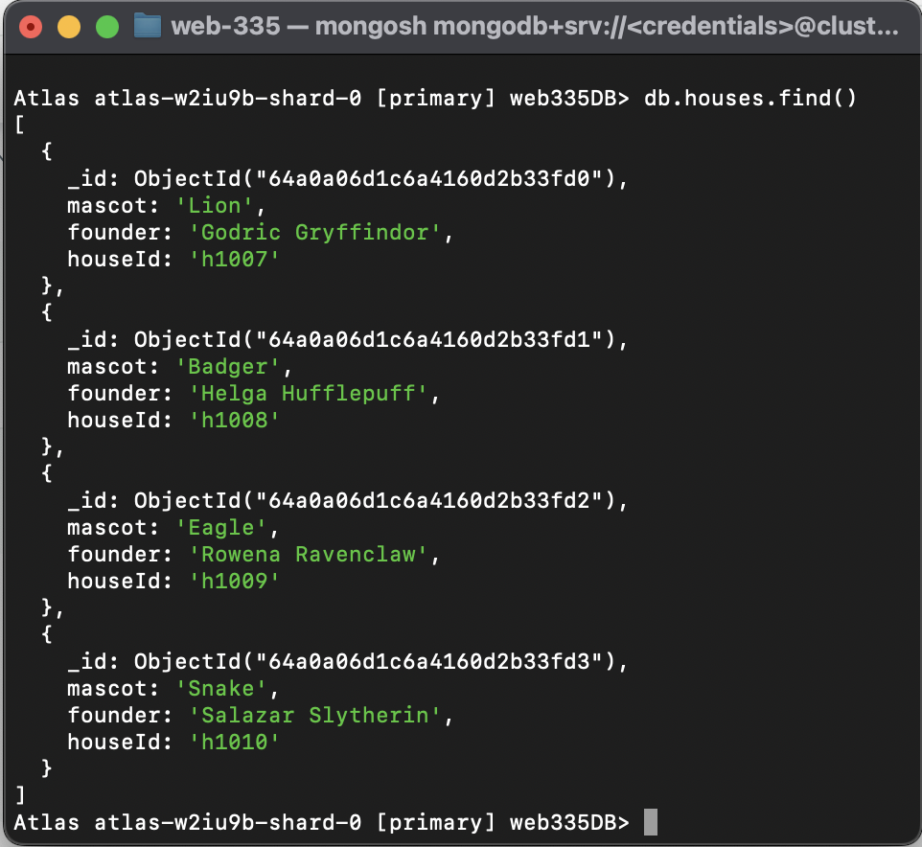

List of documents in the ‘students’ collection

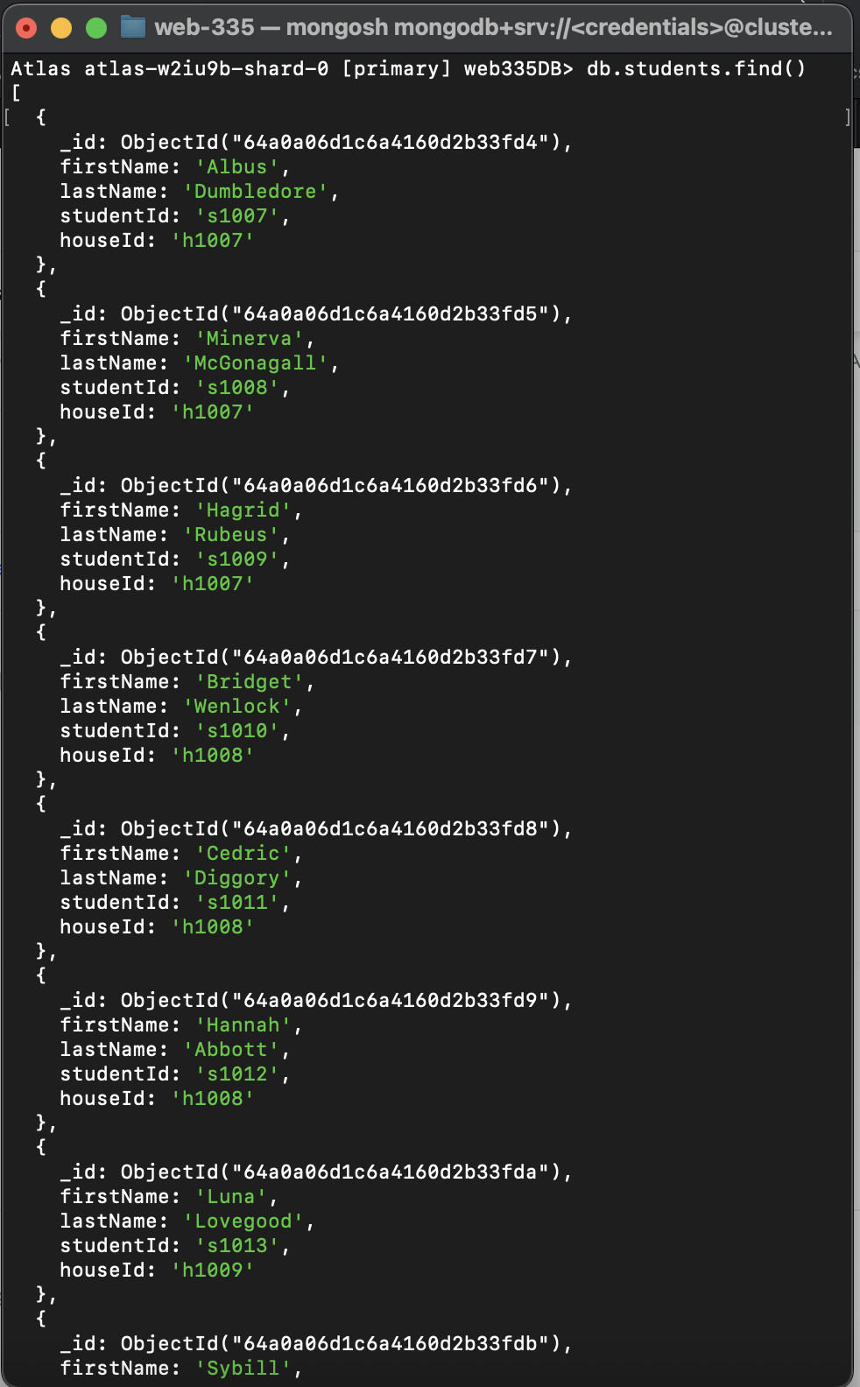

Query adding a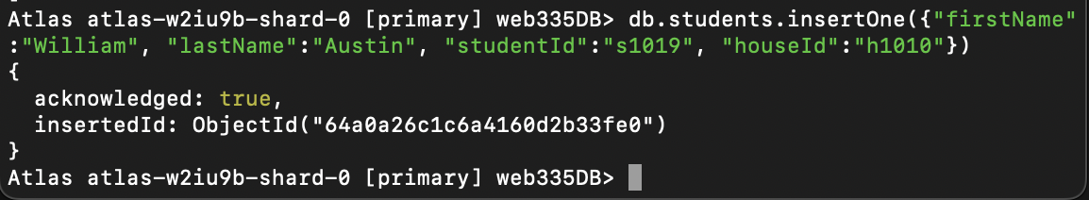 new student to the ‘students’ collection

Query finding the document we just added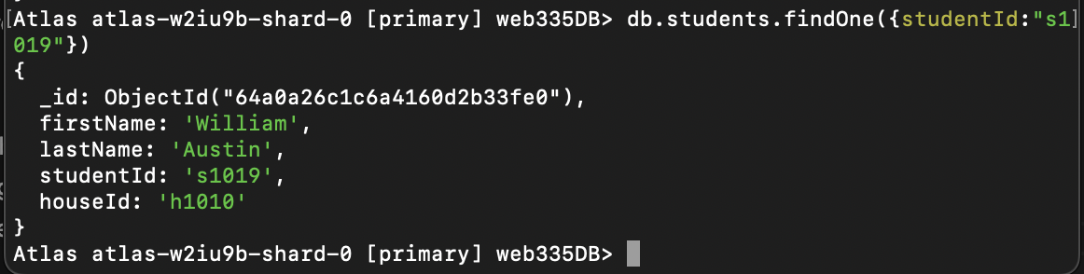

Deleting the newly added document

Proving the document was deleted 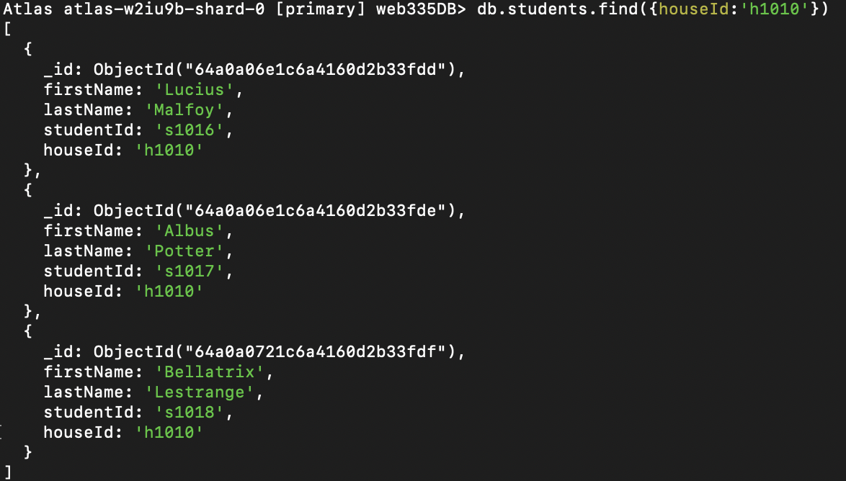

Students listed by house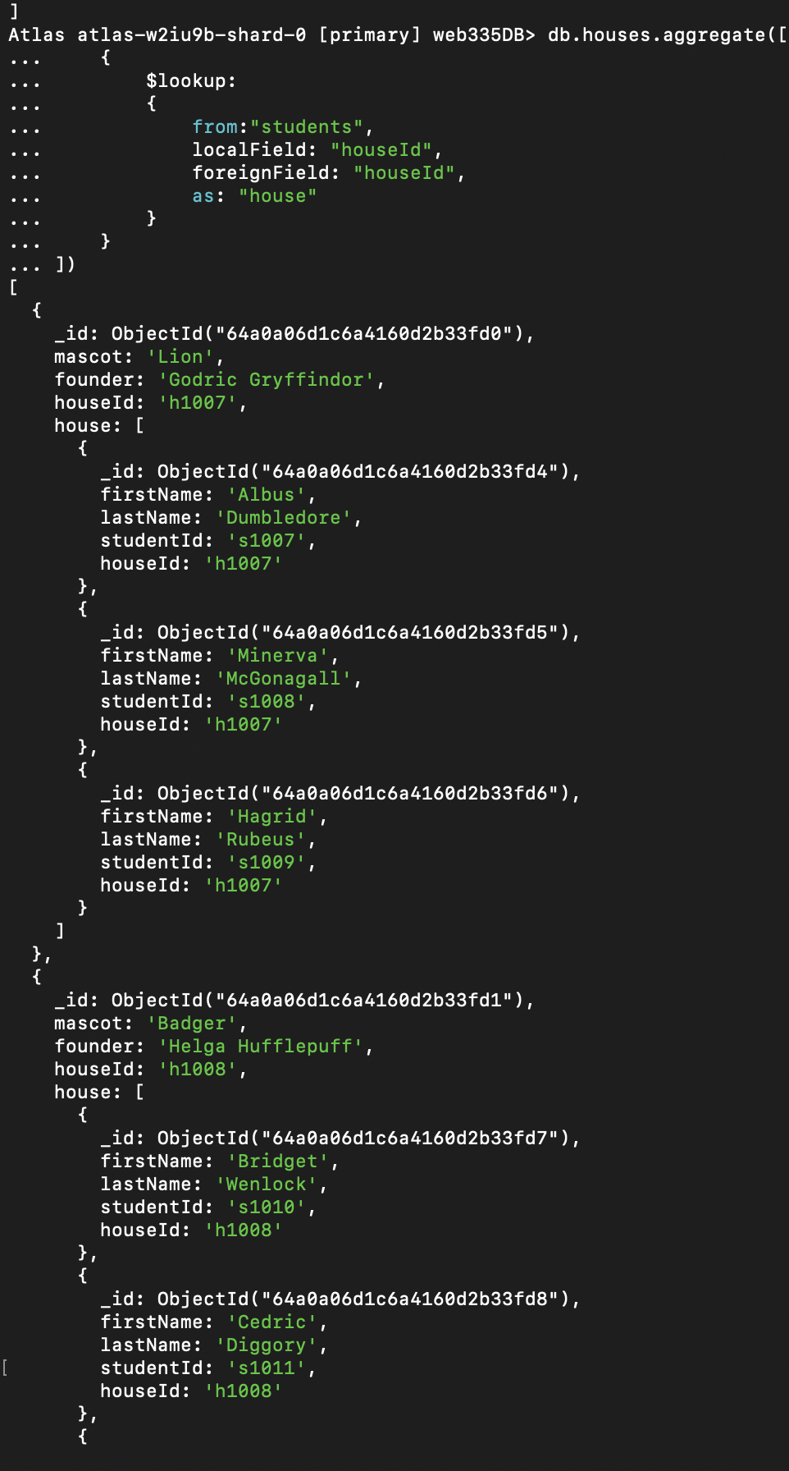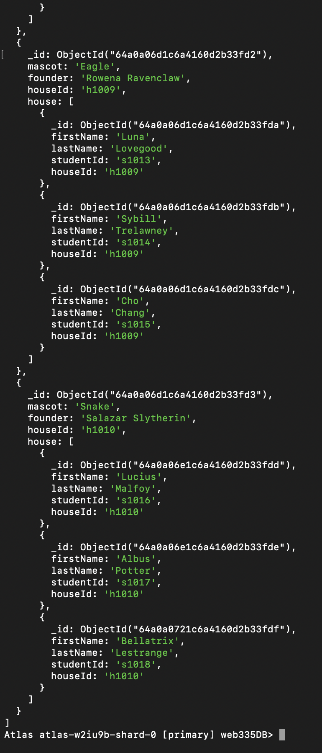

A list of students who 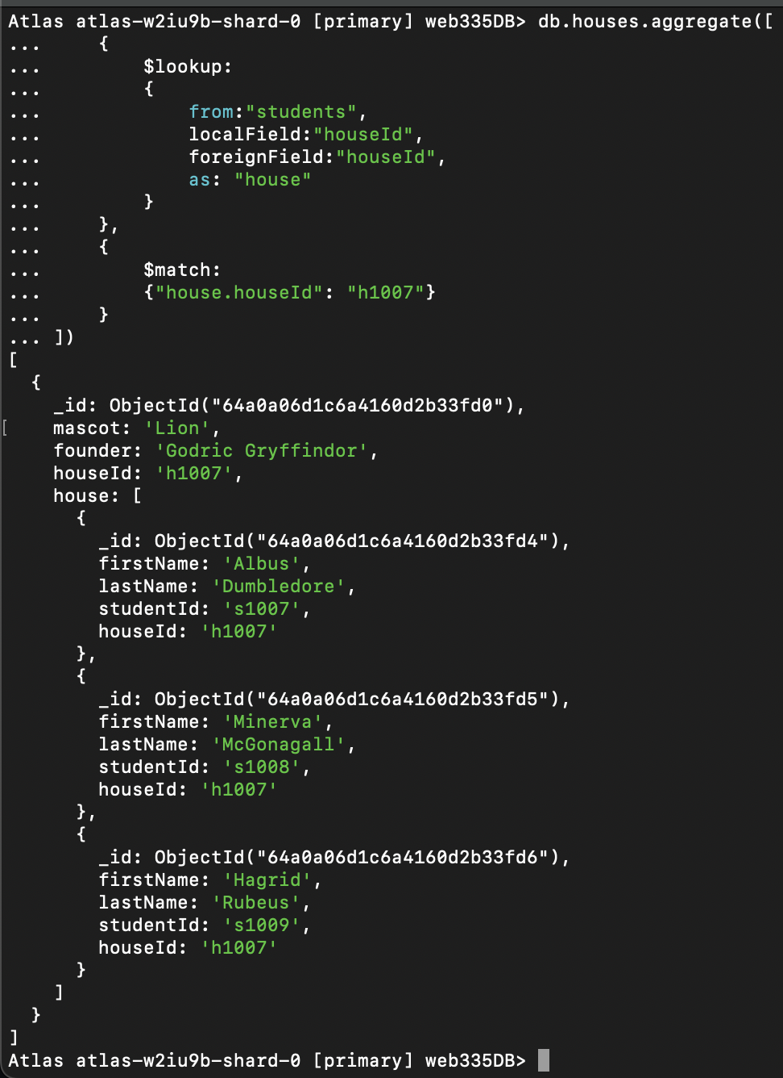are in Gryffindor

A list of students who have the Eagle as their mascot