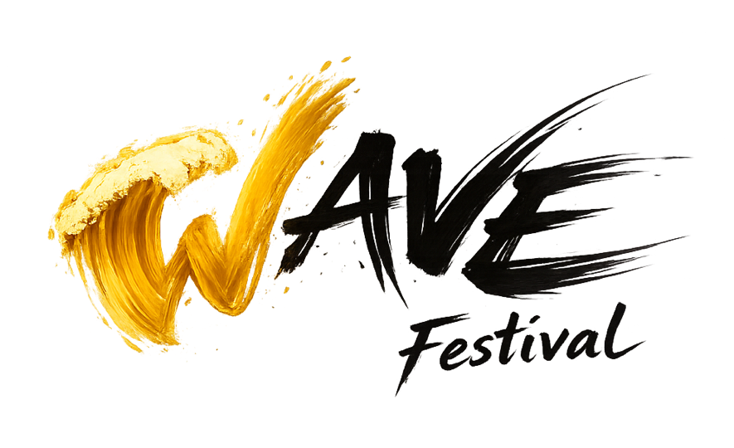
WOMEN AMPLIFY THE VOICE OF ELECTROACOUSTIC MUSIC FESTIVAL
SUBMISSION FORM

- Name
Your name as you would like it to appear in the WAVE Fest program

- Bio
Your bio as you would like it to appear in the WAVE Fest program (maximum of 250 words). You may attach the bio after the form.

- Country
Your country as you would like it to appear in the WAVE Fest program

- Title
Your title as you would like it to appear in the WAVE Fest program

- Program Note
Maximum of 250 words

- Year Completed

- Duration
Format is mm:ss, for example: 04:33. Under 7 minutes is preferred.

- Number of Audio Channels
1, 2, 3, 4, 5, 6, 7, or 8.

- Does your work include video?
Please note that WAVE Fest is only able to show single-channel videos.

- Media Links
Please submit works as links to external files. Please ensure that all author information is stripped from files and that links are completely anonymous. Links should be made accessible until WAVE Fest on May 9, 2026.

- By initialing here, I confirm that I have read the criteria for applicants listed in the call for works and that I meet the listed criteria.

