作 业
姓名：梁炜杰 学号：26261216002
题1（2.3） 仿真8位计数器
`timescale 1ns / 1ps
module counter8 (
input wire clk, // 时钟，上升沿有效
input wire clr, // 异步清零，高电平有效
output reg [7:0] cnt // 8 位计数输出
);
always @(posedge clk or posedge clr) begin
if (clr)
cnt <= 8'd0;
else
cnt <= cnt + 8'd1;
end
endmodule

/*---------------testbench------------------*/

`timescale 1ns / 1ps
module counter8_tb;
reg clk;
reg clr;
wire [7:0] cnt;

counter8 dut (
.clk (clk),
.clr (clr),
.cnt (cnt)
);

initial clk = 1'b0;
always #5 clk = ~clk;

integer i;

initial begin
clr = 1'b1;
#20;

clr = 1'b0;
for (i = 1; i <= 260; i = i + 1) begin
@(posedge clk);
#1;
end

@(posedge clk);
clr = 1'b1;
#1;

$stop;
end
endmodule

题2（2.3） 仿真2位比较器
`timescale 1ns / 1ps
module comp2 (
input wire [1:0] a,
input wire [1:0] b,
output wire a_gt_b,
output wire a_eq_b,
output wire a_lt_b
);
assign a_gt_b = (a > b);
assign a_eq_b = (a == b);
assign a_lt_b = (a < b);
endmodule

/*---------------testbench------------------*/

`timescale 1ns / 1ps

module comp2_tb;

reg [1:0] a, b;
wire a_gt_b, a_eq_b, a_lt_b;

integer ia, ib;

comp2 dut (
.a (a),
.b (b),
.a_gt_b (a_gt_b),
.a_eq_b (a_eq_b),
.a_lt_b (a_lt_b)
);

initial begin
for (ia = 0; ia < 4; ia = ia + 1) begin
for (ib = 0; ib < 4; ib = ib + 1) begin
a = ia[1:0];
b = ib[1:0];
#1;
end
end
$stop;
end

endmodule

题3（2.3） 仿真三态驱动器
`timescale 1ns / 1ps

module tristate (
input wire [7:0] in,
input wire en,
output wire [7:0] out // tri-state output
);

assign out = en ? in : 8'bz;

endmodule

/*---------------testbench------------------*/

`timescale 1ns / 1ps

module tristate_tb;

reg [7:0] in;
reg en;
wire [7:0] out;

integer i;

tristate dut (
.in (in),
.en (en),
.out (out)
);

initial begin
en = 1'b1;
for (i = 0; i < 256; i = i + 1) begin
in = i[7:0];
#1;
end

en = 1'b0;
for (i = 0; i < 8; i = i + 1) begin
in = i[7:0];
#1;
end

$stop;
end

endmodule

题4（2.4） 用reg型变量生成触发器
`timescale 1ns / 1ps

module reg_trigger (
input wire clk, // 时钟
input wire rst, // 异步高电平复位
input wire d, // D 输入
output reg q // Q 输出（reg 型）
);

always @(posedge clk or posedge rst) begin
if (rst)
q <= 1'b0;
else
q <= d;
end

endmodule
/*---------------testbench------------------*/

`timescale 1ns / 1ps

module reg_trigger_tb;

reg clk, rst, d;
wire q;

integer i;

reg_trigger dut (
.clk (clk),
.rst (rst),
.d (d),
.q (q)
);

initial clk = 1'b0;
always #5 clk = ~clk;

initial begin
rst = 1'b1;
d = 1'b1;
#20;

rst = 1'b0;
for (i = 0; i < 10; i = i + 1) begin
d = i[0];
@(posedge clk);
#1;
end

rst = 1'b1;
d = 1'b1;
@(posedge clk);
#1;

$stop;
end

endmodule

题5（2.5） 仿真除法和求模运算
`timescale 1ns / 1ps

module div_mod (
input wire [7:0] a,
input wire [7:0] b,
output wire [7:0] quotient,
output wire [7:0] modulus
);

assign quotient = a / b;
assign modulus = a % b;

endmodule

/*---------------testbench------------------*/

`timescale 1ns / 1ps

module div_mod_tb;

reg [7:0] a, b;
wire [7:0] quotient, modulus;

integer ia, ib;

div_mod dut (
.a (a),
.b (b),
.quotient (quotient),
.modulus (modulus)
);

initial begin
for (ia = 0; ia < 256; ia = ia + 1) begin
for (ib = 1; ib < 16; ib = ib + 1) begin
a = ia[7:0];
b = ib[7:0];
#1;
end
end
$stop;
end

endmodule

题6（2.5） 仿真逻辑与和按位与运算
`timescale 1ns / 1ps

module logic_bitwise_and (
input wire [3:0] a,
input wire [3:0] b,
output wire logic_and, // 1 位
output wire [3:0] bitwise_and // 4 位
);

assign logic_and = a && b;
assign bitwise_and = a & b;

endmodule

/*---------------testbench------------------*/

`timescale 1ns / 1ps

module logic_bitwise_and_tb;

reg [3:0] a, b;
wire logic_and;
wire [3:0] bitwise_and;

integer i;

logic_bitwise_and dut (
.a (a),
.b (b),
.logic_and (logic_and),
.bitwise_and (bitwise_and)
);

initial begin
for (i = 0; i < 256; i = i + 1) begin
a = i[7:4];
b = i[3:0];
#1;
end
$stop;
end

endmodule
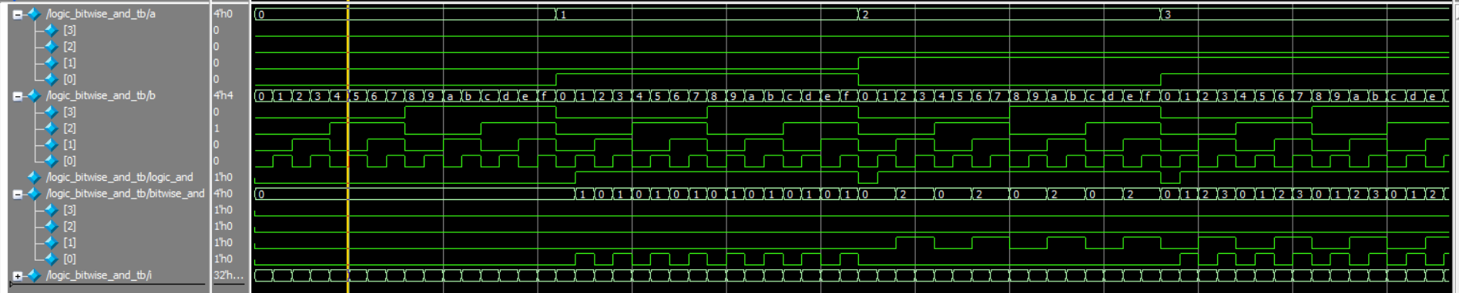

题7（2.6） 仿真非阻塞方式赋值
`timescale 1ns / 1ps

module nonblocking_reg (
input wire clk,
input wire rst,
input wire [3:0] a,
output reg [3:0] b,
output reg [3:0] c
);

always @(posedge clk or posedge rst) begin
if (rst) begin
b <= 4'd0;
c <= 4'd0;
end
else begin
b <= a;
c <= b; // 右侧的 b 是这一拍还没更新的旧值
end
end

endmodule
/*---------------testbench------------------*/

`timescale 1ns / 1ps
module nonblocking_reg_tb;
reg clk, rst;
reg [3:0] a;
wire [3:0] b, c;

integer i;

nonblocking_reg dut (
.clk (clk),
.rst (rst),
.a (a),
.b (b),
.c (c)
);

initial clk = 1'b0;
always #5 clk = ~clk;

initial begin
rst = 1'b1;
a = 4'd0;
#20;
rst = 1'b0;

for (i = 0; i < 12; i = i + 1) begin
a = i[3:0];
@(posedge clk);
#1;
end

$stop;
end

endmodule

题8（2.6） 仿真阻塞方式赋值
`timescale 1ns / 1ps
module blocking_reg (
input wire clk,
input wire rst,
input wire [3:0] a,
output reg [3:0] b,
output reg [3:0] c
);

always @(posedge clk or posedge rst) begin
if (rst) begin
b <= 4'd0;
c <= 4'd0;
end
else begin
b = a;
c = b; // 上一条已经用 = 更新了 b，这里拿到的就是本拍 a
end
end

endmodule
/*---------------testbench------------------*/

`timescale 1ns / 1ps
module blocking_reg_tb;

reg clk, rst;
reg [3:0] a;
wire [3:0] b, c;

integer i;

blocking_reg dut (
.clk (clk),
.rst (rst),
.a (a),
.b (b),
.c (c)
);

initial clk = 1'b0;
always #5 clk = ~clk;

initial begin
rst = 1'b1;
a = 4'd0;
#20;
rst = 1'b0;

for (i = 0; i < 12; i = i + 1) begin
a = i[3:0];
@(posedge clk);
#1;
end

$stop;
end
endmodule

题9（2.6） 用顺序块和延迟控制组合产生一个时序波形
`timescale 1ns / 1ps

module wave_seq (
input wire clk,
input wire rst,
output reg sig
);

`ifdef SYNTHESIS

// Quartus 综合版本：用计数器产生 0/1 交替波形
reg [2:0] cnt;

always @(posedge clk or posedge rst) begin
if (rst)
cnt <= 3'd0;
else
cnt <= cnt + 3'd1;
end

always @(posedge clk or posedge rst) begin
if (rst)
sig <= 1'b0;
else
sig <= (cnt < 3) ? 1'b0 : 1'b1;
end

`else

// ModelSim 仿真版本：顺序块，每条 #10 相对上一条执行，自然累加
// 实际时刻：0 / 10 / 20 / 30 / 40 / 50 ns
initial begin
sig = 1'b0;
#10 sig = 1'b1;
#10 sig = 1'b0;
#10 sig = 1'b1;
#10 sig = 1'b0;
#10 sig = 1'b1;
end

`endif

endmodule

/*---------------testbench------------------*/

`timescale 1ns / 1ps

module wave_seq_tb;

reg clk;
reg rst;
wire sig;

wave_seq dut (
.clk (clk),
.rst (rst),
.sig (sig)
);

initial clk = 1'b0;
always #5 clk = ~clk;

initial rst = 1'b0;

initial begin
#60;
$stop;
end

endmodule

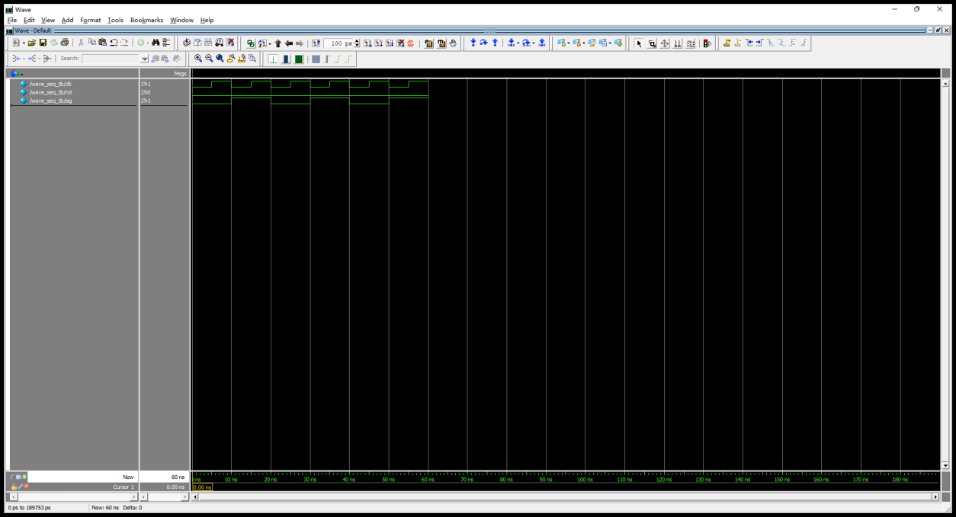

题10（2.6） 用并行块和延迟控制组合产生一个与题9相同的时序波形
`timescale 1ns / 1ps

module wave_par (
input wire clk,
input wire rst,
output reg sig
);

`ifdef SYNTHESIS

// Quartus 综合版本：用计数器产生 0/1 交替波形
reg [2:0] cnt;

always @(posedge clk or posedge rst) begin
if (rst)
cnt <= 3'd0;
else
cnt <= cnt + 3'd1;
end

always @(posedge clk or posedge rst) begin
if (rst)
sig <= 1'b0;
else
sig <= (cnt < 3) ? 1'b0 : 1'b1;
end

`else

// ModelSim 仿真版本：并行块，每条 #N 都从 fork 时刻起算
// 要得到与顺序块相同的波形，延迟值必须写成 10/20/30/40/50
initial fork
sig = 1'b0;
#10 sig = 1'b1;
#20 sig = 1'b0;
#30 sig = 1'b1;
#40 sig = 1'b0;
#50 sig = 1'b1;
join

`endif

endmodule

/*---------------testbench------------------*/

`timescale 1ns / 1ps

module wave_par_tb;

reg clk;
reg rst;
wire sig;

wave_par dut (
.clk (clk),
.rst (rst),
.sig (sig)
);

initial clk = 1'b0;
always #5 clk = ~clk;

initial rst = 1'b0;

initial begin
#60;
$stop;
end

endmodule

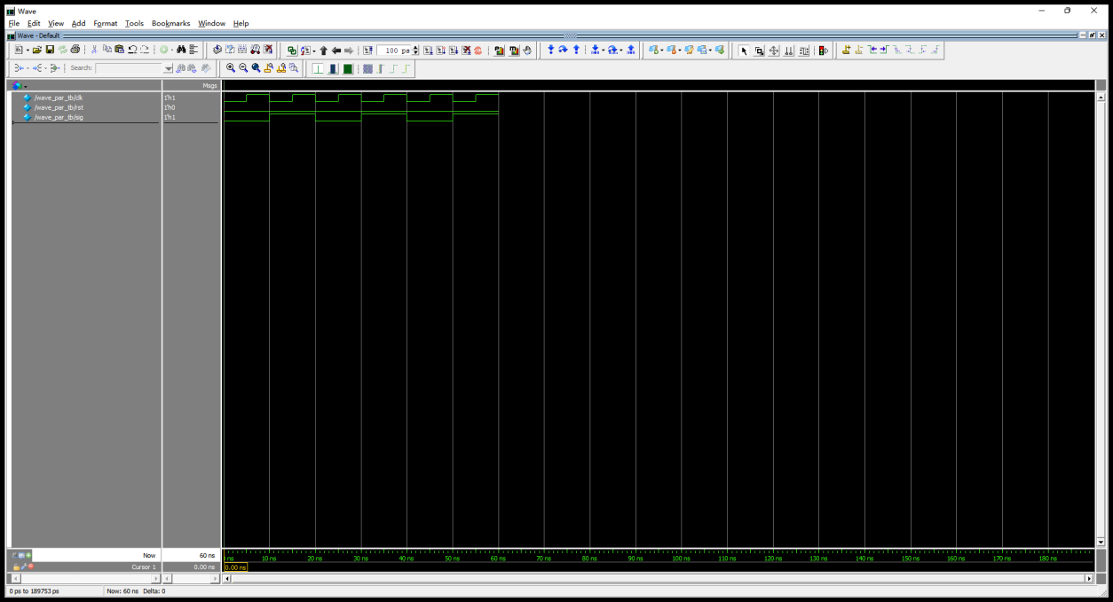

题11（2.6） 仿真模为60的BCD码加法计数器
`timescale 1ns / 1ps

module bcd60 (
input wire clk,
input wire clr, // 异步高电平清零
output reg [3:0] units, // 个位 BCD 0-9
output reg [2:0] tens // 十位 BCD 0-5（3 位足够）
);

always @(posedge clk or posedge clr) begin
if (clr) begin
units <= 4'd0;
tens <= 3'd0;
end
else if (units == 4'd9 && tens == 3'd5) begin
// 59 -> 00 归零
units <= 4'd0;
tens <= 3'd0;
end
else if (units == 4'd9) begin
// 个位到顶，十位 +1，个位归零
units <= 4'd0;
tens <= tens + 3'd1;
end
else begin
units <= units + 4'd1;
end
end

endmodule

/*---------------testbench------------------*/

`timescale 1ns / 1ps

module bcd60_tb;

reg clk, clr;
wire [3:0] units;
wire [2:0] tens;

integer i;

bcd60 dut (
.clk (clk),
.clr (clr),
.units (units),
.tens (tens)
);

initial clk = 0;
always #5 clk = ~clk;

initial begin
clr = 1'b1;
#20;
clr = 1'b0;

for (i = 1; i <= 125; i = i + 1) begin
@(posedge clk);
#1;
end

clr = 1'b1;
#1;

$stop;
end

endmodule

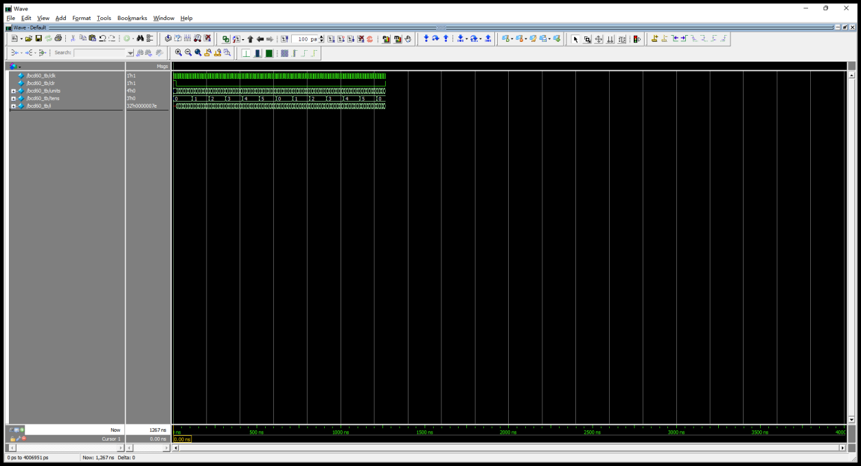

题12（2.6） 仿真数据选择器（采用casez语句）
`timescale 1ns / 1ps

module casez_mux (
input wire [3:0] a, b, c, d,
input wire [1:0] sel,
output reg [3:0] y
);

always @(*) begin
casez (sel)
2'b00: y = a;
2'b01: y = b;
2'b10: y = c;
2'b11: y = d;
default: y = 4'b0000;
endcase
end

endmodule

/*---------------testbench------------------*/

`timescale 1ns / 1ps

module casez_mux_tb;

reg [3:0] a, b, c, d;
reg [1:0] sel;
wire [3:0] y;

integer ia, ib, ic, id, isel;

casez_mux dut (
.a (a),
.b (b),
.c (c),
.d (d),
.sel (sel),
.y (y)
);

initial begin
a = 4'd1; b = 4'd2; c = 4'd3; d = 4'd4;

sel = 2'b00; #1;
sel = 2'b01; #1;
sel = 2'b10; #1;
sel = 2'b11; #1;

for (ia = 0; ia < 16; ia = ia + 1) begin
for (ib = 0; ib < 16; ib = ib + 1) begin
for (ic = 0; ic < 16; ic = ic + 1) begin
for (id = 0; id < 16; id = id + 1) begin
for (isel = 0; isel < 4; isel = isel + 1) begin
a = ia[3:0]; b = ib[3:0]; c = ic[3:0]; d = id[3:0];
sel = isel[1:0];
#1;
end
end
end
end
end

$stop;
end

endmodule

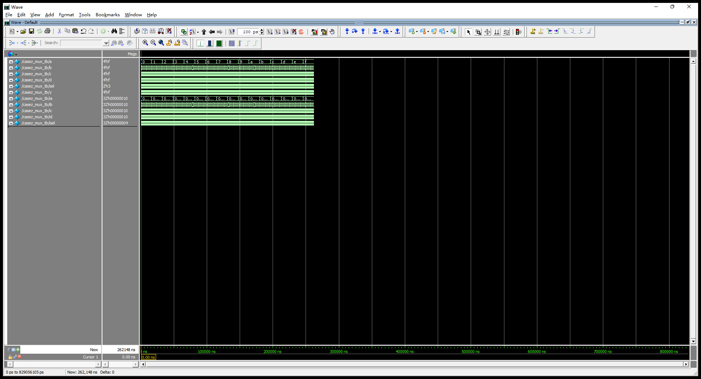

题13（2.6） 仿真7人投票表决器（采用for语句）：若4人或以上投票赞成，则表决通过
`timescale 1ns / 1ps

module vote7 (
input wire [6:0] vote,
output reg pass
);

integer i;
reg [2:0] count; // 最多 7，3 位足够

always @(*) begin
count = 3'd0;
for (i = 0; i < 7; i = i + 1) begin
if (vote[i])
count = count + 3'd1;
end
pass = (count >= 3'd4);
end

endmodule

/*---------------testbench------------------*/

`timescale 1ns / 1ps

module vote7_tb;

reg [6:0] vote;
wire pass;

integer i;

vote7 dut (
.vote (vote),
.pass (pass)
);

initial begin
for (i = 0; i < 128; i = i + 1) begin
vote = i[6:0];
#1;
end
$stop;
end

endmodule

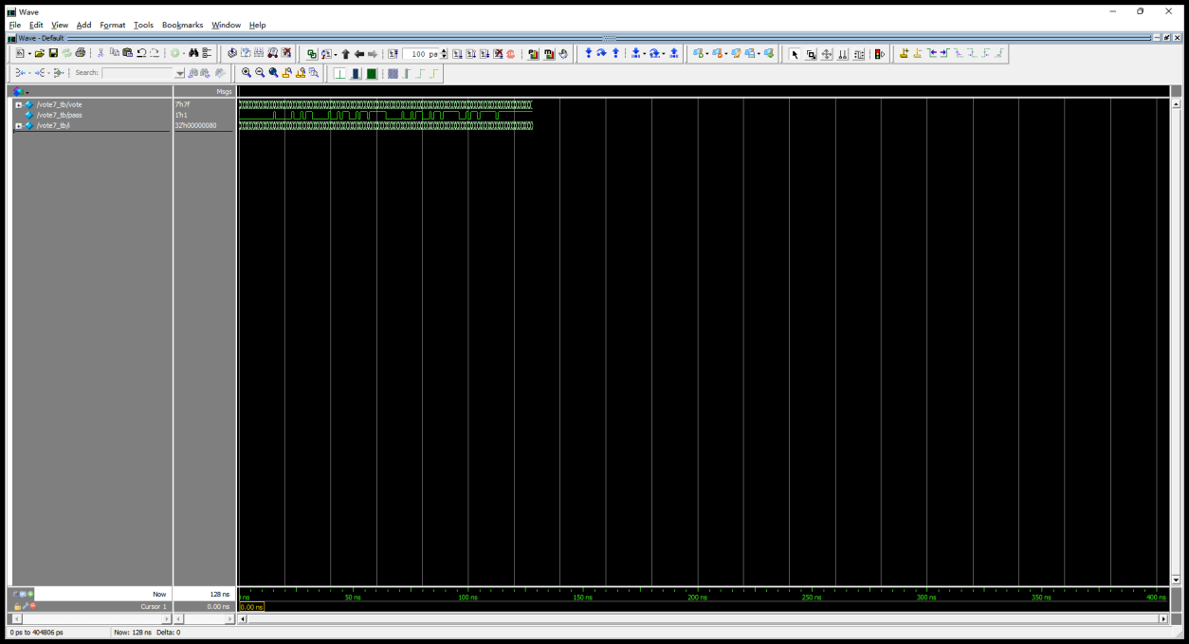

题14（2.6） 仿真8位二进制乘法器
`timescale 1ns / 1ps

module mult8 (
input wire [7:0] a,
input wire [7:0] b,
output wire [15:0] product
);

assign product = a * b;

endmodule

/*---------------testbench------------------*/

`timescale 1ns / 1ps

module mult8_tb;

reg [7:0] a, b;
wire [15:0] product;

integer ia, ib;

mult8 dut (
.a (a),
.b (b),
.product (product)
);

initial begin
for (ia = 0; ia < 256; ia = ia + 1) begin
for (ib = 0; ib < 256; ib = ib + 1) begin
a = ia[7:0];
b = ib[7:0];
#1;
end
end
$stop;
end

endmodule

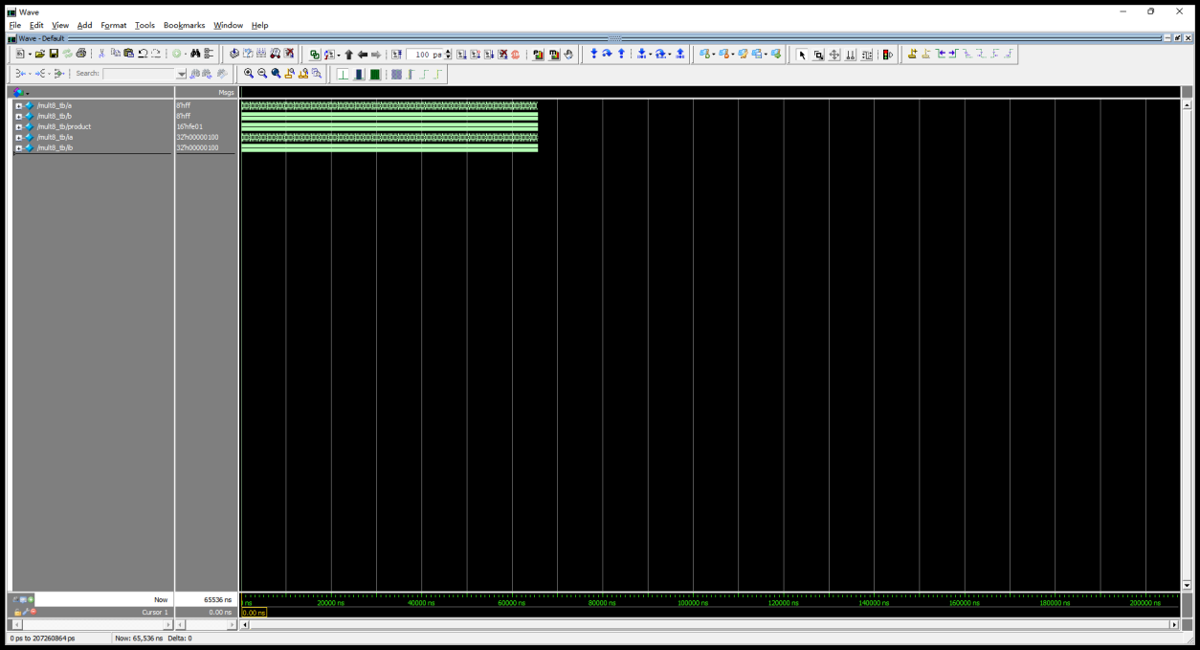

题15（2.6） 仿真计数器对8位二进制数中值为1的位进行计数
`timescale 1ns / 1ps

module bit_counter (
input wire [7:0] data,
output reg [3:0] count
);

integer i;

always @(*) begin
count = 4'd0;
for (i = 0; i < 8; i = i + 1) begin
if (data[i])
count = count + 4'd1;
end
end

endmodule

/*---------------testbench------------------*/

`timescale 1ns / 1ps

module bit_counter_tb;

reg [7:0] data;
wire [3:0] count;

integer i;

bit_counter dut (
.data (data),
.count (count)
);

initial begin
for (i = 0; i < 256; i = i + 1) begin
data = i[7:0];
#1;
end
$stop;
end

endmodule

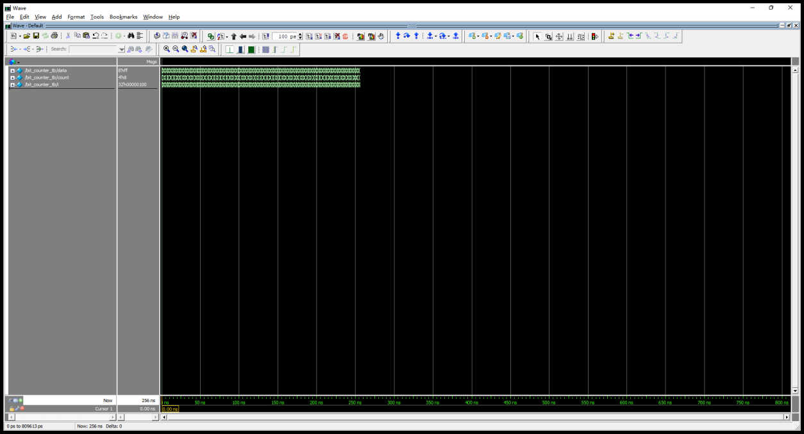

题16（2.6） T’FF和8位二进制计数器（采用always语句）
`timescale 1ns / 1ps

module tff_counter (
input wire clk,
input wire clr,
output wire [7:0] cnt
);

// 用 8 个 reg 分别实现 T'FF，然后级联
reg [7:0] q;
integer i;

// 方法一：用 always @(posedge clk) 整块统一处理（推荐）
// 这样整个计数器都是同步的，避免 ripple counter 的级联延迟问题
// 教材说 "采用 always 语句"，所以用单 always 块最稳妥
always @(posedge clk or posedge clr) begin
if (clr) begin
q <= 8'd0;
end
else begin
q <= q + 8'd1; // T'FF 级联的效果就是整体 +1
end
end

assign cnt = q;

endmodule

/*---------------testbench------------------*/

`timescale 1ns / 1ps

module tff_counter_tb;

reg clk, clr;
wire [7:0] cnt;

integer i;

tff_counter dut (
.clk (clk),
.clr (clr),
.cnt (cnt)
);

initial clk = 0;
always #5 clk = ~clk;

initial begin
clr = 1'b1;
#20;
clr = 1'b0;

for (i = 1; i <= 515; i = i + 1) begin
@(posedge clk);
#1;
end

clr = 1'b1;
#1;

$stop;
end

endmodule

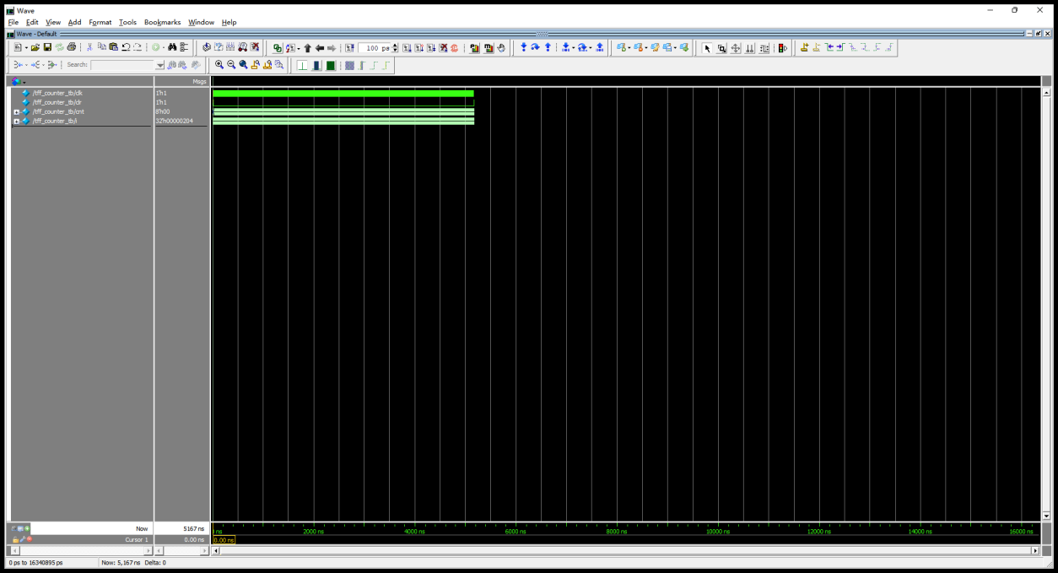

题17（2.6） 通过任务调用完成4个4位二进制输入数据的冒泡排序
`timescale 1ns / 1ps

module bubble_sort (
input wire [3:0] in0, in1, in2, in3,
output wire [3:0] out0, out1, out2, out3
);

// 内部暂存寄存器
reg [3:0] a, b, c, d;

// task：对 4 个输入冒泡排序，结果放在 a,b,c,d 里
task sort_4;
input [3:0] x0, x1, x2, x3;
output [3:0] y0, y1, y2, y3;

reg [3:0] t0, t1, t2, t3;
reg [3:0] tmp;
integer j;

begin
t0 = x0; t1 = x1; t2 = x2; t3 = x3;

// 共 4 轮冒泡
for (j = 0; j < 3; j = j + 1) begin
// 比较相邻两对
if (t0 > t1) begin tmp = t0; t0 = t1; t1 = tmp; end
if (t1 > t2) begin tmp = t1; t1 = t2; t2 = tmp; end
if (t2 > t3) begin tmp = t2; t2 = t3; t3 = tmp; end
end

y0 = t0; y1 = t1; y2 = t2; y3 = t3;
end
endtask

always @(*) begin
sort_4(in0, in1, in2, in3, a, b, c, d);
end

assign out0 = a;
assign out1 = b;
assign out2 = c;
assign out3 = d;

endmodule

/*---------------testbench------------------*/

`timescale 1ns / 1ps

module bubble_sort_tb;

reg [3:0] in0, in1, in2, in3;
wire [3:0] out0, out1, out2, out3;

integer i;

bubble_sort dut (
.in0 (in0), .in1 (in1), .in2 (in2), .in3 (in3),
.out0 (out0), .out1 (out1), .out2 (out2), .out3 (out3)
);

initial begin
for (i = 0; i < 2000; i = i + 1) begin
in0 = (i * 7 + 3) & 4'hF;
in1 = (i * 13 + 11) & 4'hF;
in2 = (i * 5 + 17) & 4'hF;
in3 = (i * 11 + 23) & 4'hF;
#1;
end

in0 = 4'd15; in1 = 4'd10; in2 = 4'd5; in3 = 4'd0; #1;
in0 = 4'd0; in1 = 4'd0; in2 = 4'd0; in3 = 4'd0; #1;

$stop;
end

endmodule

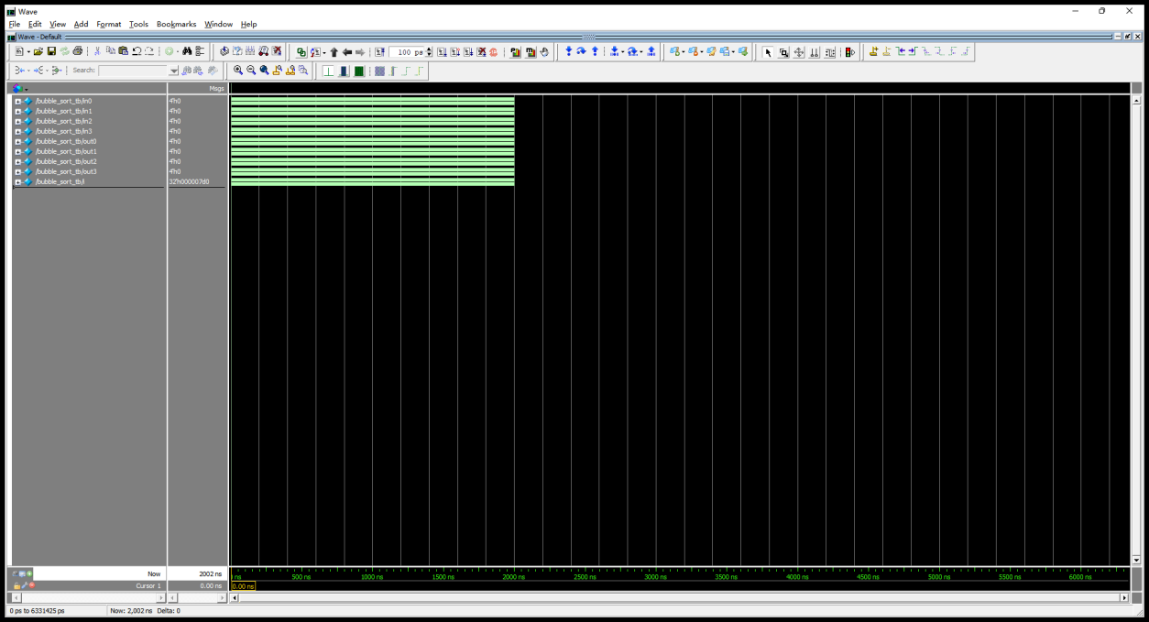

题18（2.6） 仿真阶乘运算
`timescale 1ns / 1ps

module factorial (
input wire [3:0] n, // 0~12
output wire [31:0] fact
);

// 用 function 计算阶乘
function [31:0] fact_fn;
input [3:0] k;
integer i;
begin
fact_fn = 32'd1;
for (i = 1; i <= k; i = i + 1)
fact_fn = fact_fn * i;
end
endfunction

assign fact = fact_fn(n);

endmodule

/*---------------testbench------------------*/

`timescale 1ns / 1ps

module factorial_tb;

reg [3:0] n;
wire [31:0] fact;

integer i;

factorial dut (
.n (n),
.fact (fact)
);

initial begin
for (i = 0; i <= 12; i = i + 1) begin
n = i[3:0];
#1;
end
$stop;
end

endmodule

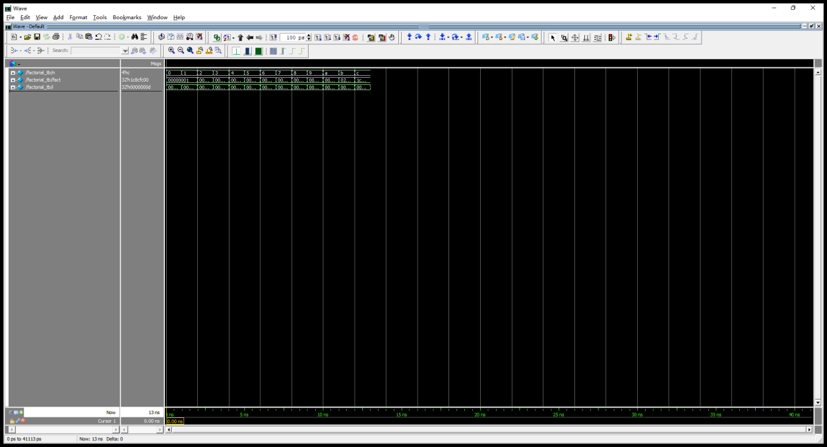

题19（2.7） 仿真4选1数据选择器
`timescale 1ns / 1ps

module mux4_1 (
input wire [3:0] d0, d1, d2, d3,
input wire [1:0] sel,
output reg [3:0] y
);

always @(*) begin
case (sel)
2'b00: y = d0;
2'b01: y = d1;
2'b10: y = d2;
2'b11: y = d3;
default: y = 4'b0000;
endcase
end

endmodule

/*---------------testbench------------------*/

`timescale 1ns / 1ps

module mux4_1_tb;

reg [3:0] d0, d1, d2, d3;
reg [1:0] sel;
wire [3:0] y;

integer i, j;

mux4_1 dut (
.d0 (d0), .d1 (d1), .d2 (d2), .d3 (d3),
.sel (sel),
.y (y)
);

initial begin
for (sel = 2'b00; sel < 2'b11; sel = sel + 1) begin
for (i = 0; i < 256; i = i + 1) begin
d0 = i[3:0]; d1 = i[7:4];
d2 = (i * 3) & 4'hF; d3 = (i * 7 + 1) & 4'hF;
for (j = 0; j < 2; j = j + 1) begin
#1;
end
end
end
sel = 2'b11;
for (i = 0; i < 256; i = i + 1) begin
d0 = i[3:0]; d1 = i[7:4];
d2 = (i * 3) & 4'hF; d3 = (i * 7 + 1) & 4'hF;
#1;
end

$stop;
end

endmodule



