Typing Instructions ICACIA Documents
Wang Xiaoming¹, john W. T. lee² *, Hu jian¹
¹Machine Learning Center, Faculty of Mathematics and Computer Science, Hebei University, Baoding 071002, China
²Department of computing, The Hong Kong Polytechnic University, Hung Hom, Kowloon, Hong Kong
E-MAIL: wangxz@mail.hbu.edu.cn, john lee@comp.polyu.edu.hk

Abstract:
Type the abstract using Times New Roman font with point size 9. The abstract is an essential part of the paper. Use short, direct, and complete sentences. It should be as brief as possible and concise. It should be complete, self-explanatory, and not require reference to the paper itself. The abstract should be informative giving the scope and emphasize the main conclusions, results, or significance of the work described. Do not use the first person; do not include mathematical expressions; do not refer to the reference, and try to avoid acronyms.
Keywords:
Tracking; Estimation; Information fusion; Resource management; With point size 9

Introduction
  - Required format
These are instructions for authors typesetting for The IEEE International Conference on Apperceiving Computing and Intelligence Analysis 2008 to be held in Chengdu, on Nov 29-30 2008. This document has been prepared using the required format. The electronic copy of this document can be found in: http://icacia.uestc.edu.cn. or http://202.115.6.206
The paper is to be written in two-column format and be right and left justified. The column width should be 85 mm (3.35 inches). The gap between the two columns should be 5 mm (0.2 inches).
  - Instructions for authors
In order for the proceedings to be ready for distribution at the conference, an electronic copy of the final version of your paper (the Camera-Ready paper) must be submitted (WORD) to the web site. Please follow the submission instructions shown on the web site.

Formatting instructions
MS Word users: please use the paragraph styles contained in this document: Title, Author, Affiliation, Abstract, Keywords, Body Text, Equation, Reference, Figure, and Caption. Try not to change the styles manually.

Length
Papers should be limited to 4 pages. Papers longer than 4 pages will be subject to extra fees based on their length.

Title
Type the title approximately 4.9 centimeters below the top border of the A4 paper sheet and use Times New Roman font with 14-point size in capital letters. Center the title (horizontally) on the page. Leave approximately 0.6 cm (0.24 inches) between the title and the name (in capital letters) and affiliation of yourself (and of your co-authors, if any), 0.6 cm (0.24 inches) between the name and affiliation, 1.8 cm (0.72 inches) between the affiliation and abstract. Type name(s), affiliation (s) and email(s) in 10 points and center them (horizontally) on the page.

Spacing
Each section (or subsection) should be separated from the previous text by 0.6 cm (as indicated in the format/paragraph menu). Please remove any unnecessary blank lines, which may make your article look more concise.

Section and subsection headings
Number section and subsection headings consecutively in Arabic numbers and type them in bold. Use point size 10 for section headings and 10 for subsection headings. Avoid using too many capital letters. Keep section and subsection headings always flushed left. If any further subdivision of a subsection is needed the titles should be 10 point.

Main text
Use 1.5 centimeters (0.6 inches) for the left and right margins. Use Times New Roman and font size 10 for text (character size). Do not use bold in the main text; if you want to emphasize specific parts of the main text, use italics. Start a new paragraph by indenting it from the left margin (and not by inserting a blank line), except under a section or subsection heading. The text should be prepared with a double column format and single line spacing.

Tables
All tables must be numbered consecutively (in Arabic numbers). Table headings should be placed (centered) above the table. Place tables as close as possible to where they are mentioned in the main text.
Table 1 Result Comparison
Name | Test Accuracy（%） | Parameter Used
Name1 | 82.3 | 1.82MB
Name2 | 35.4 | 2.61MB
Name3 | 49.5 | 1.82MB
Name4 | 85.6 | 2.61MB

Figures
All illustrations should be original drawings or photographic prints of originals. Photographs should be glossy prints. Photocopies are often not good enough and should be avoided. All illustrations must be numbered consecutively (i.e., not section-wise), using Arabic numbers. Center figure captions beneath the figure (see Fig. 1). If possible, do not assemble figures at the back of your article, but place them as close as possible to where they are mentioned in the main text. No part of a figure should go beyond the typing area. Captions should appear (centered) below graphical objects, as in Fig. 1.

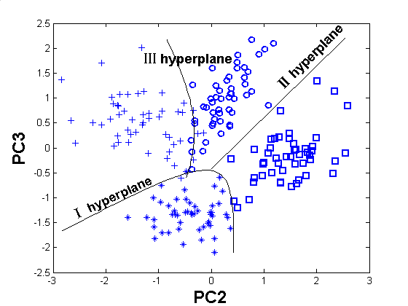
Fig. 1 Figure’s name

Mathematical formulas
Mathematical formulas should be roughly centered and have to be numbered as formula (1).
(1)

References
References to the literature should be mentioned in the main text by an Arabic number in square brackets [1][2], List these (in cited order) at the very end of your paper (under the heading References). Start each reference on a new line with its number in square brackets [3].

Copyright form and copyright notice
One of the authors must submit a signed copyright form to the Publications Chair before the final version of the paper can be accepted for publication. The copyright form is available from the conference web site
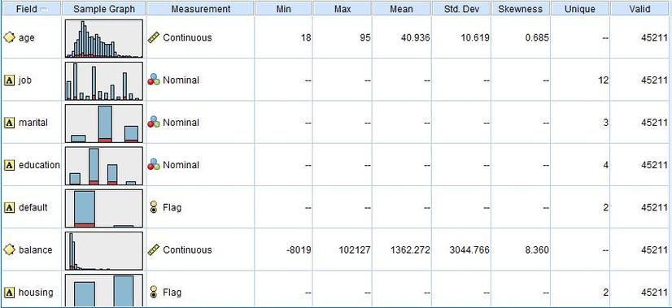
Fig. 2 The name of the two-column-occupied Figure

Fine tuning
- Do not end a page with a section or subsection heading.
- Do not include page numbers in the text.

Final version
After proofreading your paper, it must be submitted on the ICACIA’08 web site electronically using WORD and PDF format. Do not send hard copies or use other file formats – they will not be accepted. Proper usage of the English language is expected of all submissions (i.e., Camera-ready papers).
In order to build the indices for the CD-ROM, we need the title and author information for your paper entered into the PDF file.
In Acrobat, select the menu option File→Document Properties →Summary and then fill in your paper title and author information.
In Word, select the menu option File→Properties, and then fill in the dialog box with your paper's title and author information.
Please use only the standard fonts that come with the system and standard font encoding schemes. If you use your own fonts, please make sure that the fonts are fully embedded into the PDF file. If you create your file on an operating system running a language other than English, please make sure that your file can be opened correctly on all computers. Missing fonts and different font encoding schemes are the main reasons for read errors in Acrobat.
Failure to follow the above guidelines may result in a submission being rejected for publication in the conference proceedings and CD ROM.

Conclusions
In this sample paper, we have presented the formatting instructions forICACIA’08.

Acknowledgements。
This paper is supported by the Machine Learning Centre of the Hebei University, Hong Kong Polytechnic University, and the IEEE Systems, Man and Cybernetics Society.

References
- Peter. C. Author, “Paper’s name”, Proceeding of ICMLC2002 Conference, Beijing, pp. 111-116, November 2002.
- John. B. Author, and A. Friend, “Journal paper’s name”, Journal’s name, Vol 39, No. 1, pp. 222-226, Feb. 2001.
- Xizhao Wang, His book’ name, Publisher, Location, Year.

* Corresponding author

