**CS 234 Algorithms and Problem-Solving – Project Proposal**

**Project Proposal Title here……**

e.g. A Java Implementation of ………… System

|  |  |
| --- | --- |
| First Author  Institution1  Institution1 address  firstauthor@i1.org | Second Author  Institution2  First line of institution2 address  secondauthor@i1.org |

Note: The title should precisely state the subject of the project. The entire project proposal is about 3~4 pages (can exceed if needed) including text, figure, table, references. **Please replace all the red-color sample text using your own words.**

**Project Description**

Please briefly introduce your project and preliminary idea about implementing this project.

e.g., This project aims to implement a Java application that. ………. To achieve this, we propose to …..

**Significance**

Please describe why it’s important to implement this project.

e.g., The project we work on will be helpful to better understand the basics and principles in Java programming and algorithms, and ………..

**Project Specification and Design**

Four main steps in program development process include: specification, design, implementation and testing. Please write the first 2 steps here. You can refer to the lecture slides of Chapter 1. Specifically,

Step1: Specification which includes problem specification and problem decomposition.

Step2: Design which includes class design (variables and methods). In this step, you need to use UML in a figure to design one or more classes. A sample UML is as follows. Note: In addition to UML, please add some description text to briefly specify the purpose of the classes, methods and variables.

Figure 1. UML (Just an example. You need to draw your own UML related to your project).

**Project Flowchart**

Please draw your project flowchart ([read Wiki here](https://en.wikipedia.org/wiki/Flowchart#:~:text=A%20flowchart%20is%20a%20type,connecting%20the%20boxes%20with%20arrows.)). A flowchart is a type of diagram that represents a workflow or process. Then briefly explain the flowchart. Note: The following is just a simple flowchart. You can design a more detailed flowchart. You can refer to Figures 3.12, 3.14, 3.15, 3.21, 6.2, 6.9, 6.11, 6.13, 6.14 in the textbook for some examples of flowcharts.

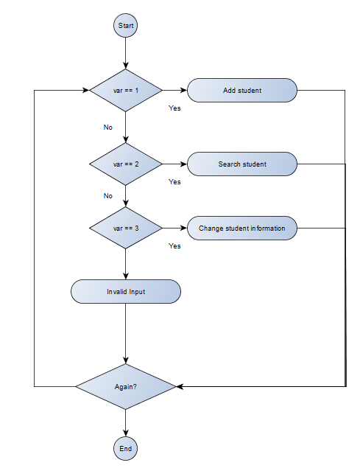

Figure 2. Flowchart (Just an example. You need to draw your own flowchart related to your project).

**Data Acquisition**

Please introduce how or where you acquire the information or data.

e.g., This information in this project can be obtained from …………

**Project Timeline**

|  |  |
| --- | --- |
| Task  (Schedule your own tasks below. Adjust it as time goes if needed.) | Time  (Schedule your own time below. Adjust it as time goes if needed.) |
| e.g., 1. Read related resources and write project proposal. | 2/7 ~ 2/19 |
| e.g., 2. Prepare information/data and implement the skeleton code for the project. | 2/20 ~ 2/28 |
| e.g., 3. Implement some classes or modules in the project. Write the project progress report. | 3/1~ 3/19 |
| e.g., 4. Implement remaining classes or modules in the project. | 3/20 ~ 4/1 |
| e.g., 5. Test the code using various test cases or inputs, implement the GUI if planned. | 4/2 ~ 4/10 |
| e.g., 6. Prepare the final submission of code, README file and final presentation PPT. | 4/11 ~ 4/18 |

**References (if any)**

1. FirstName Alpher, , and J. P. N. Fotheringham-Smythe. Frobnication revisited. Journal of Foo, 13(1):234–778, 2003.
2. FirstName Alpher, , FirstName Fotheringham-Smythe, and FirstName Gamow. Can a machine frobnicate? Journal of Foo, 14(1):234–778, 2004.