**Contents**

Que 1): Expected Value understanding : 2

Que 2) Matrix Dot Product/Multiplication: 2

Que 3) Example of Expected Value Calculation i.e. E(X). 3

Que 4) More 5 Example Questions on Expected Value calculations. i.e. E(X). 4

Que 5) Inequality Question to Prove (Example): 5

Que 6) Overfitting and Train Loss and Test Loss: 6

Que 7) Markov’s Inequality with Example & Practical Applications. 6

Que 8) Variance of X. i.e. V(X) with an example 7

Que 9) Eigen Values and Eigen Vectors with example and practical applications: 8

Que 10) Dimensionality Reduction Techniques: PCA and Random Projection 9

Que 11) Random Projection (Dimensionality Reduction) Performance Evaluation with example. 10

Que 12) PCA Performance (Dimensionality Reduction) Evaluation with example of a new dataset 11

Que 13) More Questions (Around 13Q) on PCA. 12

Que 14) More Questions on basic Probability: 14

Que 15) Sample Movie Dataset and Performing Basic Matrix Operations: 16

Que 16) SVD (Singular Value Decomposition) with example and practical applications: 17

Que 17) Contrastive Learning, Practical Applications and other ways of lack of labels to use contrastive learning. 18

Que 18) Loss Function definition, with gradient computation example, Loss function’s optimization and Applications: 19

Que 19) Dictionary Learning & Sparse Coding: 21

Que 20) low-rank matrix estimation, with applications to recommender systems Large language: 22

Que 21) Collaborative Recommendation System, example, evaluation techniques, loss function, advantages, disadvantages and alternatives. 23

# **Que 1): Expected Value understanding :**

Explain Expected value of X function meaning and its practical applications.

Ans:

# **Que 2) Matrix Dot Product/Multiplication:**



------------

# **Que 3) Example of Expected Value Calculation i.e. E(X).**

i.e. EV = 20 cents per game. i.e. **$0.20.**

**hence, Final answer is 500!**

# **Que 4) More 5 Example Questions on Expected Value calculations. i.e. E(X).**

# **Que 5) Inequality Question to Prove (Example):**

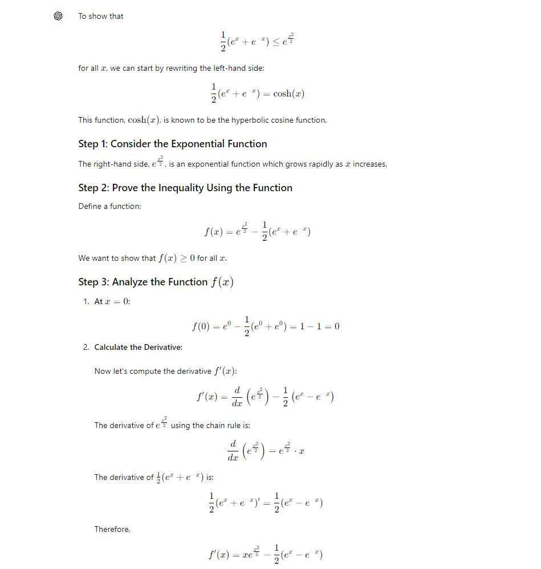

# **Que 6) Overfitting and Train Loss and Test Loss:**

# **Que 7) Markov’s Inequality with Example & Practical Applications.**

# **Que 8) Variance of X. i.e. V(X) with an example**

# **Que 9) Eigen Values and Eigen Vectors with example and practical applications:**

# **Que 10) Dimensionality Reduction Techniques: PCA and Random Projection**

# **Que 11) Random Projection (Dimensionality Reduction) Performance Evaluation with example.**

# **Que 12) PCA Performance (Dimensionality Reduction) Evaluation with example of a new dataset**

# **Que 13) More Questions (Around 13Q) on PCA.**

# **Que 14) More Questions on basic Probability:**

# **Que 15) Sample Movie Dataset and Performing Basic Matrix Operations:**

# **Que 16) SVD (Singular Value Decomposition) with example and practical applications:**

# **Que 17) Contrastive Learning, Practical Applications and other ways of lack of labels to use contrastive learning.**

# **Que 18) Loss Function definition, with gradient computation example, Loss function’s optimization and Applications:**

# **Que 19) Dictionary Learning & Sparse Coding:**

# **Que 20) low-rank matrix estimation, with applications to recommender systems Large language:**

# **Que 21) Collaborative Recommendation System, example, evaluation techniques, loss function, advantages, disadvantages and alternatives.**

