Name: Gaurav Wawdhane
Mis no: 111803107
Branch: Computer Engineering

Ups and Downs in Machine Learning

Machine Learning:
Machine learning is the leading field in the technology. Machine learning helps the computer or any electrical gadget to work like a human being. There are so many ups and down in the field of machine learning, many of the scientist tried to give their best to this field and they came up with a good solution to the on going problems and tat can be solved with the help of machine learning techniques.
The term of machine learning was came by Arthur Samuel, an American IBMer and pioneer in the field of computer gaming and artificial intelligence. The idea of machine laerning came in his mind because in 1952 he saw the first computer program ehich could learn as it ran. It was a game which played by checkers, created by him. Frank Rosenblatt designed the first artificial neural network in 1958, called Perceptron. The main goal of this was pattern and shape recognition. Another extremely early instance of a neural network came in 1959, when Bernard Widrow and Marcian Hoff created two models of them at Standford university. The first was called ADELINE, and it could detect binary patterns. The next generation was called MADELINE, and it could eliminate echo on phone lines, so had a useful real world application. It is still in use today.
There is no much prgress in the ML till 1970s for many reason. That might be because of the Von Neumann architecture where instructions and data are stored in the same memory, which is arguably simpler to understand than a neural network, and so many people build programs based on this.
In 1982, The interest in neural network started to pick up again, when john Hopefield suggested a network which had bidirectional lines, similar to how neurons actually work. Further, in 1982, japan announced that it was focusing on more advanced neural networks, which incentivised American funding into the area, and thus created more research in this area.
Neural networks most used algorithm in the machine learning field. Neural network uses back propogation algorithm and the important step came in 1986, when three researchers from the standford psychology department decided to extend an algorithm created by Widrow and Hoff in 1962. This therefore allowed multiple layers to be used in a neural network, creating what are known as ‘slow learners’, Which will learn over a long period of time.Durig the 1970s the first AI winter kicked in, the result of promises that couldn’t be kept. The impact of this lack of funding limited both DL and AI research. Fortunately, there were individuals who carried on the research without funding.
In 1980s and 1990s , there is no much development in this field. However, in 1997, the IBM computer Deep Blue, which was a chess playing computer, beat the world chess champion. Since there, there was many more development in this field.
In 21st centuary, many of the companies know that the ML algorithm increases the Computational power and reduces the lot of work ,Thats why now every company is trying to give their best to this field and developed various new algorithms. There are certain big projects going in this field ex. GoogleBrain(2012), AlexNet(2012), DeepFace(2014) etc.
Now, to learn so many things about this field we have to study the advantage and disadvantages in this field. There are so many advantages of this field, but besides that there are disadvantage also, As machine learning algorithm works on a large amount of dataset, we require more powerful machine and high efficiency algorithm’s to overcome the problem of tmore time consumption.

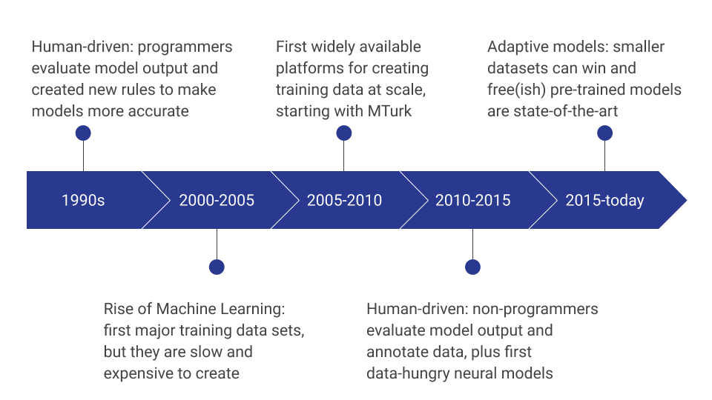

Advantages of Machine Learning (ML)

1) Identifies trends and patterns easily
Machine learning can handle large amount of data i.e. large volume of data is required for machine learning process. It discover specific trends and patterns that would not be apparent to humans. For instance, like flipkart e-commerce application , it serves to understand the browsing behaviours and purchase histories of its users to help cater to the right products, deals, and reminders relevant to them. It uses the result to reveal relevant advertisements to them.

2) Automation is there (No humans required)
With the help of machine learning you don’t need to tell everything to the system on each step of the way. Since it means giving machines the ability to learn, it lets means giving machines the ability to learn, it lets them to make predictions and also improve the algorithms on their own. A common example of this is anti-virus software.

3) Continuous Improvement
As Machine learning algorithm learns on their own thats why they have their continuous improvement like, as the data set increases so they can work with a high efficiency than previous.

4) Handle multi-variety data
Machine learning algorithms are good at handling data that are multi-dimensional and multi-variety, and they can do this in dynamic or uncertain environments.

5) Wide Applications
It has a wide applications and with the help of their own system it can work, Thats why today the machine learning is the most demanding sector in the technology field.

Disadvantage of Machine Learning (ML)

1) Time and Resources
As the ML algorithm needs enough time to learn by itself and develop their own system. So, it is the disadvantage. It also needs massive resources to function. This can mean additional requirements of computer power for you.

2) Data Acquisition
Machine learning requires massive data sets to train on, and these should be inclusive/unbaised, and of good quality. There can also be times where they must wait for new data to be generated.

3) Results
We have to choose the correct algorithm that can be used to solve a particular problem to get correct output. And to get the high efficiency of the result.

Deep Learning:
The impact of deep learning in industry began in the early 2000s, when CNNs already processed as estimated 10% to 20% of all the checks written in the US, according to Yann LeCun. Industrial applications of deep learning to large-scale speech recognition started around 2010. The adjectie “deep” in deep learning comes from the use of multiple layers in the network. Deep learning is a class of machine learning algorithms that uses multiple layers to progressively extract higher level features from the raw input.

Advantages of Deep Learning
1) The features of the system are automatically deduced and optimally tuned for desired outcome. Features are not required to be extracted ahead of time. This avoid time consuming machine learning techniques.
2) The system automatically learns. Robustness to natural variations in the data is automatically learned.
3) The same neural network based approach can be applied to many different applications and data types. Massive parrlel computation can be done using GPUs and are scalable for large voulmes of data.
4) The deep learning architecture is flexible to be adapted to new problems in the future.

Disadvantage of Deep Learning
1) It requires high amount of data to get the better performance i.e. we need to train in good manner.
2) It is extremely expensive to train due to complex data models. Morever deep learning requires expensive GPUs and hundreds of machine. This increases cost of the user.
In Al or DL , the requirement of large amount of data is the major issue and that’s why it is dificult to train our AI system.

