plotMissingnessStr(data.in=test[,apply(test, 2, function(x) { sum(is.na(x)) > 0 })], title="Test data set")
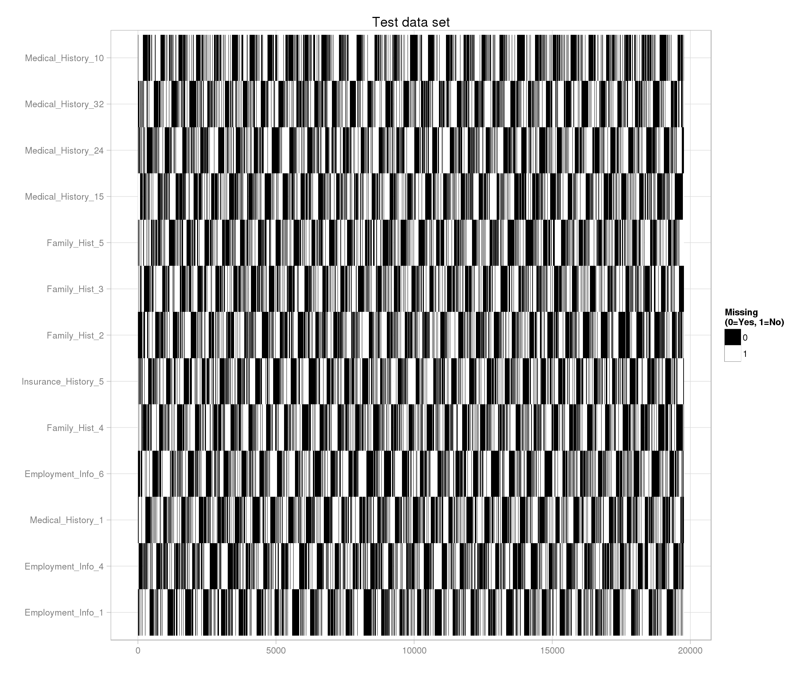
Are there any duplicate rows?
cat("Train data set - Number of duplicated rows:", nrow(train) - nrow(unique(train)), "\n")
## Train data set - Number of duplicated rows: 0
cat("Test data set - Number of duplicated rows:", nrow(test) - nrow(unique(test)), "\n")
## Test data set - Number of duplicated rows: 0
Are there any constant columns?
train.const <- sapply(train, function(x) { length(unique(x)) == 1 })test.const <- sapply(test, function(x) { length(unique(x)) == 1 })cat("Train data set - Number of constant columns:", sum(train.const), "\n")
## Train data set - Number of constant columns: 0
cat("Test data set - Number of constant columns:", sum(test.const), "\n")
## Test data set - Number of constant columns: 0
Plot histograms of categorical variables
plotHist <- function(data.in, i) {
data <- data.frame(x=data.in[,i])
p <- ggplot(data=data, aes(x=factor(x))) + geom_histogram() + xlab(colnames(data.in)[i]) + theme_light() +
theme(axis.text.x=element_text(size=8))
return (p)}
doPlots <- function(data.in, fun, ii, ncol=3) {
pp <- list()
for (i in ii) {
p <- fun(data.in=data.in, i=i)
pp <- c(pp, list(p))
}
do.call("grid.arrange", c(pp, ncol=ncol))}
doPlots(data.in=train.cat, fun=plotHist, ii=1:4, ncol=2)
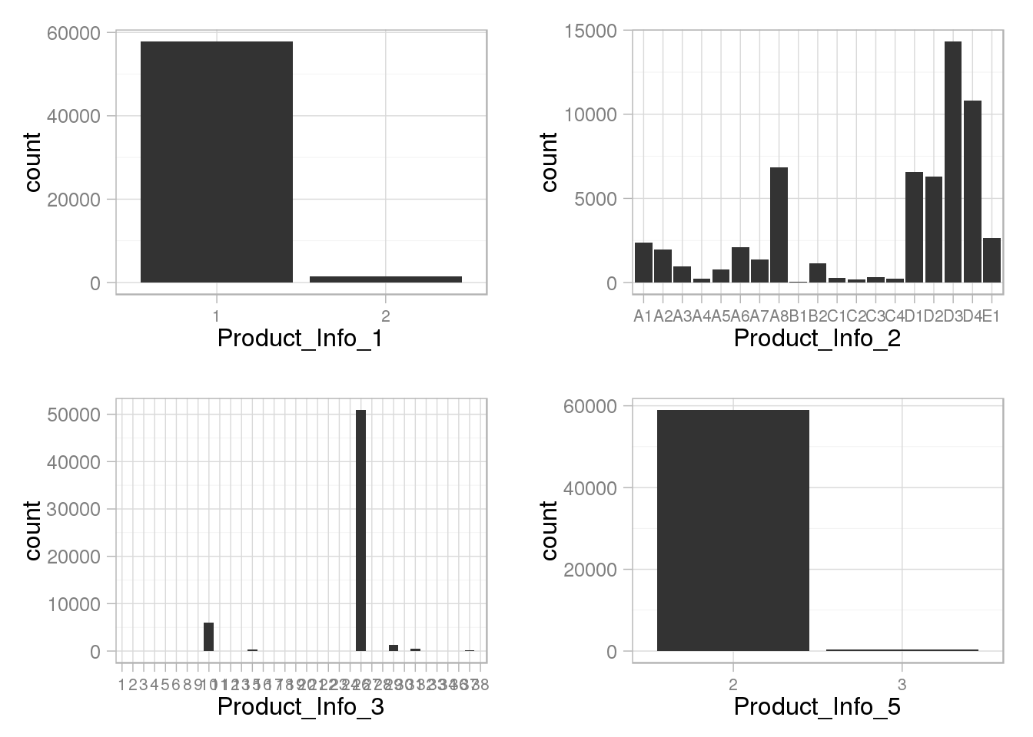
doPlots(data.in=train.cat, fun=plotHist, ii=5:8, ncol=2)
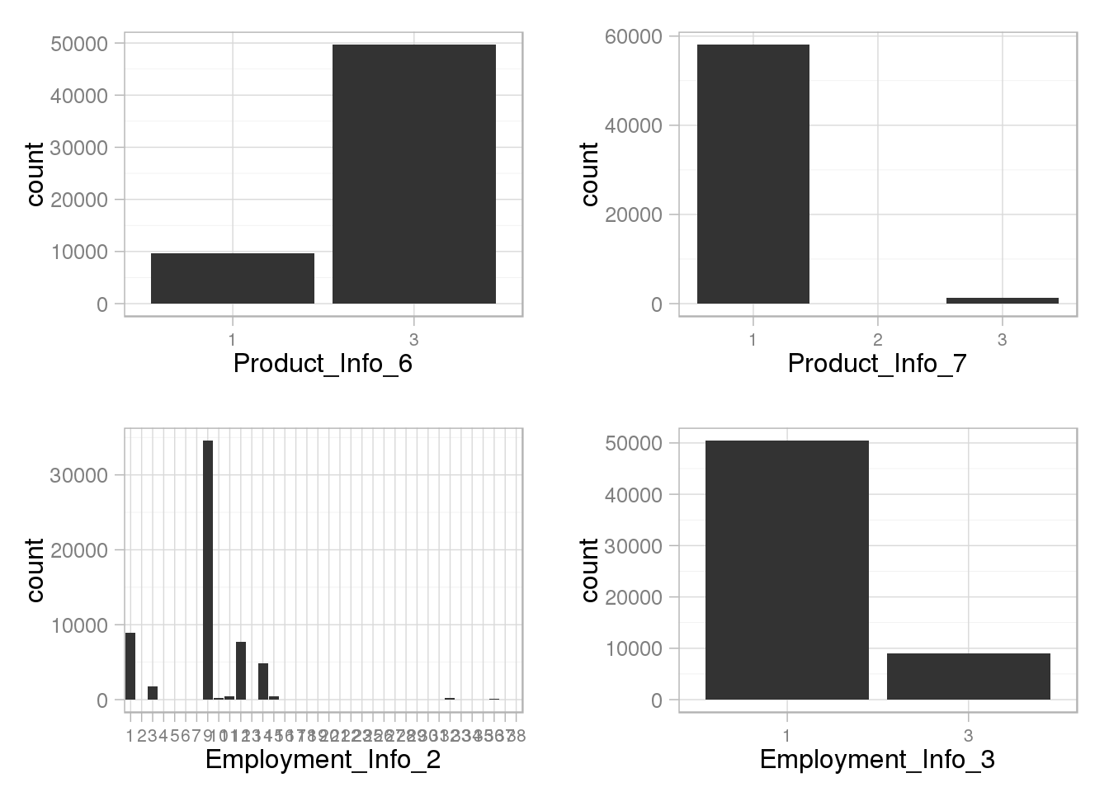
doPlots(data.in=train.cat, fun=plotHist, ii=9:12, ncol=2)
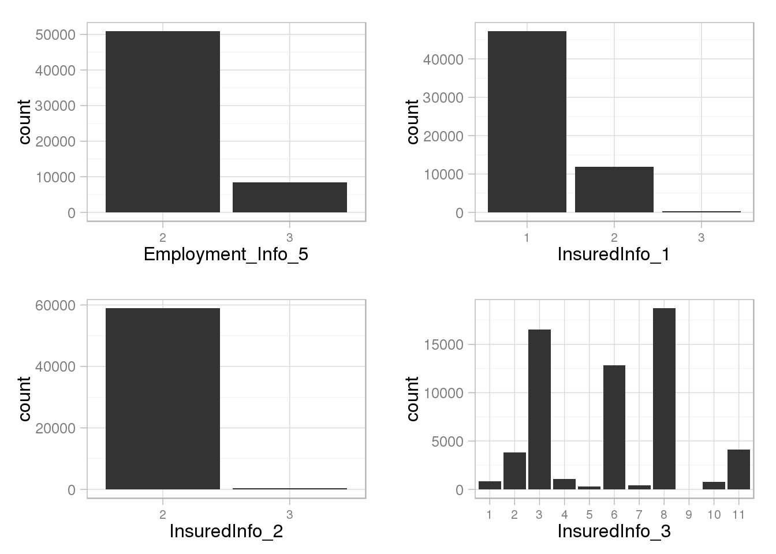
doPlots(data.in=train.cat, fun=plotHist, ii=13:16, ncol=2)
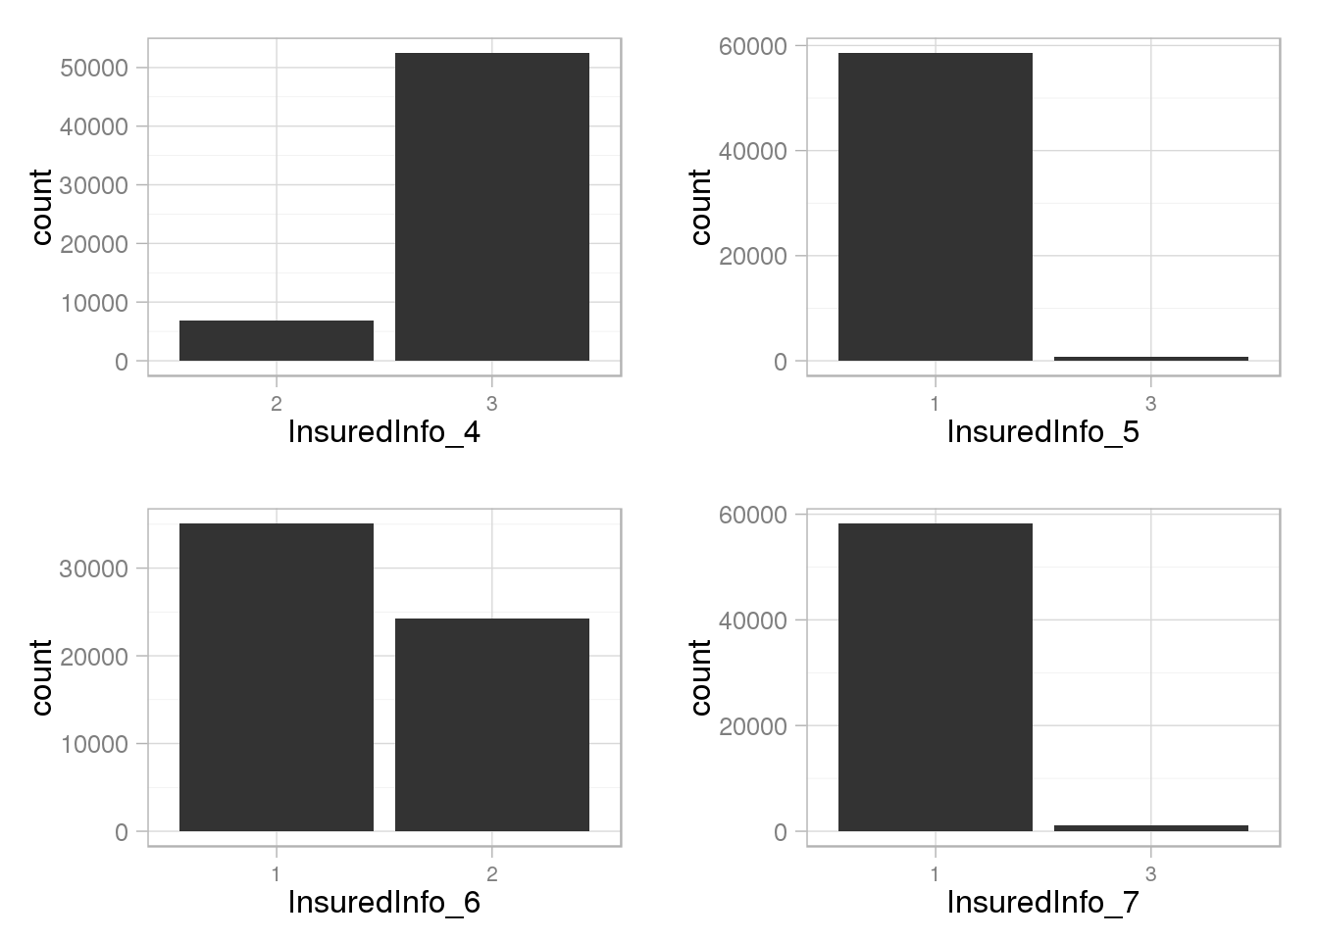
doPlots(data.in=train.cat, fun=plotHist, ii=17:20, ncol=2)
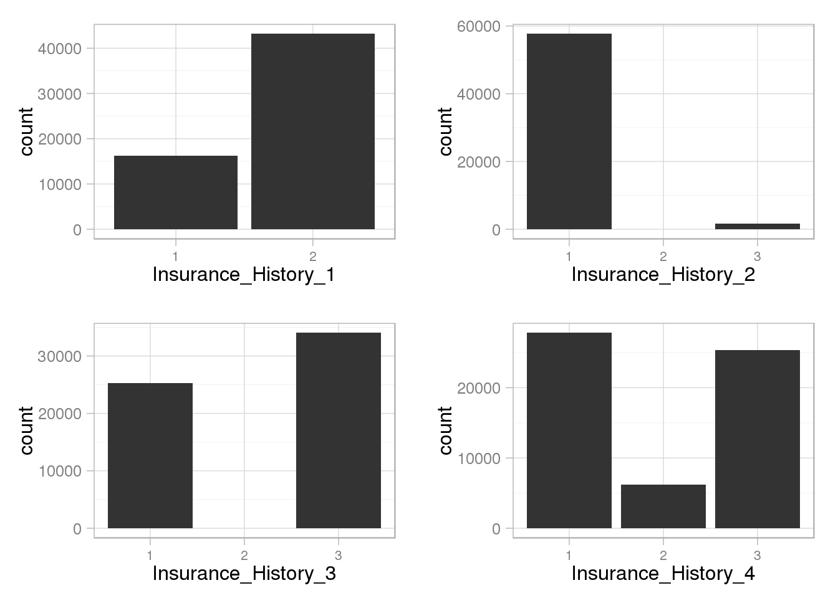
doPlots(data.in=train.cat, fun=plotHist, ii=21:24, ncol=2)
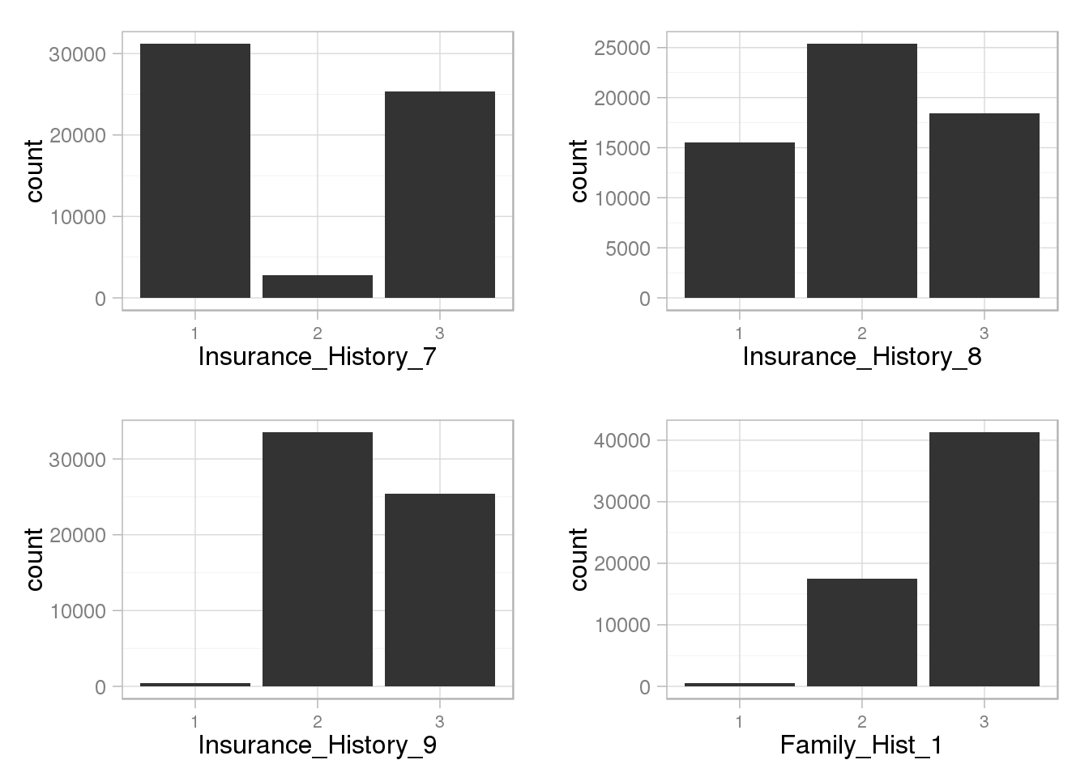
doPlots(data.in=train.cat, fun=plotHist, ii=25:28, ncol=2)
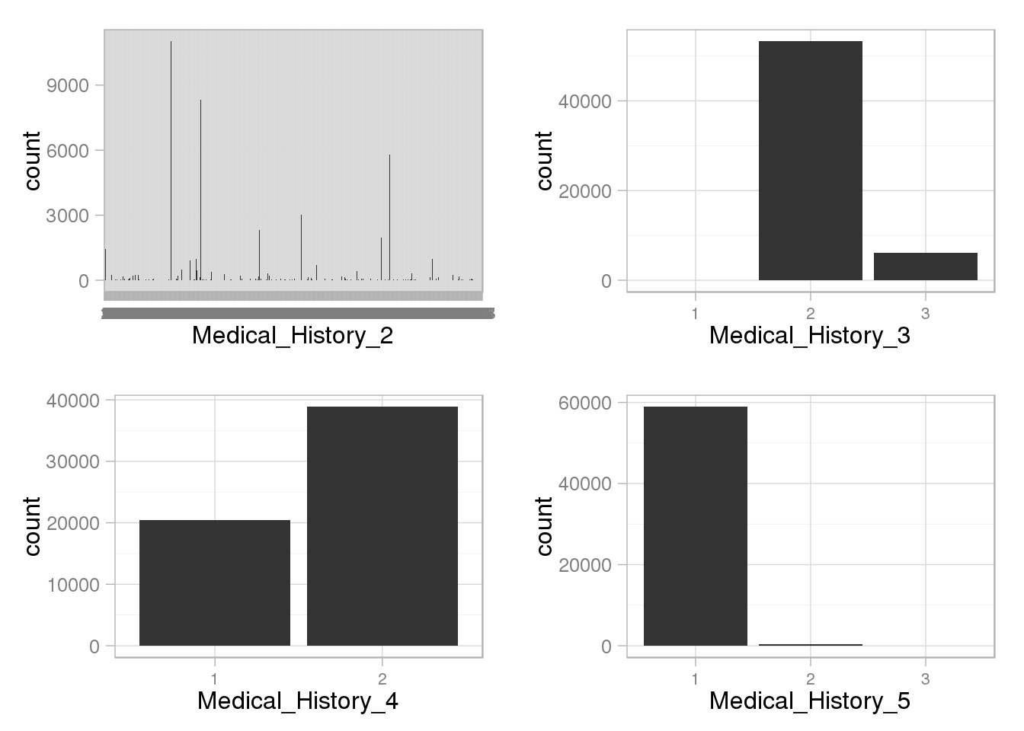
doPlots(data.in=train.cat, fun=plotHist, ii=29:32, ncol=2)
doPlots(data.in=train.cat, fun=plotHist, ii=33:36, ncol=2)
doPlots(data.in=train.cat, fun=plotHist, ii=37:40, ncol=2)
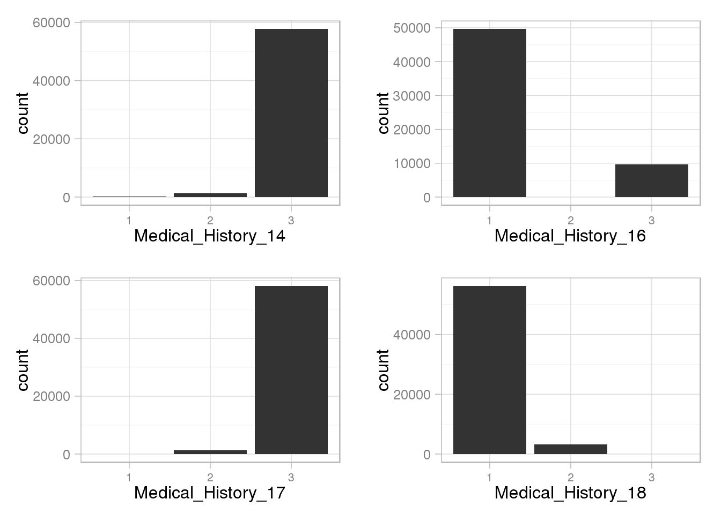
doPlots(data.in=train.cat, fun=plotHist, ii=41:44, ncol=2)
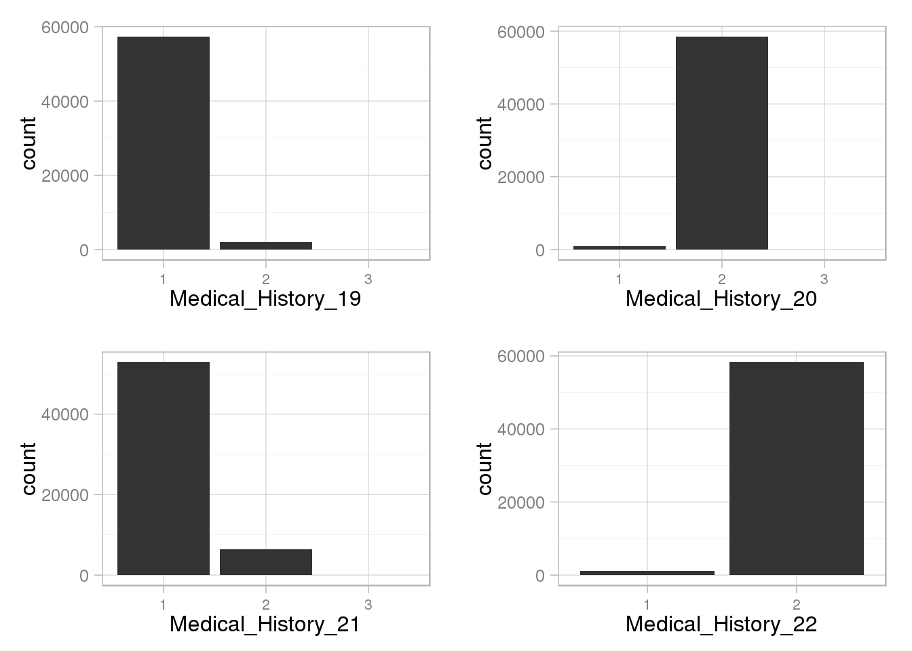
doPlots(data.in=train.cat, fun=plotHist, ii=45:48, ncol=2)
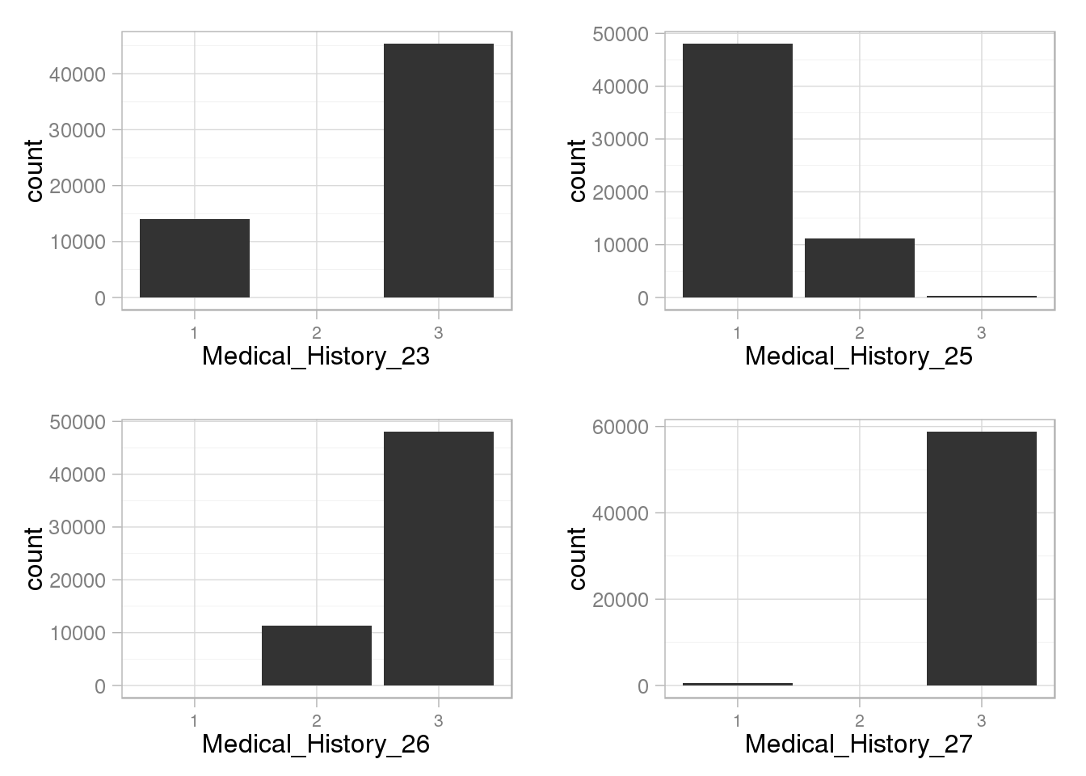
doPlots(data.in=train.cat, fun=plotHist, ii=49:52, ncol=2)
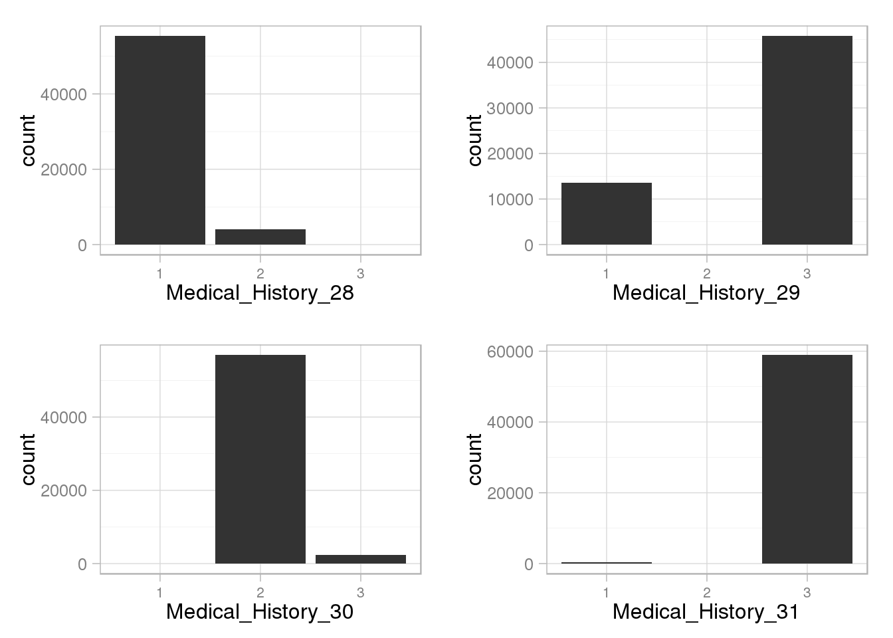
doPlots(data.in=train.cat, fun=plotHist, ii=53:56, ncol=2)
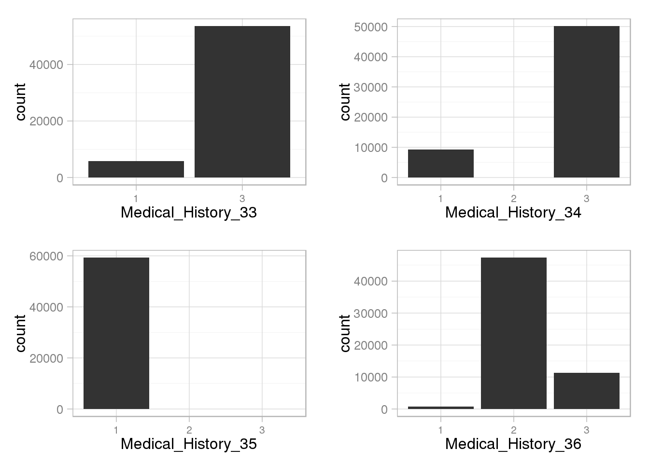
doPlots(data.in=train.cat, fun=plotHist, ii=57:60, ncol=2)
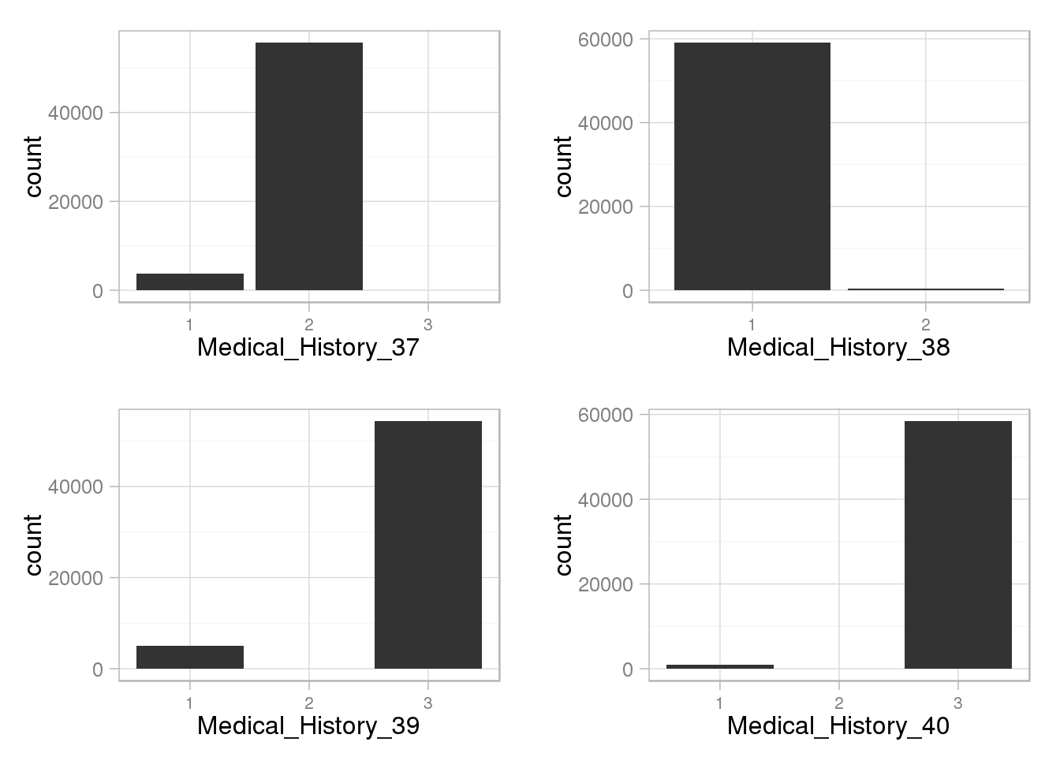
doPlots(data.in=train.cat, fun=plotHist, ii=61, ncol=2)
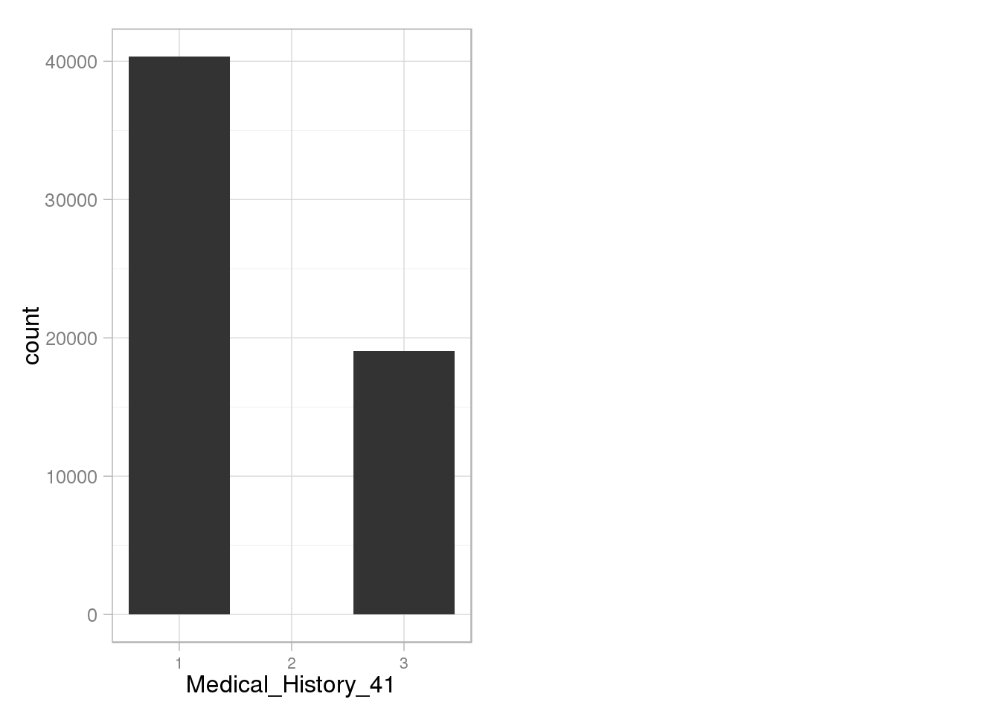
Densities of continous Features
train.cont <- data.frame(train.cont, Response=train$Response)plotDensity <- function(data.in, i) {
data <- data.frame(x=data.in[,i], Response=data.in$Response)
p <- ggplot(data) + #geom_density(aes(x=x, colour=factor(Response))) +
geom_line(aes(x=x), stat="density", size=1, alpha=1.0) +
xlab(colnames(data.in)[i]) + theme_light()
return (p)}
doPlots(data.in=train.cont, fun=plotDensity, ii=1:4, ncol=2)
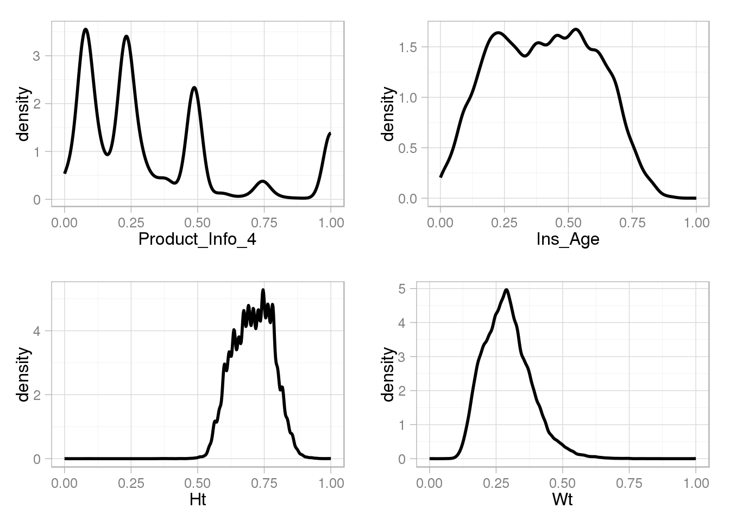
doPlots(data.in=train.cont, fun=plotDensity, ii=5:8, ncol=2)
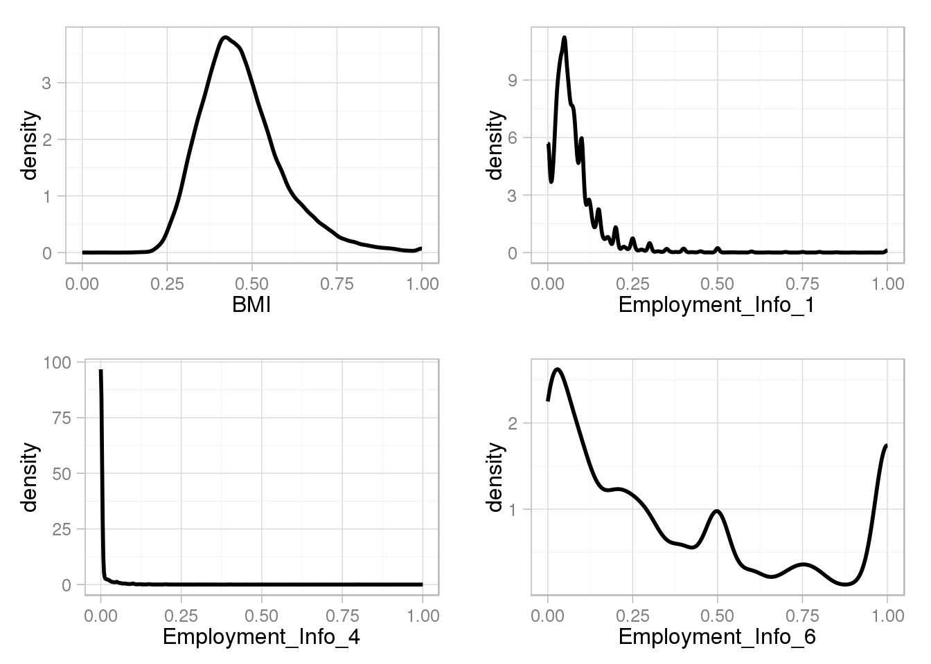
doPlots(data.in=train.cont, fun=plotDensity, ii=9:12, ncol=2)
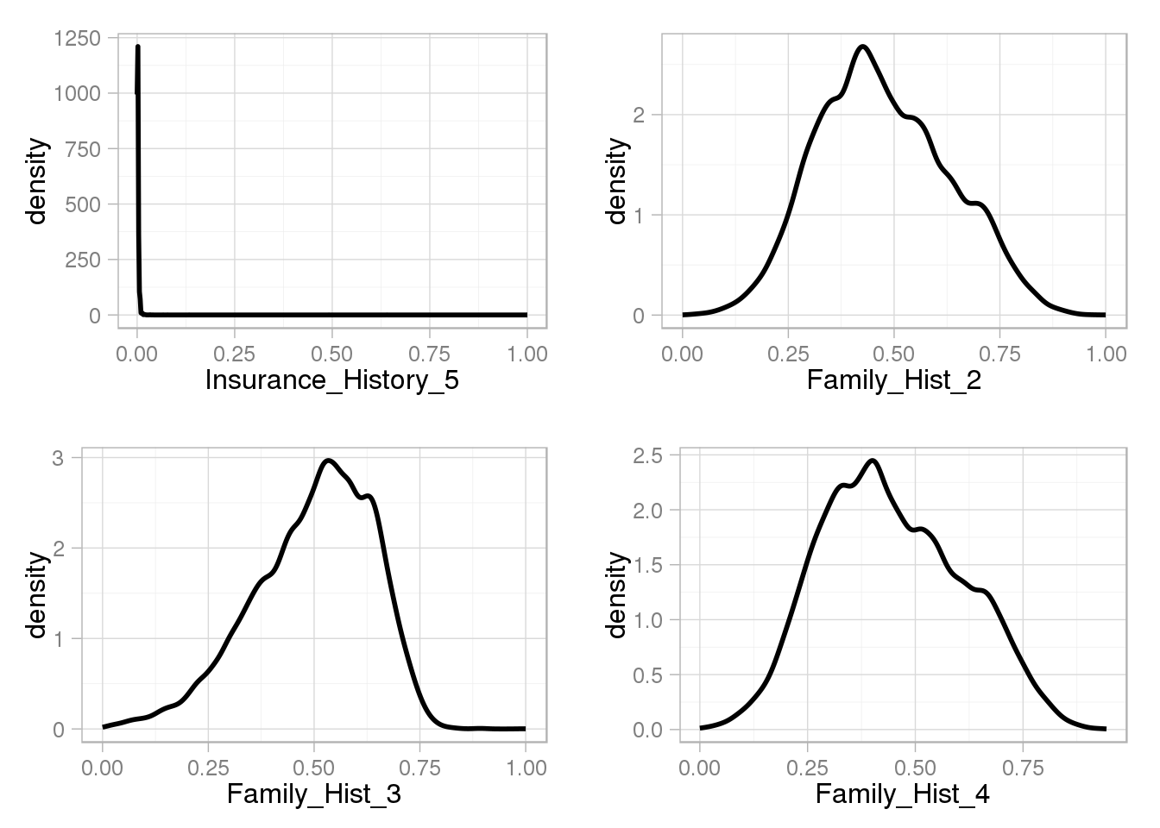
doPlots(data.in=train.cont, fun=plotDensity, ii=13, ncol=2)
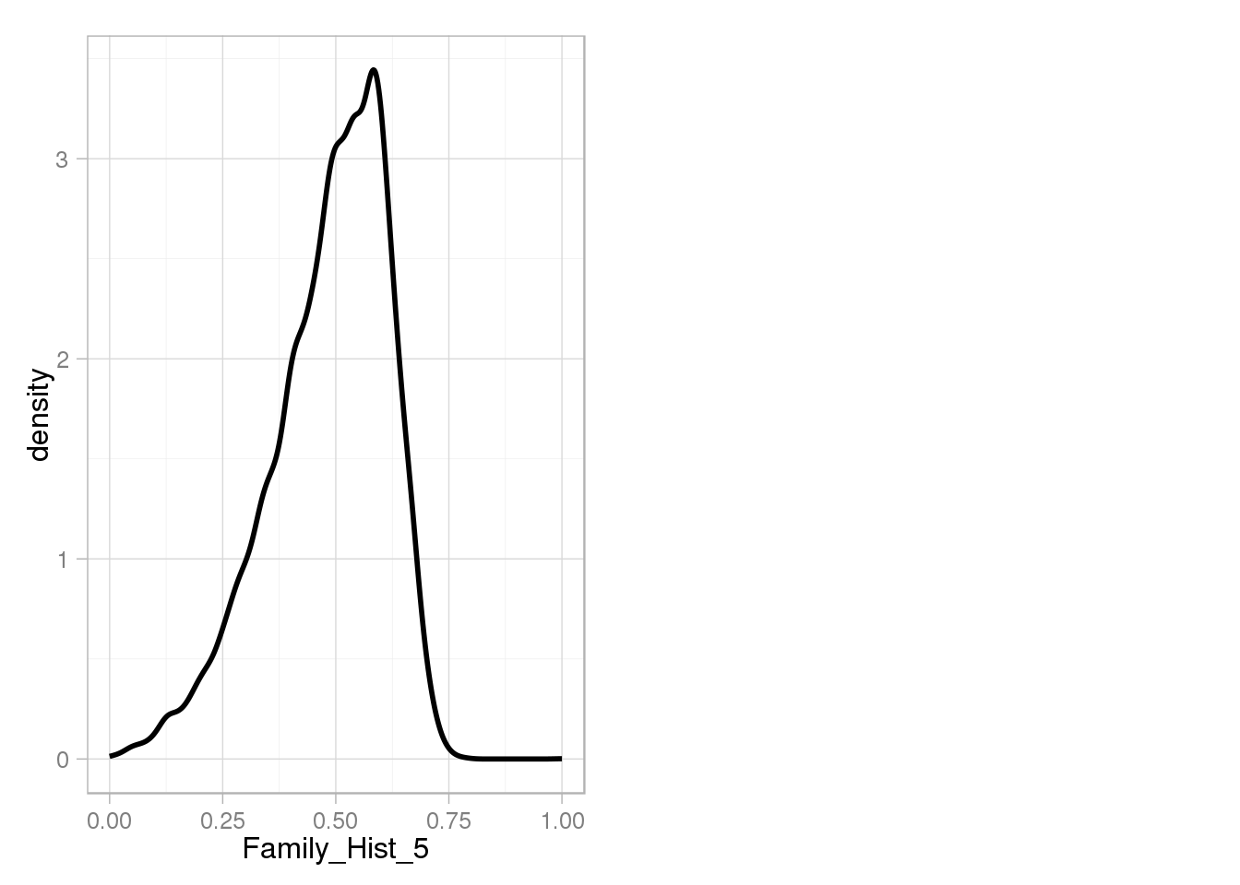
Boxplots of continous Features depending on Response
plotBox <- function(data.in, i) {
data <- data.frame(y=data.in[,i], Response=data.in$Response)
p <- ggplot(data, aes(x=factor(Response), y=y)) + geom_boxplot() + ylab(colnames(data.in)[i]) + theme_light()
return (p)}
doPlots(data.in=train.cont, fun=plotBox, ii=1:4, ncol=2)
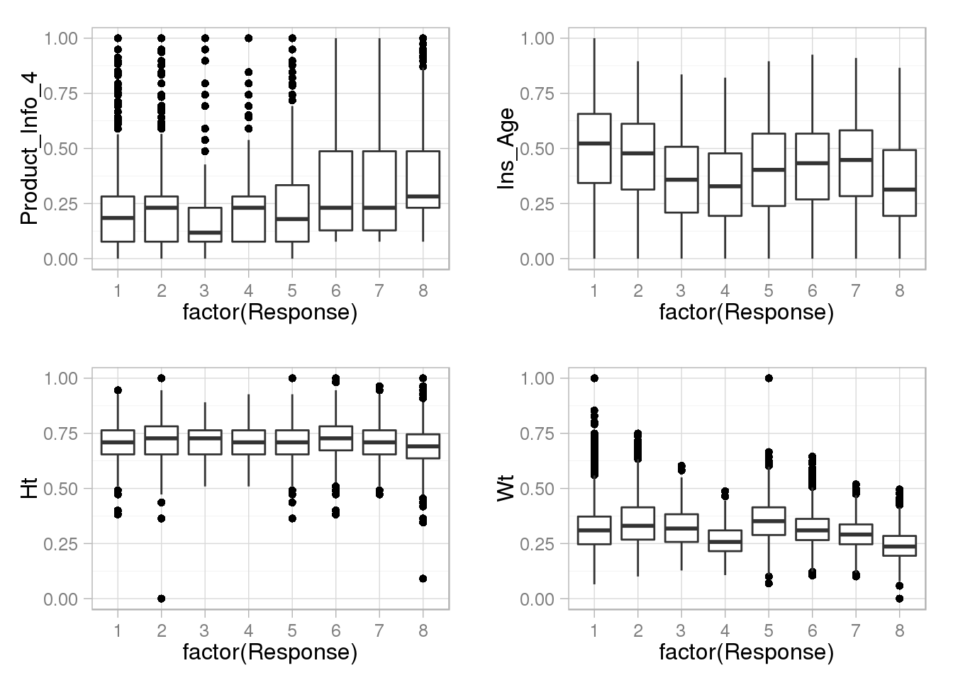
doPlots(data.in=train.cont, fun=plotBox, ii=5:8, ncol=2)
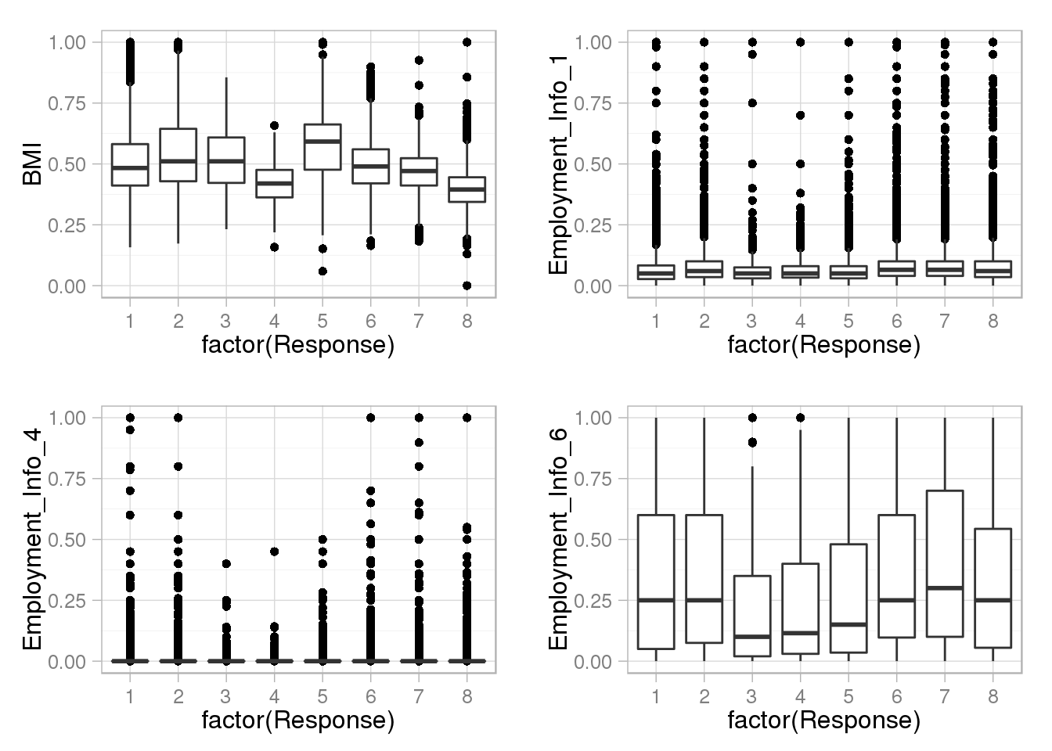
doPlots(data.in=train.cont, fun=plotBox, ii=9:12, ncol=2)
doPlots(data.in=train.cont, fun=plotBox, ii=13, ncol=2)
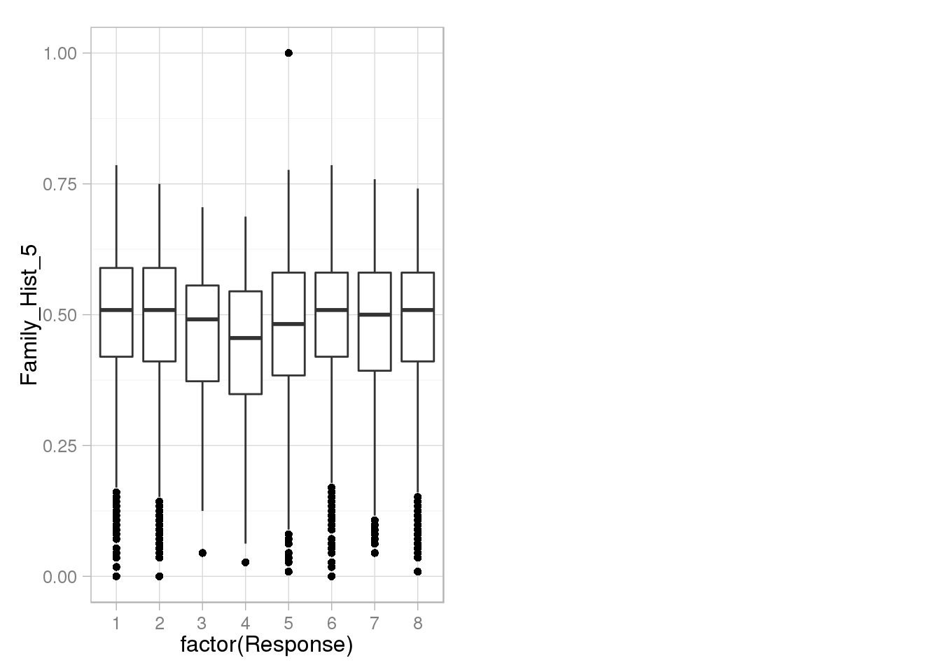
Take a look at the response
ggplot(train) + geom_histogram(aes(factor(Response))) + xlab("Response") + theme_light()
