Tasks:

1. Ran 2D-RZ_finiteStrain_test.i for more complex meshes and longer times
- changed dt in test file (too large for model)
- changed PressureTM BC (from factor to function)
- also edited 3D-RZ_finiteStrain_test.i
- re-golded
- marked 3D (fake 3D) test 'heavy' to be skipped on run_tests
- merged on github (issue #5584)
2. Created master SM vs TM list
- all categories (bcs, materials, auxkernels, etc.)
- missing items, replaced items, etc.
3. Added save_in_disp_r/z
- aux variables to save r/z displacement residuals
- file changed: TensorMechanicsAxisymmetricRZAction.C
  - to match TensorMechanicsAction.C
- added test: tensor_mechanics/tests/2D_geometries/2D-RZ_finiteStrain_resid.i & gold
- merged on github (issue #5610)
4. Compared timing of TM J2 tests vs LSH SM tests
- added j2_plasticity_vs_LSH directory in modules/combined/tests
  - side-by-side comparison of TM vs SM for the same problem
  - huge time discrepency for plastic steps (5-7x slower with 4x4x4 mesh) (Figure 1)
- merged on github (issue #5628)
5. Worked on TM timing by adding special J2 case
- wrote radial return map and radial consistent tangent operator for J2 plasticity
- worked with Andy to move radial return map to J2 userObject and set up for future custom return maps & consistent tangent operators for other userObjects
- timing vastly improved (less than 2x slower)
- created j2_hard2_exp.i test for exponential hardening
  - plotted vm stress vs intnl to check exponential relationship, correct (Figure 2)
  - plotted same for j2_hard1 (constant hardening), correct (Figure 3)
- waiting for Andy then PR & merge on github (issue #5628 & #5667)
8. Make possible multi surface plasticity, n internal parameters per model
- started work on this but did not finish
  - most coding done, getting segfault / out-of-bounds
7. Created flow charts
- mapped inheritance for TM materials
  - ComputeStress :: (Figure 4)
  - UserObjects :: TMHardeningXX & TMPlasticXX (Figure 5)
8. Wiki needs to be updated
- wiki > physics modules > tensor mechanics > plasticity and return map
  - FiniteStrainMultiPlasticity Material mentioned (should be ComputeMultiPlasticityStress)
  - should add something about implementing custom return maps & ctos via userObjects

Skills:

A. No prior experience:
1. C++
2. github and git command tools, along with the git MOOSE development process
3. return mapping

B. Some experience:
1. MOOSE

Figures:

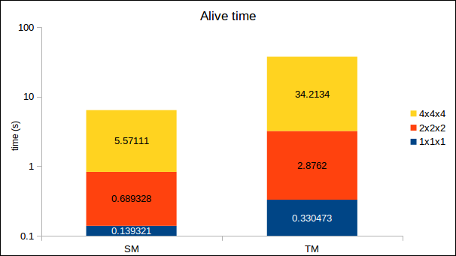Figure 1: Original run-time comparison of TM/J2 vs SM/LSH, Linux

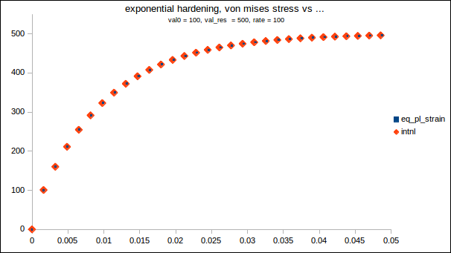Figure 2: Von-mises stress vs equivalent plastic strain and vs internal parameter for TM/J2 with exponential hardening

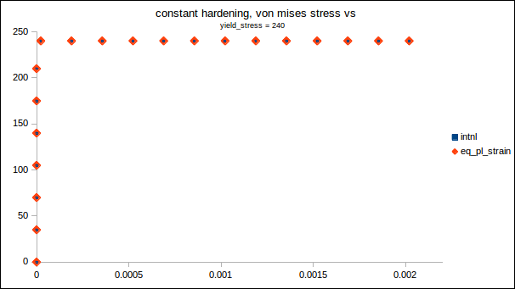Figure 3: Von-misses stress vs equivalent plastic strain and vs internal parameter for TM/J2 with constant hardening
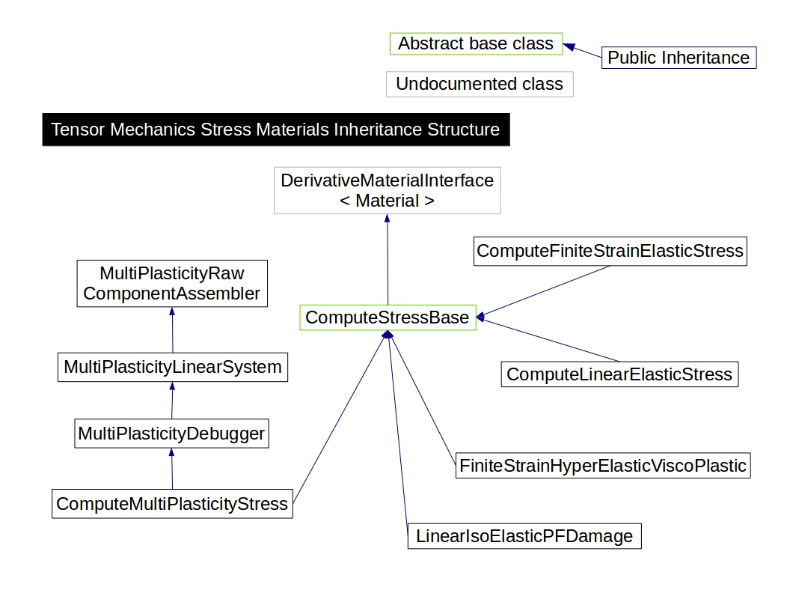Figure 4: Tensor mechanics stress materials inheritance structure

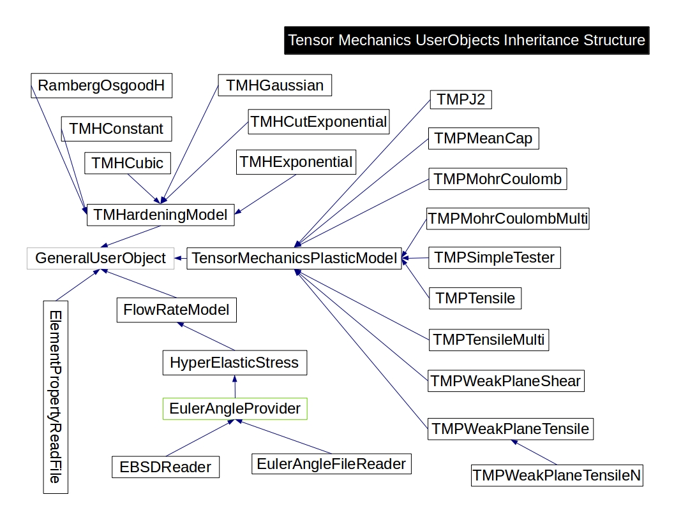Figure 5: Tensor mechanics userObjects inheritance structure

