1. Ran 2D-RZ_finiteStrain_test.i for more complex meshes and longer times
- changed dt in test file (too large for model beyond one time step)
- changed PressureTM BC (from factor to function)
- also edited 3D-RZ_finiteStrain_test.i
- marked 3D (fake/axisymmetric 3D) test 'heavy' to be skipped on run_tests
- re-golded, merged on github (issue #5584)
2. Created master SM vs TM list
- all categories (bcs, materials, auxkernels, etc.)
- missing items, replaced items, etc.
3. Added save_in_disp_r/z
- aux variables to save r/z displacement residuals
- file changed: TensorMechanicsAxisymmetricRZAction.C
  - to match TensorMechanicsAction.C
- added test: tensor_mechanics/tests/2D_geometries/2D-RZ_finiteStrain_resid.i & gold
- merged on github (issue #5610)
4. Compared timing of TM J2 tests vs LSH SM tests
- added j2_plasticity_vs_LSH directory in modules/combined/tests
  - side-by-side comparison of TM vs SM for the same problem (no hardening)
  - time discrepancy for plastic steps (TM 5-7x slower with 4x4x4 mesh) (Figure 1)
- merged on github (issue #5628)
5. Worked on TM timing by adding special J2 case
- wrote radial return map and radial consistent tangent operator for J2 plasticity
- worked with Andy to move radial return map to J2 userObject and set up for future custom return maps & consistent tangent operators for other userObjects (Figure 2)
- timing vastly improved (TM now less than 2x slower)
  - previously: 5.57s SM vs 34.21s TM (ten time steps)
  - now: 3.49s SM vs 5.75s TM (21.28s SM vs 35.56s TM for 50 time steps)
- created j2_hard2_exp.i test for J2 with exponential hardening
  - plotted vm stress vs intnl to check exponential relationship, correct (Figure 3)
  - plotted same for j2_hard1 (constant/no hardening), correct (Figure 4)
- waiting for Andy then PR & merge
  - still needs to be re-golded, j2_hard2_exp.i to be added to test (csvdiff?)
- pushed on github (issue #5628 & #5667), branch returnMappingTM_5667
8. Coded multi surface plasticity, n internal parameters per model
- started work on this but did not finish
  - most coding done, getting segfault / out-of-bounds
  - pushed on github, branch CMPS_multi_ics, but no issue or PR
7. Created flow charts
- mapped inheritance for TM classes
  - FiniteStrain Materials (to be deprecated?) (Figure 5)
  - ComputeStress Materials (Figure 6)
  - UserObjects :: TMHardeningXX & TMPlasticXX (Figure 7)
  - traced example jacobian function (df_dintnl) to show userObject incorporation via MultiPlasticityRawComponentAssembler and _f[model]->function() (Figure 8)

8. Wiki needs to be updated
- wiki > physics modules > tensor mechanics > plasticity and return map
  - FiniteStrainMultiPlasticity Material mentioned (should be ComputeMultiPlasticityStress?)
  - should add something about implementing custom return maps & ctos via userObjects after PR & merge

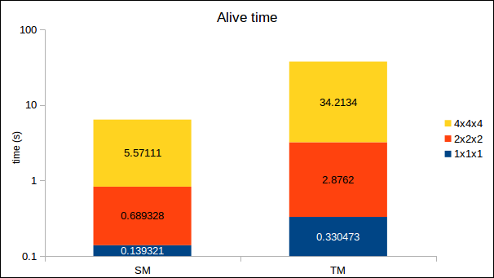Figure 1: Original timing, SM LSH vs TM J2

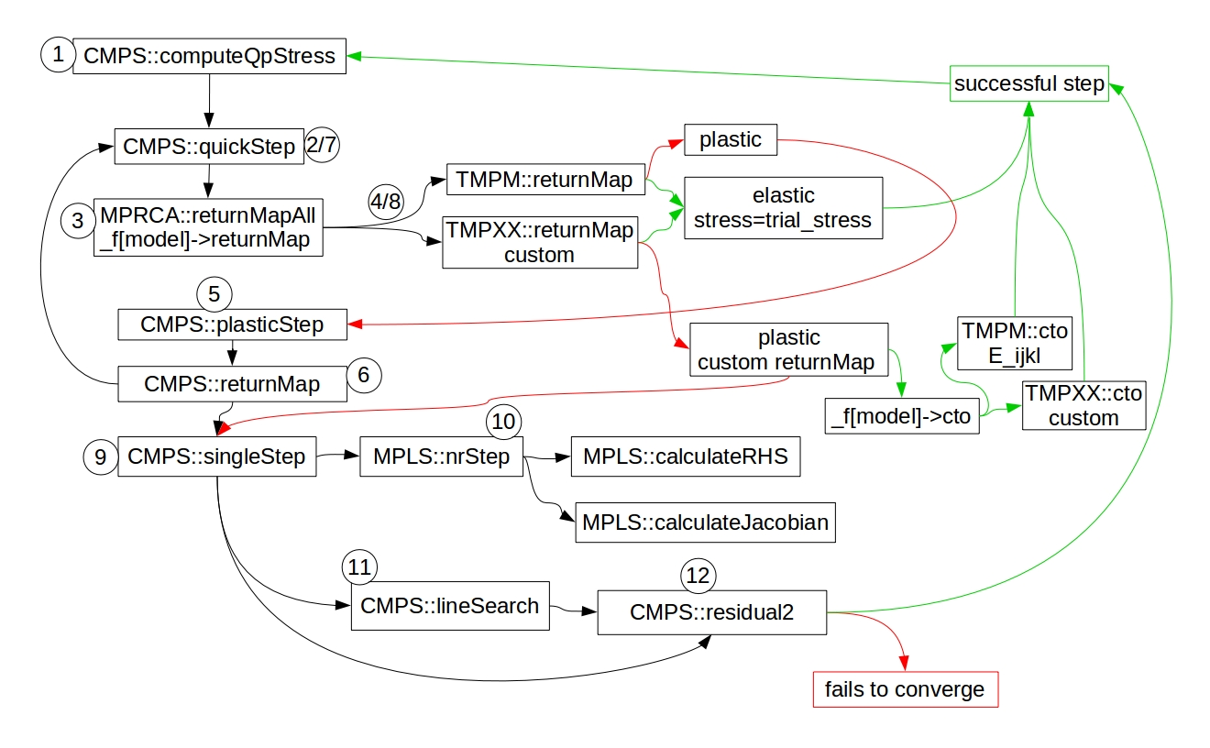Figure 2: New function calling sequence for ComputeMultiPlasticityStress (see explanation next page)

Figure 2 explanation
1. CMPS::computeQpStress calls
2. CMPS::quickStep(update_pm=false) calls
3. MPRCA::returnMapAll(update_pm=false) calls
4. TMPM::_f[model]->returnMap(update_pm=false)
4.a. if no custom return map provide, base class function called
4a.i. if elastic: accepts trial stress, cto=E_ijkl, returns true, moves on to next step/element (to step 1)
4aii. if plastic: returns false (to step 5)
4.b. if custom return map provided, userObject TMPXX function called
4.b.i. if elastic: accepts trial stress, cto=E_ijkl, returns true, moves on to next step/element (to step 1)
4.b.ii. if plastic: runs through custom return map
4.b.ii.a. if custom return map succeeds (f < _f_tol && iter < max_iters), cto=custom cto (_f[model]->cto function), returns true, moves on to next step/element (to step 1)
4.b.ii.b. if custom return map fails to converge, returns false (to step 5)
5. CMPS::plasticStep calls
6. CMPS::returnMap calls
7. CMPS::quickStep(update_pm=true)
8. Repeat steps 3–4, with update_pm=true, and 'to step 5' becomes 'to step 9'
9. CMPS::singleStep calls
10. MPLS::nrStep calls
10.a. MPLS::calculateRHS
10.b. MPLS::calculateJacobian (then returns to CMPS::singleStep)
11. CMPS::lineSearch calls
11.a. CMPS::residual2 (then returns to CMPS::singleStep)
12. CMPS::residual2

A. converges: moves on to next step/element (back to 1) or exits with results if last step
B. fails to converge: exits with error

Abbreviations:
CMPS = ComputeMultiPlasticityStress
MPRCA = MultiPlasticityRawComponentAssembler
TMPM = TensorMechanicsPlasticModel
TMPXX = TensorMechanicsPlasticXX (e.g., XX = J2, MohrCoulomb, &c)
MPLS = MultiPlasticityLinearSystem
cto = consistent_tangent_operator
f = yieldFunction
_f[model] = UserObject vector

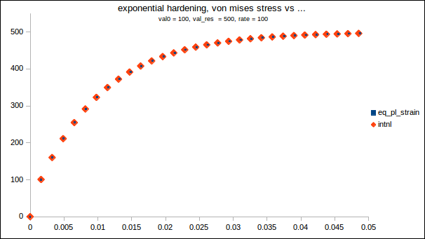Figure 3: Von-mises stress vs equivalent plastic strain and vs internal parameter for TM/J2 with exponential hardening

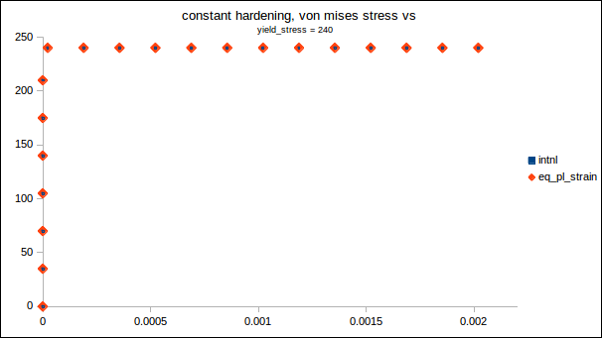Figure 4: Von-misses stress vs equivalent plastic strain and vs internal parameter for TM/J2 with constant hardening

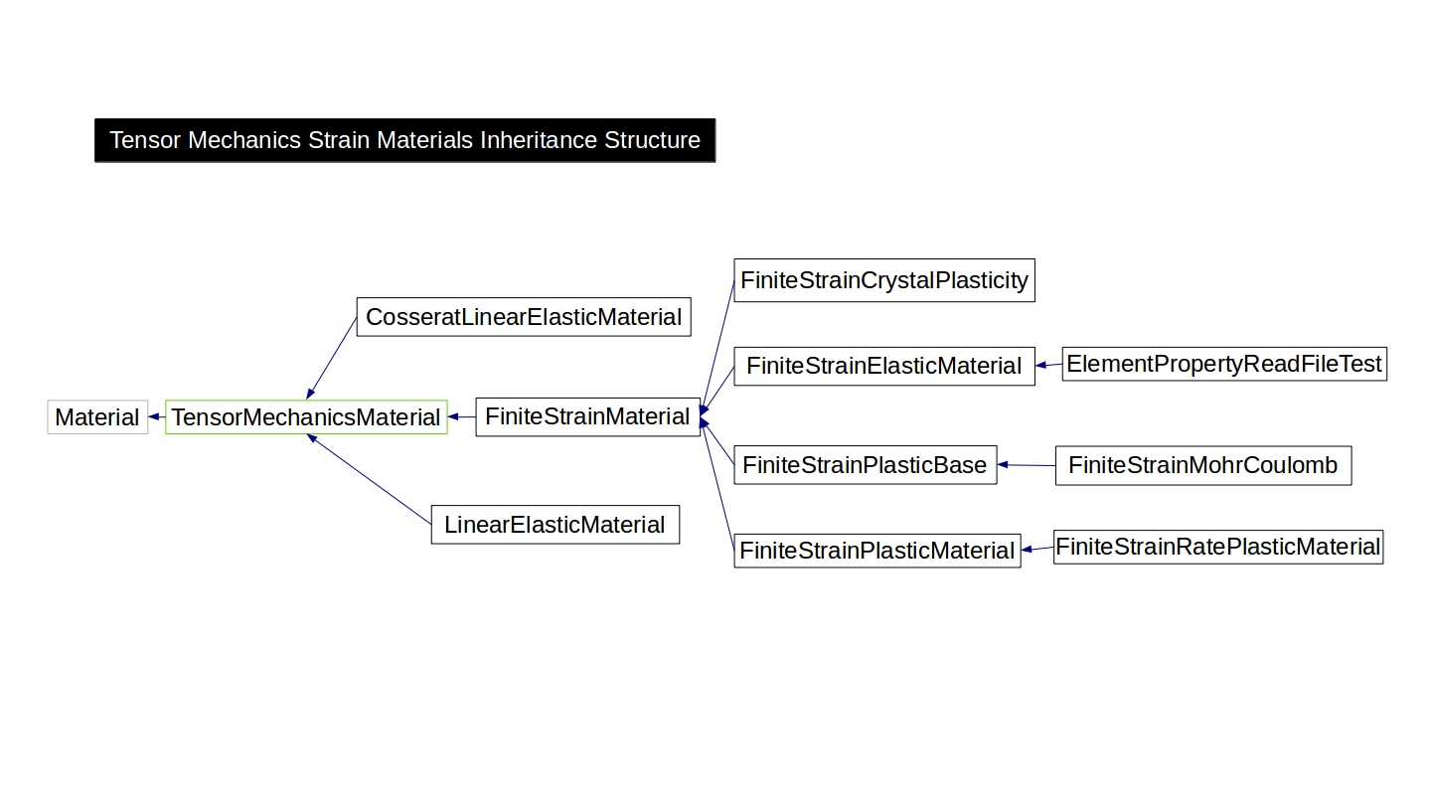Figure 5: Tensor mechanics FiniteStrain material class inheritance, to be deprecated in favor of userObjects and ComputeStressBase

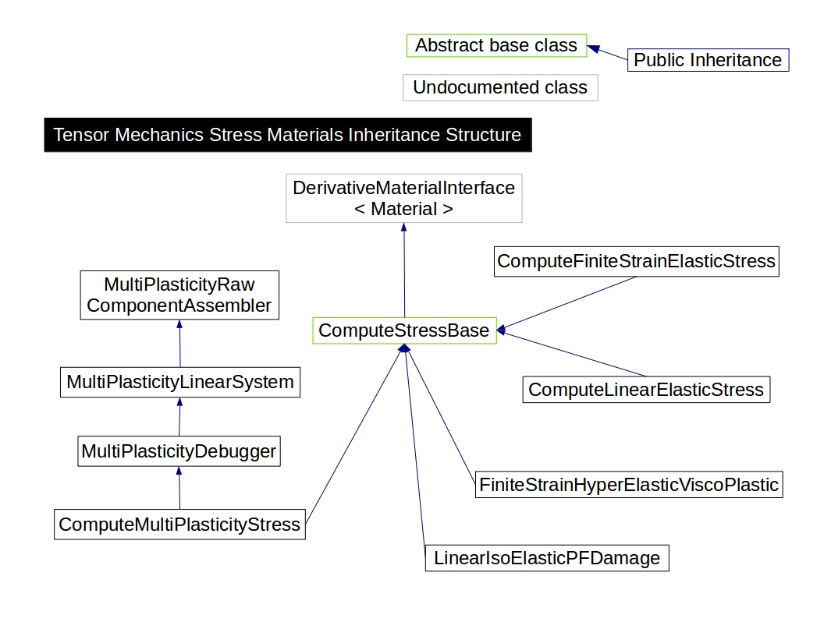Figure 6: Tensor mechanics ComputeStress material class inheritance, used with userObjects

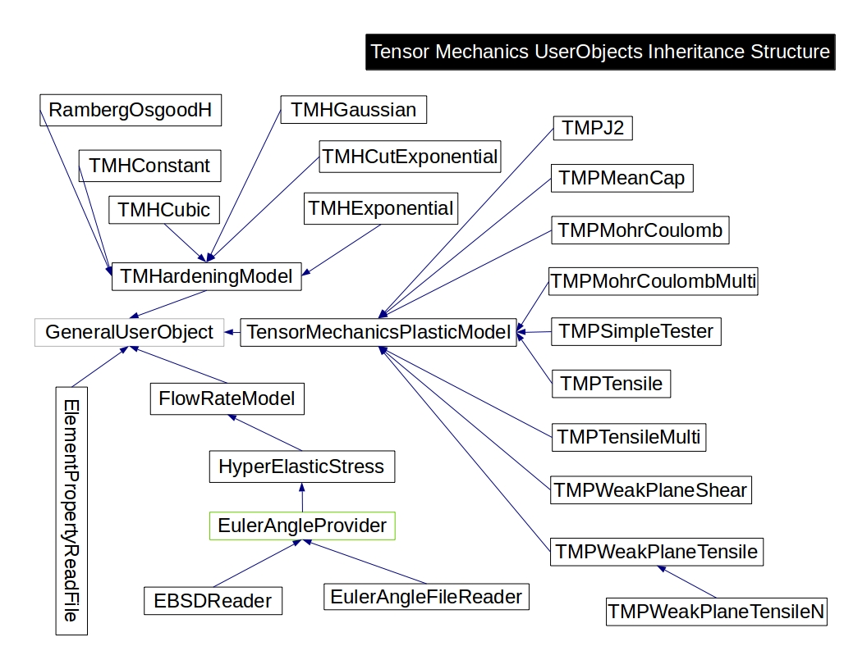Figure 7: Tensor mechanics userObjects class inheritance, plasticity and hardening models, used with ComputeStress materials

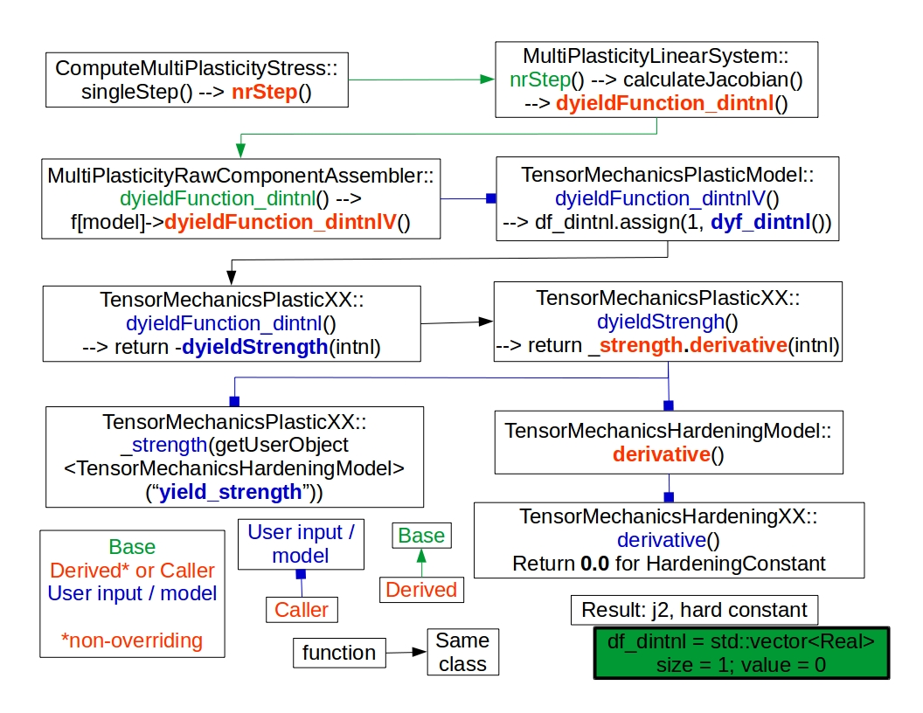Figure 8: Function calling to evaluate calculateJacobian() in ComputeMultiPlasticityStress::nrStep() via userObjects

Figure 8 explanation:
1. ComputeMultiPlasticityStress::nrStep() calls calculateJacobian, which calls dyieldFunction_dintnl, which is defined in CMPS's base class, MultiPlasticityRawComponentAssembler.

2. MPRCA::dyieldFunction_dintnl calls _f[model]->dyielfFunction_dintnlV, which accesses userObjects.

3. TensorMechanicsPlsaticModel::dyieldFunction_dintnlV calls TensorMechanicsPlasticJ2::dyieldFunction_intnl.

4. J2::dyf_dintnl calls dyieldStrength, within J2.

5. J2::dyieldStrength returns _strength.derivative.

6a. _strength is the user-defined variable "yield_strength" from J2.

6b. .derivative comes from TMHardeningModel::derivative, which calls TMHardeningConstant::derivative, which returns zero.

