1. Edit your ~/.ssh/config file and add the following content:

Host hpcgitlab.inl.gov

User <your user id>

ProxyCommand nc -x localhost:5555 %h %p

Example:

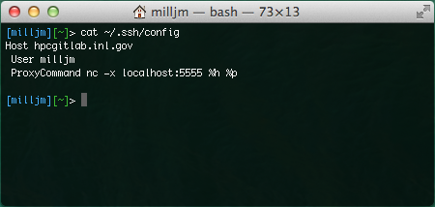

1. Create a tunnel into the HPC environment and leave it running while you require access to GitLab. If you close this window, you will loose the connection:

ssh -D 5555 [milljm@hpclogin.inl.gov](mailto:milljm@hpclogin.inl.gov)

Example:

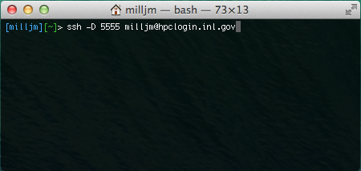

Note: Connecting in this method requires the same RSA PIN + Token you have always used when establishing a connection to HPC.

1. Adjust your socks proxy settings for your web browser to reflect the following settings:
   1. localhost:5555
   2. If you do not know how to do that, look up “Change socks proxy settings for <insert the name of your web browser here>” on google.com or some other search engine.
2. Login to <https://hpcgitlab.inl.gov>
   1. The user id and password will be the same one you have always used in the past. Note: This is _not_ your RSA token or PIN.
   2. Create your SSH public/private key and install it on GitLab. Instructions for doing so can be found on GitLab itself at: <https://hpcgitlab.inl.gov/help/ssh/ssh.md>
3. With now being able to connect to <https://hpcgitlab.inl.gov>, and having generated an SSH public/private key pair, please inform a project owner that you require access to their project.
4. Once you receive an email stating you have been added as a member of said project, you should now be able to create a Fork of that repository (using the <https://hpcgitlab.inl.gov> web site)
5. To clone the repository you just forked:

git clone [git@hpcgitlab.inl.gov](mailto:git@hpcgitlab.inl.gov):<your user id>/<project>.git

Example:

