1. Support vector machines

The support vector machine approach is based on the structural risk minimisation principle of computational learning theory, and its main idea is to find a hyperplane in high-dimensional space as a partition of the two classes for binary classification problems to ensure minimum classification error. the SVM approach is suitable for solving binary classification problems that solve high-dimensional, non-linear problems. In this project, we used linear kernel, polynomial kernel and Gaussian kernel as the kernel functions of SVM respectively.

1.1linear kernel

The linear kernel, which is used in the case of linearly divisible data, is fast and effective. The disadvantage is that it cannot handle linearly indivisible data.

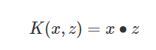

1.2Polynomial kernel

The polynomial kernel is one of the commonly used kernel functions for linear indivisible SVM, but has more parameters and is more computationally intensive.

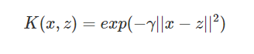

1.3 Gaussian kernel function

The Gaussian kernel, also known as the radial basis kernel function in SVM, is the most dominant kernel function for nonlinear classification SVM. The Gaussian kernel function also maps the samples to a high dimensional space, but requires fewer parameters than the polynomial kernel function and usually performs well.



1. Experimental results

In this project, we selected the better parameters by using 10-fold cross-validation on the training set and trained the model with the selected parameters and validated it using the test set. The figure below shows a comparison of the accuracy of the three kernel functions.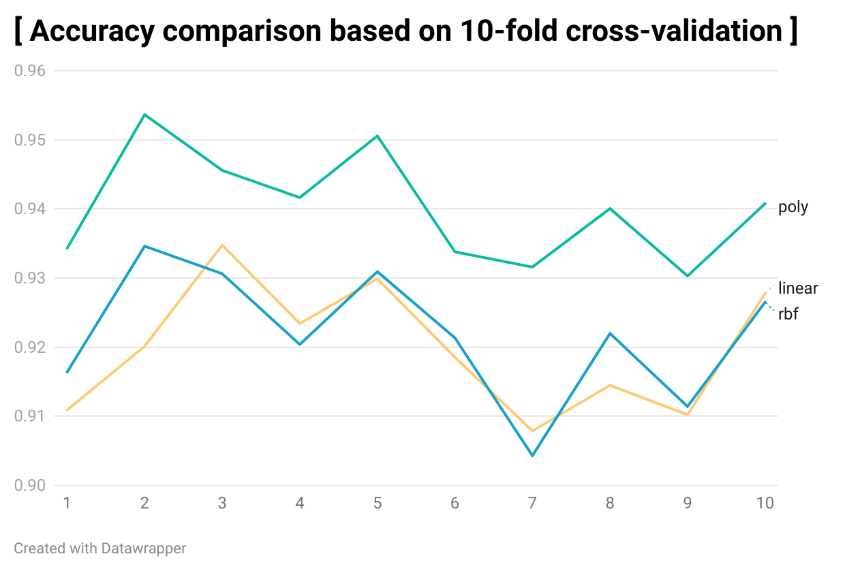

|  |  |  |  |
| --- | --- | --- | --- |
|  | rbf | Linear | Poly |
| Average precision | 0.921845959 | 0.919798355 | 0.940222388 |

As we can be seen from the above table, the highest accuracy is achieved when using polynomial kernel functions as SVM parameters, with an accuracy of approximately 94%, and the SVM model with polynomial functions as parameters will also be chosen in subsequent model comparisons.