**Extended HCP Atlas (HCPex) User Guide**

The extended HCP-MMP atlas (HCPex) is described by Huang, Rolls et al (2021a).

The extended HCP-MMP atlas is provided in the asymmetric MNI standard space of the ICBM152 2009c T1 template. The cortical regions in this atlas are adopted and reordered based on the HCP-MMP v1.0 atlas and the CortexID provided in the Supplementary Material File NIHMS68870-supplement-Neuroanatomical_Supplementary_Results.pdf of Glasser et al (2016). 66 new subcortical parcellations (33 in each hemisphere) are added in HCPex after the cortical regions.

Note: In practice, we have found that for group data, taking the average of 172 participants’ functional connectivity (Rolls et al. 2021), the correlation between the average functional connectivity map for 360 cortical areas between HCPex and surface-based registration is 0.94, but is less good for single subjects, for which surface-based analysis is better, as set out in Huang, Rolls et al (2021a). On the other hand, HCPex is likely to be helpful for activation studies in which detailed information about the brain region activated will be useful; and is very helpful for diffusion tractography studies (Huang et al. 2021b), which are usually performed in volumetric space.

**Download**

HCPex was released on 18 November 2021. The latest version can be downloaded from <https://www.oxcns.org/NeuronalNetworkSimulationSoftware.html>

or <https://github.com/wayalan/HCPex> as HCPex.zip.

**User Guide**

This HCPex atlas is mainly based on the HCP-MMP v1.0 (Glasser et al. 2016), but adds 33 subcortical regions in each hemisphere, and provides a reordering of the 360 cortical regions based on the cortical name these regions belong to. The regions are re-ordered as follows: *primary visual, early visual, dorsal stream visual, ventral stream visual, MT + complex and neighboring visual areas, somatosensory and motor, paracentral lobular and middle cingulate, premotor, posterior opercular, early auditory, auditory association, insular and frontal opercular, medial temporal, temporo-parieto-occipital junction, superior parietal, inferior parietal, posterior cingulate, anterior cingulate and medial prefrontal, orbital and polar frontal, inferior frontal, dorsolateral prefrontal,* and *subcortical* regions.

The new atlas is available as a toolbox for SPM (Results > Atlas), MRIcroGL (MRIcroGL should be used and not MRIcron, for the latter cannot handle more than 255 regions.), FreeSurfer viewer (Freeview), and is also compatible with AAL3 software. The HCPex atlas is provided with isotropic voxel size 1x1x1 mm. In addition, a lower resolution version of HCPex is provided with 2x2x2 mm voxel size for use in for example functional MRI studies.

**Content of the package**

This HCPex archive contains NIfTI files for HCPex in two different resolutions (1x1x1mm & 2x2x2mm), a skull-stripped ICBM152 T1 template for atlas overlapping, and necessary files for MRIcroGL, Freesurfer, SPM, and AAL3 software. We also provide a useful function “HCPexOrdering.m” for users to alter the connectivity matrix from the HCPex to the original HCP-MMP v1.0 label ordering.

|  |  |  |
| --- | --- | --- |
| File Type | Filename | Description |
| 1x1x1 mm3 | HCPex.nii.gz | Atlas file; Required for MRIcroGL, Freeview, and SPM software |
| HCPex.nii.txt | Required for MRIcroGL |
| HCPex.xml | Required for SPM12 |
| HCPex_LookUpTable.txt | Required for Freeview |
| HCPex_LookUpTable.lut | Required for FSL |
| mni_icbm152_t1_tal_nlin_asym_09c_brain.nii.gz | Skull-stripped T1 template |
| 2x2x2 mm3 | HCPex_2mm.nii | Atlas file; Required for MRIcroGL, Freeview, SPM, and AAL3 software |
| HCPex_2mm.txt | Required for MRIcroGL |
| HCPex_2mm.xml | Required for SPM12 |
| Matlab files | HCPexOrdering.m | Reordering function |
| HCPex_LabelID.mat | Required for the reordering function |
| HCPex_2mm_Border.mat | Required for AAL3 software |
| HCPex_2mm_vol.mat | Required for AAL3 software |
| HCPex_2mm_List.mat | Required for AAL3 software |

You can find HCPex ordering (1st column), HCP-MMP ordering (2nd column), Region name in two different format (3rd and 4th column), cortex labels (5th column), and cortex names (6th column) in the HCPex_LabelID.mat file.

**Tutorial for use of HCPex with MRIcroGL**

1. Copy HCPex.nii.gz and HCPex.nii.txt files to the MRIcroGL/atlas directory

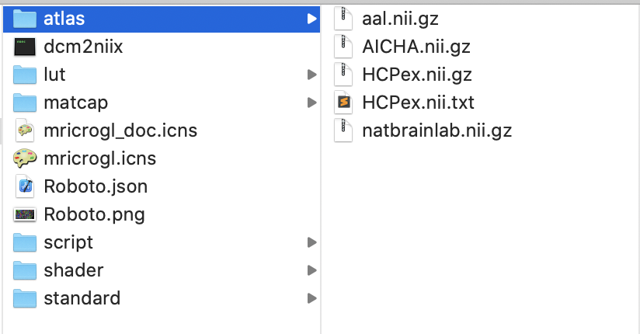

1. Open the MRIcroGL application
2. Add Atlas > HCPex
3. 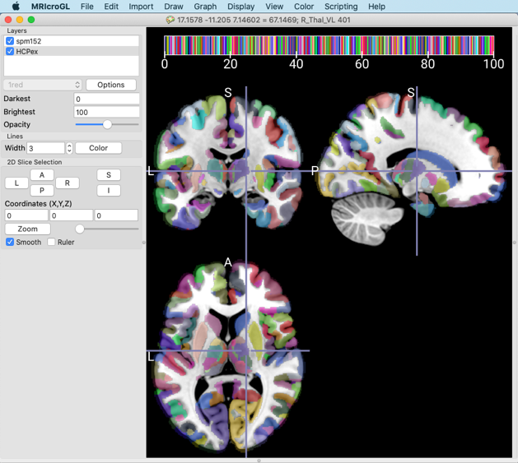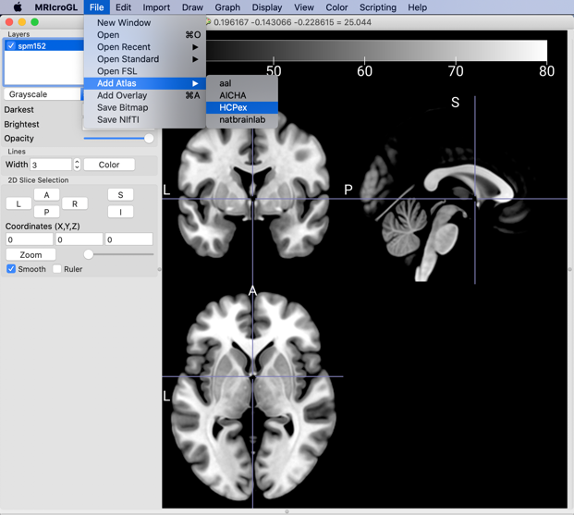Done! Drag the mouse to navigate the atlas labels.

*## Please confirm that the HCPex.nii.txt file is in the same directory with HCPex.nii.gz, so that MRIcroGL can automatically detect the labelling file.*

*## HCPex is defined in the MNI ICBM152 2009c asymmetric T1 template. Please open “mni_icbm152_t1_tal_nlin_asym_09c_brain.nii” as the background T1 image if you wish for more accurate overlapping visualization.*

***Tutorial for Freesurfer viewer (freeview)***

1. Open the freeview application (with command line tool ↵ freeview)
2. File → Load Volume → Select volume file “mni_icbm152_t1_tal_nlin_asym_09c_brain.nii” → OK
3. File → Load Volume → Select volume file “HCPex.nii.gz” → OK
4. Color map popup menu: Lookup Table
5. Lookup table: HCPex_LookUpTable.txt
6. Done! Drag the mouse to navigate the atlas labels.

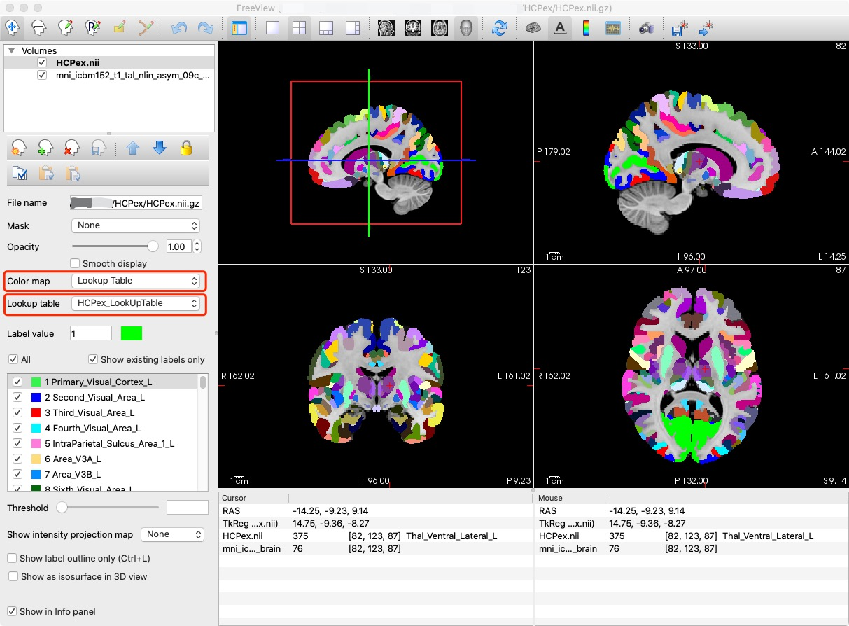

**## Note: Freeview command line is also supported:**

*freeview -v mni_icbm152_t1_tal_nlin_asym_09c_brain.nii.gz   
-v HCPex.nii.gz:colormap=lut:lut=HCPex_LookUpTable.txt*

**Tutorial for use of HCPex with FSL**

1. Launch FSLEYES
2. File > Add from file > mni_icbm152_t1_tal_nlin_asym_09c_brain.nii.gz
3. File > Add from file > HCPex.nii.gz
4. Overlay type > Label image

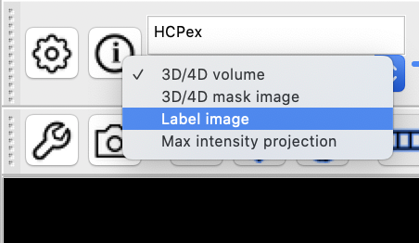

1. Settings > Ortho View 1 > Lookup tables > Load LUT > HCPex_LookUpTable.lut

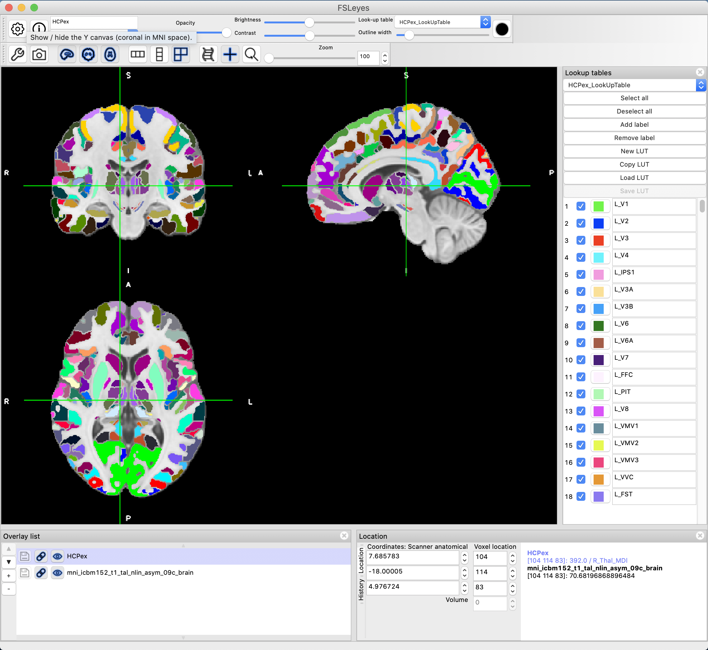

***Tutorial for SPM (Results)***

1. Copy the HCPex.nii and HCPex.xml into your SPM12/atlas directory
2. Launch SPM12 from the command window in Matlab

>> spm fmri

1. Select the desired contrast, mask, probability and extent threshold in the regular “Results”.
2. In the SPM12 Results window: Atlas/ Label using/ HCPex

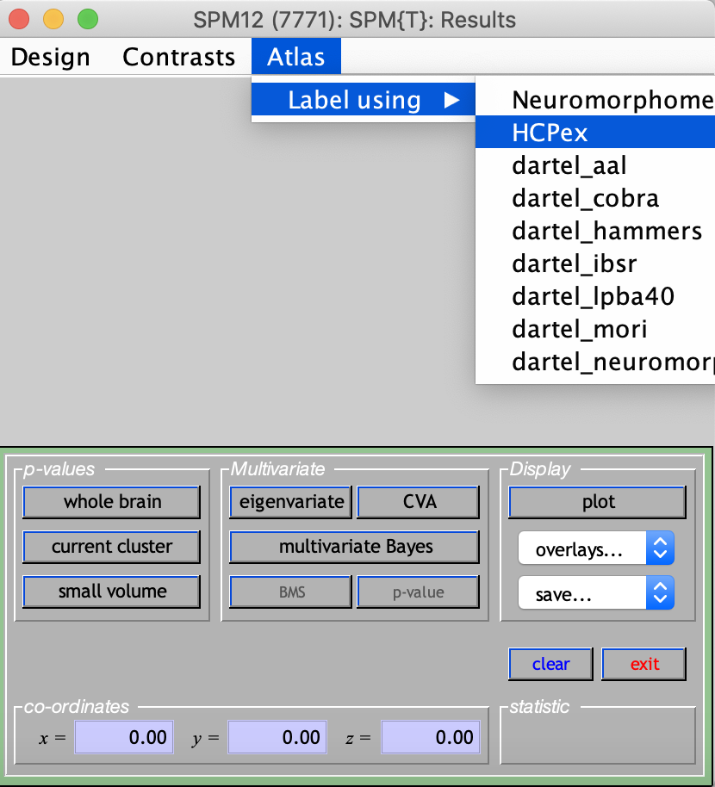

1. You can get the label with a right click on the coordinates in the right of the Graphic window

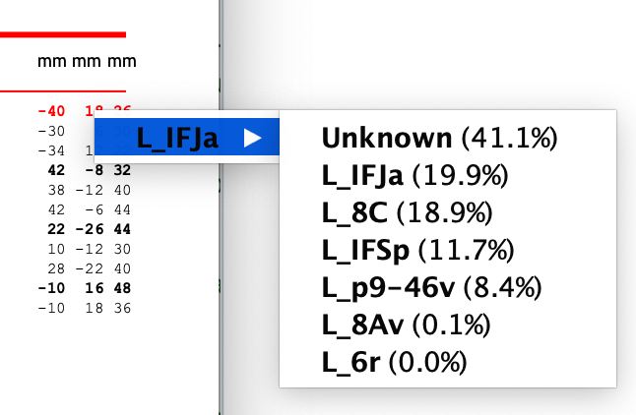

***Tutorial for SPM (with AAL3 software)***

1. Download AAL3 from the website: <https://www.oxcns.org/NeuronalNetworkSimulationSoftware.html>

Or

<http://www.gin.cnrs.fr/tools/aal>

1. Gunzip and untar the archive will create an AAL3 directory
2. Add the extracted directory to your Matlab path
3. Launch AAL3 function from the Matlab command window

>> AAL3

1. Choose a labeling procedure. Three choices are explained and documented in the paper (Tzourio-Mazoyer et al. 2002): Local maxima labeling, Extended local maxima labeling and Cluster labeling. For "Extended local maxima labeling" input the local maxima radius of the sphere in millimeters (default 10 mm).
2. Select the desired contrast, mask, probability and extent threshold like in the regular spm Results.
3. Select the anatomical parcellation: HCPex_2mm.nii
4. Then you get the label on the coordinates in the Graphic window.

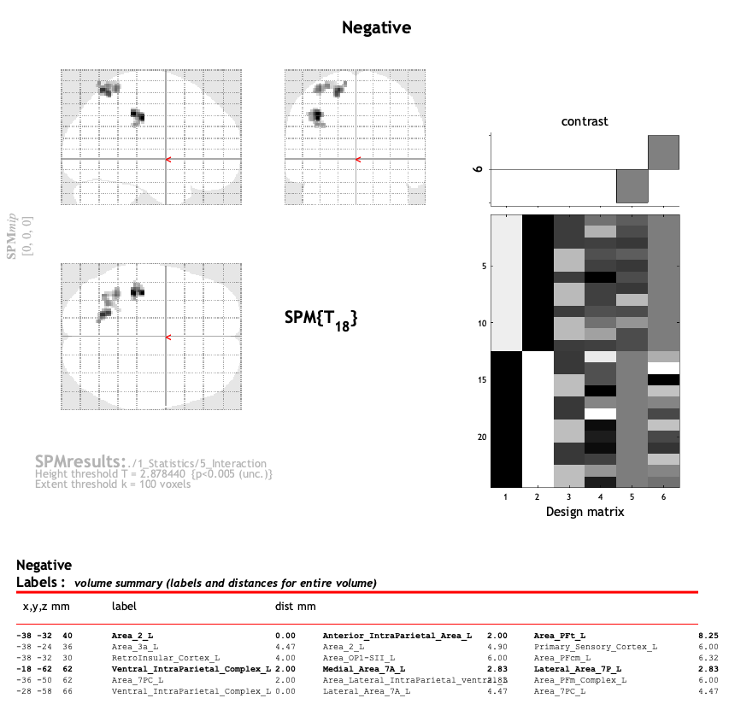

**Tutorial for the matrix reordering function (HCPexOrdering.m)**

1. Load matrix file from the Matlab command window. Here, we provide an example connectivity matrix for demonstration.

Example: > load ExampleMatrix.mat

1. Run the HCPexOrdering.m function from the Matlab command window to reorder the input matrix from the original HCP-MMP ordering to the new HCPex ordering ***(forward)***.

> rMatrix = HCPexOrdering(ExampleMatrix, 1);

or

1. Run the HCPexOrdering.m function from the Matlab command window to reorder the input matrix from the new HCPex ordering to the original HCP-MMP ordering ***(backward)***.

> OrigMat = HCPexOrdering(rMatrix, -1);

***## Note:*** HCPex_LabelID.mat is needed when running the HCPexOrdering.m function (should be placed in the same folder).You can find HCPex ordering (1st column), HCP-MMP1 ordering (2nd column), Region name in two different formats (3rd and 4th column), cortex labels (5th column), and cortex names (6th column) in the HCPex_LabelID.mat file.

**Notes for atlas resampling**

The current HCPex atlas is established based on the ICBM152 2009c asymmetric template in MNI standard space with the dimensions of 193x229x193 (1mm3 atlas). Although the atlas in 2x2x2mm3 is provided, we noticed that there are many variants of MNI space images found in different studies, especially fMRI, and most of the software handles images with identical resolution and dimension only. In this regard, we would like to suggest a hint for users who want to resample the atlas by themselves.

Taking FSL *flirt* function for example, to resample the HCPex to MNI152 T1 template provided by FSL:

flirt -in mni_icbm152_t1_tal_nlin_asym_09c_brain.nii.gz   
-ref MNI152_T1_1mm_brain.nii.gz -omat icbm2fsl.mat -dof 6

flirt -ref MNI152_T1_1mm_brain.nii.gz -in HCPex.nii.gz   
-applyxfm -init icbm2fsl.mat -out HCPex_FSLspace.nii.gz   
-interp nearestneighbour

However, resampling is not recommended if you want to keep the useful subcortical regions, such as the thalamic nuclei. The best solution will be using the ICBM152 2009c asymmetric template (Fonov et al. 2011) for normalization in the first place so to keep the small subcortical regions. Moreover, surface-based or diffeomorphic image registration techniques are highly recommended during MNI standard space mapping, so that the feature of gray matter ribbon can be largely preserved.

**Note on registration.**

To obtain optimal spatial normalization at the individual level, we recommend nonlinear registration using the brain-extracted T1w volume to the brain-extracted ICBM 2009c asymmetrical template in MNI152 space.

References

Fonov V, Evans AC, Botteron K, Almli CR, McKinstry RC, Collins DL, Brain Development Cooperative G (2011) Unbiased average age-appropriate atlases for pediatric studies. Neuroimage 54 (1):313-327. doi:10.1016/j.neuroimage.2010.07.033

Glasser MF, Coalson TS, Robinson EC, Hacker CD, Harwell J, Yacoub E, Ugurbil K, Andersson J, Beckmann CF, Jenkinson M, Smith SM, Van Essen DC (2016) A multi-modal parcellation of human cerebral cortex. Nature 536 (7615):171-178. doi:10.1038/nature18933

Huang C-C, Rolls ET, Feng J, Lin C-P (2021a) An extended Human Connectome Project anatomical atlas. Brain Structure and Function: doi: 10.1007/s00429-00021-02421-00426

Huang C-C, Rolls ET, Hsu C-CH, Feng J, Lin C-P (2021b) Extensive cortical connectivity of the human hippocampal memory system: beyond the "what" and "where" dual-stream model. Cereb Cortex 31:4652-4669. doi:10.1093/cercor/bhab113

Rolls ET, Deco G, Huang CC, Feng J (2021) The effective connectivity of the human hippocampal memory system. Cereb Cortex: doi: 10.1093/cercor/bhab1442

Tzourio-Mazoyer N, Landeau B, Papathanassiou D, Crivello F, Etard O, Delcroix N, Mazoyer B, Joliot M (2002) Automated anatomical labeling of activations in SPM using a macroscopic anatomical parcellation of the MNI MRI single-subject brain. Neuroimage 15 (1):273-289. doi:10.1006/nimg.2001.0978