How to perform a SharePoint Content Redirect using Regex Expressions

**Request:**

On clicking on a sharepoint list result link, redirect from the respective list item to its respective list

From:

http://***/Lists/{List Name}/DispForm.aspx?ID=***

To:

http://***/Lists/{List Name}

**Update:**

The selection query has a bug and cannot run functions, Sinequa engineering recommended the following work around:

Map

url1

to:

IfEquals("Lists",RegexGetMatchedValues(url1,'(.*)(Lists)(.*\/DispForm\.aspx\?ID=)', 2),RegexGetMatchedValues(url1,'(.*\/Lists\/.*)(\/DispForm\.aspx\?ID=)', 1) , url1)

**Old Approach (Selection Query Fails, but Regexes are still valid)**

To accomplish this, we can do a mapping in the sharepoint connector using the function [RegexGetMatchedValues](https://doc.sinequa.com/en.sinequa-es.v10/Default.htm#en.sinequa-es.syntax.value-patterns.html).

Map:

url1

to

RegexGetMatchedValues(url1,'(.*\/Lists\/.*)(\/DispForm\.aspx\?ID=)', 1)

With a selection query of:

RegexGetMatchedValues(url1,'(.*)(Lists)(.*\/DispForm\.aspx\?ID=)', 2) = 'Lists'

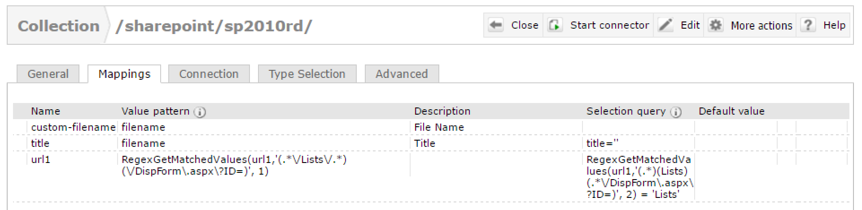

**Verifying Our Regex:**

We can verify our regex expressions by going to <http://regexlib.com/>

Select Regex Tester and fill out the following:

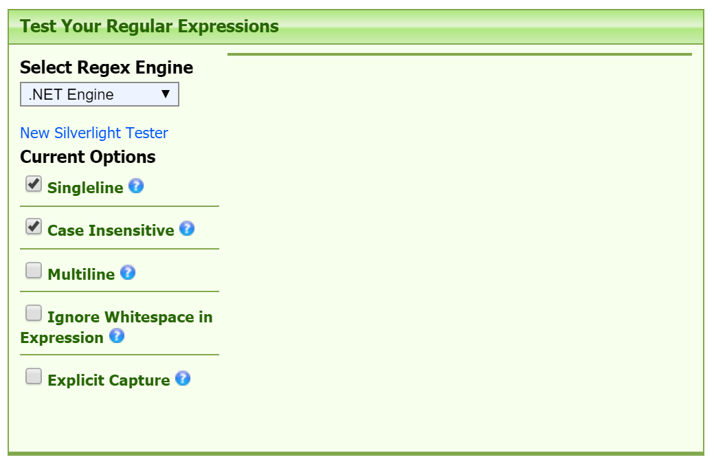

See Regex Input and Testing Results on Next Page.

**Selectively Test Our Expressions:**

Map url1 to RegexGetMatchedValues(url1,'(.*\/Lists\/.*)(\/DispForm\.aspx\?ID=)', 1)

url1 maps to $1 (see value of $1 below in the results)

which is exactly what we want

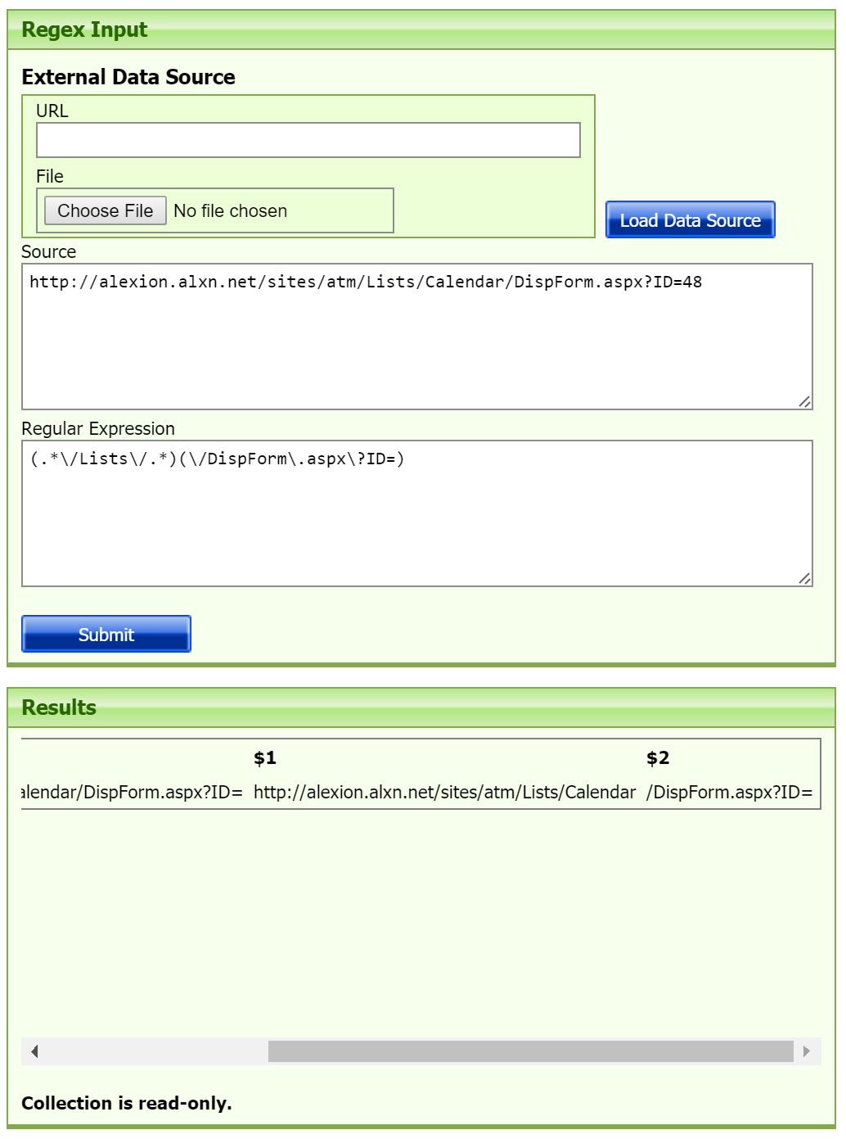

**For the Selection Query:**

RegexGetMatchedValues(url1,'(.*)(Lists)(.*\/DispForm\.aspx\?ID=)', 2) = 'Lists'

$2 = ‘Lists’ (See results of $2 below in the results)

