©VIT IPR&TTCELL
 Invention Disclosure Format (IDF)-A | Document No. | 02-IPR-R002
 | Issue No/Date | 2/01.02.2024
 | Amd. No/Date | 0/00.00.0000

1. Inventor(s) information

(i) | Full Name | Konatham Sumalatha
 | VIT Employee ID: | 20109
 | Gender | Female
 | Nationality | Indian
 | Position | Associate Professor Sr Gr 1
 | Department | Database Systems
 | School/Center | SCOPE
 | Phone & E-Mail (Office) | 9618507771. Konatham.sumalatha@vit.ac.in
 | Complete Address (Office) | Vellore Institute of Technology, Vellore
(ii) | Full Name | Dibyendu De
 | VIT ID: | 23BCE0637
 | Gender | Male
 | Nationality | Indian
 | Position | Student
 | Department | CSE
 | School/Center | SCOPE
 | Phone & E-Mail (Office) | 90070 45453, dibyendu.de2023@vitstudent.ac.in
 | Complete Address (Office) | VIT Vellore
(iii) | Full Name | Diya Arvind
 | VIT ID: | 23BCE0798
 | Gender | Female
 | Nationality | Indian
 | Position | Student
 | Department | CSE
 | School/Center | SCOPE
 | Phone & E-Mail (Office) | 96632 94641, diya.aravind2023@vitstudent.ac.in
 | Complete Address (Office) | VIT Vellore
(iv) | Full Name | Aryan Jain
 | VIT ID: | 23BCT00020
 | Gender | Male
 | Nationality | Indian
 | Position | Student
 | Department | CSE-IoT
 | School/Center | SCOPE
 | Phone & E-Mail (Office) | 9987512927, aryanramesh.jain2023@vitstudent.ac.in
 | Complete Address (Office) | VIT Vellore
(v) | Full Name | Vinay G
 | VIT ID: | 23BCT0066
 | Gender | Male
 | Nationality | Indian
 | Position | Student
 | Department | CSE-IoT
 | School/Center | SCOPE
 | Phone & E-Mail (Office) | 9108012372
 | Complete Address (Office) | VIT Vellore

NOTE:
In case of co-inventors from external organization (Academic institution/ Industry / R&D lab/Funding agency with specific IP sharing agreement) contact IPR&TT Cell before submitting the IDF.

Declaration:

I declare that the information provided in this document is complete and true to the best of my knowledge and based on records.

Date: 31-10-2025
Inventor Name: Dr. Konatham Sumalatha

Signature:

Inventor Name: Dibyendu De
Signature:
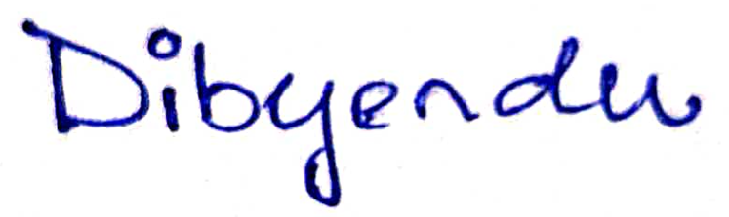
Inventor Name: Diya Arvind
Signature:
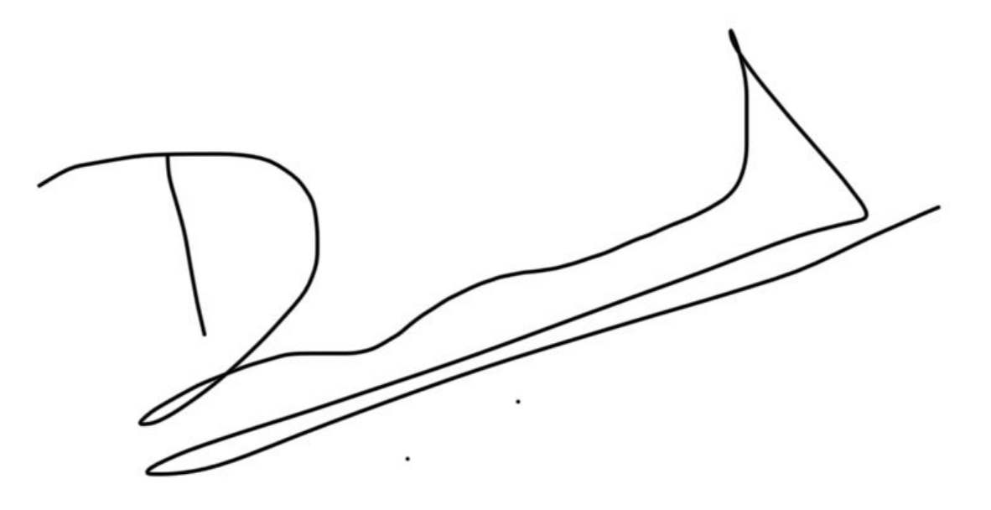
Inventor Name: Aryan Jain
Signature:
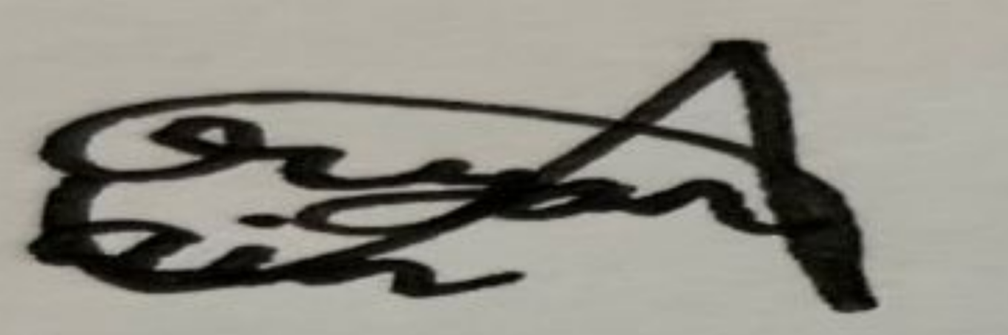

Inventor Name: Vinay G

Signature:
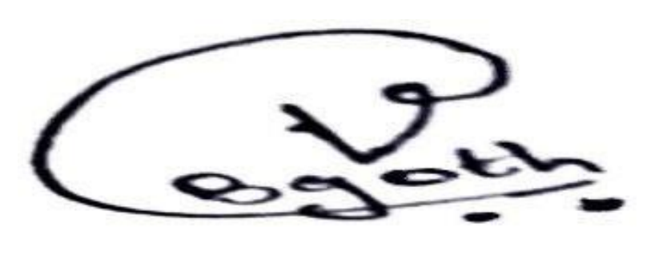

(Add more rows if necessary)

---------------------END OF THE DOCUMENT-----------------------------

