Image1

Qiu Yifeng is a brave and curious boy who loves to explore the world around him. In this story, he learns the values of friendship, sharing, and courage. Qiu Yifeng is a curious boy who carries a small backpack every day, ready for a new adventure.

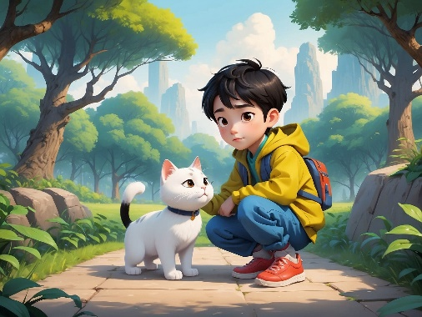Image2

Qiu Yifeng meets a little cat in the park. It looks scared, and Qiu Yifeng decides to help it.

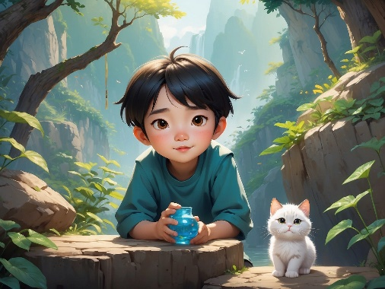Image3

Qiu Yifeng gently picks up the little cat and takes it to find food and water. The little cat feels Qiu Yifeng’s kindness and begins to trust him.

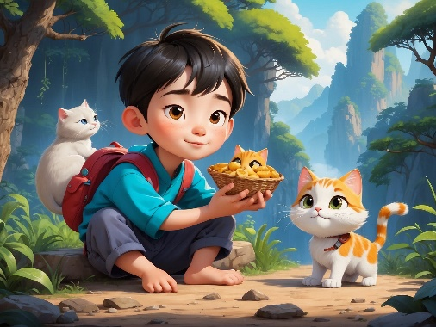Image4

Qiu Yifeng takes the little cat home and shares snacks with his family. He learns the importance of sharing.

Image5

One day, the little cat gets lost, and Qiu Yifeng decides to use a map to find it. Along the way, he faces challenges but refuses to give up.

Image6

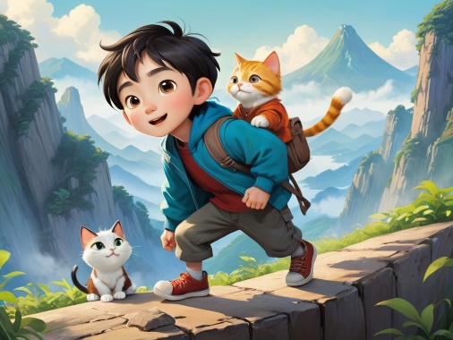Qiu Yifeng climbs a small hill and eventually finds the little cat from a higher vantage point. He is happy because he overcame his fear.

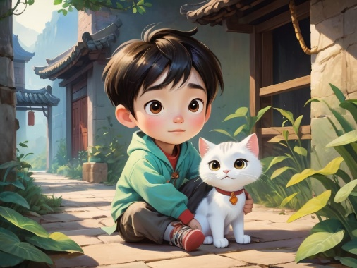Image7

Qiu Yifeng finally brings the little cat home, and everyone is proud of him. He realizes that he has become braver.

Image8

In the park, Qiu Yifeng meets more little animals and starts building friendships with them. He learns more about friendship and caring for others.

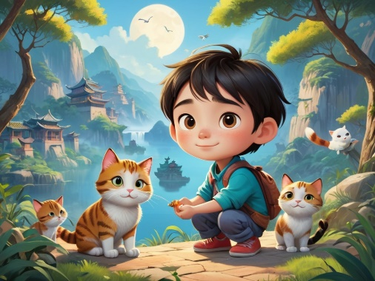Image9

One day, the little cat brings more animals, and together they help Qiu Yifeng complete a big challenge. He learns the importance of cooperation and teamwork.

Image10

At the end of the story, Qiu Yifeng sits on a park bench, reflecting on his adventure. His heart is filled with satisfaction and pride. He knows that no matter what challenges lie ahead, he won’t give up because he has learned to be brave, share, and care for others.