ChangeIS | Relay – delivery wisdom | 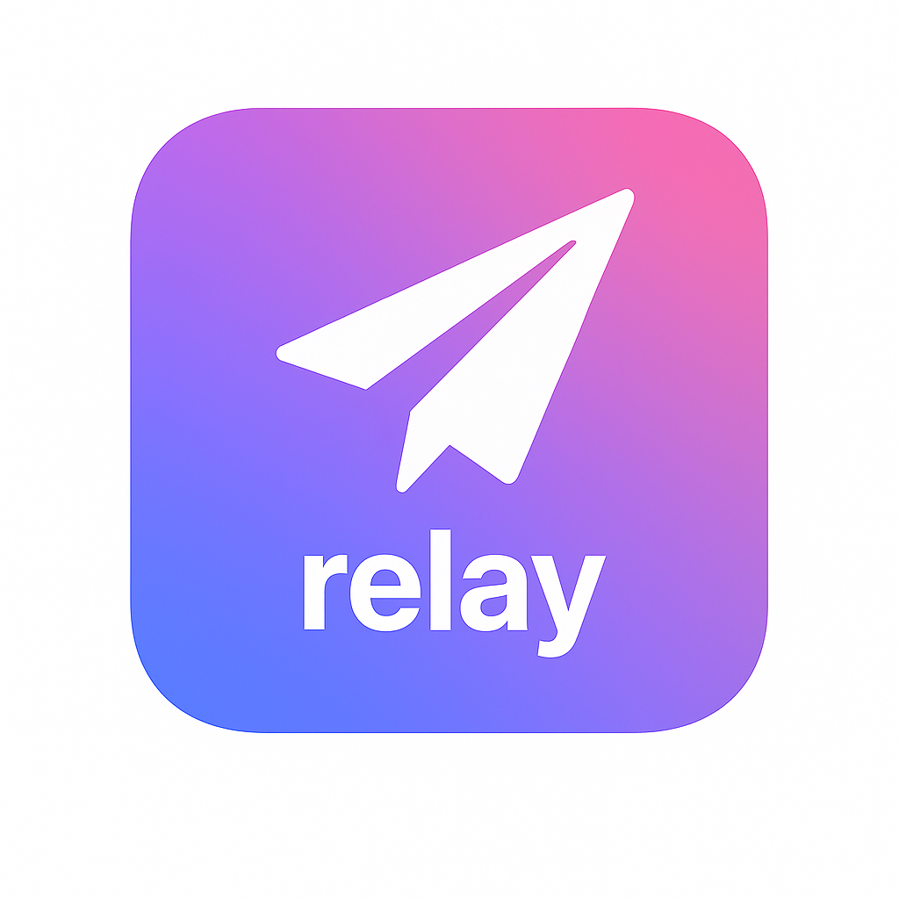
“From commit to completion: predictable, aligned, and clear.”

Situation: Is This You?

Do your deployments suffer from unpredictable handoffs, last-minute surprises, or unclear ownership?

Relay keeps delivery flow predictable, with no surprises, no ambiguity, and no last-mile chaos.

Do release pipelines drift between teams, environments, or projects?

Relay eliminates drift and keeps pipelines consistent across teams and environments.

Do you struggle with limited visibility into what was deployed, when, how, and why?

Relay provides clear and traceable visibility, so Release, Support, and leadership always know the truth of delivery.

Solution: What We Do.

Relay is GuruSuite’s Delivery Wisdom System, providing clarity, predictability, and confidence across releases.
It learns from delivery activity, ensuring changes move from commit to completion in a clean and aligned flow.
It distills institutional knowledge into community wisdom in a constantly evolving and growing library containing:

- Delivery and pipeline data
- Organized information about release events
- Enriched knowledge of handoff and environment patterns
- Derived wisdom from successful deployment methods
- Actionable delivery insights for improvement

Summary: How It Helps You.

Reliable · Assured · Efficient · Traceable · Aligned

Deliver confidently. Turn deployment chaos into clean completion. Move from inconsistent to predictable flow.
Relay brings learning to the last mile: each release becomes safer, cleaner, and smarter than the one before.
Deployment directed by you, supported by your personal Mentor, Librarian, and Sage.

