ChangeIS | Fluid – collaboration wisdom | 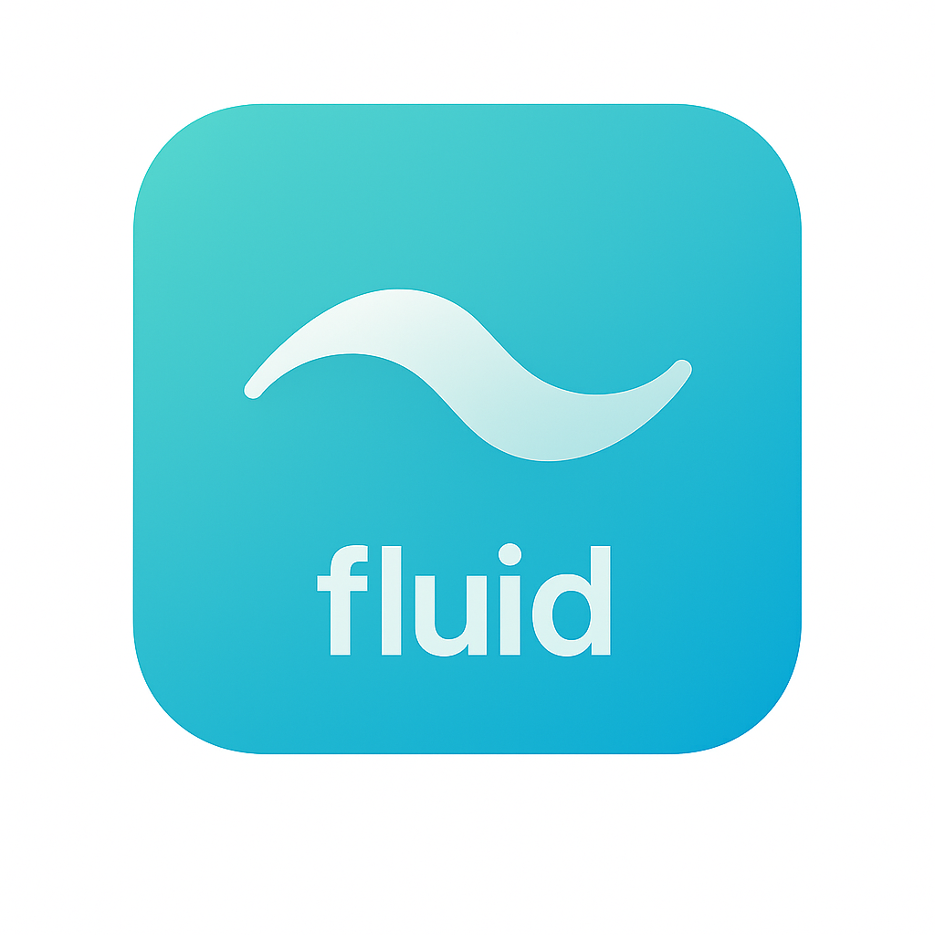
“Communication. Consensus. Coordinated action.”

Situation: Is This You?

Do conversations scatter across chats, emails, meetings, and tools with no clear source of truth?
Fluid brings clarity by gathering scattered communication into one coherent flow.

Do projects slow down because decisions are unclear, forgotten, or buried in threads?
Fluid strengthens alignment by capturing decisions, context, and actions so nothing gets lost.

Do teams struggle to move from discussion to coordinated execution?
Fluid turns communication into shared understanding and shared understanding into coordinated action.

Solution: What We Do.

Fluid is GuruSuite’s Collaboration Wisdom System, aligning teams across tools, conversations, and contexts so nothing is lost and everyone moves together.

It learns from communication, decisions, and activity, building a living library of how work connects and how teams coordinate, which contains:
- Communication and decision data.
- Organized information about actions and follow-through.
- Enriched knowledge of roles, context, and dependencies.
- Derived wisdom from collaboration patterns.
- Actionable insights for coordination and execution.

Summary: How It Helps You.

Unified · Collaborative · Adaptive · Coherent · Aligned
Fluid turns scattered communication into coordinated consensus.
Fluid turns fragmented actions into unified flow.
Fluid brings clarity to how people work together.

