ChangeIS | Nexa – DevOps wisdom | 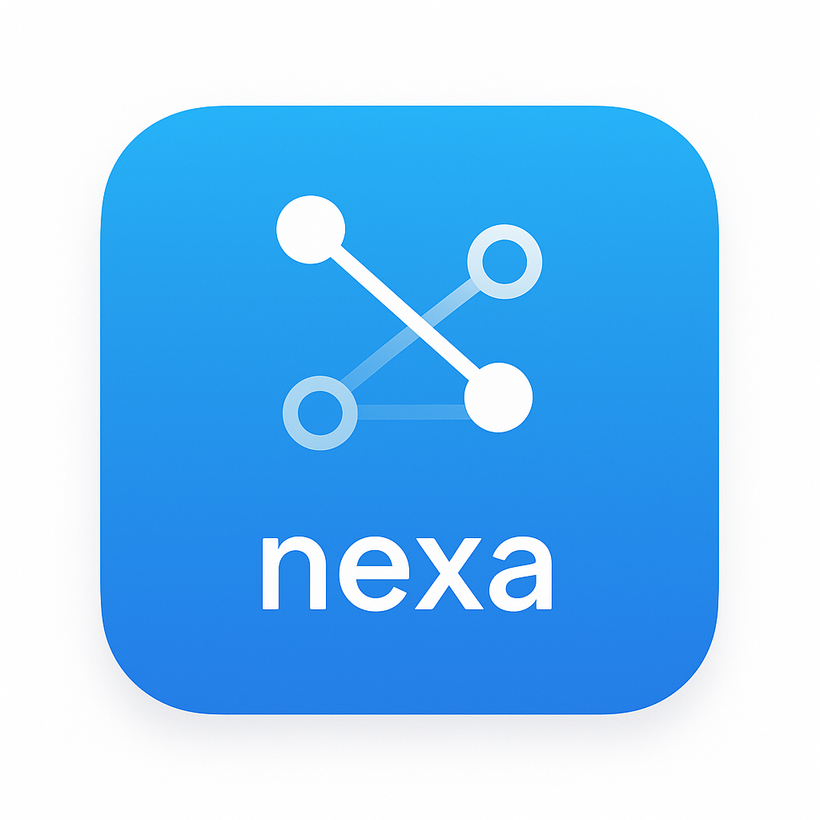
“Where real work becomes real alignment.”

Situation: Is This You?

Do your operations rely on institutional knowledge that only a few people truly understand?
Nexa captures what you do: not what was documented, turning hidden expertise into shared, reliable intelligence.

Do handoffs, coordination gaps, or missing context slow down delivery?
Nexa aligns DevOps, Operations, and the business so work moves forward without conflict, confusion, or rework.

Do your systems and expectations drift over time?
Nexa learns as you learn: updating a living ops library growing with your people, processes, and environment.

Solution: What We Do.

Nexa is GuruSuite’s DevOps wisdom system. It connects teams, systems, and action into a coherent flow. It observes activity, captures it, and turns it into a living operations library that evolves with every interaction.

Nexa learns as you learn, updating a living library that grows with you grow, becoming your backbone of operations, stopping drift and supporting execution. Nexa provides:

• Operational activity and workflow data.

• Organized information about changes, ownership, and dependencies.

• Enriched knowledge of patterns, constraints, and engineering flow.

• Derived wisdom from repeated delivery successes and failures.

• Actionable insights that strengthen DevOps alignment and execution.

Summary: How It Helps You.

Reliable · Transparent · Evolving · Aligned · Efficient

Operate with confidence.
Turn institutional knowledge into shared, living intelligence.

