ChangeIS | Maestro – testing wisdom | 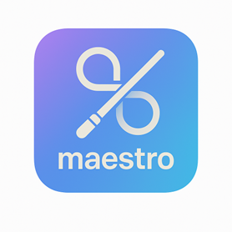
“Developing testing confidence and clarity.”

Situation: Is This You?

Do you have mission-critical testing that can't fail?
Maestro ensures every test and automated check runs reliably and predictably, building expertise.
Do you need your testing to evolve as you learn more?
Using adaptive orchestration, Maestro evolves alongside your team, getting smarter with every iteration.
Do you want testing to enable learning?
Maestro connects data, tools, and agents, turning testing into an intelligent learning engine.
Solution: What We Do.
Maestro provides clarity, confidence, and continuous validation across systems, software, and workflows.
It learns from testing activity, reduces uncertainty, and ensures every change is validated before it matters.
It distills institutional knowledge into community wisdom in a constantly evolving, growing library containing:
- System, setup and testing data
- Organized information on results
- Enriched knowledge about test strategies
- Derived wisdom from successful methods
- Insights into continuous testing improvement

Summary: How it helps you.
Orchestrated · Intelligent · Seamless · Controlled · Precise

Orchestrate testing automation with precision and intelligence.
Testing directed by you, guided by your personal Mentor, Librarian, and Sage.

