ChangeIS | Weavr – knowledge wisdom | 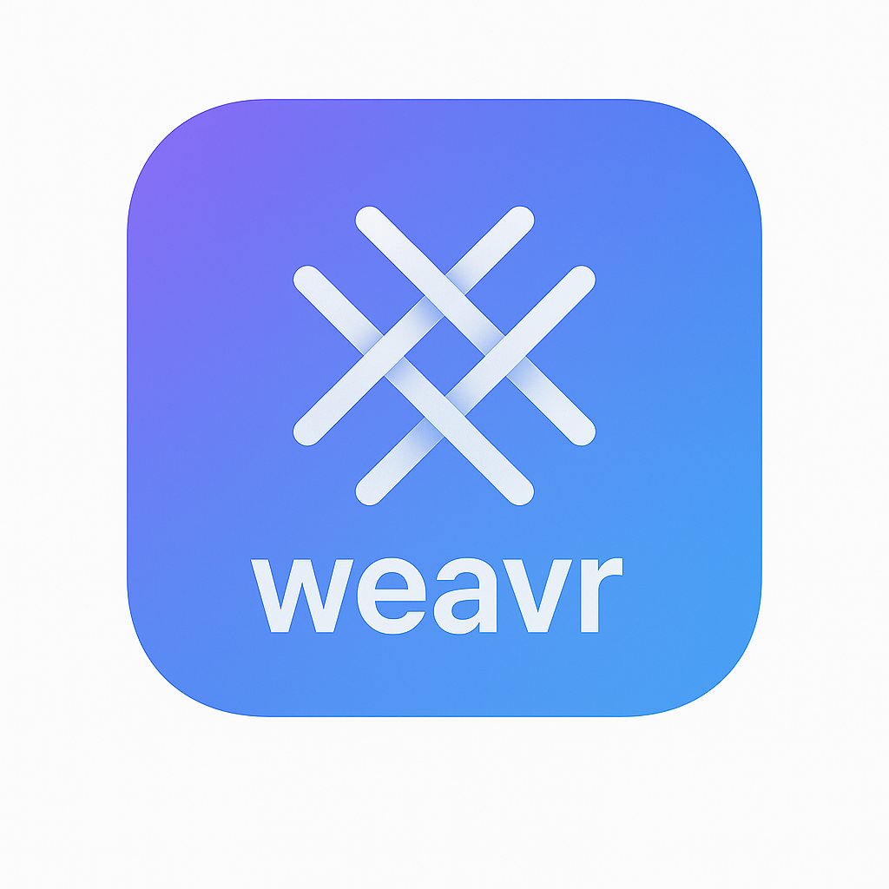
“When everything connects, everything becomes clear.”

Situation: Is This You?

Is your organization struggling with how to capture and use institutional memory and expertise?

Weavr brings clarity and confidence by turning scattered information into shared wisdom.

Is critical knowledge scattered across teams, tools, or outdated pages?

Weavr connects understanding so anyone can trace how things work, why they work, and what they depend on.

Do people ask the same questions repeatedly because context is missing or hard to find?

Weavr provides navigable maps that reveal relationships between information, decisions, systems, and people.

Solution: What We Do.

Weavr transforms disconnected information into clear, contextual understanding across the entire organization.

Learning from activity and captures how work happens, creating a living map of knowledge that evolves with real experience, not static documentation.

People learn from Weavr, and Weavr learns from them, capturing understanding in an evolving library:

Captured organizational data.

Organized information about processes and decisions.

Enriched knowledge of relationships and dependencies.

Derived wisdom from repeated patterns of work.

Actionable insights into how things truly operate.

Summary: How It Helps You.

Connected · Navigable · Adaptive · Contextual · Coherent

Weavr turns scattered information into shared wisdom, siloed knowledge into organizational clarity.
Weavr becomes the living map of your organization’s memory and meaning.

