- Install Anaconda Individual Edition: https://docs.anaconda.com/anaconda/install/

- Running Jupyter Notebook: https://jupyter-notebook-beginner-guide.readthedocs.io/en/latest/execute.html

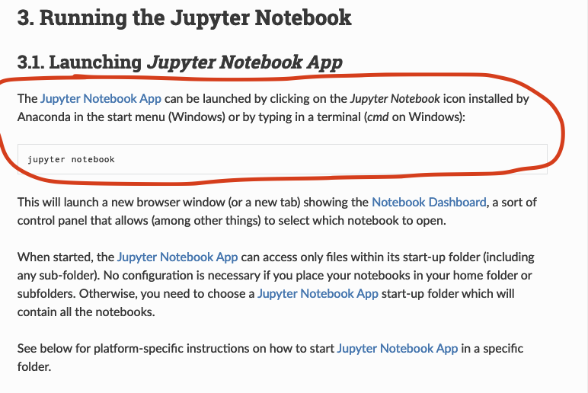

- Don’t close the “terminal” after starting jupyter or it will crash it

- Some Jupyter Notes
  - All Jupyter files are .ipynb
  - Create a new file: Click the “new” button at the top.

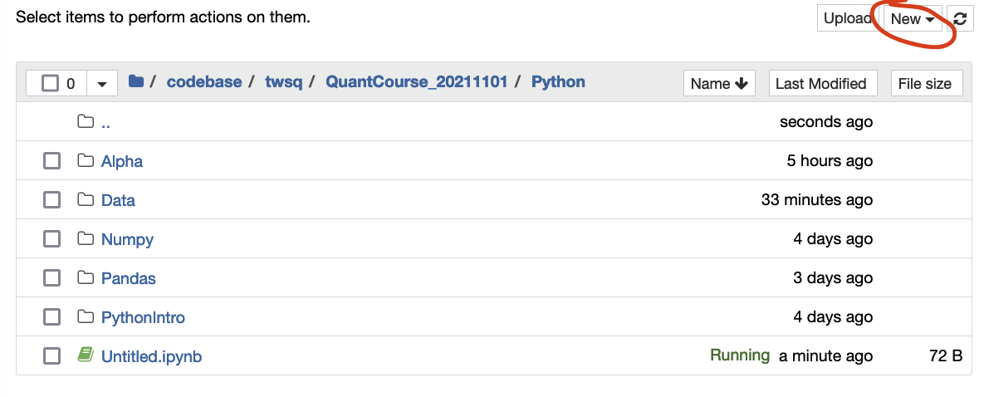

  - Naming/Renaming a notebook: Click into the name of the book in top left and start typing

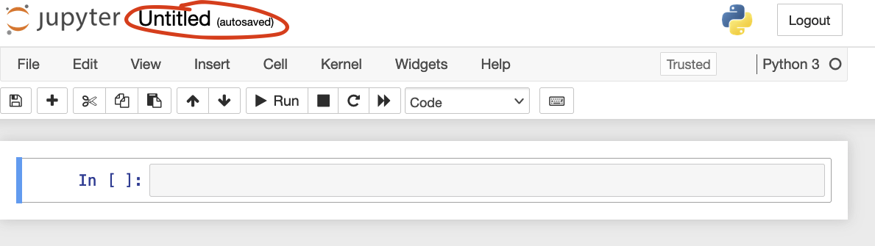

  - Run a cell : Press “Shift + Enter” after you’ve clicked into it
  - Add a cell: Click the + button

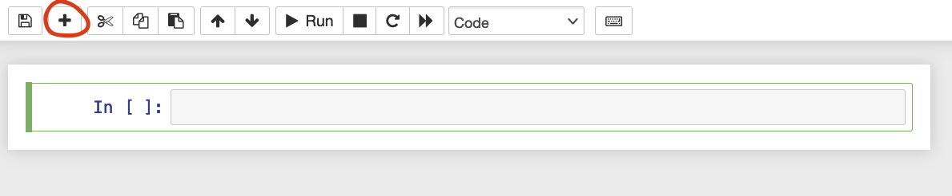

  - Delete a cell: Click the scissors after you’ve clicked into it

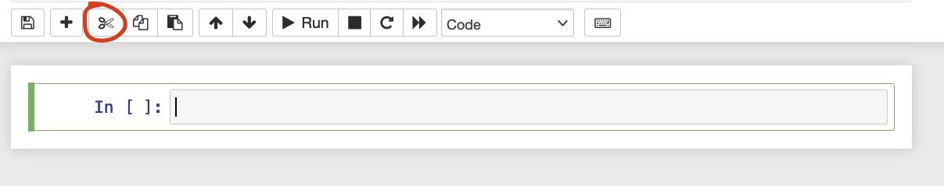

  - Move a Cell up or down: use the up/down arrow buttons

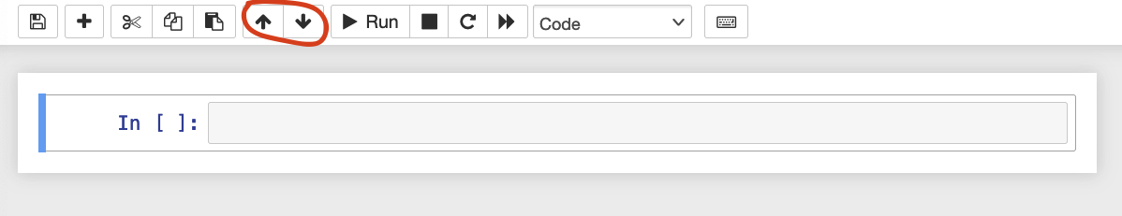

  - Restart a notebook & clear output

