**Algorithm Programming HW#1 Report**

B04501095

黃平瑋

1. **Runtime & memory used**

|  |  |  |  |  |  |  |  |  |
| --- | --- | --- | --- | --- | --- | --- | --- | --- |
|  | Insertion Sort | | Merge Sort | | Heap Sort | | Quick Sort | |
|  | Time  (Sec) | Memory (KB) | Time  (Sec) | Memory (KB) | Time  (Sec) | Memory (KB) | Time  (Sec) | Memory (KB) |
| case1 | 2.12e-3 | 13592 | 1.164e-3 | 13596 | 5.87e-4 | 13592 | 5.82e-4 | 13596 |
| case2 | 0.1006 | 14652 | 7.481e-3 | 15272 | 4.767e-3 | 14652 | 4.179e-3 | 14656 |
| case3 | 16.4679 | 23432 | 8.783e-2 | 28908 | 7.25e-2 | 23432 | 6.157e-2 | 23436 |
| case4 | 134.866 | 34412 | 0.1812 | 46388 | 0.1867 | 34412 | 0.1513 | 34416 |

Time is measured by AlgTimer.

Memory is measured by htop command.

1. **Plotting**
2. **Runtime Comparision**

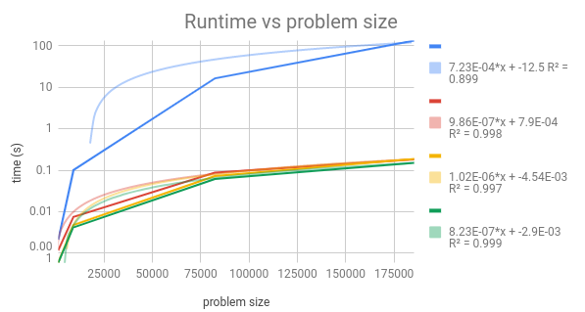

藍色為insertion sort

紅色為merge sort

黃色為heap sort

綠色為quick sort

**b. memory comparison**

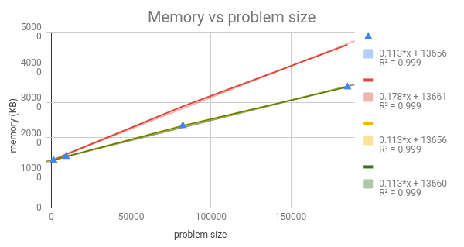

藍色為insertion sort

紅色為merge sort

黃色為heap sort

綠色為quick sort