2018 Numerical Analysis Homework #3, 2D Gaussian Quadrature

1. We have to compute the integration of a 2-variate polynomial $f\left(x,y\right)=\sin\left(x^{2}y+xy^{2}\right)+1.$ The integral domain is $D=\left[0,4\right]×[0,4]$.
2. Use 2D Gaussian quadrature to evaluate the integration.
3. Method of the integration:
   1. Divide **D** into 1, 4, and 16 blocks as shown in Fig. 1.
   2. Use N sample points in each block when evaluating the integration, where N=2*2, 3*3, and 4*4. (Get the coordinates and weights of the sample points from our textbook or the internet.)
   3. The determinants of the Jacobian matrices are $A/4$, where *A* is the area of a block.
4. Therefore, we will generate 9 results which are constituted by meshes of 3 resolutions and 3 different numbers of sample points.
5. Requirements
   1. Evaluate the integral by using MatLab using a high-accuracy setting, and treat it as the exact solution.
   2. Compare the results with III. (Remember to use double-precision when evaluating the results.)
   3. Can we improve the accuracy by dividing **D** into a finer mesh, if we use the same number of sample points?
   4. Can we improve the accuracy by using more sample points, if we divide **D** into the same mesh?
   5. Which factor is more important, the number of sample point or the mesh resolution?
   6. Draw some graphs to show the variation of relative errors if possible.

[Note] Demo your programs and hand-in your papers three weeks later.

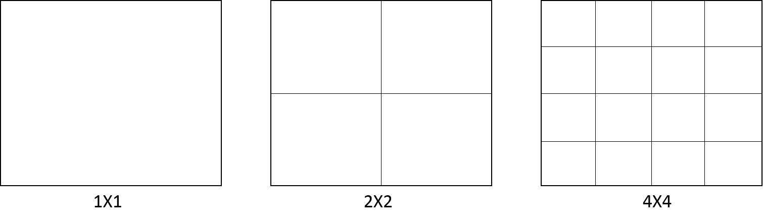

Fig. 1 the 3 meshes of the domain **D**.